Surgical Decision-Making Exam
Gastric Surgery | PMC8140555
A rare case report of late-onset phytobezoar formation following laparoscopic sleeve gastrectomy: delayed redo bariatric surgery.

Clinical Images
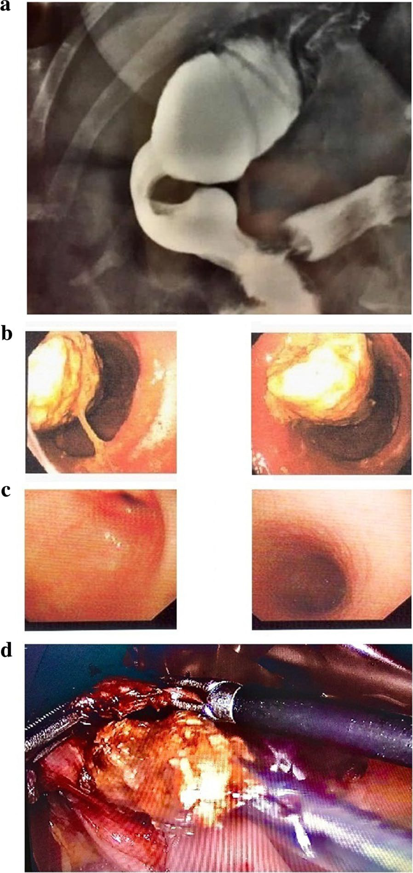
Figure 1

Question 1: Intraoperative Decision-Making
Clinical Vignette
A 52-year-old woman with morbid obesity (preoperative BMI 40.7 kg/m²) previously underwent a laparoscopic bariatric gastric restrictive operation. Early recovery was uncomplicated, but within 1 month she developed persistent nausea, postprandial vomiting, and early satiety, including episodes of self-induced emesis. Despite proton pump inhibitor therapy, symptoms persisted with marked weight loss to BMI 30.7 kg/m² by 3 months. Upper endoscopy showed reflux esophagitis (Los Angeles grade B) and mild antral gastritis. An upper GI contrast study demonstrated a fixed narrowing at the incisura angularis suspicious for a mechanical stricture. At 1 year, she remains symptomatic with profound weight loss (BMI 25.7 kg/m²). Repeat endoscopy shows a medium sliding hiatal hernia and a large gastric phytobezoar; dietary history reveals frequent intake of indigestible high-fiber foods. Chemical dissolution followed by endoscopic fragmentation and retrieval clears the bezoar, but obstructive symptoms persist, and the incisura narrowing remains the leading anatomic abnormality. She is taken to the operating room for definitive surgical management of suspected post-bariatric gastric outlet obstruction with associated reflux anatomy. Laparoscopic exploration confirms a fixed incisura stricture and a rotated/twisted gastric conduit with poor outflow. After a gastrotomy to assess the lumen, a substantial amount of recurrent phytobezoar material is encountered, and the hiatal hernia is confirmed.
Question
What definitive intraoperative strategy should be performed to relieve the obstruction and reduce recurrence, what are the critical technical steps (including management of the intragastric bezoar and repair of the hiatus), and which pitfalls must be avoided to prevent leak, recurrent stenosis, or persistent reflux?
Please deliver your answer as a structured DOCX document containing: (1) Clinical Analysis — key findings and their significance; (2) Decision & Reasoning — your recommended approach with detailed justification; (3) Evidence Basis — relevant guidelines, literature, or clinical data supporting your decision; (4) Step-by-Step Action Plan — concrete, ordered steps for implementation.

Your Answer:

Question 2: Postoperative Complication Management
Clinical Vignette
A 52-year-old woman underwent bariatric upper gastrointestinal surgery one year ago for morbid obesity. Since the operation she has had persistent early satiety, nausea, and postprandial vomiting with progressive weight loss (current BMI 25 kg/m²). Multiple evaluations have suggested impaired gastric emptying, including a fixed narrowing at the gastric incisura and intermittent intragastric stasis with recurrent phytobezoar formation despite prior endoscopic clearance. Because of ongoing obstructive symptoms and nutritional decline, she undergoes a planned reoperative upper-GI procedure to definitively relieve the functional obstruction and restore gastric drainage.
On postoperative day 3, she develops new tachycardia (HR 125/min), low-grade fever (38.2°C), increasing epigastric/left upper quadrant pain, and shortness of breath. She appears ill and mildly hypotensive. Urine output is decreased. Laboratory tests show leukocytosis and rising C-reactive protein; lactate is mildly elevated. The abdominal exam reveals localized tenderness without frank peritonitis. A surgical drain placed near the upper stomach begins to produce cloudy fluid with an enteric odor.
You are concerned for an anastomotic or staple-line leak from the surgically modified stomach/upper GI tract with evolving sepsis.
Question
In this postoperative scenario, (1) explain the pathophysiologic reasons a leak can occur after revisional bariatric upper-GI surgery in a patient with chronic obstruction/stasis; (2) list the key early clinical findings and the diagnostic workup you would use to confirm or exclude a leak; (3) present an evidence-based, severity-stratified management algorithm including antibiotics, source control (percutaneous/surgical drainage), endoscopic therapies, and indications/timing for reoperation; and (4) describe specific strategies to reduce leak risk in future cases across preoperative optimization, intraoperative technique, and postoperative care—what would you do?
Please deliver your answer as a structured DOCX document containing: (1) Clinical Analysis — key findings and their significance; (2) Decision & Reasoning — your recommended approach with detailed justification; (3) Evidence Basis — relevant guidelines, literature, or clinical data supporting your decision; (4) Step-by-Step Action Plan — concrete, ordered steps for implementation.

Your Answer:

