Surgical Decision-Making Exam
Gynecology | PMC10273530
Parasitic myoma after transabdominal hysterectomy for fibroids: a case report.

Clinical Images
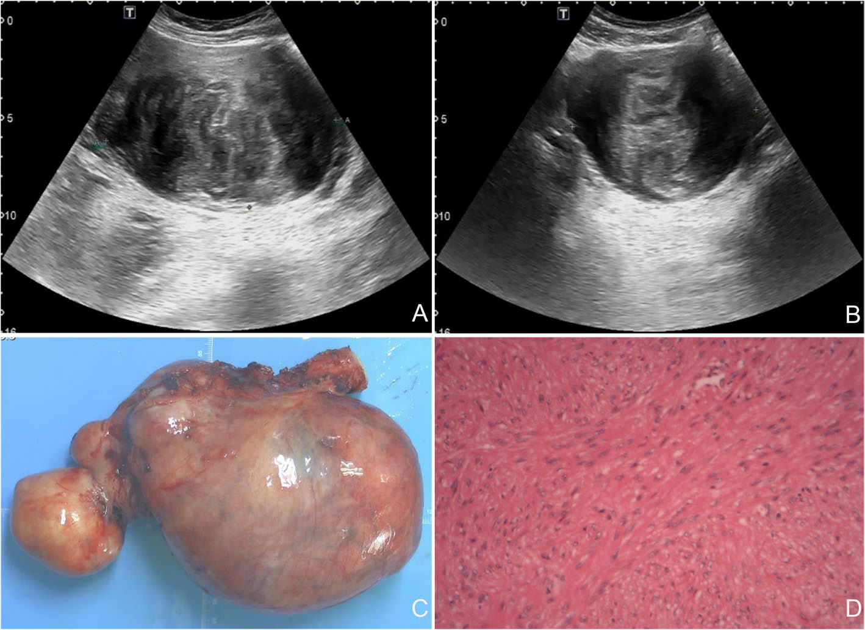
Figure 1
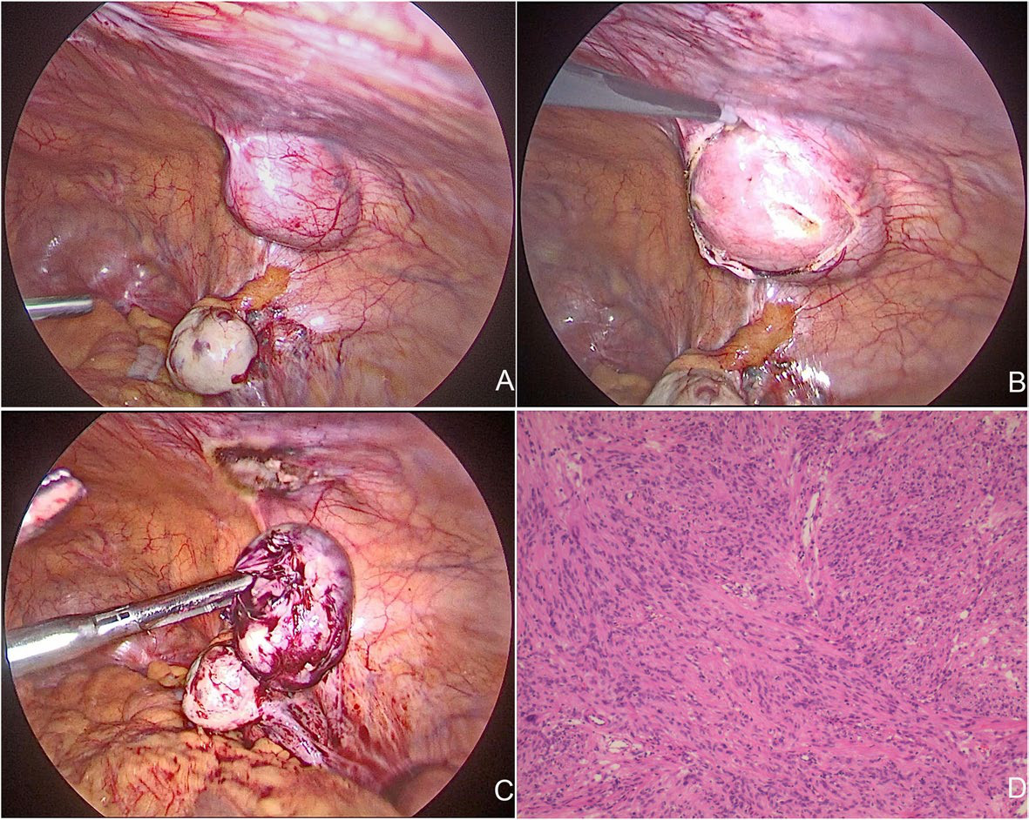
Figure 2
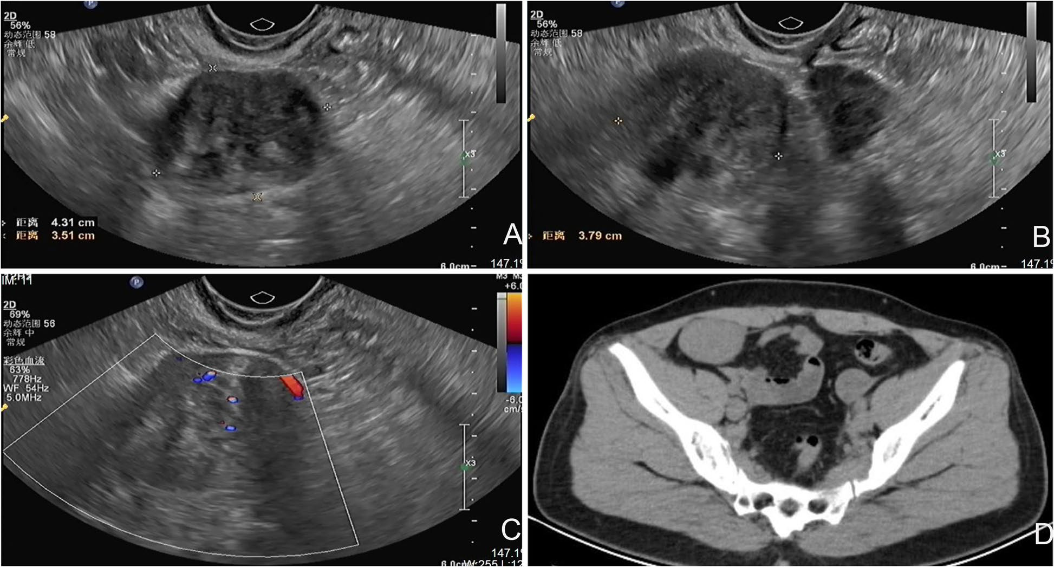
Figure 3

Question 1: Intraoperative Decision-Making
Clinical Vignette
A 46-year-old Chinese woman (G1P1) presents with a firm, mobile right lower-quadrant mass noticed 20 days ago. One year earlier she underwent transabdominal hysterectomy with bilateral salpingectomy for multiple uterine leiomyomas via a transverse lower abdominal incision. She has no weight loss, fever, or bowel/urinary symptoms. Pelvic ultrasound shows a 4.3 × 3.8 × 3.5 cm well-circumscribed solid mass in the right iliac fossa with heterogeneous medium-to-low echogenicity and internal vascular flow on Doppler. CT demonstrates an oval, well-defined soft-tissue density lesion in the right iliac fossa measuring ~4.6 × 3.1 cm with attenuation ~53 HU. CA-125 is normal. Because the lesion’s origin is uncertain (adnexa/broad ligament vs abdominal wall vs other), she is taken to the operating room for minimally invasive exploration with intent to diagnose and treat. On entry, both ovaries appear normal and no adnexal or broad-ligament mass is found. Instead, a solitary 4.5 × 4.0 cm, smooth, pink-white, well-circumscribed tumor is seen arising from the right anterior abdominal wall/peritoneum, ~3 cm lateral to the right edge of the prior transverse scar, covered by peritoneum, without obvious invasion of bowel.
Question
Given intraoperative diagnostic uncertainty (parasitic leiomyoma vs desmoid-type fibromatosis vs malignant soft-tissue tumor), what should you do next: perform limited biopsy versus attempt en bloc complete excision, should you request frozen section, and what specific operative steps will you use to minimize tumor seeding/implantation and prevent abdominal wall/incisional complications? Which technical pitfalls should be avoided, and what findings or circumstances should prompt conversion to open surgery and/or intraoperative specialty consultation?
Please deliver your answer as a structured DOCX document containing: (1) Clinical Analysis — key findings and their significance; (2) Decision & Reasoning — your recommended approach with detailed justification; (3) Evidence Basis — relevant guidelines, literature, or clinical data supporting your decision; (4) Step-by-Step Action Plan — concrete, ordered steps for implementation.

Your Answer:

Question 2: Postoperative Complication Management
Clinical Vignette
A 46-year-old woman is on postoperative day 3 after surgical excision of a solitary, well-circumscribed ~4–5 cm solid mass from the right anterior abdominal wall near a prior transverse lower-abdominal scar. Her early recovery was initially unremarkable. She now reports increasing pain at the incision with progressive redness, warmth, and swelling around the wound. She notes a new sense of “fluid shifting” beneath the skin and has a low-grade fever (38.0°C). On examination, the incision is intact without obvious dehiscence, but there is tender erythema extending several centimeters from the wound edges and a palpable fluctuant area consistent with a subcutaneous collection. She is hemodynamically stable and denies nausea, vomiting, or diffuse abdominal pain. Laboratory studies show mild leukocytosis. Bedside ultrasound of the abdominal wall demonstrates a hypoechoic fluid collection superficial to the fascia (in the prefascial/subcutaneous plane) without clear intraperitoneal fluid. There is concern for a postoperative wound complication such as seroma, hematoma, superficial surgical-site infection, abscess, or a deeper fascial-space infection.
Question
In this patient, what are the likely causes and pathophysiology of a prefascial postoperative fluid collection with erythema and fever, how should the diagnosis be rapidly confirmed and risk-stratified (seroma vs abscess vs deep fascial infection), and what is the evidence-based management plan (antibiotics, aspiration/drainage vs operative exploration, and timing/indications), including key preventive measures for future similar cases?
Please deliver your answer as a structured DOCX document containing: (1) Clinical Analysis — key findings and their significance; (2) Decision & Reasoning — your recommended approach with detailed justification; (3) Evidence Basis — relevant guidelines, literature, or clinical data supporting your decision; (4) Step-by-Step Action Plan — concrete, ordered steps for implementation.

Your Answer:

