Surgical Decision-Making Exam
Hernia Surgery | PMC4113598
Perforated sigmoid diverticulitis in a lumbar hernia after iliac crest bone graft--a case report.

Clinical Images
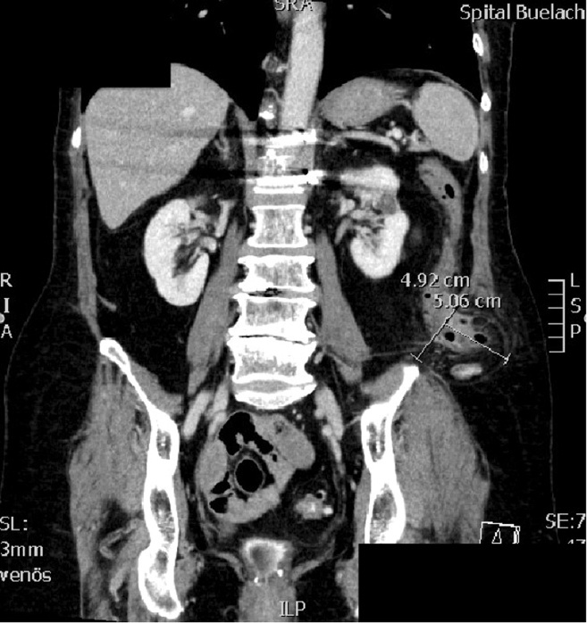
Figure 1
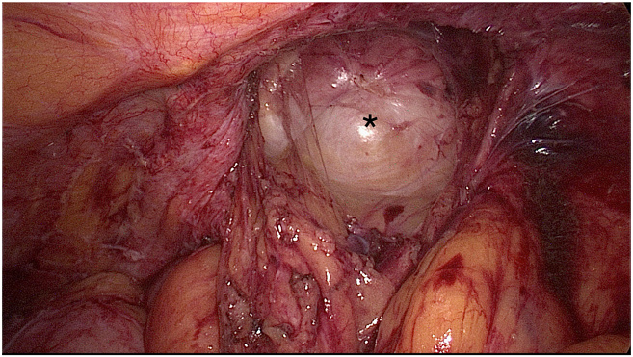
Figure 2
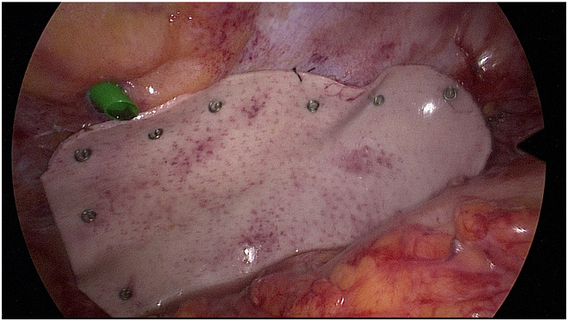
Figure 3

Question 1: Intraoperative Decision-Making
Clinical Vignette
A 66-year-old Caucasian woman (BMI 26.4 kg/m²) with hypertension, dyslipidemia, hypothyroidism, and osteopenia presents with 1 week of worsening left lower-quadrant pain. She received empiric ciprofloxacin and metronidazole for 5 days for presumed diverticulitis with transient improvement, followed by rapid deterioration. She has a long-standing left flank bulge since thoracolumbar fusion with left iliac crest bone graft 18 years ago. Exam shows left lower-quadrant tenderness and a prominent, painful, nonreducible left lumbar bulge; temperature 37.2°C. CRP is 41 mg/dL with a normal WBC count. CT demonstrates sigmoid diverticulitis with free perforation and partial herniation of the sigmoid colon into a left inferior lumbar (Petit) hernia, without CT signs of strangulation. She is taken urgently to the operating room for exploration to achieve source control and address the incarcerated hernia content. Intraoperatively, after reducing the sigmoid colon from the hernia, you find a small localized pocket of purulent fluid at the cranial edge of the hernia orifice with fibrinous coating of the sigmoid. There is free intraperitoneal air and localized putrid peritonitis, but no visible full-thickness colonic defect, no fecal contamination, and no pus elsewhere—most consistent with a sealed perforation and Hinchey III diverticulitis.
Question
How should you proceed intraoperatively to achieve safe source control—laparoscopic lavage/drainage versus immediate sigmoid resection (with or without diversion)—and what specific technical steps and pitfalls (including drain placement near the hernia orifice and whether to repair the lumbar hernia and/or use mesh in this contaminated setting) must be considered?
Please deliver your answer as a structured DOCX document containing: (1) Clinical Analysis — key findings and their significance; (2) Decision & Reasoning — your recommended approach with detailed justification; (3) Evidence Basis — relevant guidelines, literature, or clinical data supporting your decision; (4) Step-by-Step Action Plan — concrete, ordered steps for implementation.

Your Answer:

Question 2: Postoperative Complication Management
Clinical Vignette
A 66-year-old woman (BMI 26 kg/m²) with hypertension, dyslipidemia, hypothyroidism, and osteopenia undergoes urgent abdominal surgery for perforated sigmoid diverticulitis associated with an incarcerated left flank (lumbar) hernia. Broad-spectrum antibiotics are continued postoperatively. Her initial recovery is uneventful. On postoperative day 4 she develops new fever (38.5°C), tachycardia, and worsening left-sided flank pain. The left lumbar bulge, previously stable, is now more tender, erythematous, and noticeably enlarged; it is not reducible and palpation elicits significant guarding. She reports decreased appetite and malaise but no overt rectal bleeding. Laboratory tests show rising inflammatory markers (CRP increasing compared with prior days) with a new leukocytosis. Urine analysis is unremarkable. Abdominal examination otherwise shows mild diffuse tenderness without frank generalized peritonitis. The surgical drain (if present) has minimal output and no obvious feculent content. The concern is for a localized postoperative complication at or adjacent to the hernia site in the setting of recent intra-abdominal sepsis and contamination risk.
Question
What is the most likely postoperative complication in this scenario, how should it be confirmed, and what stepwise evidence-based management (including indications for reoperation) and prevention strategy would you apply in future similar cases?
Please deliver your answer as a structured DOCX document containing: (1) Clinical Analysis — key findings and their significance; (2) Decision & Reasoning — your recommended approach with detailed justification; (3) Evidence Basis — relevant guidelines, literature, or clinical data supporting your decision; (4) Step-by-Step Action Plan — concrete, ordered steps for implementation.

Your Answer:

