Surgical Decision-Making Exam
Pancreatic Surgery | PMC7216496
Two-stage pancreatic head resection after previous damage control surgery in trauma: two rare case reports.

Clinical Images
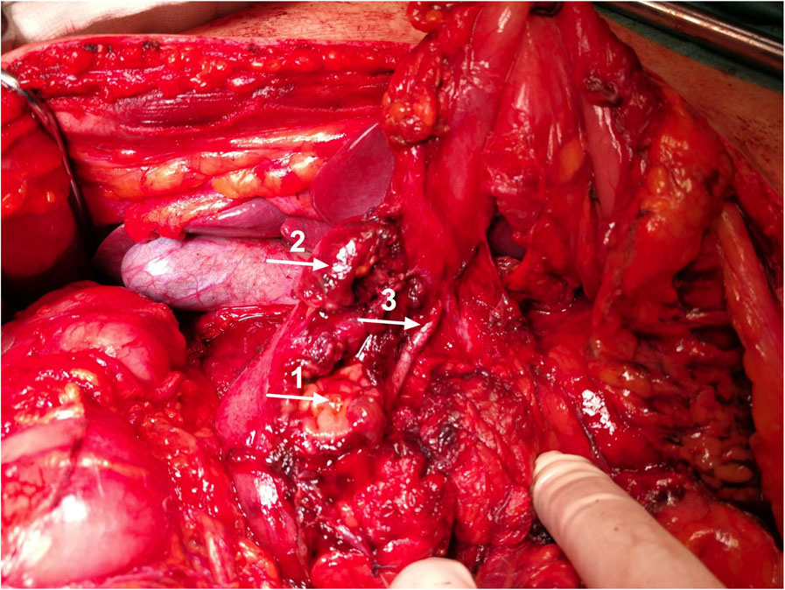
Figure 1
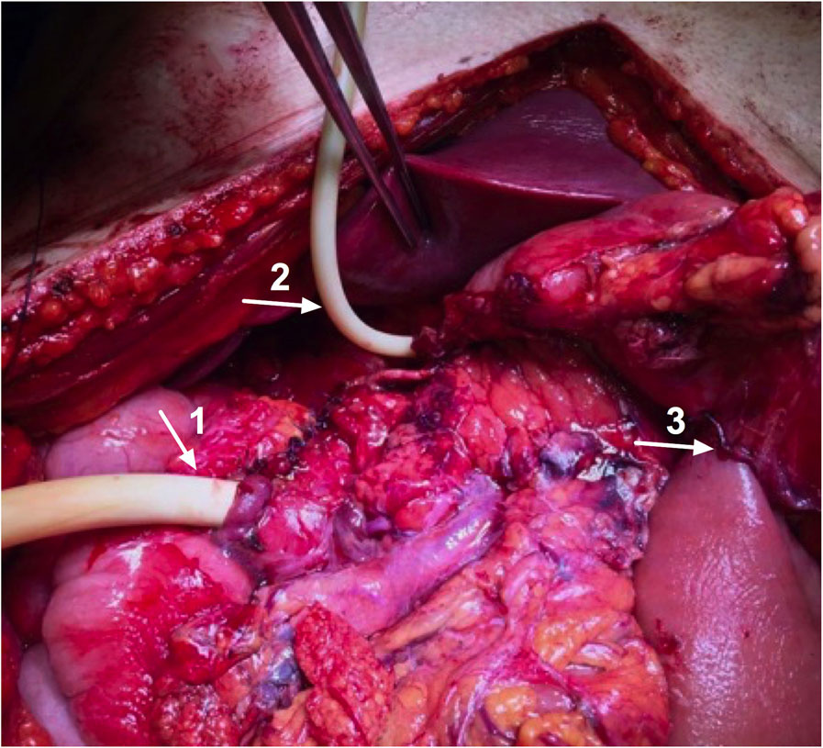
Figure 2
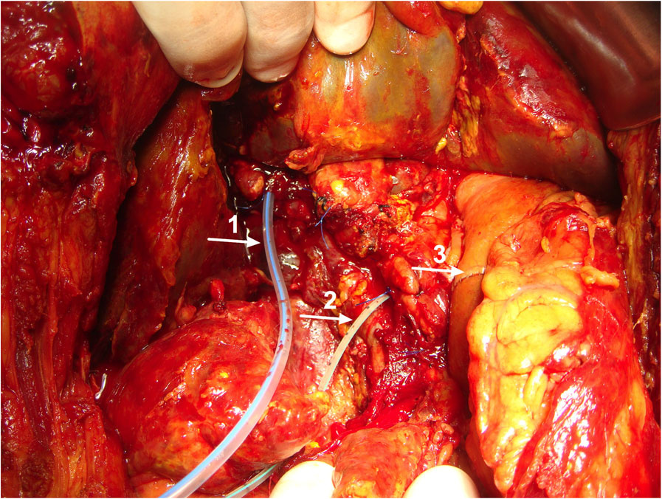
Figure 3
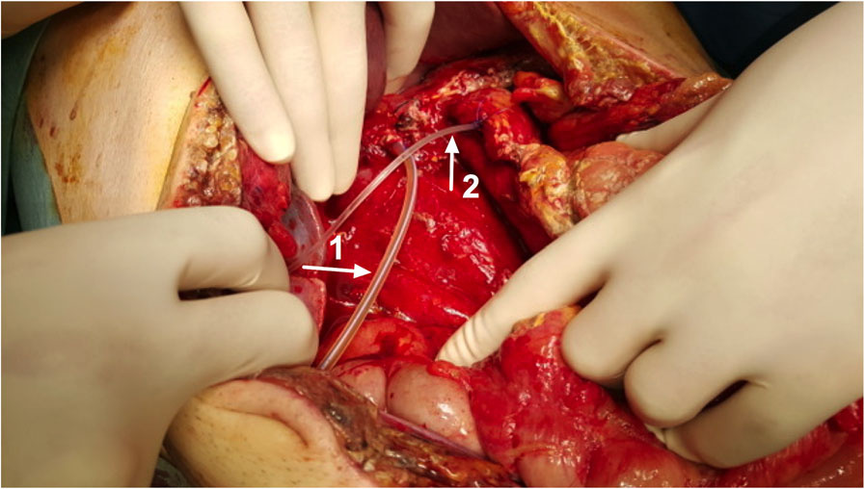
Figure 4

Question 1: Intraoperative Decision-Making
Clinical Vignette
A 47-year-old man suffered severe blunt epigastric trauma while paddle-surfing. Initial CT at a peripheral trauma center showed hemopneumoperitoneum, injury centered on the pancreatic head/uncinate region, and radiologic evidence of duodenal rupture without clear main pancreatic duct disruption. Emergent laparotomy there revealed ~300 mL hemoperitoneum from the duodenum/pancreatic head region, >75% disruption of the second portion of the duodenum, massive pancreatic head disruption, and complete transection of the main pancreatic duct at the pancreatic neck; the portal vein and SMV were intact. Given physiologic instability and limited resources, temporizing hemorrhage and contamination control were performed and the abdomen was left open with drains. He was transferred 48 hours later to an HPB referral unit with a laparostomy. After ICU resuscitation he stabilizes, but drain output rises, becomes amylase-rich, then clearly bilious. You return to the OR for re-exploration due to concern for ongoing pancreatic duct and biliary leakage. On entering the abdomen, there is diffuse intraperitoneal bile with a heavily inflamed field and markedly edematous bowel. After debridement/exposure, you identify a small extrahepatic bile duct (~4 mm) and a centered, readily identifiable main pancreatic duct (~3 mm) in a normal-consistency pancreas.
Question
In this contaminated, inflamed operative field with small-duct anatomy, what is the safest intraoperative strategy to control both biliary and pancreatic effluent—proceed with definitive reconstruction now versus staged/damage-control management—and what key technical steps and pitfalls would determine success or failure?
Please deliver your answer as a structured DOCX document containing: (1) Clinical Analysis — key findings and their significance; (2) Decision & Reasoning — your recommended approach with detailed justification; (3) Evidence Basis — relevant guidelines, literature, or clinical data supporting your decision; (4) Step-by-Step Action Plan — concrete, ordered steps for implementation.

Your Answer:

Question 2: Postoperative Complication Management
Clinical Vignette
A 47-year-old man is postoperative day 3 after emergency operative management for severe blunt upper-abdominal trauma with major pancreaticoduodenal disruption. He had an initial temporizing operation at another hospital and was transferred with temporary abdominal closure. After resuscitation in the ICU, he undergoes definitive abdominal management and closure with two closed-suction drains left in the right upper quadrant. Over the next 24–48 hours, drain output rises to 800–1200 mL/day. The fluid is initially clear but becomes progressively amylase-rich, then turns frankly bilious. He develops fever (38.8°C), tachycardia, and increasing vasopressor requirements. Urine output declines. Laboratory studies show leukocytosis, rising CRP, and mild hyperbilirubinemia. The abdomen becomes tense with diffuse tenderness. CT abdomen with IV contrast demonstrates moderate intraperitoneal fluid without a discrete abscess and no major vascular thrombosis. Drain fluid analysis shows amylase >3× the serum level and bilirubin concentration higher than serum. Blood cultures are pending. Given the escalating sepsis physiology and the character of the drain effluent, an ongoing pancreatic fistula with concurrent bile leak is suspected, with risk of diffuse peritonitis and secondary intra-abdominal infection in an edematous, contaminated postoperative field.
Question
What is the most likely postoperative complication pattern (name it precisely) and why is it occurring? Outline: (1) the criteria and workup you would use to confirm and grade the pancreatic component and to identify ongoing biliary leakage, (2) an evidence-based stepwise management plan over the next 24–72 hours including specific source-control and nutritional strategies, and (3) concrete intraoperative and postoperative prevention strategies relevant to small-duct pancreaticobiliary reconstruction in a contaminated, edematous field?
Please deliver your answer as a structured DOCX document containing: (1) Clinical Analysis — key findings and their significance; (2) Decision & Reasoning — your recommended approach with detailed justification; (3) Evidence Basis — relevant guidelines, literature, or clinical data supporting your decision; (4) Step-by-Step Action Plan — concrete, ordered steps for implementation.

Your Answer:

