Surgical Decision-Making Exam
Vascular Surgery | PMC9429316
Perioperative stroke during carotid endarterectomy: benefits of multimodal neuromonitoring - a case report.

Clinical Images
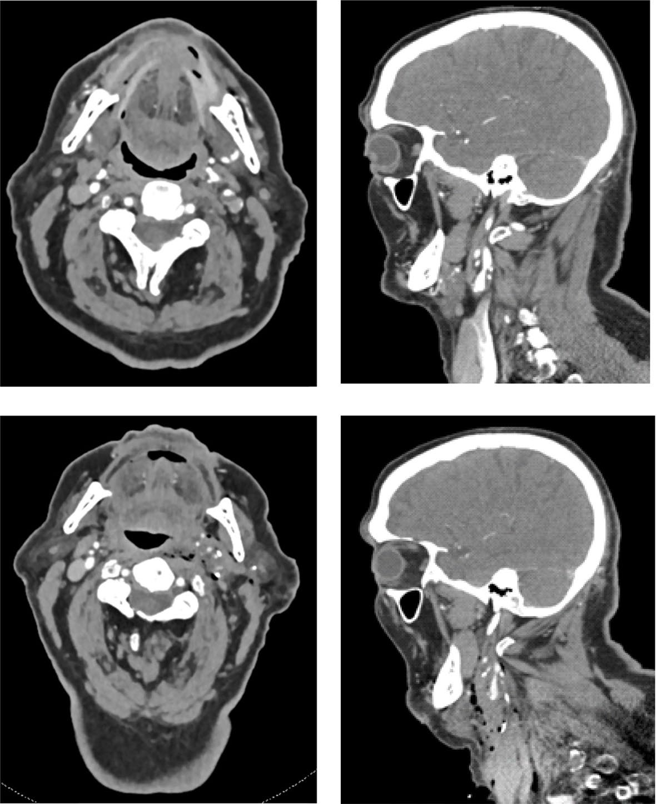
Figure 1
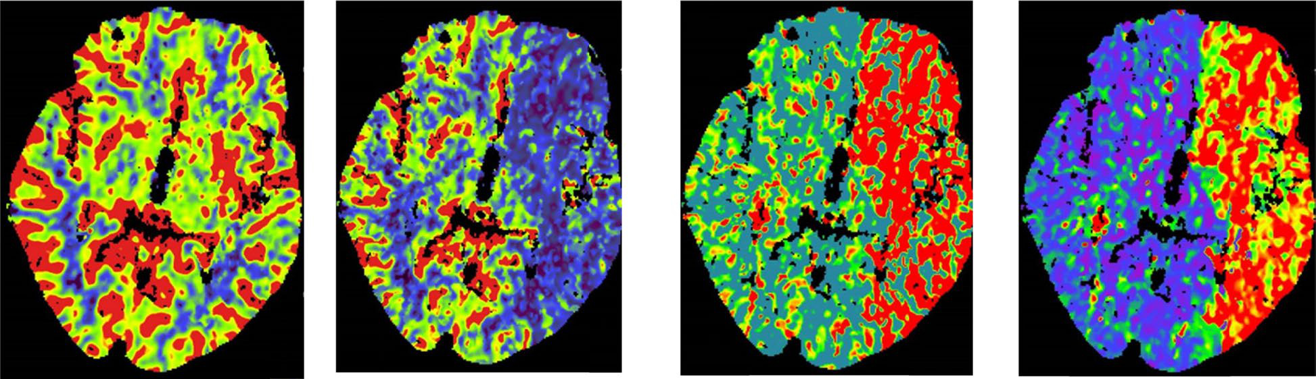
Figure 2
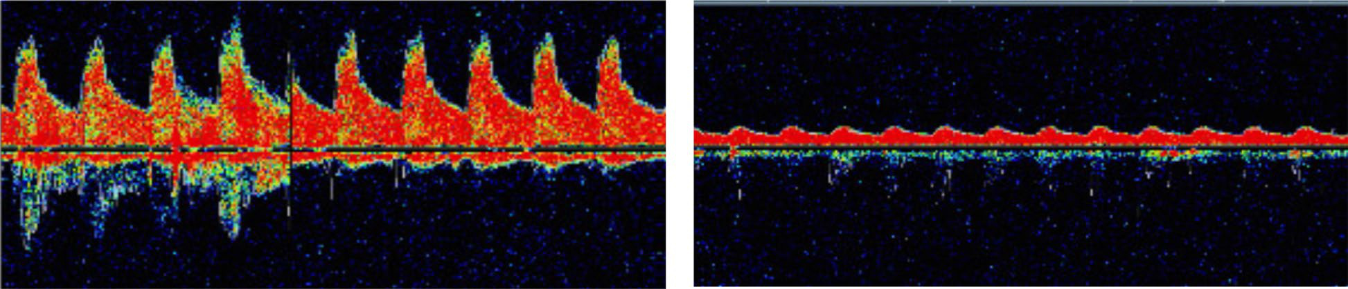
Figure 3
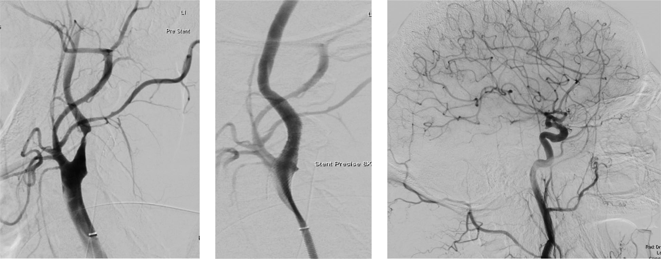
Figure 4

Question 1: Intraoperative Decision-Making
Clinical Vignette
An 85-year-old right-handed man with prior myocardial infarction and peripheral vascular disease had a minor ischemic stroke in the left MCA territory 13 days ago. He has recovered to near baseline with only subtle residual deficit. Vascular workup for symptomatic carotid disease shows a 60–70% stenosis of the left internal carotid artery (NASCET) on contrast-enhanced CT angiography, confirmed by duplex ultrasound without adherent thrombus or unstable plaque features. The right carotid system has no hemodynamically significant stenosis. He is brought to the operating room for planned surgical revascularization of the symptomatic left carotid bifurcation. General anesthesia is used, and multimodality cerebral monitoring is in place: transcranial Doppler (TCD) of the left MCA, bilateral near-infrared spectroscopy (NIRS), and continuous visual/quantitative EEG. During neck exposure and carotid dissection—before any arterial clamping—TCD suddenly shows a drop in left MCA mean flow velocity from 70 cm/s to 13 cm/s (>80% decrease). NIRS shows only a mild 7% ipsilateral decrease with a stable contralateral signal, EEG remains unchanged, and systemic blood pressure and end-tidal CO2 are stable.
Question
What is your immediate intraoperative management plan, including the key technical steps at the operative field to prevent stroke, how you would interpret and act on the discordant TCD/NIRS/EEG findings, and which pitfalls (e.g., iatrogenic embolization, intimal injury, or propagation of dissection) you must specifically avoid?
Please deliver your answer as a structured DOCX document containing: (1) Clinical Analysis — key findings and their significance; (2) Decision & Reasoning — your recommended approach with detailed justification; (3) Evidence Basis — relevant guidelines, literature, or clinical data supporting your decision; (4) Step-by-Step Action Plan — concrete, ordered steps for implementation.

Your Answer:

Question 2: Postoperative Complication Management
Clinical Vignette
An 85-year-old man with a history of prior myocardial infarction and peripheral arterial disease undergoes major open cervical vascular surgery for symptomatic carotid atherosclerotic disease. Two weeks earlier he had a minor ischemic stroke with near-complete neurologic recovery before surgery. In the post-anesthesia care unit, he is initially awake and following commands. Within 30 minutes he develops new right arm weakness and expressive aphasia. Vital signs show blood pressure 105/60 mmHg (lower than his preoperative baseline), heart rate 68/min, oxygen saturation 98% on supplemental oxygen, and he is afebrile. Neurologic exam confirms a new focal deficit consistent with left hemispheric ischemia. The neck incision dressing has mild oozing but no expanding hematoma, stridor, or respiratory distress. Point-of-care glucose is normal. ECG shows no new ischemic changes. Bedside carotid duplex demonstrates reduced flow in the operated carotid system with dampened distal waveforms compared with preoperative studies. He is not able to cooperate reliably for a full neurologic assessment due to aphasia. The team must rapidly determine whether this represents reversible hypoperfusion, acute thrombotic/embolic occlusion, or another early postoperative vascular complication and initiate time-critical management to prevent permanent stroke.
Question
What is the most likely early postoperative complication causing this new focal neurologic deficit, and what are the immediate diagnostic and management steps that should be performed to maximize neurologic salvage?
Please deliver your answer as a structured DOCX document containing: (1) Clinical Analysis — key findings and their significance; (2) Decision & Reasoning — your recommended approach with detailed justification; (3) Evidence Basis — relevant guidelines, literature, or clinical data supporting your decision; (4) Step-by-Step Action Plan — concrete, ordered steps for implementation.

Your Answer:

