Application Notes
Gwas.lasso: How to compute high-dimensional GWAS data in population designs

Zhong Wang¹, Jiahan Li², and Rongling Wu^{1,2*}
¹Center for Computational Biology, Beijing Forestry University, Beijing 100083, China
²Center for Statistical Genetics, The Pennsylvania State University, Hershey, PA 17033, USA

Received on XXXXX; revised on XXXXX; accepted on XXXXX
Associate Editor: XXXXXXX

abstract
Motivation: As an increasingly popular approach for studying and comprehending the genetic architecture of complex traits and diseases, genome-wide association studies (GWAS) are particularly designed with thousands of thousands of single nucleotide polymorphisms (SNPs) (big p) genotyped on tens of thousands of subjects (small n) sampled from a natural population, confronting a significant difficulty in analyzing the genetic effects of all SNPs simultaneously. More recently, a statistical model founded on dimension reduction has been developed to solve this big p/small n problem. To make this model computationally accessible to applied geneticists, we wrote an R package of computer software, Gwas.lasso, release in CRAN, which is particularly designed to analyze high-dimensional GWAS data sets. Functions in the package encompass single SNP analyses, significance-level adjustment, preconditioning, and model selection for a high-dimensional set of SNPs. Gwas.lasso provides the estimates of genetic parameters and the confidence intervals of these estimates. We demonstrate the features of Gwas.lasso through real data analysis.
Availability: http://statgen.psu.edu/software.
Supplementary information: Supplementary data are available at Bioinformatics online.

1 INTRODUCTION
The genetic architecture of quantitative traits is highly complex in terms of the number of genes involved, their distribution, actions and interactions. The recent development of high-throughput genotyping techniques has made it possible to dictate a comprehensive view of the genetic control for complex traits. This approach, by genotyping a high density of single nucleotide polymorphisms (SNPs) throughout the entire genome, leads to the birth of genome-wide association studies (GWAS) (Manolio 2010). To test the associations between SNPs and qualitative traits, GWAS can be designed with case-control cohorts, whereas it can use population cohorts to estimate genetic effects of SNPs on quantitative traits.
Because the number of subjects (n) for GWAS is strikingly less than the number of SNPs (p), traditional regression analysis has no power to fit all SNPs at the same time. For such a reason, a single SNP analysis (SSA) is commonly implemented into GWAS, with the significance level adjusted for multiple comparisons. To overcome the limitations of SSA, many efforts have been made to develop statistical models and algorithms for analyzing all SNPs together. Currently, most of these efforts focus on case-control GWAS designs (Wu et al. 2009; Yung et al. 2011).
More recently, a powerful statistical method has been developed for population-based GWAS to first fit all SNPs simultaneously and then simultaneously (comment: I think “fit” means parameter estimations given data and the model) select significant SNPs through lasso penalty and estimate their genetic effects within a Bayesian paradigm (Li et al. 2010). The merit of this method lies in its capacity to systematically study the genetic effects of all SNPs, with which to overcome “missing heritability” problems by single SNP analysis (Manolio et al. 2009). Although this method has been validated through computer simulation and real data analysis, its heavy statistical component may limit a practical use by applied geneticists with little training in statistics. Here, we report a package of software, written in R and C/C++, by incorporating Bayessian lasso and group lasso into a GWAS setting.
The software integrates the capacity of Bayesian lasso to perform high-dimension model selection on the model selection on high-dimensional GWAS data and estimate effect parameters of SNPs and confident intervals of the estimates. The software enables users to estimate the number of genes involved in the genetic variation of a complex trait and test the inheritance mode of any gene. By providing a comprehensive view of genetic actions and interactions over the entire genome, Gwas.lasso will facilitate our understanding of the genetic and developmental mechanisms of any biological and pathological traits.

2 IMPLEMENTATION
Regression Model: Gwas.lasso was implemented with two parts: (1) single SNP analysis by functional GWAS model, (2) high-dimensional SNP analysis for longitudinal phenotype by Bayesian lasso and (3) high-dimensional SNP analysis for longitudinal phenotype by group lasso. In part (1), functional GWAS model is used to estimate and test the overall genetic effects of individual SNPs for single measured phenotype or longitudinal phenotype. Gwas.lasso draws the Manhattan plot of p-values for the association of individual SNPs by genomic position, with horizontal lines denoting the adjusted significance levels based on Bonferroni or FDR corrections. Gwas.lasso also allows the test of additive, dominant or recessive inheritance, considering the likelihood that SNPs trigger their effects in different manners.
Part (2) is founded on a lasso penalized regression model of a phenotypic variable on a set of SNPs subject to preconditioning via a supervised principal component analysis. Preconditioning is a technique that can reduce the effect of observational noise on model selection (Paul et al. 2008). For the preconditioned response of subject i 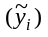, we build a high-dimensional regression model, expressed as
(1)
where µ is the overall mean, X_{i} is the r-dimensional vector of discrete covariates for subject i, α = (α₁, …, α_{r} )^{T} is the vector of regression coefficients for discrete covariates, Z_{i} is the s-dimensional vector of continuous covariates for subject i, β = (β₁, …, β_{s})^{T} is the vector of regression coefficients for continuous covariates, a = (a₁, …, a_{p})^{T} and d = (d₁, …, d_{p})^{T} are the p-dimensional vectors of the additive and dominant effects of SNPs,
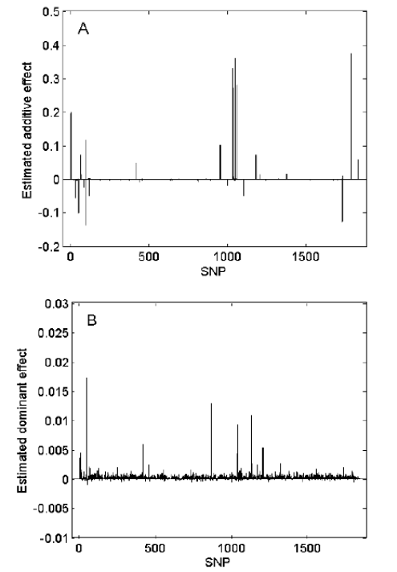
Figure 3 Estimated additive (A) and dominant effects (B) and heritabilities explained by each of xxxx SNPs from the Framingham heart study.

respectively, ξ_{i} and ζ_{i} are the indicator vectors of the additive and dominant effects of SNPs for subject i, and ε_{i} is the residual error assumed to follow a N(0,σ²) distribution. For each SNP, there are three different genotypes. The values of ξ_{i} and ζ_{i} are defined according to these genotypes (Li et al. 2010).
Among a high-dimensional set of SNPs, only a minority of it has notable effects. To detect these significant SNPs, Hgwas poses penalties on the sizes of additive effects and the dominant effects and encourages sparse solutions. Thus, equation (1) is solved by the penalized least squares, expressed as
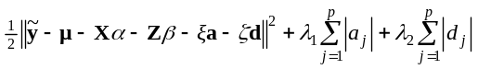 (2)
where , µ, X, Z, ξ, and ζ each are a n-dimensional vector; λ₁ and λ₂ are tuning parameters or lasso parameters that control the degrees of shrinkage in the estimate of the genetic effects.

Computing Algorithm: Li et al. (2010) deployed the MCMC algorithm to estimate the parameters (α, β, a, d, λ₁, λ₂, σ²) in equation (2) by sampling from their conditional posterior distributions. Based on results from previous researchers, Li et al. discussed the choice of prior distribution for each parameter. The statistical behavior of the parameter estimates, along with empirical power for gene detection and false positive rates, from this lasso-based model has been examined through simulation studies.
Hgwas implemented Li et al.’s algorithm to a software platform, allowing the simultaneous estimates of multiple SNPs from any GWAS design for genetic analysis of quantitative traits. Hgwas was written in two versions, one in VC++ 6.0 and the other in R. Its C version is characteristic of high computing speed and can be used for practical high-dimensional GWAS analysis. The R version is flexible, allowing interested researchers to perform simulation studies, test additional hypotheses and modify the statistical models to fit their data.

2 EXAMPLE
Hgwas was used to analyze a real GWAS data set from the Framingham Heart Study (FHS). One of the FHS projects contains 418 males and 559 females, genotyped for 550,000 SNPs and phenotyped for body mass index (BMI) at different ages from 29 and 61 years. By treating sex and age as covariates, single SNP analysis (SSA) provides a p-value for each SNP and the Manhattan plot for all SNPs (Supplementary Fig. 1). After corrections for multiple comparisons, Hgwas detected xx significant SNPs whose names, positions, significance levels and inheritance modes are given in Supplementary Table 1.
There are xxx SNPs whose –log10 p-value of > 0.0 from SSA. Hgwas performed a preconditional (comment: preconditioning?) analysis for these SNPs to mitigate observational noise and regressed the preconditioned phenotypes on all SNPs simultaneously based on equation (2). We claim that a genetic effect is significant if its 95% posterior credible interval does not contain zero. Alternatively, Hoti and Sillanpaa (2006) suggested the use of a threshold value, preset on researchers’ experience, to determine significant effects. Figure 1 plots the estimated additive and dominant effects and heritabilities explained by each SNP after adjusting for the effects of other SNPs and covariates. The details of these SNPs are summarized in Supplementary Table 2.

3 DISCISSION
We have reported one of the first software packages named Hgwas, for population-based GWAS designs. It incorporates traditional single SNP analysis widely used in current GWAS projects and Li et al.’s (2011) high-dimensional data analysis. It not only allows the comparison of these two approaches, but also provides a procedure to use the results from the former to strengthen data analysis and modeling using the latter. The software was implemented with the Bayesian algorithm to take advantage of the estimates of confident intervals of the parameter estimates. Also, Hgwas was written in two different languages one in C for enhancing computing efficiency and the other in R for the flexibility of method tests and modifications.
Haplotype diversity, epistasis, genotype-environment interactions and genetic imprinting may play an important role in trait development and disease expression. We are under way to incorporate these important biological phenomena into Hgwas. Perhaps, the bottleneck of GWAS analyses arises from computing burden. A cluster of machines can be paralleled to accelerate analysis and discrimination processes of high-dimensional GWAS data.
Funding: NSF/IOS-0923975.
References
Li, J.H. et al. (2011) Bayesian lasso for genome-wide association studies. Bioinformatics 27, 516-523.
Manolio, T.A. et al. (2009) Finding the missing heritability of complex diseases. Nature 461, 747–753
Manolio, T.A. (2010) Genomewide association studies and assessment of the risk of disease. N. Engl. J. Med. 363, 166–176
Paul, D. et al. (2008) Preconditioning for feature selection and regression in high-dimensional problems, Ann. Stat., 36, 1595-1618.
Wu, T.T. et al. (2009) Genome-wide association analysis by lasso penalized logistic regression, Bioinformatics, 25, 714-721.
Yung, L.S. et al. (2011) GBOOST: a GPU-based tool for detecting gene-gene interactions in genome-wide case control studies. Bioinformatics 27, 1309-1310.

*To whom correspondence should be addressed.

