1. Step One: Determine the purpose of your database：

The database is designed to provide an overview of the operations at the West Municipal Library, describes the daily library functions, and presents the database through queries.

Daily Library Functions include:

* People can register as members of two type: Adult or Juvenile
* Uniquely identify Books (item) by ISNB (title, language, binding and publisher)
* Check if one book is available or how many copies left
* Members can reserve books that are all loaned out.
* Members can borrow or return books

1. Step Two: Determine the Entities you need:

Tables we need:

Titles, Items, Copies, Members, Adults, Juveniles, Reservations, Loans, OverDues

1. Step Three: Determine the attributes (fields) in each entity:
2. Step Four: Create the Data Dictionary

For step 3 and 4, please refer to:

<Library_Entities.xlsx>

1. Step Five: Determine the Relationships

Employees AbsenteForms Categories Departments : SpecialOccasions OverTimeForms

1. From Adults to Members
2. Min: One Adult registers as **1** member
3. Max: One Adult registers as **1** member

From Members to Adult

1. Min: One Member is registered for **0** adult
2. Max: One Member is registered for **1** Adult
3. From Juveniles to Members
4. Min: One Juvenile register as 1 member
5. Max: One Juvenile register as only 1 member

From Members to Juvenile

1. Min: One Member is registered for **0** Juvenile
2. Max: One Member is registered for max **1** Juvenile
3. From Members to Loans
4. Min: One Member takes **0** Loan
5. Max: One Member takes **many** Loans

From Loans to Members

1. Min: One Loan is taken by **1** Member
2. Max: One Loan is taken by **1** Member
3. From Members to Reservations
4. Min: One Member reserves 0 Reservation
5. Max: One Member reserves **many** Reservations

From Reservations to Members

1. Min: One Reservation is reserved by **1** Employee
2. Max: One Reservation is reserved by **1** Employee
3. From Loans to OverDues
4. Min: One Loan causes **0** OverDue
5. Max: One Loan causes **1** OverDue

From OverDues to Loans

1. Min: One OverDue is caused by **1** Loan
2. Max: One OverDue is caused by **1** Loan
3. From Loans to Copies
4. Min: One Loan contains **1** Copy
5. Max: One Loan contains **1** Copy

From Copies to Loans

1. Min: One Copy may be in **0** Loan
2. Max: One Copy may be in **many** Loans
3. From Reservations to Items
4. Min: One Reservation contains 1 Item
5. Max: One Reservation contains 1 Item

From Items to Reservations

1. Min: One Item is in **0** Reservation
2. Max: One Item is in **1** Reservations
3. From Items to Copy
4. Min: One Item owns **1** Copy
5. Max: One Item owns **many** Copies

From Copies to Items

1. Min: One Copy is owned by **1** Item
2. Max: One Copy is owned by **1** Item
3. From Items to Titles
4. Min: One Item belongs to 1 Title
5. Max: One Item belongs to 1 Title

From Titles to Items

1. Min: One Title contains **1** Item
2. Max: One Title contains **many** Items

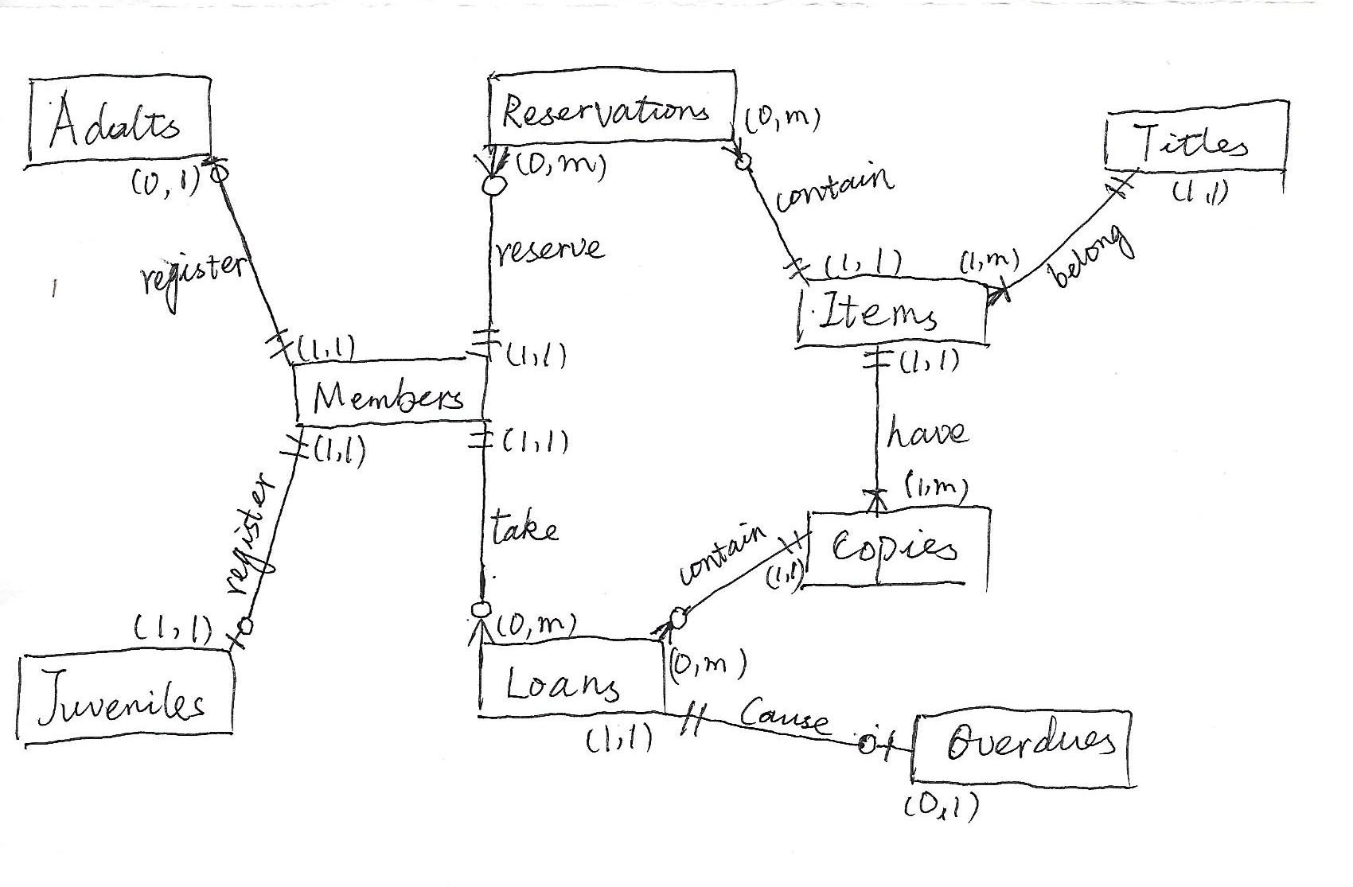

1. Step Six: Transfer the ERD into a relational system (tables, fields, data types, etc.)

Please refer to the scripts enclosed