# List of Views, Functions, Procedures, Triggers

* Views

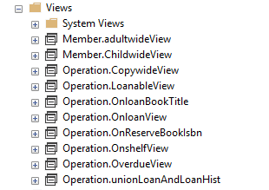

* Functions

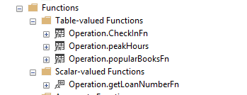

* Procedures

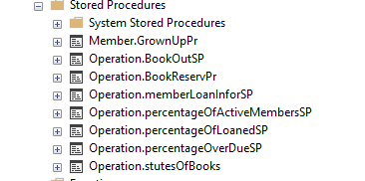

* Triggers

## operation.BookOutTR

Operation.CheckInTr

Member.GrownUpTr

# Querys for task 4

* 1. Make data more user friendly:

Using CONCAT_WS to return full name, full address

* 2. Search datas from two tables:

INNER JOIN selects records that have matching values in both tables.

* 3.Display member’s information with reservation details

LEFT JOIN returns all records from the left table (members), and the matched records from the right table (reservations). The result is NULL from the right side, if there is no match.

* 4. Member.adultwideView return full information about all adult members

INNER JOIN (members) and (adults)

5. Member.ChildwideView return full information about all children members

INNER JOIN three tables : member(name), adults(address), Juveniles(id)

.

.

.

.

.

# Generating usage report of Library database

Create a view operation.unionLoanAndLoanHist to union Table Loan and LoanHist, give a ‘Status’ (on loan or closed)

1. How many loans did the library do last year?

operation.unionLoanAndLoanHist

AnalyseYear number

2. What percentage of the membership borrowed at least one book

operation.unionLoanAndLoanHist

AnalyseYear

Active Members

Total number of members (from members)

# Generating usage report of Library database

3. What was the greatest number of books borrowed by any one individual?

-- may return a TABLE of BOOKS

>>.

Select

count(v.title_no) as 'Total number of Loan',

ot.title

from operation.unionLoanAndLoanHist as v

inner join [Operation].[Titles] as ot

on v.title_no=ot.Title_no

group by v.title_no , ot.title

having count(v.title_no)=

(

select top 1 count(title_no)

from operation.unionLoanAndLoanHist

group by title_no

order by count(title_no) desc

)

4. What percentage of the books was loaned out at least once last year

--ltrim(cast(@bookLoanded*1.0*100/@totalBook as decimal(5,2)))+'%'

operation.unionLoanAndLoanHist

AnalyseYear

Number of books was loaned

Total number of books (from copies)

# Generating usage report of Library database

5. What percentage of all loans eventually becomes overdue?

operation.unionLoanAndLoanHist

Number of loans

Number of Overdue books on loan + Number of Overdue Books in loans closed

loans

loansHist

6. What is the average length of a loan?

-- count data only from table LoanHist

select avg(abs(DATEDIFF(day,[in_Date],[out_Date]))) from [Operation].[Loanhist])

7. What are the library peak hours for loans?

-- only count out_date as example

-- Use datepart() retune check hour

datepart(hour,out_date) as 'Peak hour',

COUNT(datepart(hour,out_date)) as 'Number of Activities'

from Operation.unionLoanAndLoanHist

group by datepart(hour,out_date)

# Questions:

1. when use view? Function? Procedure…

>> if not count MEMOEY used

A stored procedure:

* accepts parameters

* can NOT be used as building block in a larger query

* can contain several statements, loops, IF ELSE, etc.

* can perform modifications to one or several tables

* can NOT be used as the target of an INSERT, UPDATE or DELETE

statement.

A view:

* “virtual” table, can use select statement or join with other table(view)

* does NOT accept parameters

* can be used as building block in a larger query

* can contain only one single SELECT query

* can NOT perform modifications to any table

* but can (sometimes) be used as the target of an INSERT, UPDATE or

DELETE statement.

A Functions:

Functions in SQL Server, can NOT be used to modify the database. READ ONLY ! Can NOT perform modifications to any table (NO!!!!!! INSERT, UPDATE , DELETE).

2. @tableName variable?

I am trying to execute this query:

declare @tablename varchar(50)

set @tablename = 'test'

select * from @tablename

Must declare the table variable "@tablename".

DECLARE @sSQL nvarchar(500);

SELECT @sSQL = N'SELECT * FROM' + QUOTENAME(@TableName);

EXEC sp_executesql @sSQL