**BioPad User Manual**

BioPad can be used to turn off-the-shelf video games into biofeedback games. It works by intercepting the controller signals based on physiological signals. It has a GUI that allows users to change between different interference modes.

To run the sample application in the program, a CronusMax device and an Xbox 360 controller are required.

To test it on a PC, do the following steps:

1) Connect the CronusMax to the PC, and connect the Xbox 360 controller to the CronusMax.

2) Open Control Panel --> devices and printers --> Xbox 360 controller for windows --> game controller settings --> properties.

You should see the following window that displays Xbox 360 values in graphics.

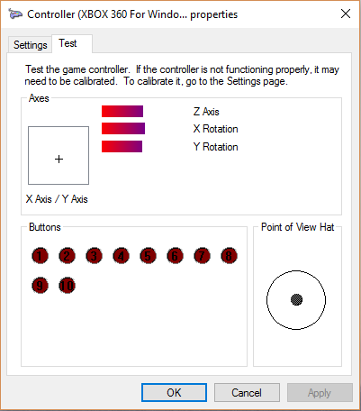 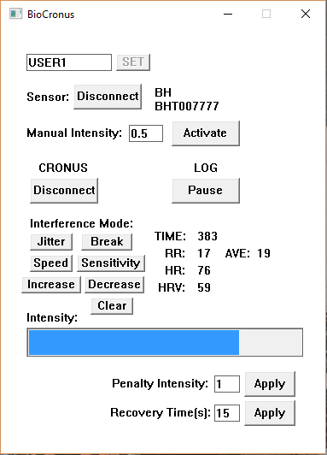

3) Compile the program with visual studio and run BioCronus.exe.

4) Via GUI, either connect the BioHarness 3 sensor, or activate the manual intensity (from 0 to 1).

5) Connect the CronusMax on the GUI

6) Select from one of the six interference modes.

At this point, you should see that the controller values are modified automatically.

Test different interference modes on any PC game that can be played with an Xbox controller.