**Country-data**

对数据进行降维后，采用kmeans算法进行聚类



**aisles.csv(****<https://www.kaggle.com/code/asindico/customer-segments-with-pca/notebook>**

**PCA 算法将消费者数据降维后分类**

**)**

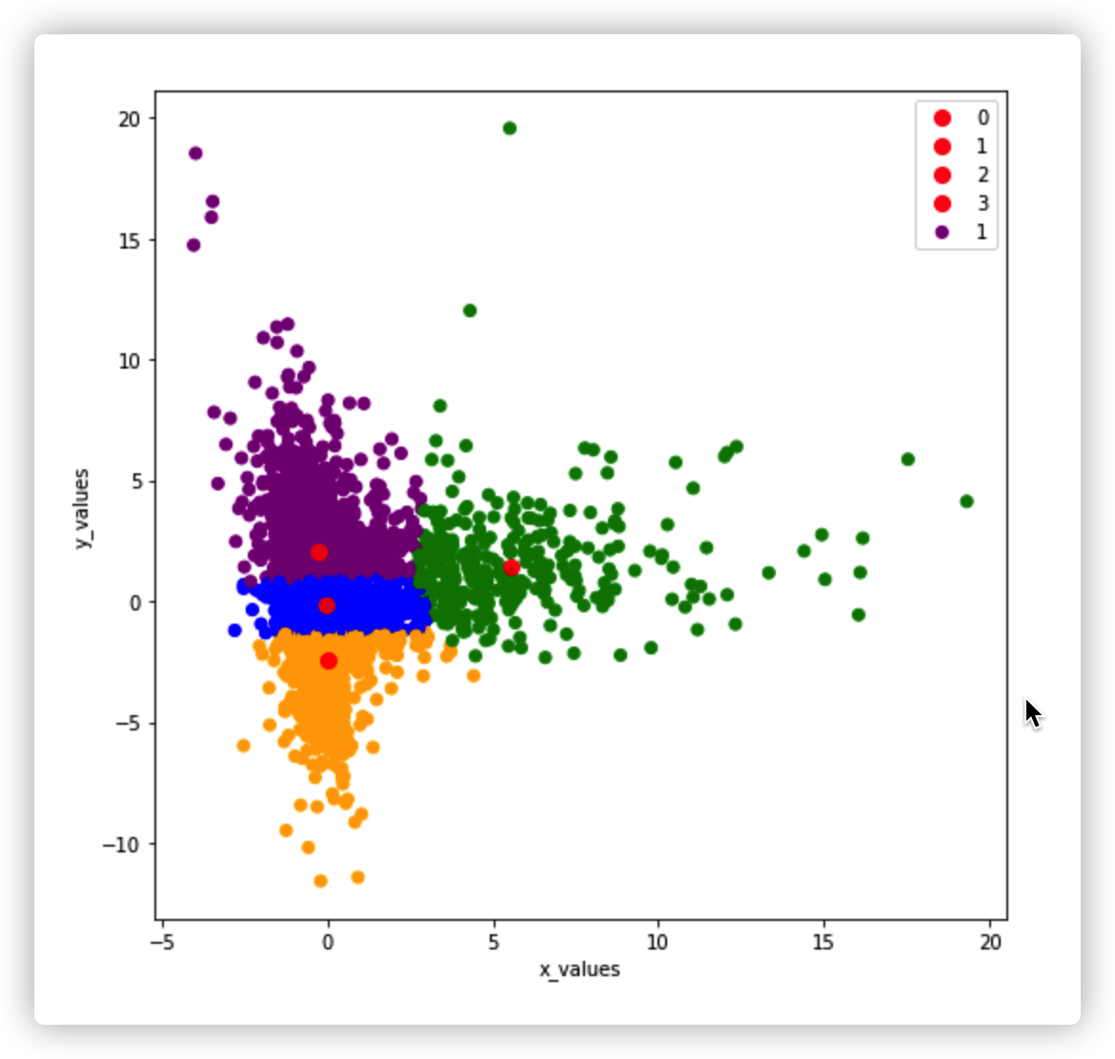

**PCA + k-means**

**Jane Street Market Prediction(通过PCA 降维到8维后使用k-means 算法聚类分析降维结果，效果不错。但是初始数据为100多维)**

[**https://www.kaggle.com/code/muhammadmelsherbini/jane-street-extensive-eda-pca-starter/notebook**](https://www.kaggle.com/code/muhammadmelsherbini/jane-street-extensive-eda-pca-starter/notebook)

**BNP Paribas Cardif Claims Management(Discussion 中看到了有人用t-SNE降维效果还不错)**

[**https://www.kaggle.com/c/bnp-paribas-cardif-claims-management/data?select=train.csv.zip**](https://www.kaggle.com/c/bnp-paribas-cardif-claims-management/data?select=train.csv.zip)

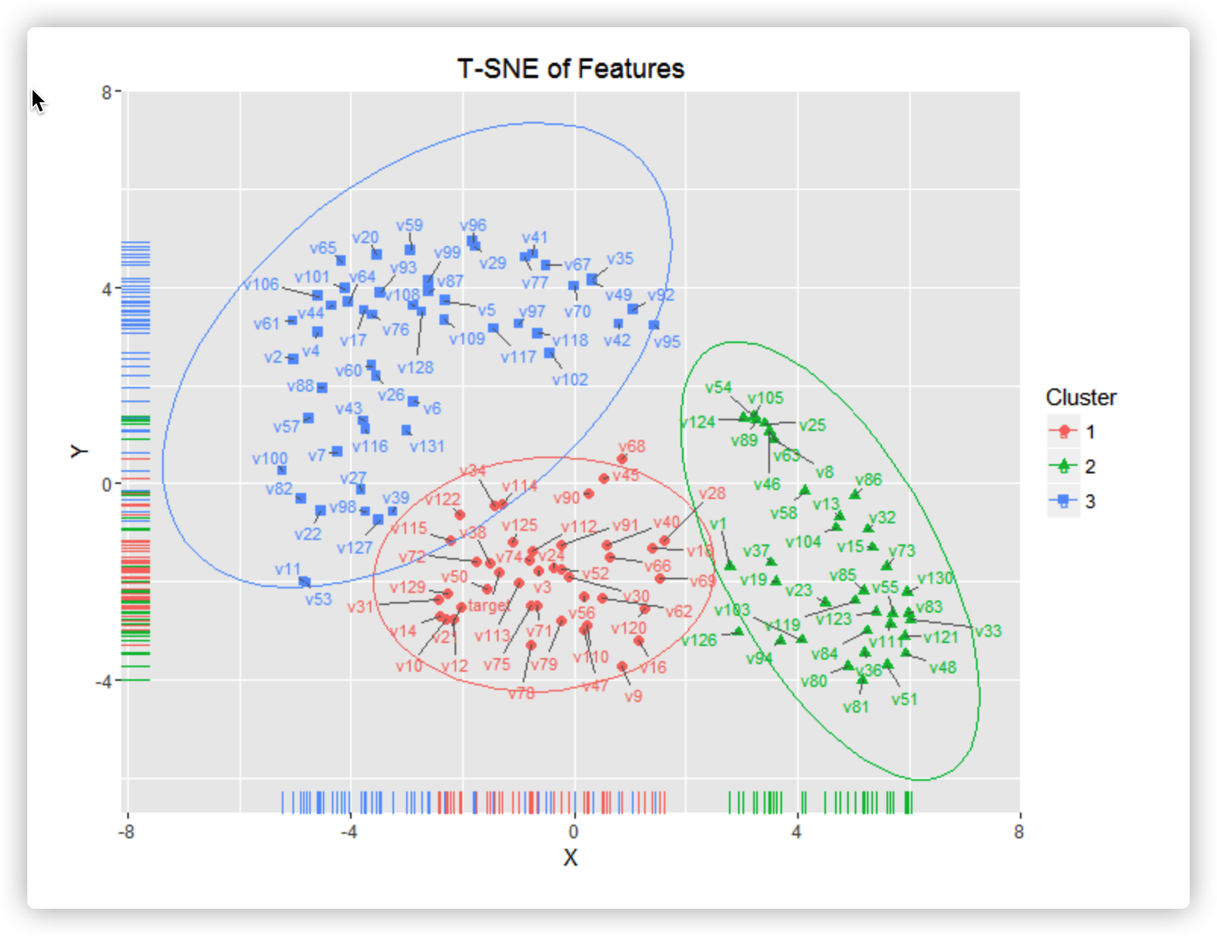

**wineQT (使用PCA算法进行降维处理)**

