Distribution-free error control for cell type annotation in spatial proteomics
Zhipeng Wang1*, Luning Wang2*, Changsong Wang1, Xiyu Xu3, Pengli Zhai4, Zejun Liu1, Hui Feng1, Qian Hou1, Ming Guo1
1 Department of TCM, Zhongda Hospital, Southeast University, Nanjing, China
2 Department of Rehabilitation Medicine, Zhongda Hospital, Southeast University, Nanjing, China
3 School of Medicine, Southeast University, Nanjing, China
4 Jiangbei Campus, Jiangsu Provincial Traditional Chinese Medicine Hospital, Nanjing, China
* These authors contributed equally to this work and are co-first authors.
Corresponding author: Wang Zhipeng, E-mail: 311000687@seu.edu.cn
Funding: Higher Education Teaching Reform Research Project of Xuzhou Medical University (XYJG042); Special Project of Artificial Intelligence Literacy Education Teaching Reform Research in Undergraduate Universities of Jiangsu Province (2026TSY013).

Abstract
Cell type annotation limits spatial proteomics throughput, yet classifiers report confidence rather than the error rate among retained labels. We introduce a post hoc, distribution-free layer that turns any probabilistic classifier into a commit-or-review rule with a finite-sample selective-error bound. Across 39,684 expert-labelled cells, a 20% budget committed 86.4% of 19,669 held-out cells at selective error 0.14. At 10%, coverage was 1.00 under exchangeable resampling, 0.82 across fields of view and 0.40 under cross-tissue transfer. Excess acceptance relative to an oracle on labelled audit cells made the failure visible, so the layer reports when its guarantee fails. Target calibration restored coverage; a real antibody-panel change held coverage at 1.00 with 0.50 acceptance at 10%. A harder cross-platform colon transfer, with 4,000 labels about half the batch, was net-negative at every budget tested. We package the method as a decision procedure, label-free audit and target-label price list.
Keywords: Spatial Proteomics, Cell Type Annotation, Conformal Prediction, Selective Error Control, Distribution-Free Inference
Introduction
Multiplexed imaging now measures dozens of proteins per cell in situ, and the resulting cell tables drive spatial proteomics¹,². Each cell needs a type, but experts still assign most labels, which limits throughput. CellSighter and CellTune have made automated typing practical³,⁴, yet neither reports how many retained labels are wrong.
A softmax score is not an error rate. It is uncalibrated on the training distribution and changes under shift⁵. With no standard marker panel⁶, antibodies, protocols and tissues differ, so a model trained on one cohort is often deployed on another with partial overlap⁷,⁸. A fixed threshold therefore means different things in different cohorts⁹.
A laboratory needs a review budget, not another score: how many cells to inspect so that the error rate among retained labels stays below a stated level. Conformal prediction and conformal risk control give finite-sample bounds with few assumptions¹⁰,¹¹. The obstacle is exchangeability, which cross-tissue and cross-panel deployment violates; a usable procedure must either survive that violation or price it.
We build a post hoc layer around the classifier. It controls the two unconditional probabilities that define selective error; the natural conditional bound fails when the accepted set and the calibration block come apart¹²,¹³. The layer is valid when calibration represents deployment and fails visibly when it does not. That boundary becomes a label-free audit and a price list in target labels, tested on a cross-panel benchmark, independent cohorts and two published classifiers.
Three questions follow. Can a threshold be certified without assuming a classifier or a parametric error model? What does the certificate mean when calibration and deployment differ? When it fails, can a laboratory choose between reviewing more cells and buying more labels? We address them with 39,684 usable expert-labelled cells, a split design that separates exchangeable from non-exchangeable deployment, and a label-free marker audit. The output is a decision procedure that states what can be committed, what must be reviewed and what a repair costs.
Results
We first test whether confidence reports error under transfer. We then define the controller, locate its boundary, price the guarantee and its repair, audit marker consistency, and test whether the behaviour replicates outside the source depot.
A benchmark where confidence is not an error rate
We assembled a benchmark from CellTuneDepot, a public resource of multiplexed imaging cohorts with expert annotation⁴,¹⁴. Four cohorts met our inclusion criteria: breast, colorectal, graft versus host disease (GVHD) and melanoma. They contain 41,602 expert-labelled cells, of which 39,684 have a defined type (Fig. 1A). The cohorts span three tissues and four panels; pairwise Jaccard overlap between panels is 0.18 to 0.44 (Fig. 1B). The transfer family uses only shared channels, so its twelve pairs, with 11 to 27 channels each, form a re-panelling stress test rather than an antibody replacement. The real replacement test appears below.
Three audit findings shaped the design. The GVHD cohort has a delivery defect. Its annotation table and shipped segmentation mask share identifiers for 17.4% of cells, 1,794 of 10,283, and the two files use disjoint ranges at field-of-view level (Fig. 1D)⁴,¹⁵. Colorectal and GVHD also ship semi-supervised labels of unknown accuracy; these disagree with expert annotation in 27% and 15% of cells (Fig. 1C). Finally, 0 to 4 of the 12 to 30 Boolean rules per cohort could not be evaluated on the available channels. We therefore treat the expert labels as the reference and keep the delivery audit separate from the error analysis.
If confidence were an error probability, a fixed threshold would mean the same thing in every cohort. Under a random split it does: expected calibration error is 0.08 on both sides. Under cross-tissue transfer it rises from 0.07 to 0.20 when weighted by cells, a factor of 2.8, while accuracy falls from 0.77 to 0.58 (Fig. 2A–F). Unit-weighted family estimates give 0.08 to 0.19, a factor of 2.4 (Fig. 2H). On the melanoma target the model is correct about 30% of the time in the 0.5–0.6 confidence bin (Fig. 2D). Cross-field-of-view splitting leaves calibration error approximately unchanged at a ratio of 0.92 (Fig. 2G,H). The degradation is consistent with the change of domain rather than with the softmax.
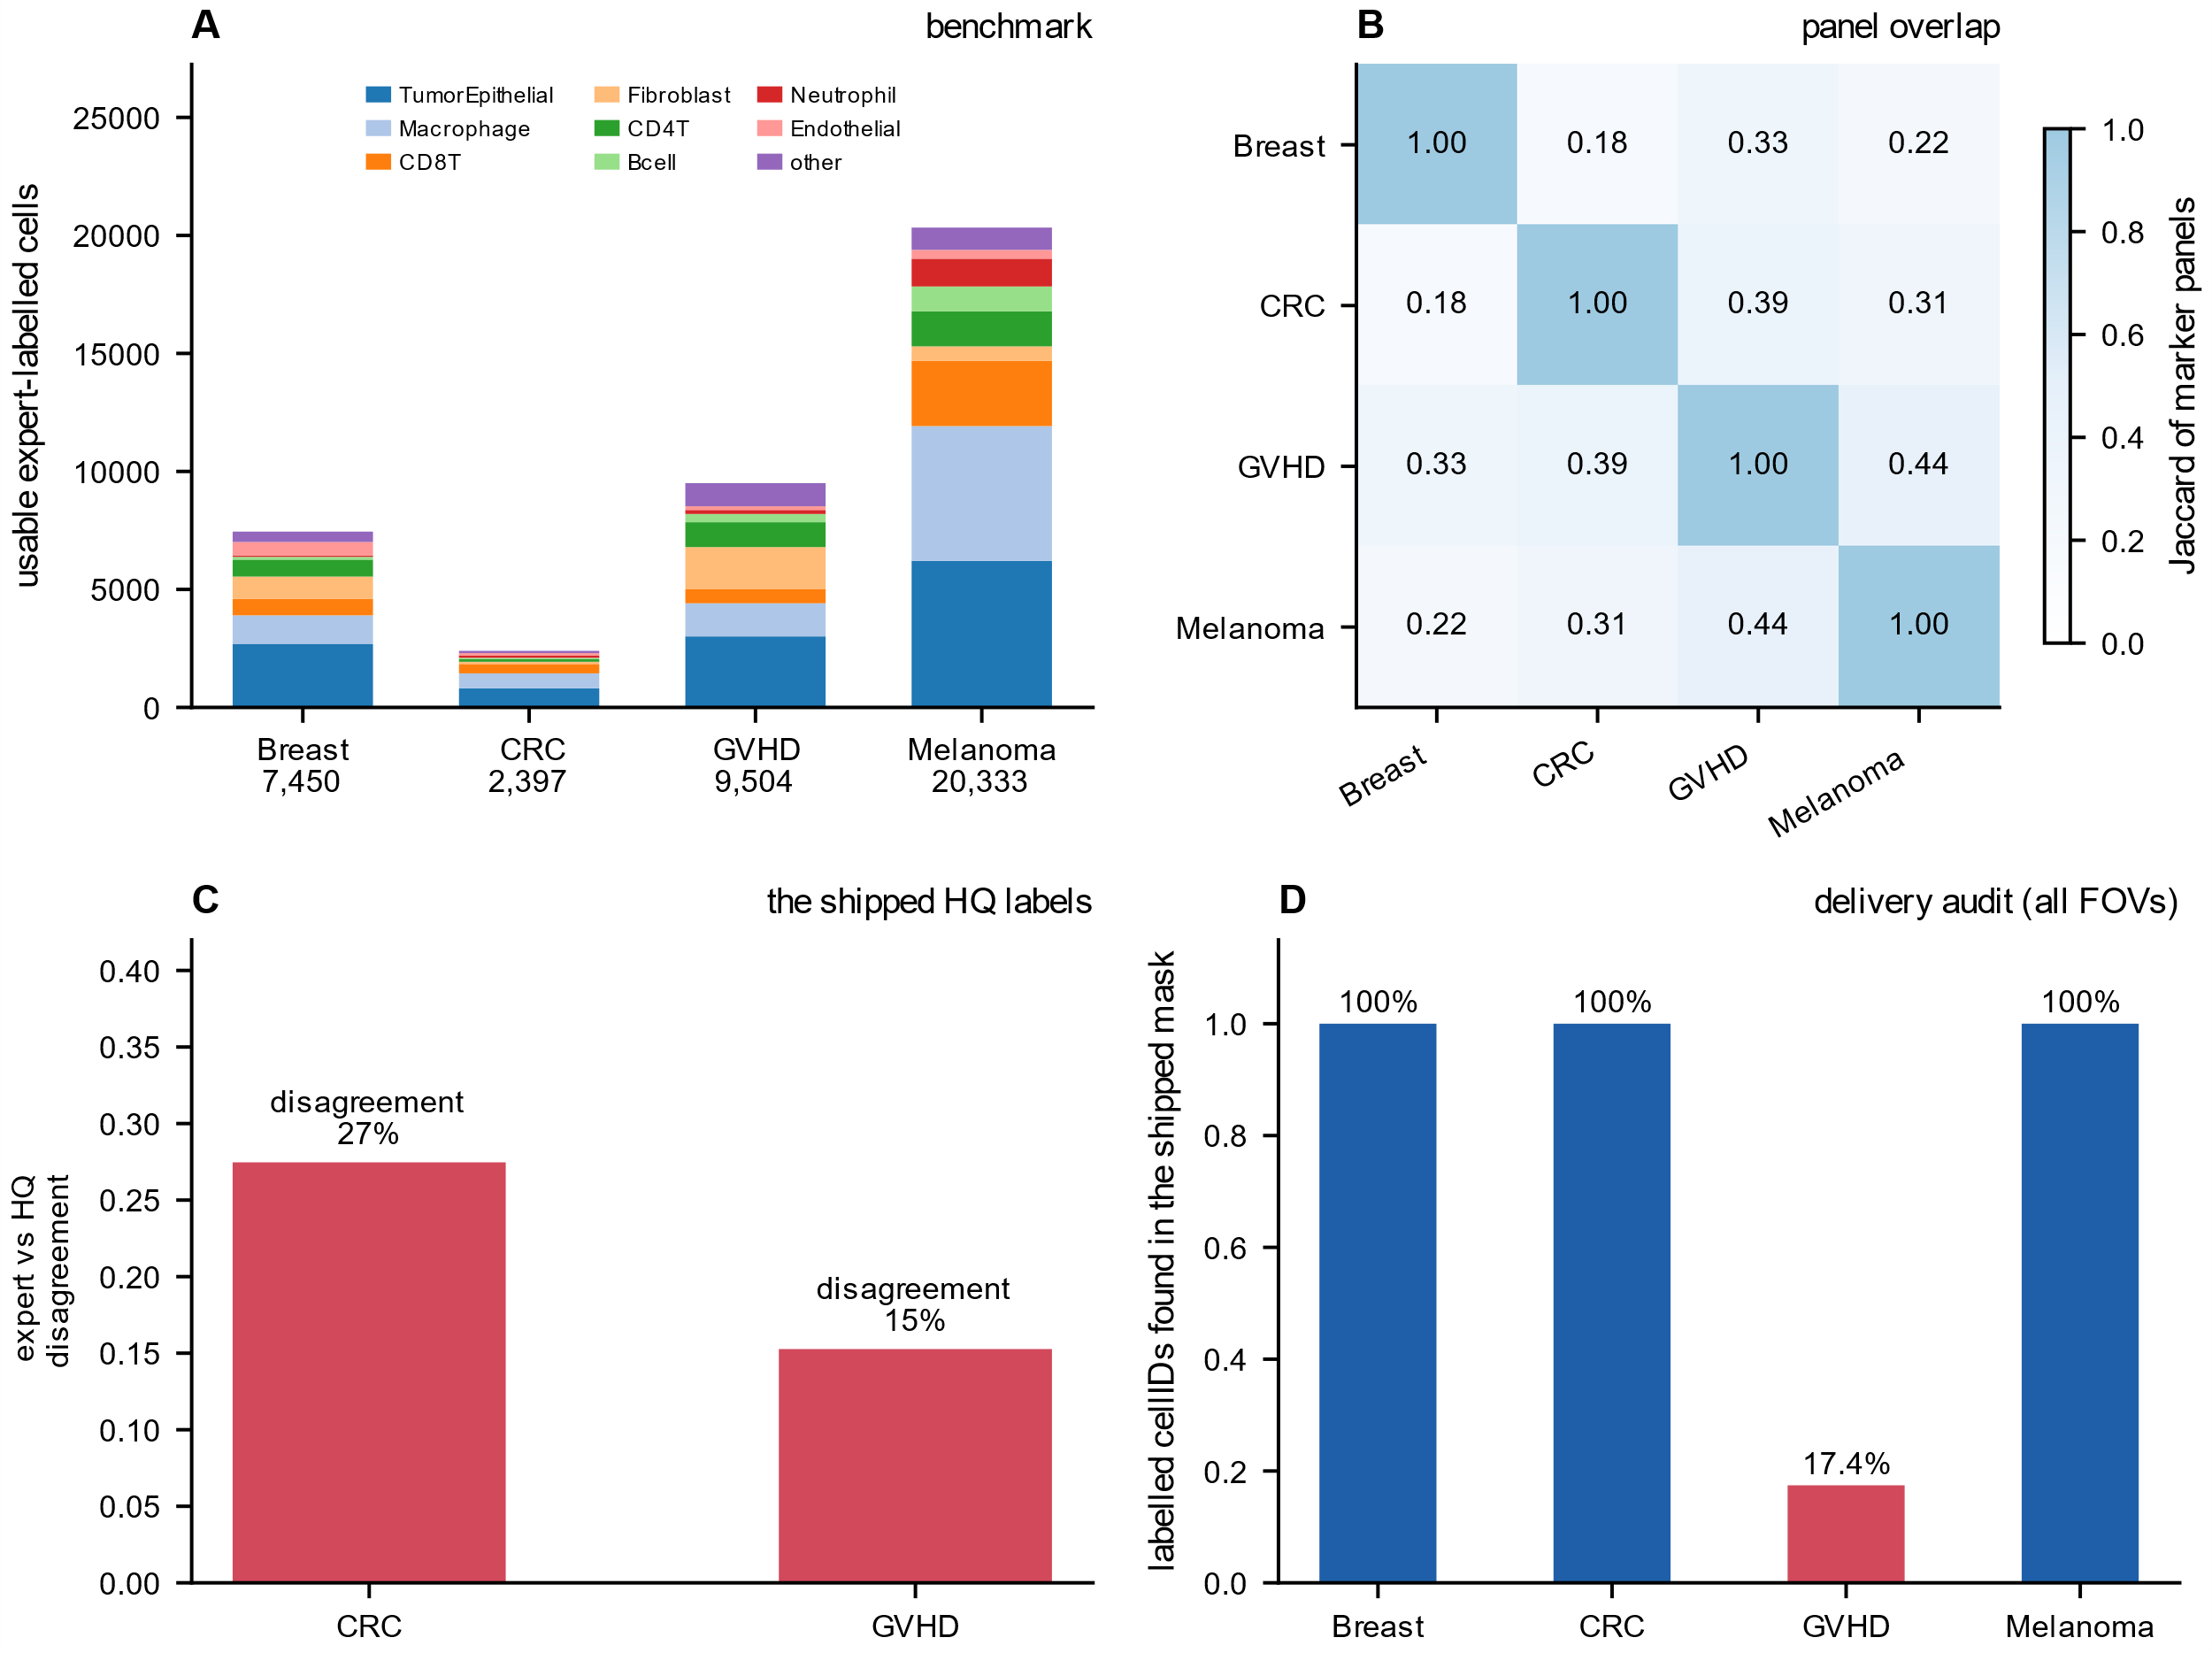
Fig. 1 | Benchmark composition, panel overlap and data audit. A Usable expert-labelled cells per cohort after excluding unidentified cells, coloured by coarse type. B Jaccard overlap between panels. C Disagreement between expert labels and the depot semi-supervised labels for the two cohorts that ship them. D Fraction of labelled cell identifiers present in the shipped segmentation mask over all labelled fields of view; the GVHD files use disjoint field-of-view ranges, so only 17.4% of cell identifiers coincide.
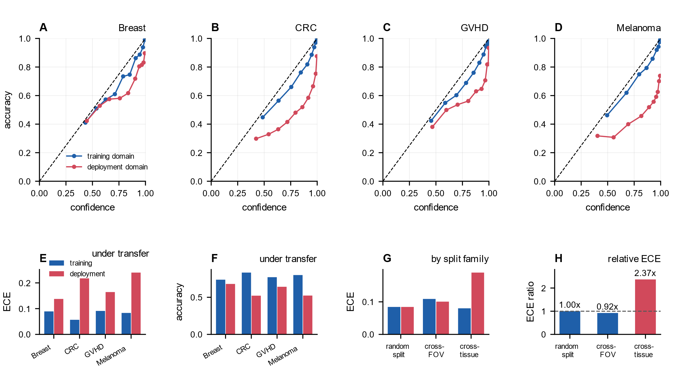
Fig. 2 | Calibration under transfer. A Reliability diagram for the breast deployment, pooling histogram gradient boosting models trained on the other three cohorts. B The same for colorectal. C The same for GVHD. D The same for melanoma. E Expected calibration error in the training and deployment domains. F Accuracy in the same domains. G Expected calibration error by split family. H Ratio of deployment-domain to training-domain ECE for each split family. Exchangeable and image-grouped splits leave calibration error relatively unchanged, whereas cross-tissue transfer multiplies it by about 2.4 under unit weighting (2.8 when weighted by cells).
A distribution-free controller with a visible boundary
We wrap the classifier in a post hoc layer. Let s(x) be one minus the maximum softmax probability, and let err(x) indicate that the prediction is wrong. For a threshold lambda the layer accepts cells with s(x) at most lambda and controls the selective error R(lambda) = E[err(x) 1{s(x) <= lambda}] / E[1{s(x) <= lambda}]. Given a budget alpha and a confidence level 1 - delta, it returns lambda_hat = max {lambda in grid : N+(lambda) <= alpha D-(lambda)}. Here N+ and D- are high-probability upper and lower limits on the two expectations. The guarantee is P(R(lambda_hat) <= alpha) >= 1 - delta. It is finite sample and assumes only that the calibration sample is exchangeable with deployment. An empty accepted set counts as a vacuous success.
The construction is the technical content, and the obvious route fails. A conditional binomial bound treats the number of wrong accepted cells as a binomial draw from the accepted count. It is valid for the block of calibration cells whose error count fixes the bound. It controls the delivered set only when that block coincides with the accepted set, which no score guarantees. A score that ranks by confidence accepts a mixture with different error probabilities, and a binomial with the mixture mean does not stochastically dominate that mixture. We therefore place exact one-sided Clopper-Pearson limits on the two unconditional probabilities and recover their ratio algebraically. A Bonferroni share delta/(2m) over the m candidate thresholds carries the uniformity over the grid. Under covariate shift at a 20% budget, this conditional route accepts a larger set than the certificate and covers 0.61 and 0.37 against a nominal 0.80. On an atomic score, which delivers a larger set than the calibration block, it covers 0.57 against a nominal 0.90. When error heterogeneity is visible to the score, the same route covered 0.99 to 1.00 across the stored heterogeneous settings, although its accepted set became small at the tightest budget. The unconditional bound costs about 2.5 points of acceptance at a 10% budget.
We evaluated three split families. In the random split the held-out pool is divided into exchangeable calibration and evaluation halves. In the cross-field-of-view split the halves come from disjoint images of one tissue and panel. In the cross-tissue split the model is trained and calibrated on one cohort and evaluated on another, which breaks exchangeability by design and is the deployment regime of interest.
Under the random split coverage is 1.00 over 19 units and 570 evaluations, with 21.2% vacuous evaluations. It is 0.996 at a 5% budget and 1.00 at 20%. A Monte Carlo study with 4,000 repetitions returns 1.00 at 200 and 500 calibration cells and 0.997 at 2,000. It stays at 1.00 when the error rate varies in a way the score cannot see, although acceptance falls sharply in the strongest settings (Fig. 3C). Fig. 3A shows the same ordering by split family and method, and Fig. 3B traces coverage against budget; the uncalibrated baseline falls below nominal as the budget tightens. Cross-field-of-view coverage is 0.83, 0.82 and 0.92 at 5, 10 and 20%, and 0.75, 0.76 and 0.90 after vacuous decisions are removed. Holding one image out per unit puts the same family on 96 units, where coverage is 0.844 [0.788, 0.894] at 5% and 0.792 [0.724, 0.855] at 10%; both intervals exclude the nominal 0.90, so the shortfall is not an artefact of twenty units. Cross-tissue coverage is 0.54, 0.40 and 0.29. At a 10% budget 38.9% of transfer evaluations returned an empty accepted set and were counted as covered. Among committed decisions coverage is 0.01, 0.01 and 0.06 across the three budgets (Table 1 reports the 10% row). Fig. 3D shows that the certificate remains non-vacuous as calibration size grows. In the simulation, the conditional rival is sharper but under-covers under shift, whereas the weighted variant is valid but largely vacuous (Fig. 3C).
The failure is visible in the controller output. Fig. 4A shows coverage against realised selective error for the four cohorts, and Fig. 4B compares acceptance at a 10% budget across methods and split families. The oracle is the best threshold available, so a controller that holds its budget cannot systematically exceed it. The ratio of certified to oracle acceptance is 0.74 under the random split, 0.77 across fields of view and 3.05 under cross-tissue transfer. Across the four transfer cohorts the ratio runs from 1.56 to 30.7, and all four exceed one (Fig. 4C). Over 1,690 evaluation units at a 10% budget the ratio exceeds one in 575, and every one is over budget. It never exceeds one among the 1,115 units within budget. On an independent cohort the rule misses 60 of 174 over-budget transfer evaluations, all cases where the oracle accepts nothing. It is a screening rule, not a theorem.
Table 1 | Coverage at a nominal 10% error budget, by split family
split family | method | acceptance | vacuous | coverage (all) | coverage (non-vacuous) | selective error (non-vacuous) | 95% CI on coverage
random split (exchangeable) | certified | 0.56 | 0.21 | 1.00 | 1.00 | 0.06 | 1.00-1.00
random split (exchangeable) | conditional | 0.58 | 0.20 | 1.00 | 1.00 | 0.06 | 1.00-1.00
random split (exchangeable) | uncalibrated | 0.75 | 0.05 | 0.58 | 0.56 | 0.10 | 0.52-0.66
random split (exchangeable) | oracle | 0.75 | 0.05 | 0.99 | 0.99 | 0.10 | 0.97-1.00
cross-FOV (same cohort) | certified | 0.53 | 0.22 | 0.82 | 0.76 | 0.07 | 0.67-0.95
cross-FOV (same cohort) | conditional | 0.56 | 0.18 | 0.78 | 0.73 | 0.08 | 0.63-0.92
cross-FOV (same cohort) | uncalibrated | 0.68 | 0.10 | 0.57 | 0.53 | 0.10 | 0.37-0.76
cross-FOV (same cohort) | oracle | 0.70 | 0.03 | 0.98 | 0.98 | 0.10 | 0.95-1.00
cross-tissue transfer | certified | 0.37 | 0.39 | 0.40 | 0.01 | 0.32 | 0.28-0.52
cross-tissue transfer | conditional | 0.40 | 0.34 | 0.37 | 0.04 | 0.31 | 0.25-0.48
cross-tissue transfer | uncalibrated | 0.57 | 0.10 | 0.16 | 0.06 | 0.31 | 0.09-0.24
cross-tissue transfer | oracle | 0.12 | 0.26 | 0.89 | 0.85 | 0.11 | 0.84-0.93
Notes: Values are means over evaluation units at a nominal 10% budget. Coverage counts an empty accepted set as covered, so the non-vacuous column is the stronger readout. Alternative arms are in the released tables; the 96-unit field-of-view re-estimation is reported in the text and gives the design-matched interval. Sources: experiments/r03_summary.csv and experiments/r13_coverage_ci.csv; scripts/r03_analyse.py and scripts/r13_coverage_ci.py.
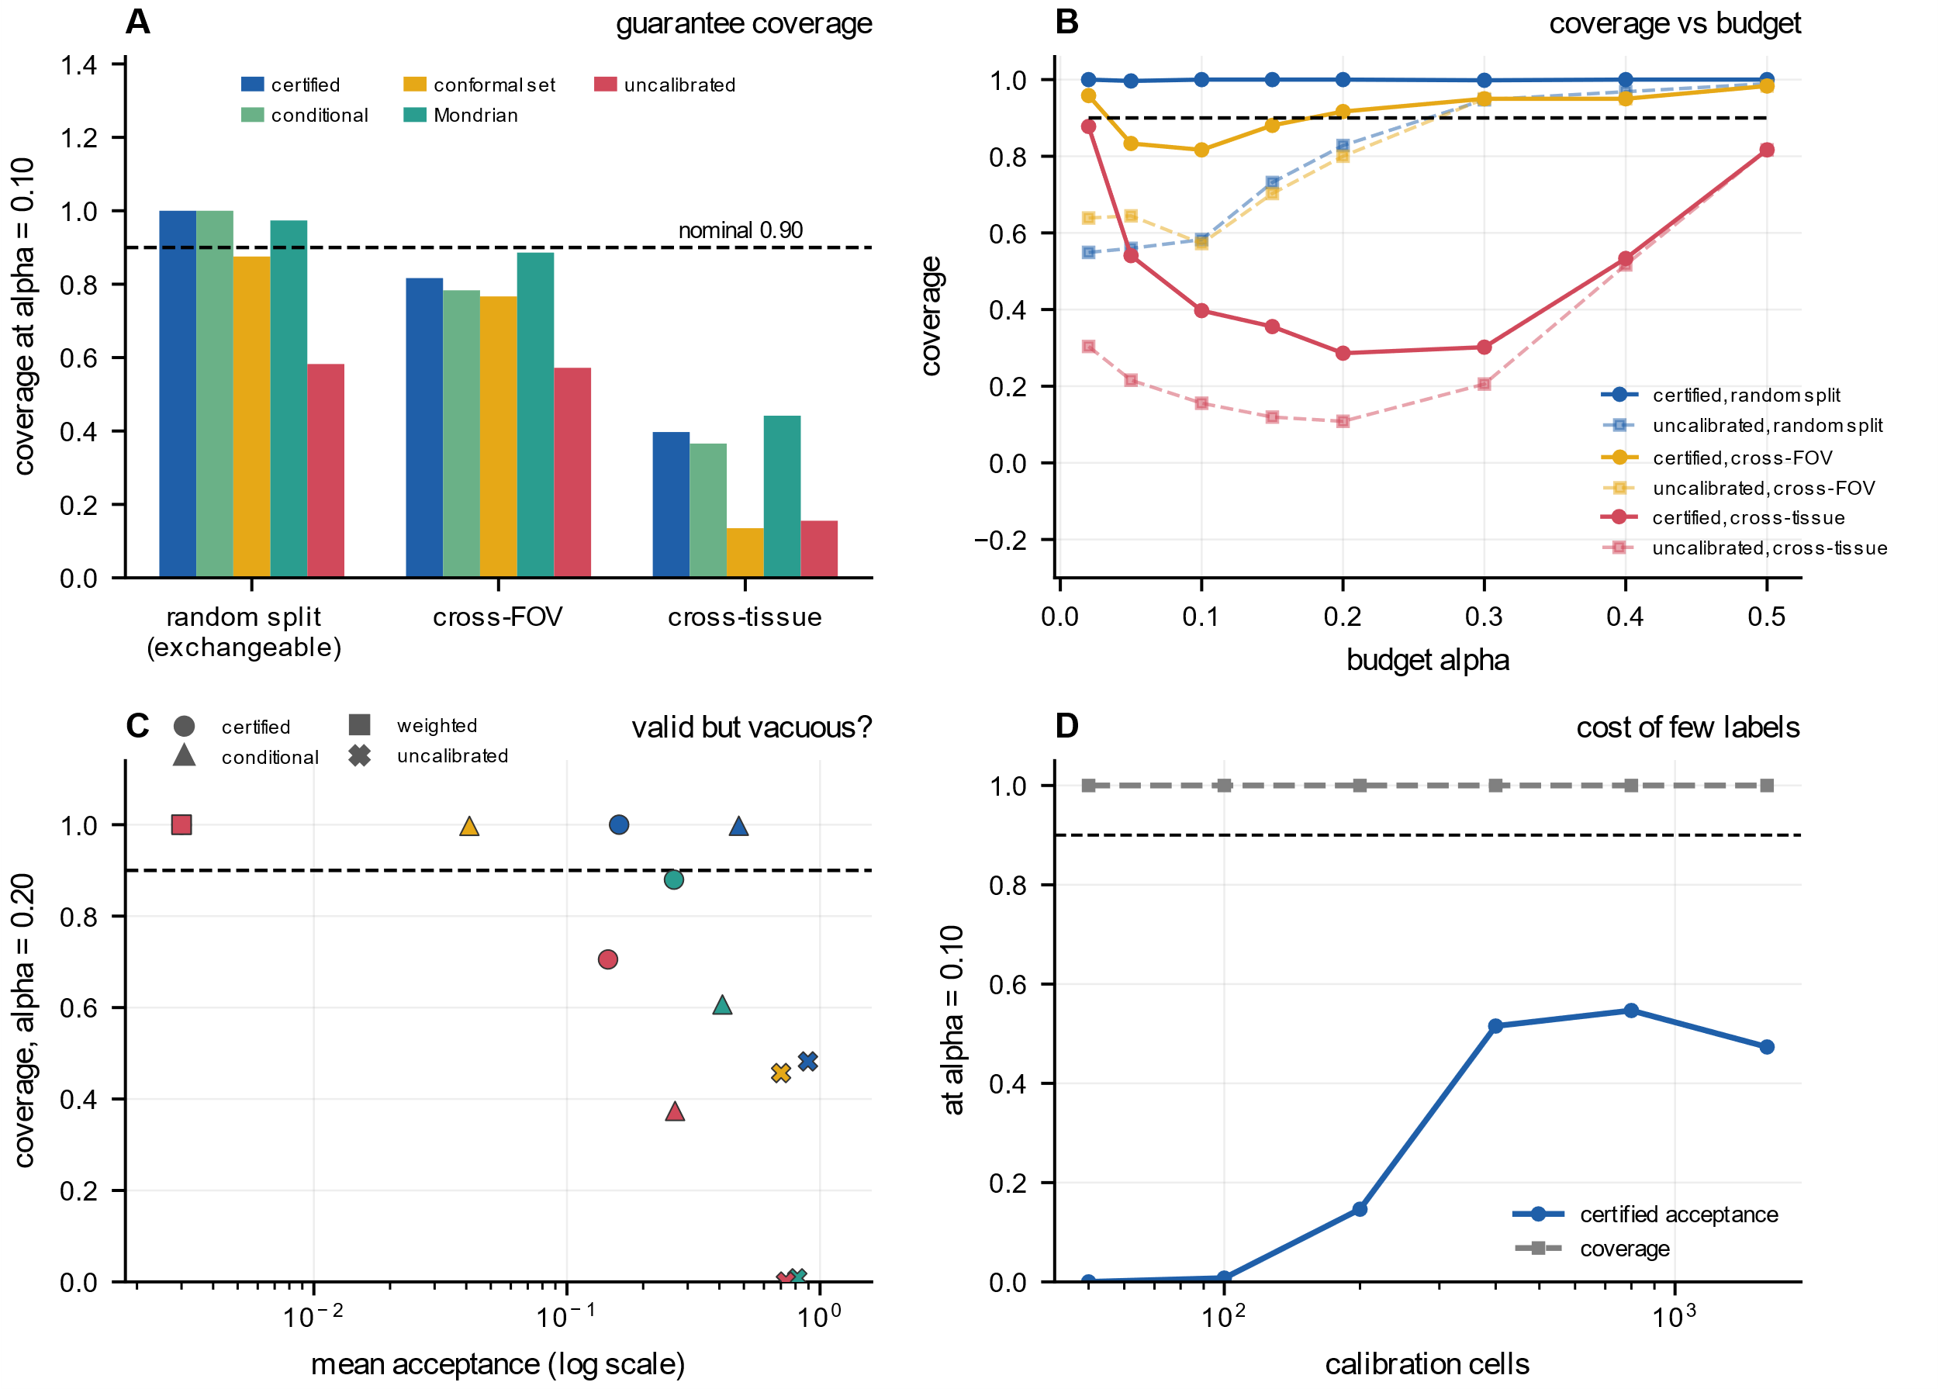
Fig. 3 | Coverage and validity. A Empirical coverage at a 10% budget by split family and method; the dashed line is nominal. B Coverage versus budget for the controller and the uncalibrated baseline. C Monte Carlo validity at a 20% budget over four data-generating settings, plotting coverage against mean acceptance, because a controller that accepts nothing is trivially valid. D Certified acceptance and coverage versus calibration size; coverage stays at 1.00 while acceptance rises with the calibration set.
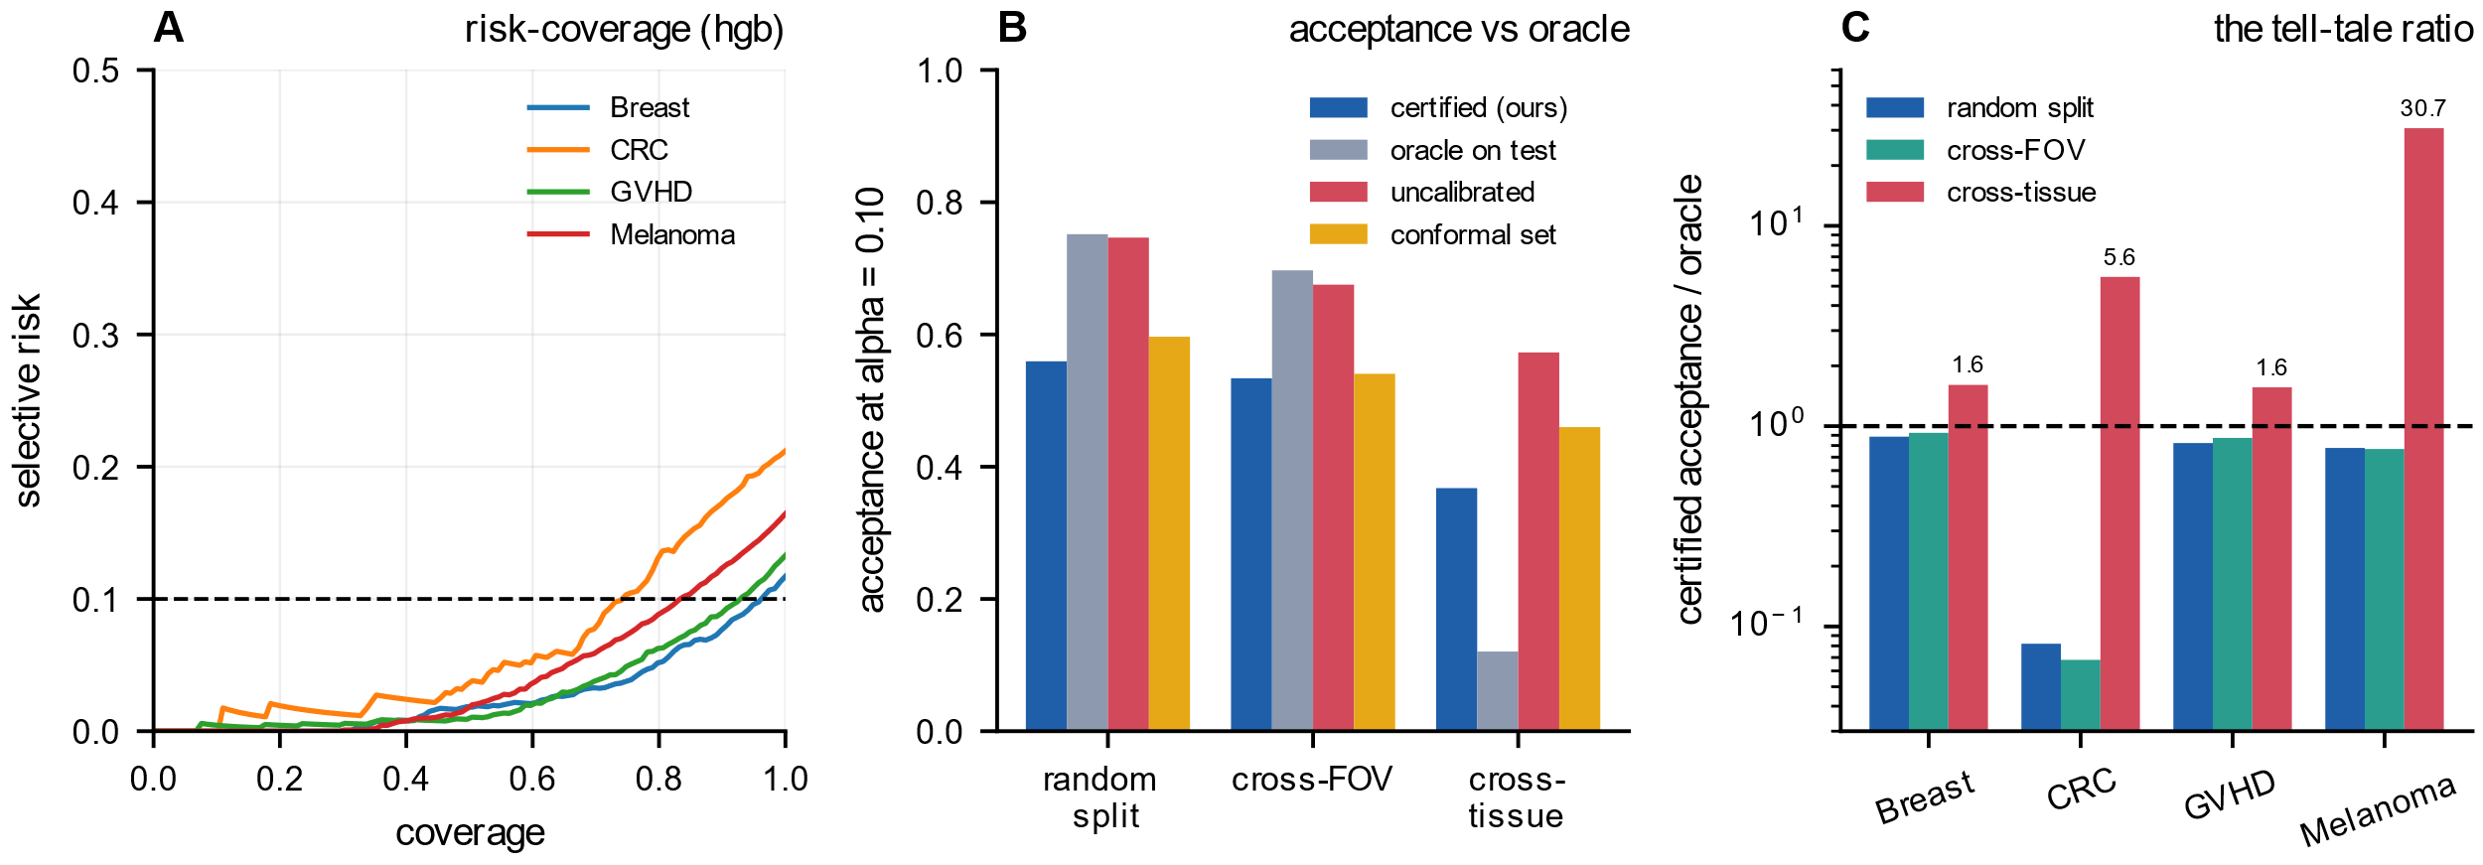
Fig. 4 | Acceptance, efficiency and the exchangeability diagnostic. A Coverage versus realised selective error, a risk-coverage curve, for the four cohorts under the random split. B Acceptance at a 10% budget for the controller, oracle, uncalibrated baseline and conformal prediction sets, by split family. C Ratio of certified to oracle acceptance; values above one are impossible under a valid certificate and indicate broken exchangeability.
The review budget and the price of a repair
Pooling the 19,669 held-out cells of the random split family, a 10% budget certifies 11,742 cells and routes 7,927 to review. It commits 59.7% of cells without review at a realised selective error of 0.06. A 20% budget commits 86.4% of pooled cells at 0.14 (Fig. 5A). The 10% budget defers 40.3% of cells against 24.4% for the oracle, about 16 extra points of human review (Fig. 5A). The 13.6% that still reaches a human at a 20% budget reflects the ranking quality of the underlying classifier and the assay; it is not evidence that the guarantee failed. This is a labour allocation result, not a validity claim.
A valid certificate must be compared with the oracle at equal realised selective error, and it does not recover oracle throughput. At matched selective error the certificate recovers 0.57 of oracle acceptance at a 5% budget and 0.91 at 30%. At a 10% budget the ratio is 0.74, with a 95% interval of 0.62 to 0.83, so the shortfall is not sampling noise; no valid method can exceed the oracle. The uncalibrated threshold accepts 0.75 of the batch against 0.56 for the certificate. Its coverage was 0.58 against 1.00 in the random split, 0.57 against 0.82 across fields of view, and 0.16 against 0.40 under transfer. The apparent 3.05 under transfer is a broken guarantee, not better control. Fig. 5B reads the same comparison at matched realised risk; the uncalibrated curve crosses the oracle only because it does not hold the budget.
Target calibration restores coverage by construction. Coverage among committed decisions is 0.998 at a 10% budget against 0.04 for the source-only certificate; eight of the twelve cross-tissue pairs produce a non-empty certified set within 2,000 target labels at that budget, and the other four never do. Across all twelve pairs and every rung up to 2,000 labels, 497 of 498 committed decisions were covered (0.998). The four that never do are limited by the transferred ranking, not by label count; two have an oracle that accepts under 2% of cells. Within a cohort, 500 uniformly drawn target labels leave acceptance at 0.53 while lifting coverage from 0.82 to 1.00. Spending half of 2,000 labels on a refit accepts 0.36 of the batch, against 0.03 for the frozen model given the same 1,000 calibration labels in the same run, and 0.04 when the full 2,000 labels calibrate the frozen model in the earlier ladder. Table 2 counts vacuous evaluations as covered, so the committed readout is the one to plan with.
Run end to end on a public liver cohort under an assumed 20 s per cell, the layer cut a full manual pass from 170.3 expert hours to 25.1 h at a 5% budget and to 11.5 h at 20%, including the labels spent on calibration. The run used 30,646 cells over nine antibody channels used in the analysis, with four donor sets held out in turn. Calibration used 500 labels from each new set, leaving 28,646 cells for evaluation; 2,523 and 65 cells were routed to a human at the two budgets. Realised selective errors were 0.017 and 0.046. A threshold tuned on the same 500 labels held the 5% budget in half the donor sets, against every one for the certificate. The guarantee buys validity, not the smallest possible review queue.
Table 2 | The review budget and the repair price, in the same units
split family | budget | mean review across units | cells/unit | labels/unit | mean acceptance (before to after) | coverage, all (before to after) | units (before to after)
random split | 0.05 | 0.67 | 690 | none needed | 0.33 | 0.996 | 19
random split | 0.10 | 0.44 | 456 | none needed | 0.56 | 1.00 | 19
random split | 0.20 | 0.20 | 206 | none needed | 0.80 | 1.00 | 19
cross-field-of-view | 0.05 | 0.64 | 1,277 | never (0.18 at 1,000) | 0.36 | 0.83 | 20
cross-field-of-view | 0.10 | 0.47 | 925 | 500 (0.25 of the pool) | 0.53 to 0.53 | 0.82 to 1.00 | 20 to 15
cross-field-of-view | 0.20 | 0.27 | 536 | none needed | 0.73 | 0.92 | 20
cross-tissue transfer | 0.05 | 0.82 | 7,807 | never (0.03 at 4,000) | 0.18 | 0.54 | 60
cross-tissue transfer | 0.10 | 0.63 | 6,011 | never (0.06 at 4,000) | 0.37 | 0.40 | 60
cross-tissue transfer | 0.20 | 0.33 | 3,146 | never (0.17 at 2,000) | 0.67 | 0.29 | 60
Notes: The certificate row is the source-only certificate of Table 1. Acceptance and review are means of per-unit fractions, so each unit contributes equally. Fig. 5A uses pooled cell fractions; for the random split the pooled review fractions are 65.3%, 40.3% and 13.6% at 5, 10 and 20% budgets. The ladder draws k target labels and evaluates on the rest. Five colorectal units drop out at the 500-label rung because too few evaluation cells remain after the calibration draw, so coverage is computed on the 15 remaining units. The repair price is the smallest target label count that restores coverage to at least 0.90 without losing source-only acceptance. Never means no ladder rung restores coverage; the acceptance in brackets is the best over rungs. Coverage counts vacuous evaluations as covered. Sources: experiments/r16_review_budget.csv and experiments/r24_efficiency.csv; scripts/r50_review_loop.py. Full label-cost tables are in the released CSV.
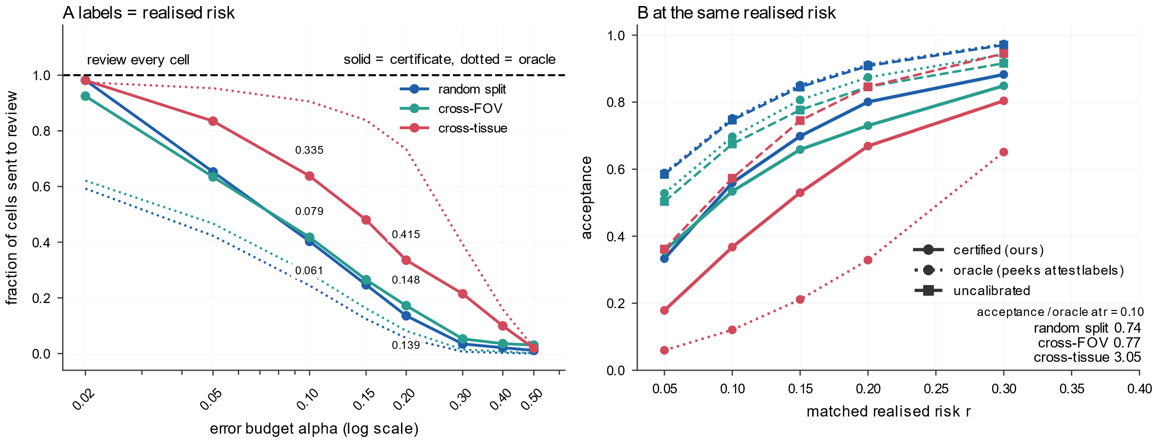
Fig. 5 | The certificate as a review budget. A Fraction of cells routed to review versus nominal budget for the three split families; numbers give the realised selective error among retained labels at the 10% and 20% budgets. B Acceptance at matched realised selective error for the certificate, oracle and uncalibrated baseline; the uncalibrated curve crosses the oracle because it does not hold the budget.
A label-free audit of labels and markers
Reference labels and classifiers can be interrogated without held-out data. We compiled each cohort's published Boolean definitions into an executable rule set and measured the fraction of cells that violate the definition of their assigned type. A single pooled rate misleads. On the strictly evaluable subset, a first pass returned 5.66% for melanoma and 4.02% for GVHD, mostly from rules that reference missing channels or from an ambiguous separator in the depot syntax⁴,¹⁶. Over the 2,397 expert colorectal labels whose type has a fully evaluable rule, reading the definitions as a conjunction rather than a disjunction moves their rate from 0.58% to 18.1%. Across 68 type-level conventions per cohort the pooled rate spans up to two orders of magnitude, so the sweep identifies the verdict rather than the level. Five cell types exceed the 5% gate in the reference labels under every convention, and the reference-label rate for colorectal APC remains below it under every convention; the full convention sweep is reported in the released tables. Accepted cells are more marker-consistent than deferred ones in 1,590 of 1,694 tie-free estimable units, with a paired sign test P < 0.001 and a median difference of 0.12. This audit is independent of held-out labels. It measures consistency with published marker logic, not correctness against an external gold standard.
External replication and published classifiers
The benchmark shares one depot and one pipeline. We next break both. The STELLAR CODEX intestine cohort has 248,285 cells over 48 markers, 235,874 with a defined label, and the tonsil and Barrett cohort has 219,926 cells over 44 markers¹⁷,¹⁸,¹⁹. Each was subsampled to 20,000 cells. Intestine reproduces exchangeable coverage 1.00 with acceptance 0.85 at a 10% budget. Image-grouped splitting accepts 0.73 at selective error 0.08 but covers 0.66 (Fig. 6A). Transfer to tonsil and Barrett on 26 shared markers covers 0.03 in aggregate over 90 evaluations each, with source-level coverage 0.07 for Barrett and 0.00 for tonsil (Fig. 6B). A multiplexed ion beam microarray, with 345,490 cells over 15 markers, and a liver imaging mass cytometry cohort, with 109,245 cells over nine antibody channels used in the analysis, cover 0.993 and 1.00 at a 10% budget²⁰,²¹. IMMUcan panel 1 V3 has 57,791 labels over 37 markers from 30 samples. Under a protocol locked before the endpoint, coverage is 1.00 at 5, 10 and 20% over five sample-grouped folds, ten draws and three classifiers, with acceptance 0.90, 0.99 and 1.00 (Table 3 reports the 10% row). The disjoint V1 batch has 290,226 labels from 149 samples and reproduces coverage 1.00 with acceptance 0.935, 0.999 and 1.000. Fig. 6C shows the ratio diagnostic on these external evaluations, including the 60 over-budget transfer evaluations it misses because the oracle accepts nothing.
The strongest cross-panel test replaced the antibody panel rather than dropping channels. We trained on STELLAR small intestine, 235,874 labelled cells over 48 markers, and deployed to an independent adult duodenum CODEX atlas, 211,424 cells over 42 channels from three donors and 107 ROIs²². Fourteen of the nineteen shared markers could be assigned a matrix row with confidence; the five ambiguous ones were excluded before any endpoint was computed. Target labels entered calibration only. At a 10% budget, an equal-weight ensemble covered 1.00 [0.93, 1.00] with realised selective error 0.09 and acceptance 0.50. Source-only calibration covered 0.00 with selective error 0.25. At 20%, acceptance rose to 0.83 with coverage 1.00 and selective error 0.19. Under within-target calibration at 10%, the same 14 markers supported acceptance 0.83, so the shortfall belongs to the cross-laboratory and cross-panel shift. Calibrating on other ROIs gave coverage 0.88 [0.76, 0.94] at 10% and 0.90 [0.79, 0.96] at 20%, locating ROI batch effects as the remaining boundary. A per-marker rank transform raised acceptance from 0.21 under a per-domain z-score to 0.50 for the ensemble. The cost of a real panel change is therefore paid mainly in labels and throughput; validity survives target calibration, whereas ROI-disjoint calibration leaves a residual coverage gap.
A second real panel change, across 27 shared channels in the colorectal-to-GVHD pair, was harder. Coverage stayed at 0.98 or above up to 8,000 labels. Without refitting, acceptance at 8,000 labels reached 0.03 at a 10% budget and 0.20 at 20%, against 0.15 and 0.41 for source calibration, which covered only 0.67 and 0.47. A refit on 1,000 labels reached 0.42 at 10% (Table 3). The MIBI-TOF microarray supplied a stronger cohort-level pairing. Its source was the depot breast cohort, 5,293 training cells over 22 channels, and its target was two breast carcinoma cores, 23,081 cells over 15 markers, from another laboratory and platform; eight markers were shared and the donors differed. At a 10% budget, 1,000 labels retained 0.62 at selective error 0.05 and +0.55 net; 500 labels retained 0.45 at 0.03 and +0.42. The same protocol gave +0.03 on a 5,458-cell colon core and +0.04 on a 65,498-cell tonsil core, and 4,000 labels returned +0.44 on the tonsil pair. To our knowledge, no public cohort pairs the same patient or serial sections across two antibody panels in two laboratories with cell-level labels, so the evidence is cohort-level, with different donors. A second colon source marks the boundary: at 8,153 cells, 1,000 labels leave the certificate silent at 10% and 4,000 labels are half the batch; no rung is net positive, and the least bad refit is −0.28 at 20%. The label-to-batch ratio, not the certificate, sets that boundary. Fig. 6D places the four external panel changes on the same net-review scale.
A 250-label pilot can price the repair. A threshold chosen on four folds and applied to the fifth admitted 43 of 45 same-tissue and 2 of 36 cross-platform units. On the same-tissue units it achieved a net share of 0.371 against 0.392 for always repairing; on the cross-platform units it cut the loss from 0.095 to 0.031. The pilot is a gate, not a universal step; its verdict depended on the base model, and prospective validation remains future work.
We also evaluated two published tool designs. CellSighter is a convolutional network over image crops, vendored unmodified³. CellTune is reimplemented from its documentation as its default XGBoost and CatBoost pair because it ships as a desktop application⁴. Both certify on held-out breast-to-colorectal pairs at a 10% budget. CellSighter retains 0.81 of cells at selective error 0.07 against 0.90 for an oracle, and CellTune retains 0.96 at selective error 0.06. Both fail under transfer at the 10% budget with the same signature: every evaluation is over budget, realised selective error is 0.53 to 0.57, ratios are 10.6 and 39.9, and accuracy falls to 0.38 and 0.43.A third pair, GVHD to colorectal, repeats the pattern: on the exchangeable split it retained 0.88 at selective error 0.07, and under transfer its ratio was 5.5.
Table 3 | External replication across independent cohorts and a real panel change
cohort | split | error budget | acceptance | selective error (committed) | coverage
Intestine (STELLAR) | exchangeable random split | 0.10 | 0.85 | 0.09 | 1.00
Intestine (STELLAR) | image-grouped folds | 0.10 | 0.73 | 0.08 | 0.66
Intestine (STELLAR) | transfer to tonsil and Barrett | 0.10 | 0.84 | 0.49 | 0.03
Ion beam microarray | exchangeable, own panel | 0.10 | 0.97 | 0.08 | 0.993
Ion beam microarray, colon core | panel swap, 13 shared, repaired | 0.10 | 0.26 | 0.03 | 1.00
Ion beam microarray, colon core, STELLAR source | panel swap, 10 shared, repaired, 4,000 labels | 0.20 | 0.42 | 0.13 | 1.00
Ion beam microarray, breast cores | cohort-level panel swap, 8 shared, repaired | 0.10 | 0.62 | 0.05 | 1.00
Ion beam microarray, tonsil cores | panel swap, 11 shared, repaired | 0.10 | 0.05 | 0.03 | 1.00
Ion beam microarray, tonsil cores | panel swap, 11 shared, repaired, 4,000 labels | 0.10 | 0.53 | 0.07 | 1.00
Liver biopsies | exchangeable, own panel | 0.10 | 0.995 | 0.06 | 1.00
Depot colorectal to GVHD | panel swap, 27 shared, repaired | 0.10 | 0.42 | 0.04 | 1.00
IMMUcan panel 1 V3 | sample-grouped folds, exchangeable | 0.10 | 0.99 | 0.07 | 1.00
IMMUcan panel 1 V1 | sample-grouped folds, exchangeable | 0.10 | 0.999 | 0.065 | 1.00
STELLAR small intestine to duodenum | real panel change, 14 shared, per-domain z-score, three-model mean | 0.10 | 0.21 | 0.08 | 1.00
STELLAR small intestine to duodenum | real panel change, 14 shared, rank-normalised, ensemble | 0.10 | 0.50 | 0.09 | 1.00
Notes: Every row uses the same certificate, split fraction and metric definitions as the benchmark. Repaired rows use 1,000 target labels unless a row states otherwise; selective error is computed among units that commit a non-empty set, whereas acceptance averages over all units. For the duodenum rows, target labels enter calibration only. The z-score row is the pre-specified pipeline; the rank row replaces that transform with a per-marker within-domain rank and reports the equal-weight ensemble of the three classifiers. Source-only calibration on the rank scores covers 0.00 at a 10% budget with realised selective error 0.25. The 20% arm reaches acceptance 0.83 with coverage 1.00, and the ROI-disjoint arm covers 0.90 [0.79, 0.96]. Base-model acceptance under the rank transform is 0.34, 0.33 and 0.48 for the linear model, gradient boosting and random forest. An empty accepted set counts as covered, so coverage 1.00 with low acceptance means the certificate declined to answer. The rows show exchangeable replications, failures, and repair or boundary cases; the full external table is in the released CSV. IMMUcan V1 and V3 are two disjoint annotation batches of one source; V1 contributes 290,226 labels from 149 samples. Sources: experiments/r34_phase2_certificate_summary.csv, experiments/r55_stellar_summary.csv, experiments/r69_external2_log1p_z_summary.csv, experiments/r72_panel_repair.csv, experiments/r75_immucan_summary.csv, experiments/r82_immucan_v1_summary.csv and experiments/r85_duodenum_crosspanel_summary.csv; the rank-normalised rerun is experiments/r87_duodenum_ranknorm_summary.csv.
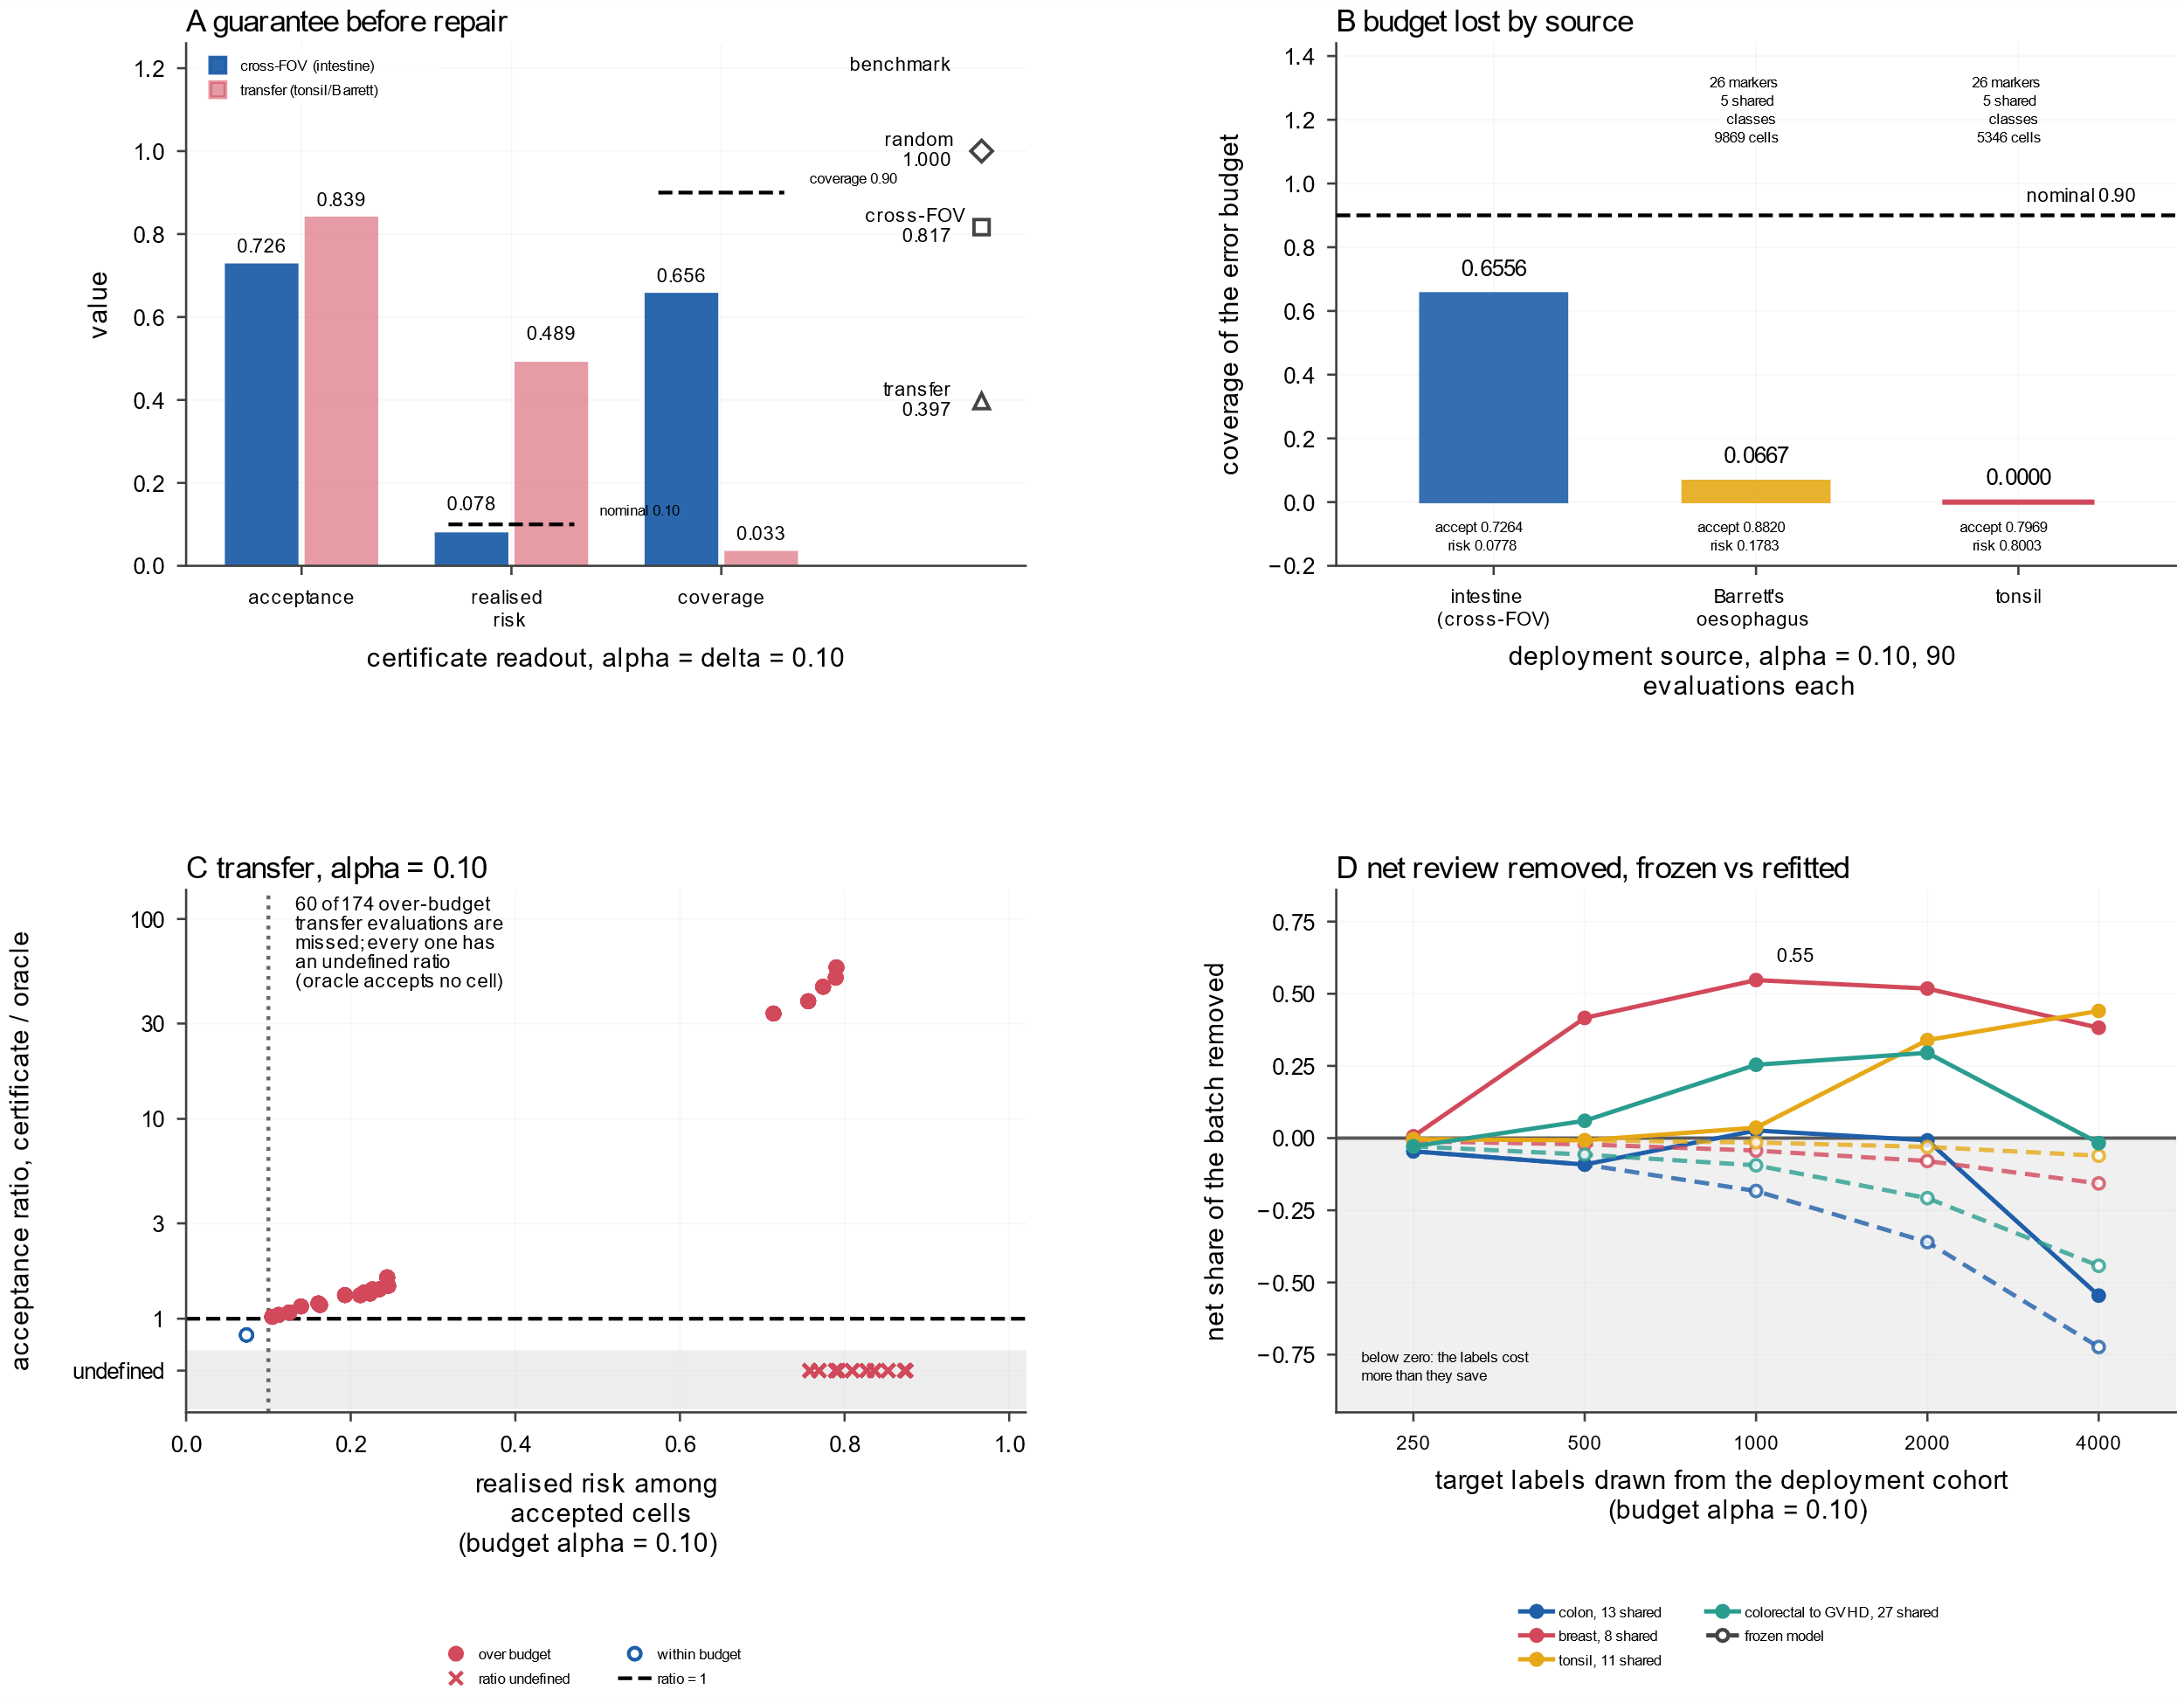
Fig. 6 | External validation. A Acceptance, realised selective error and coverage at a 10% budget for the cross-FOV intestine and transfer-to-tonsil-and-Barrett arms, with depot benchmark values as reference markers. B Coverage decomposed by deployment source. C Ratio diagnostic against realised selective error, marking over-budget transfer evaluations it misses and evaluations where the oracle accepts nothing. D Net review removed, accepted cells minus labels spent on repair, as a share of the batch against target labels for four real panel changes; open circles are a frozen model, filled circles a refit, and the shaded band below zero marks label counts where repair costs more than it saves.
From a certificate to a deployment decision
The procedure is packaged as one run that leaves the classifier unchanged (Fig. 7A). On the liver cohort, 30,646 cells from four donor-held-out units were scored with a fixed classifier, and 500 target labels per unit were spent on calibration, leaving 28,646 evaluated cells (Fig. 7B). At a 5% budget the layer committed 91.2% of cells at a realised selective error of 0.017, left 2,523 cells for review and cut the manual pass from 170.3 to 25.1 expert hours. At 20% it committed 99.8% at 0.046, left 65 cells and cut it to 11.5 h. These totals include the calibration labels, so they measure net review removed rather than gross acceptance. A 250-label pilot then acts as a deployment gate (Fig. 7C). Leave-one-fold-out decisions admitted 43 of 45 same-tissue units and 2 of 36 cross-platform units. The gate raised the cross-platform mean net share by 0.064 [0.032, 0.092] and cost the same-tissue arm 0.022 [-0.054, 0.000]. The pilot separates deployments likely to repay a repair from those where the label price exceeds the review saved. It does not establish validity; the certificate does that.
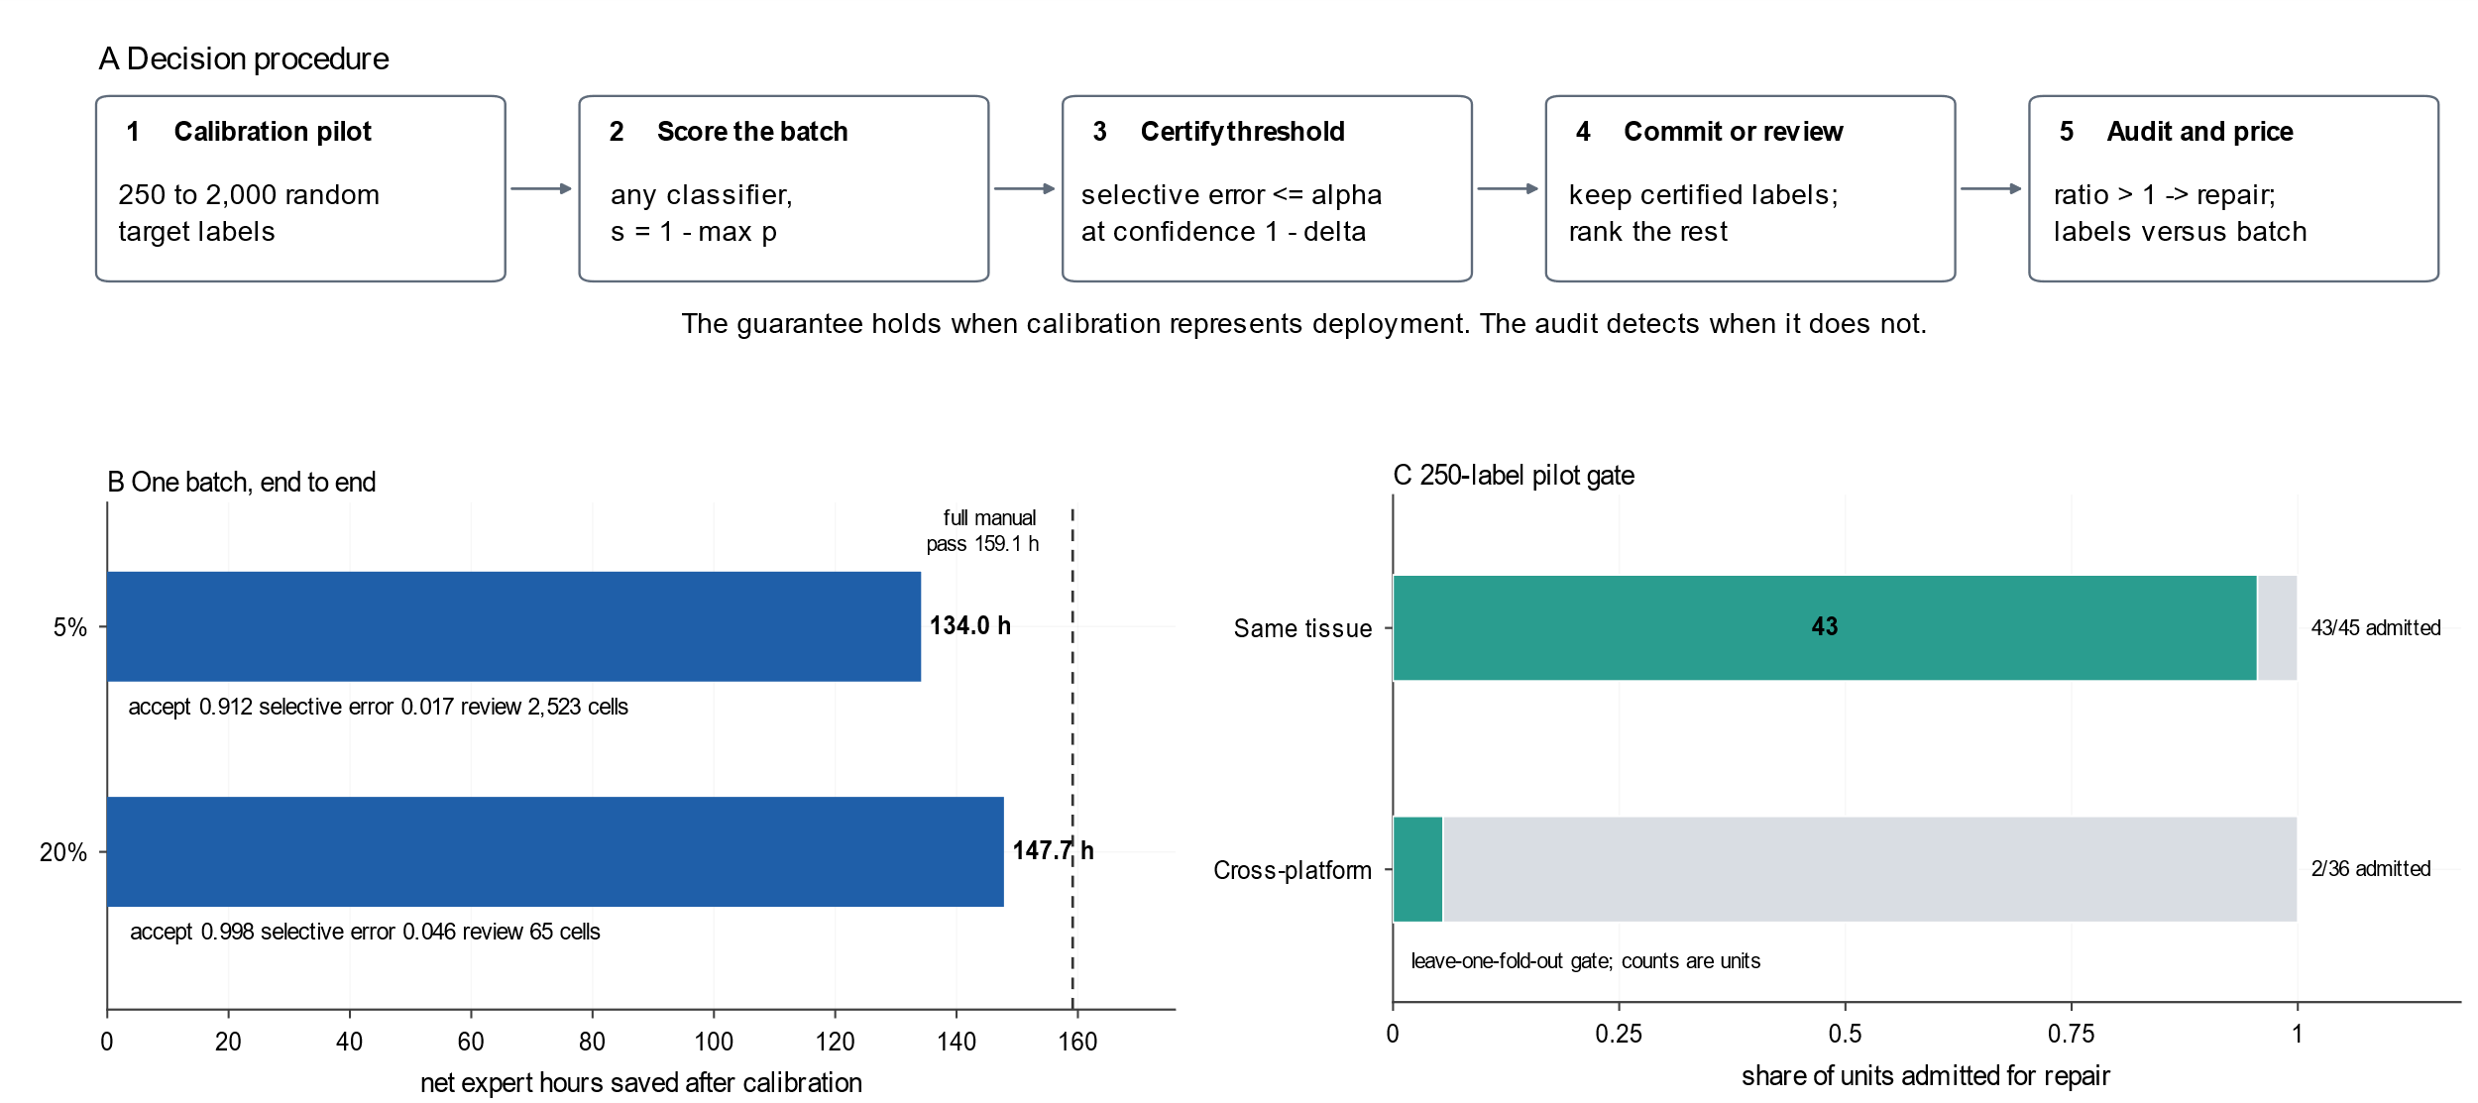
Fig. 7 | From a certificate to a deployment decision. A Five-step procedure: a calibration pilot, batch scoring with any probabilistic classifier, certification of a threshold at a stated selective error, a commit-or-review decision and an audit that prices repair. B Expert hours under an assumed 20 s per cell, from a full manual pass over all 30,646 scored cells to the workload after calibration and review, on four held-out liver units at 5 and 20% budgets; labels give acceptance, realised selective error and review count. C Leave-one-fold-out 250-label pilot gate for same-tissue and cross-platform repair, showing units admitted and rejected. The gate is descriptive and does not constitute prospective validation.
Discussion
The contribution is a decision layer, not a better classifier. It tells a laboratory which labels can be kept at a stated error budget with finite-sample validity, and changes the question from which model is best to which labels can be kept. The layer is valid when calibration represents deployment and visibly broken when it does not.
The closest method is conformal risk control²³. Our increment is a construction for the two unconditional probabilities that define selective error: the conditional binomial bound fails once the accepted set and calibration block diverge²⁴, and it fails under shift or an atomic score. Cross-field-of-view coverage is 0.82 at a 10% budget²⁵; cross-tissue transfer falls to 0.40 and 0.01 among committed decisions²⁶. Weighted conformal control restores coverage without exchangeability, at a label price²⁷: with a bounded density ratio the certificate needs Theta(M/alpha) labels. In the stored transfer pairs only 30 and 80 of 180 units produced a non-empty certificate at 10 and 20% budgets, with mean acceptance 0.08 and 0.28, respectively²⁸,²⁹.
The practical answer is a decision rule priced in target labels. Across fields of view, 500 labels restored coverage without reducing acceptance; at a 10% budget, eight of twelve cross-tissue pairs produced a non-empty set within 2,000 labels. A real panel change is repaired by spending labels on the model, not only on the calibrator, and the label-to-batch ratio sets the boundary. A 250-label pilot can act as a gate, but it is not universal³⁰. A certified-to-oracle ratio above one indicates that calibration does not represent the batch.
External validation includes a positive cohort-level panel change. Target calibration on 14 shared markers covered 1.00 at a 10% budget against 0.00 for source-only calibration; acceptance was 0.50 with a rank-normalised ensemble, and ROI-disjoint calibration exposed the batch boundary. Earlier cohorts reproduce the guarantee for exchangeable splits²⁰,²¹, whereas the intestine transfer and source-only colorectal-to-GVHD calibration show the failure for non-exchangeable ones in Fig. 6B and Table 3. A second IMMUcan batch adds 290,226 labels and reproduces coverage 1.00, with acceptance 0.935 at 5% and 0.999 at 10%, and accepted cells were more marker-consistent than deferred ones. The cohorts are not a probability sample, shared annotation bias is invisible, and no pair was collected prospectively.
Deployment should begin with a small pilot from the target batch. It supplies labels for the certificate and estimates whether a repair will repay its cost. If it admits repair, split the labels between a refit and the calibration of the refitted model, because calibration restores validity only for the model it is applied to. If it rejects repair, review the batch or change the classifier; do not lower the nominal budget. Report the nominal budget, the realised selective error among committed labels and the share left for review separately, because conflating them invites the conclusion that a low review fraction is evidence of validity. Residual review reflects the score and assay, not a failure of the guarantee. At a 20% budget the benchmark left 13.6% for review.
The framework may transfer beyond this benchmark. Single-cell transcriptomics interfaces through reference atlases³¹,³²,³³,³⁴; spatial transcriptomics admits the same construction with marker genes in place of proteins³⁵, and imaging mass cytometry, CODEX and multiplexed ion beam imaging pose the same statistical problem³⁶,³⁷,³⁸. The next step is active learning, so labels are spent where they buy the most certified throughput.
Methods
Data
The primary benchmark used CellTuneDepot, which provides manual annotations with a per-field-of-view segmentation mask and semi-supervised labels as per-cell mean intensities, areas and centroids for colorectal and GVHD. The four cohorts contain 7,610, 2,505, 10,283 and 21,204 expert labels. After excluding coarse unidentified cells, 7,450, 2,397, 9,504 and 20,333 remain usable. The panels have 22, 58, 42 and 40 markers, and the cohorts have 13, 12, 30 and 19 Boolean rules. In total, 41,602 expert-labelled and 39,684 usable cells enter the analysis.
External cohorts were the public STELLAR CODEX intestine and tonsil data, the MIBI tissue microarray and the liver imaging mass cytometry cohort. We also used the adult duodenum CODEX atlas and IMMUcan panel 1 V3 and V1. IMMUcan V3 and V1 contributed 57,791 and 290,226 labels over 37 markers from 30 and 149 disjoint samples, split by sample. The duodenum atlas contributed 211,424 labelled cells over 42 channels from three donors and 107 ROIs. The cross-panel replication used the 14 markers CD31, CD4, CD8, CD44, CD3, CD90, aSMA, CD206, CD138, CD19, CD163, HLA-DR, PDPN and VIM. Nineteen markers are shared by name; fourteen could be assigned a matrix row with confidence. The other five, CD45, CD11c, CD69, Ki67 and CD15, could not be assigned a matrix row with confidence from the published annotations. They were excluded on row-identity grounds before any error endpoint was computed. No marker was added or removed on the basis of classification performance. Target labels entered calibration only.
We audited delivery integrity by intersecting each labelled field of view's shipped segmentation identifiers with those in the annotation table. No result depends on the delivery defect because the features of the two affected cohorts come from the per-cell table, where labels join at full coverage.
Preprocessing and marker logic
One table per cohort is built along two paths. Colorectal and GVHD take per-cell mean intensities, areas and centroids from the shipped table. Breast and melanoma decode each field's channel images and segmentation mask. For each mask label, this gives each channel's mean over the cell pixels, the pixel count and the mask centroid. Preprocessing applies a log transform and then z-scores each marker. The transform is fitted once on the training cells and applied to training, calibration and deployment. The transfer family is the exception: it fits two domains and therefore uses unlabelled deployment features. Each cohort defines its populations by a Boolean expression over channels. A recursive descent parser evaluates the expression and canonicalises every identifier, so a rule written for one panel can be evaluated on another. Four colorectal definitions use a semicolon where the others use a conjunction or an alternative. The alternative reading is the default. A marker is called positive at the mixture crossing point of the cohort's own populations.
Selective error control
The controller is calibrated on a labelled sample exchangeable with the deployment population. It bounds the two expectations that define selective error rather than their ratio. The numerator takes an exact one-sided Clopper-Pearson upper limit at confidence 1 - delta/(2m). The denominator takes an exact lower limit at the same level, where m is the size of the candidate threshold grid. The ratio of the two limits is compared with the budget. Dropping the Bonferroni share voids the simultaneous guarantee, and the uncalibrated threshold covers the budget in only 0.58 of evaluations. The alternatives compared are a conditional binomial route, an empirical Bernstein variant, a density-ratio weighted variant, a Mondrian variant per predicted class, and split conformal prediction sets. Defaults are delta 0.10, a minimum acceptance of 25 cells, a grid of 120 thresholds and the score one minus the maximum predicted probability.
Split families and the label-cost ladder
In the exchangeable family, the fields of view of one cohort are shuffled into five folds. One fold is held out from training, and its cells are split at random into calibration and evaluation halves in ten independent draws. In the within-cohort family, the deployment set is one fold, the calibration pool is the next and the remaining three train the model. In the transfer family, the model is trained and calibrated on a source cohort and deployed on another. The analysis is restricted to the canonical panel intersection of 11 to 27 channels over the twelve ordered pairs. Classes must have at least 30 source and 20 target cells.
The label-cost ladder draws k cells at random from the deployment pool. It calibrates on those k cells alone and evaluates on the rest, so the two are exchangeable at any k. A model adaptation arm splits the k cells in half. It refits on the source training set plus one half and calibrates the refitted model on the other. In the duodenum replication the five target ROI folds were each split ten times into exchangeable calibration and evaluation halves. Three classifiers were trained on STELLAR, and their equal-weight ensemble was evaluated. Marker features were normalised in two label-free ways. The z-score pipeline applies log1p, subtracts the domain mean and divides by the domain standard deviation. The rank pipeline applies log1p, maps each marker to its within-domain empirical quantile and then to a standard normal score. Both transforms were fitted separately inside each domain and used no labels. The rank pipeline is reported as the operating point because the z-score left the linear model with an uninformative confidence ranking. The ROI-disjoint arm calibrated on 10,000 labels from the other four folds and evaluated on the held-out fold.
Evaluation metrics
Selective error is the fraction of accepted cells whose predicted class differs from the reference label, and it is undefined when nothing is accepted. Acceptance is the accepted fraction of deployment cells. Coverage is the fraction of evaluation units whose realised selective error is at most the budget. An empty accepted set counts as covered, and the fraction of empty decisions is stored separately. The fraction of oracle acceptance divides the controller's acceptance by that of a threshold chosen with the deployment labels in hand. Expected calibration error bins the confidence into at most 15 quantile bins and returns the bin-count weighted mean absolute difference between mean confidence and empirical accuracy.
Classifiers, compute and reproducibility
The certificate propositions, including the bounded-ratio price, are in the repository documentation. Three off-the-shelf classifiers were left untuned because the contribution is the layer above them: multinomial logistic regression, a random forest and histogram gradient boosting. A comparison arm bagged the two cheaper learners five times to form maximum probability, entropy and mutual information scores³⁹,⁴⁰,⁴¹. All code is Python 3.10 with numpy, pandas, scikit-learn, scipy and matplotlib and runs on CPU. The CellSighter wrap imports PyTorch and also runs there. A single command re-derives the reported negative results, the external replications and the panel repairs from the released tables and exits non-zero on mismatch.
The layer as a tool
The procedure leaves the classifier untouched and is illustrated in Fig. 7A. A laboratory annotates a few hundred to two thousand random target cells, scores the batch with any probabilistic classifier, fixes the error budget and commits cells under the certified threshold. The remainder is reviewed in order of uncertainty. Arriving labels then update the audit: a certified-to-oracle acceptance ratio above one indicates that calibration does not represent the batch, and the price list states whether more labels or a refit is the cheaper repair. The same command certifies a labelled table, deploys on a new batch, repairs a shifted batch, or accepts a batch whose labels exist only for a calibration pilot. It writes per-cell decisions, a report and the budget figure.
Data availability
The source cohorts are part of CellTuneDepot and are distributed under a non-commercial academic-use licence that does not permit redistribution. We therefore ship the retrieval and preprocessing path, not the data. No clinical, diagnostic or patient-level material is redistributed, and no individual-level record is included in the repository or in any released table. The independent cohorts are public and redistributable. The STELLAR CODEX cell tables are at Zenodo record 6836372 (DOI 10.5281/zenodo.6836373), with source data at Dryad DOI 10.5061/dryad.g4f4qrfrc (CC0-1.0). The multiplexed ion beam tissue microarray is at Zenodo record 5945388 under CC-BY-4.0. The liver allograft cohort is available with the published study at DOI 10.3389/fimmu.2022.831103 and its Zenodo record 7570242 under CC-BY-4.0. The adult duodenum CODEX atlas is at Zenodo record 10724499 under DOI 10.5281/zenodo.10724499 and CC-BY-4.0. IMMUcan panel 1 V3 and V1 are at Zenodo record 12912567 under DOI 10.5281/zenodo.12912567 and CC-BY-4.0. Only de-identified sample identifiers are used from IMMUcan.
Code availability
All code is available at https://github.com/wzp24k/distribution-free-error-control under the MIT licence and runs on CPU only. The manuscript and Supplementary Information are distributed in the same repository. The package src/errctl contains the preprocessing, marker-logic, controller and evaluation modules. scripts/errctl_cli.py advise implements the commit or review budget, the target-label price list and the label-free audit, including batches whose labels exist only for a calibration pilot. scripts/r63_reproduce_check.py rechecks the negative results and the positive replications, scripts/r83_verify_immucan_v1.py rechecks the V1 replication, scripts/r86_verify_duodenum.py rechecks the cross-panel replication and work/_preflight.py runs the numerical preflight checks used for the submission. Exact commands are listed in docs/submission/code_availability.md.
Author contributions
Z.W. and L.W. contributed equally to this work and are co-first authors. Z.W. conceived and supervised the study, acquired funding and revised the manuscript. L.W. contributed to the study design, data interpretation and revised the manuscript. C.W. contributed to the formal analysis and revised the manuscript. X.X. contributed to the data curation and formal analysis. P.Z. contributed to the methodology and validation. Z.L. contributed to the investigation and visualization. H.F. contributed to the software and data curation. Q.H. contributed to the validation and revised the manuscript. M.G. contributed to the formal analysis and revised the manuscript. All authors reviewed and approved the manuscript.
Competing interests
The authors declare no competing interests.
Ethics statement
Not applicable.This study uses open public datasets without identifiable patient data; no specimen collection or human intervention.
Clinical trial number
Not applicable.
Funding
Special Project of "Research on Teaching Reform of General purpose Artificial Intelligence Literacy Education" for Undergraduate Universities in Jiangsu Province (Grant No. 2026TSY013); Higher Education Teaching Reform Research Project of Xuzhou Medical University (Grant No. XYJG042)
References
1. Schürch, C. M. et al. Coordinated cellular neighborhoods orchestrate antitumoral immunity at the colorectal cancer invasive front. Cell 183, 838 (2020). https://doi.org/10.1016/j.cell.2020.10.021
2. Hickey, J. W. et al. Spatial mapping of protein composition and tissue organization: a primer for multiplexed antibody-based imaging. Nature Methods 19, 284–295 (2022). https://doi.org/10.1038/s41592-021-01316-y
3. Amitay, Y. et al. CellSighter: a neural network to classify cells in highly multiplexed images. Nature Communications 14, 4302 (2023). https://doi.org/10.1038/s41467-023-40066-7
4. Bussi, Y. et al. CellTune: an integrative software for accurate cell classification in spatial proteomics. Nature Methods 23, 1574–1587 (2026). https://doi.org/10.1038/s41592-026-03162-2
5. Van Calster, B., McLernon, D. J., van Smeden, M., Wynants, L. & Steyerberg, E. W. Calibration: the Achilles heel of predictive analytics. BMC Medicine 17, 230 (2019). https://doi.org/10.1186/s12916-019-1466-7
6. Futoma, J., Simons, M., Panch, T., Doshi-Velez, F. & Celi, L. A. The myth of generalisability in clinical research and machine learning in health care. The Lancet Digital Health 2, e489–e492 (2020). https://doi.org/10.1016/S2589-7500(20)30186-2
7. Black, S. et al. CODEX multiplexed tissue imaging with DNA-conjugated antibodies. Nature Protocols 16, 3802–3835 (2021). https://doi.org/10.1038/s41596-021-00556-8
8. Zech, J. R. et al. Variable generalization performance of a deep learning model to detect pneumonia in chest radiographs: a cross-sectional study. PLOS Medicine 15, e1002683 (2018). https://doi.org/10.1371/journal.pmed.1002683
9. Chow, C. On optimum recognition error and reject tradeoff. IEEE Transactions on Information Theory 16, 41–46 (1970). https://doi.org/10.1109/TIT.1970.1054406
10. Vovk, V., Gammerman, A. & Shafer, G. Algorithmic learning in a random world. Springer, 2005. https://doi.org/10.1007/b106715
11. Lei, J., G’Sell, M., Rinaldo, A., Tibshirani, R. J. & Wasserman, L. Distribution-free predictive inference for regression. Journal of the American Statistical Association 113, 1094–1111 (2018). https://doi.org/10.1080/01621459.2017.1307116
12. Angelopoulos, A. N. & Bates, S. A gentle introduction to conformal prediction and distribution-free uncertainty quantification. Preprint at https://doi.org/10.48550/arXiv.2107.07511 (2021).
13. Geifman, Y. & El-Yaniv, R. Selective classification for deep neural networks. Preprint at https://doi.org/10.48550/arXiv.1705.08500 (2017).
14. Azizi, E. et al. Single-cell map of diverse immune phenotypes in the breast tumor microenvironment. Cell 174, 1293–1308.e36 (2018). https://doi.org/10.1016/j.cell.2018.05.060
15. Greenwald, N. F. et al. Whole-cell segmentation of tissue images with human-level performance using large-scale data annotation and deep learning. Nature Biotechnology 40, 555–565 (2022). https://doi.org/10.1038/s41587-021-01094-0
16. Pelka, K. et al. Spatially organized multicellular immune hubs in human colorectal cancer. Cell 184, 4734–4752.e20 (2021). https://doi.org/10.1016/j.cell.2021.08.003
17. Nowicki-Osuch, K. et al. Molecular phenotyping reveals the identity of Barrett's esophagus and its malignant transition. Science 373, 760–767 (2021). https://doi.org/10.1126/science.abd1449
18. King, H. W. et al. Single-cell analysis of human B cell maturation predicts how antibody class switching shapes selection dynamics. Science Immunology 6, eabe6291 (2021). https://doi.org/10.1126/sciimmunol.abe6291
19. Brbić, M. et al. Annotation of spatially resolved single-cell data with STELLAR. Nature Methods 19, 1411–1418 (2022). https://doi.org/10.1038/s41592-022-01651-8
20. Liu, C. C. et al. Reproducible, high-dimensional imaging in archival human tissue by multiplexed ion beam imaging by time-of-flight (MIBI-TOF). Laboratory Investigation 102, 762–770 (2022). https://doi.org/10.1038/s41374-022-00778-8
21. Ung, N. et al. Adaptation of imaging mass cytometry to explore the single cell alloimmune landscape of liver transplant rejection. Frontiers in Immunology 13, 831103 (2022). https://doi.org/10.3389/fimmu.2022.831103
22. Harnik, Y. et al. A spatial expression atlas of the adult human proximal small intestine. Nature 632, 1101–1109 (2024). https://doi.org/10.1038/s41586-024-07793-3
23. Angelopoulos, A. N., Bates, S., Fisch, A., Lei, L. & Schuster, T. Conformal risk control. Preprint at https://doi.org/10.48550/arXiv.2208.02814 (2022).
24. Barber, R. F., Candès, E. J., Ramdas, A. & Tibshirani, R. J. The limits of distribution-free conditional predictive inference. Information and Inference: A Journal of the IMA 10, 455–482 (2021). https://doi.org/10.1093/imaiai/iaaa017
25. Roberts, D. R. et al. Cross-validation strategies for data with temporal, spatial, hierarchical, or phylogenetic structure. Ecography 40, 913–929 (2017). https://doi.org/10.1111/ecog.02881
26. Domínguez Conde, C. et al. Cross-tissue immune cell analysis reveals tissue-specific features in humans. Science 376, eabl5197 (2022). https://doi.org/10.1126/science.abl5197
27. Tibshirani, R. J., Barber, R. F., Candès, E. J. & Ramdas, A. Conformal prediction under covariate shift. Preprint at https://doi.org/10.48550/arXiv.1904.06019 (2019).
28. Sugiyama, M. et al. Direct importance estimation for covariate shift adaptation. Annals of the Institute of Statistical Mathematics 60, 699–746 (2008). https://doi.org/10.1007/s10463-008-0197-x
29. Lipton, Z. C., Wang, Y.-X. & Smola, A. Detecting and correcting for label shift with black box predictors. Preprint at https://doi.org/10.48550/arXiv.1802.03916 (2018).
30. Ben-David, S. et al. A theory of learning from different domains. Machine Learning 79, 151–175 (2010). https://doi.org/10.1007/s10994-009-5152-4
31. Lotfollahi, M. et al. Mapping single-cell data to reference atlases by transfer learning. Nature Biotechnology 40, 121–130 (2022). https://doi.org/10.1038/s41587-021-01001-7
32. Aran, D. et al. Reference-based analysis of lung single-cell sequencing reveals a transitional profibrotic macrophage. Nature Immunology 20, 163–172 (2019). https://doi.org/10.1038/s41590-018-0276-y
33. Abdelaal, T. et al. A comparison of automatic cell identification methods for single-cell RNA sequencing data. Genome Biology 20, 194 (2019). https://doi.org/10.1186/s13059-019-1795-z
34. Kiselev, V. Yu., Yiu, A. & Hemberg, M. scmap: projection of single-cell RNA-seq data across data sets. Nature Methods 15, 359–362 (2018). https://doi.org/10.1038/nmeth.4644
35. Ståhl, P. L. et al. Visualization and analysis of gene expression in tissue sections by spatial transcriptomics. Science 353, 78–82 (2016). https://doi.org/10.1126/science.aaf2403
36. Keren, L. et al. A structured tumor-immune microenvironment in triple negative breast cancer revealed by multiplexed ion beam imaging. Cell 174, 1373–1387.e19 (2018). https://doi.org/10.1016/j.cell.2018.08.039
37. Goltsev, Y. et al. Deep profiling of mouse splenic architecture with CODEX multiplexed imaging. Cell 174, 968–981.e15 (2018). https://doi.org/10.1016/j.cell.2018.07.010
38. Baharlou, H., Canete, N. P., Cunningham, A. L., Harman, A. N. & Patrick, E. Mass cytometry imaging for the study of human diseases: applications and data analysis strategies. Frontiers in Immunology 10, 2657 (2019). https://doi.org/10.3389/fimmu.2019.02657
39. Guo, C., Pleiss, G., Sun, Y. & Weinberger, K. Q. On calibration of modern neural networks. Preprint at https://doi.org/10.48550/arXiv.1706.04599 (2017).
40. Gal, Y. & Ghahramani, Z. Dropout as a Bayesian approximation: representing model uncertainty in deep learning. Preprint at https://doi.org/10.48550/arXiv.1506.02142 (2015).
41. Ovadia, Y. et al. Can you trust your model's uncertainty? Evaluating predictive uncertainty under dataset shift. Preprint at https://doi.org/10.48550/arXiv.1906.02530 (2019).

