**1.Geoacoustic Inversion Based on Neural Network**

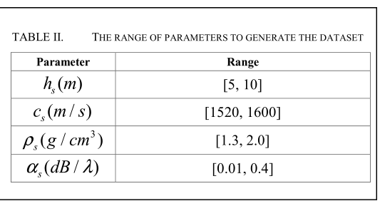

海水深度、声速、基底密度为经验值

We have generated 20,000 data samples, the training set, valid set, and test set account for 70%, 15%, and 15% of the total dataset respectively.

As we have got the dataset and build our neural network for inversion, we will get an effective MLP model for inferring after we have the MLP properly trained. We set our training process

as follows. An Adam optimizer is used in the training with the learning rate 5e-4. The batch size is set to 4000 and the total training epoch number is 1500. Besides, root mean square error (RMSE) is utilized to measure the difference between predicted values and true values.

Taking one data

point every 20Hz from 3000Hz to 3980Hz, we take 50 data

points to compose each piece of data.

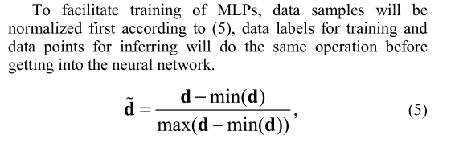

**2.Matched-field geoacoustic inversion based on radial basis function neural network**

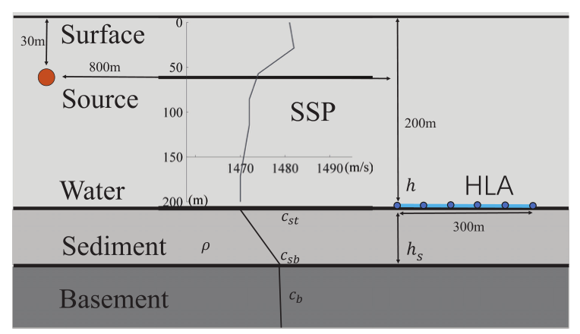

2*105个数据

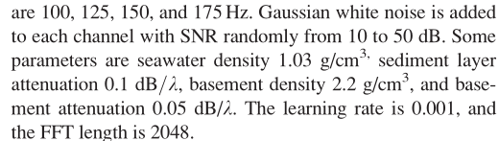

A single batch N 10000

**3.Deep-learning geoacoustic inversion using multi-range vertical array data in shallow water**

The mini-batch size is 128。The training process is stopped when the validation errors do not decrease in 20 successive epochs. Furthermore, a maximum of 200 epochs is given to force a stop of training. The geoacoustic inversion network is coded in Pytorch.58

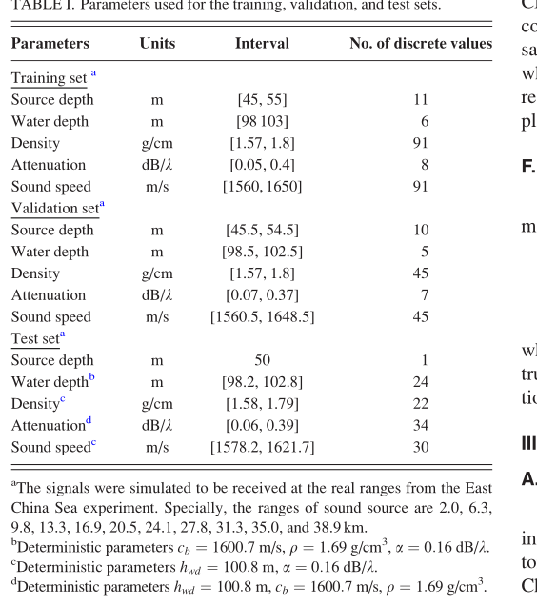

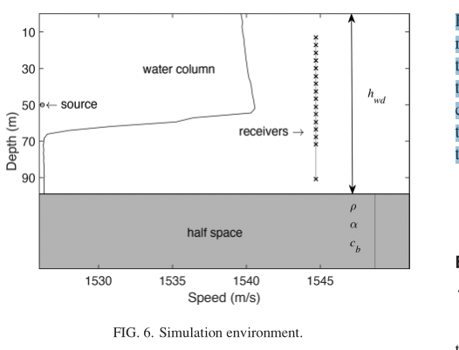

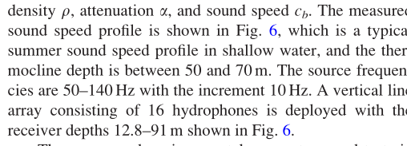

|  |  |  |  |  |  |
| --- | --- | --- | --- | --- | --- |
| 变量 | 简写 | 最小值 | 最大值 | 间隔 | 个数 |
| 频率 | freq | 3000 | 3960 | 40 | 25 |
| 沉积层深度 | hs | 7.5 | 55 |  | 20 |
| 发射/接收器位置 | hsr | 50 | 50 |  |  |
| 基质声速 | cb | 1840 | 2600 | 40 | 20 |
| 沉积层密度 | $$ρ(rou)$$ | 1.69 | 1.69 |  |  |
| 沉积层声速 | cs | 1506 | 1800 | 6 | 50 |
| 沉积层衰减率 | $$α(a)$$ | 0.05 | 0.4 | 0.05 | 8 |

|  |  |
| --- | --- |
| batchsz | 400 |
| setsz | 350 |
| querysz | 50 |
| param | c_s or alpha |
| Task_num(meta batchsz) | 1 |
| Update_step | 350 |
|  |  |