Interim Report

William Wang

Department of Civil and Environmental Engineering
Imperial College London

1. Introduction

According to WHO, road traffic crashes are the eighth leading cause of death globally, claiming 1.35 million lives annually and 50 million non-fatal injuries that lead to disabilities. With rapid increases of population and urbanisation, the standards revolving around transport safety are constantly developing to improve safety. The growing number of vehicles combined with the introduction of automated vehicles poses an integration predicament for future transport networks. Therefore, more research into human interactions is key to ensure maximum safety in a technologically developing industry. The analysis of driver behaviour is vital in reducing traffic accidents as over 95% of accidents are caused by human imperfections (Csiszar, 2017). Fatigue and sleepiness are amongst the biggest reasons for traffic accidents and driver based questionnaires have recently played a big role in identifying the underlying causes of aberrant driving behaviour. (Vahedi et al., 2018) explains that high annual driving mileage, and a high number of daily taxi trips positively associate with accident involvement. Furthermore, there was a positive correlation between violations and accident involvement. Taxi drivers benefit economically from longer driving periods and earn more for quicker journey times. Since their income is dependent on the number of customers, they are more likely to drive aggressively and commit ABD (Useche et al. 2020). (Tseng, 2013) explored the determinant factors of taxi drivers' speeding violations in Taiwan. Data gathered from a nationwide survey of taxi drivers showed results that 96.6% were males and 92.5% had less than a college level education. The mean daily working hours was 10.12 hours and taxi drivers worked approximately 27.35, taking only 2.65 days rest per month. Of the observed taxi drivers, 25.6% reported at least one speeding violation in a one-year period. Therefore, the relationship between fatigue and sleepiness with ADB need to be evaluated further to reduce the risk of accidents and incidents resulting from driving behaviour. The use of physiological factors to identify fatigue and sleepiness in drivers has been explored in recent years and trends can be detected using brain activity, heart rate variability and muscle electric activity.

Developments in artificial intelligence and machine learning has led to model development which can be used to predict ADB amongst taxi drivers and increase the safety of road traffic, reducing the risk of crashes. Peppes et al. (2021) explains that in the last few decades a plethora of vehicle sensors has pushed the transportation domain to a new, more intelligent and efficient era. Figure 1 portrays the upward trend in machine learning algorithms since 1984. As computing technology and commercialisation of ML methods continue to progress, even more data will be available for researchers to use to create a breeding ground for driver behaviour analysis.
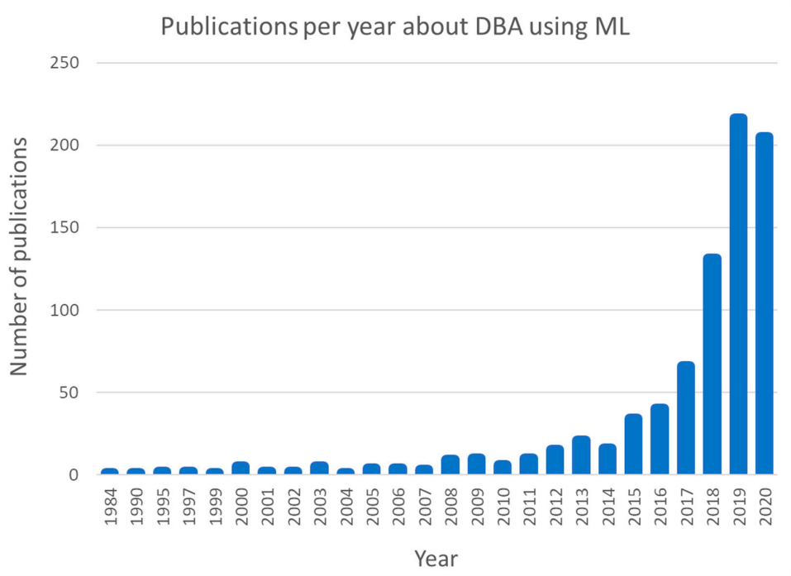
Figure 1: Publications per year using ML for driver behaviour analysis according to SCOPUS (Peppes et al., 2021)

The aims and objectives of this study are to understand the relationship between fatigue, sleepiness and ABD occurrences. Comparing alterations in HR and HRV measurement between baseline and moments prior to ADB occurrence (Tsai et al., 2022), a prediction of future ADB events can be attained. HRV parameters based on time and frequency domain analysis can be used to develop robust machine learning models as they are related to the autonomic nervous system (ANS) and peripheral nervous system (PNS). HR is controlled by the balancing action of the SNS and PNS (Kim et al., 2018). The ANS is composed of the sympathetic and parasympathetic nervous system. Duong et al. (2020) explains that alterations in these two systems will result in beat-to-beat heart rate variation which reflects autonomic nervous system activity. Time-domain variables are calculated directly from R-R intervals using methods such as the root mean square successive differences (RMSSD). Frequency domain variables are generated from spectral analysis using the fast Fourier transform. A comparison of the low frequency to high frequency domain of the HRV can provide insights to the brain to heart relationship. The balance between these is correlated with physiological states and can be identified through HRV (Tsai et al., 2022). Data has also been collected after using CPAP machines to reduce sleep apnoea and increase quality of sleep. This will serve to understand whether increased sleep quality can reduce occurrences of ADB and fatigue levels.

2. Literature review

This study looks to explore the use of machine learning models to predict Aberrant Driving Behaviour (ADB) in taxi drivers in Taipei, Taiwan. Using a RootiRx chest patch, an ECG signal is continuously monitored and heart rate data collected. A mobile application, Unigo Plus, has been used to collect driving infromation based on GPS data. Data analysis in Python is used to find the Heart Rate Variability (HRV) data for real-world taxi driving scenarios . 40 taxi drivers have volunteered to take part in the study over the course of 4 days. GPS data from mobile applications are used to track driver behaviour based on speeding, abrupt acceleration, sharp steering and aggressive braking. The mobile application is used to identify instances of ADB based on certain levels of each of these indicators. Time-domain and frequency-domain analyses are used to process the HRV data. Several different indicators of HRV have been calculated for a more in-depth analysis of the time domain features. The ratio of low frequency to high frequency power can estimate the ratio between the sympathetic and parasympathetic nervous systems. A Fast Fourier Transform can be used to analyse the power spectral density received from the software connected to the RootiRx patch. These will be used to develop a range of machine learning models to predict the occurrence of ADB.

Existing fatigue detection systems among drivers can be split into two categories: intrusive and non-intrusive. Intrusive techniques use physiological measurements of drivers to predict fatigue and sleepiness. Previous studies have used different signalling methods including brainwaves, muscle electrical activity and heart rate variability for fatigue inference models. Other behavioural-based methods such as body movements have also been experimented to seek the best results. Some of these methods are difficult to use in real-world, portable circumstances. Therefore, this literature review will investigate the different physiological factors that can be used to indicate fatigue and which ones are the most effective in real-world scenarios. A decision can then be made on which features to base the study on. Non-intrusive methods use data collected from the vehicle and driver without applying any machinery to the driver. There is no contact with the driver so that they can drive more naturally. (Li et al., 2017) explored a method using steering wheel angles and yaw angles under real driving conditions to detect drivers’ fatigue levels. It analysed the angles under different levels of fatigue and then calculated an entropy value based on a sliding window time series. After 15 hours of driving, the data were labelled with awake, drowsy or very drowsy. It effectively identified over 88% of fatigue situations. The application of machine learning models to predict ADB events will also be explored. Literature surrounding data acquisition for successful models and information on how to apply machine learning in driving scenarios is reviewed. The comparison between machine learning models and conventional analysis techniques has been explored. An insight into deep learning techniques is also researched for a full literature review.

2.1. Fatigue indicating factors

Driver constructs including fatigue and drowsiness are particularly difficult to measure, especially in real-world situations, however, physiological features can serve as indicators. Studies in the field of driver safety and monitoring have developed different prediction models based on various physiological signals. According to the research (Zhao et al., 2012), mental fatigue is a contributing factor to serious transportation crashes. In the study, the mental fatigue was measured using EEG and ECG. 13 subjects performed a simulated driving task for 90 minutes to investigate the parameters before and after driving. The results from the experiment show that the lower and upper bands of the power of heart rate variability are different before and after driving. Therefore the EEG and ECG are good indicators for measuring driver mental fatigue. The link between brain activity and heart rate variability was also supported. For all subjects, the power spectra of different EEG rhythms showed statistic differences before and after long-term driving. Alpha and theta increases and beta decreases indicated decline in arousal level showing mental fatigue. The mental fatigue impacts the function of the central nervous system which controls and regulates the cardiovascular system. These changes were reproduced within the HRV data, further exemplifying the link between fatigue and HRV. Nevertheless, there are several limitations in the study. The number of test subjects is too small and more data should be used in future studies. There were also no controls so mental fatigue may have been unrelated to driving. Although unlikely, the fatigue may have resulted from other activity so a control group could be used in future. Another option is to track EEG and ECG during normal everyday activity to identify the normal HRV of each participant. Jung, Shin and Chung (2014) proposed a real time driver health condition monitoring system with drowsiness alertness. This study used an ECG sensor with electrically conductive fabric electrodes on the steering wheel. The sampling rate of 100 Hz was taken from the palms and the performance was assessed under continuous 2 hours of driving. The condition of the driver was split by normal, fatigued and drowsy states and analysed using HRV time and frequency domains.
Figure 2 shows the HRV in drowsy, fatigued and normal states and it is clearly visible that the HRV is decreased when the subject gets more fatigued and drowsy. The SDNN, RMSSD and pNN50 values are measured and the LF/HF ratio is also derived. The results indicate that the HRV analysis enables detection of drowsiness and fatigue condition in the driver so that an assessment of the driver’s health condition can be made.
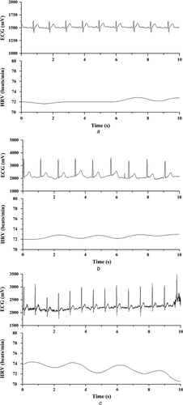
Figure 2: HRV signals in drowsy, fatigued and normal states (Jung, Shin and Chung., 2014)

Following on from these studies, a larger sample could be used to attain more data and allow for the use of machine learning models to increase accuracy. HRV tracking is more difficult on the steering wheel due to drivers’ natural hand movements which are restricted. An improved tracking device is therefore preferred over steering wheel electrodes and this can be utilised in future studies. It is apparent that HRV is a critical factor of the mental state of drivers and therefore can be used as a physiological indicator for driver fatigue.

(Lee and Chung, 2012) developed a smartphone-based driver safety monitoring system using data fusion. In this study, eye movements were captured using the smartphone built-in front facing camera. The set-up and sensors can be seen in Figure 3. Slower eyelid movements separated drowsy drivers from ordinary blinking. Bio-sensors were also used and attached to the steering wheel for ECG, PPG and temperature measurements. A 3-axis accelerometer was used to track the speed and a warning alert would be used to warn the driver of a reduction in driving attention. An anonymous call would ring through the phone in a bid to inform the driver of potential fatigue and drowsiness. However, these tests were conducted through an indoor driving simulation and may not be suitable in real scenarios. Having PPG and ECG sensors on the steering wheel meant that drivers needed to be in contact with the wheel at all times to attain a reading which is unrealistic. Any movements off the wheel, which tend to occur during normal driving activity, will result in a gap in the readings which can lead to errors. In terms of the experiment, telling participants that they would be required to keep their hands on the wheel may influence their driving style and improve their focus. This would deter them from displaying ‘normal’ driving behaviour and could skew the results. Furthermore, image and video detection using the smartphone may be problematic since it is highly dependent on lighting. Driver arm movements may block cameras and head movements off-centre might disrupt the apps ability to track eyelid movements. Infra-red lights were used so that light intensity could be adjusted to enable clear capture of facial imaging even during night driving which was beneficial. Nevertheless, image and video detection will be unreliable and also has high energy requirements if constant video tracking of the eyes is necessary. Only driving speed was measured and other factors such as acceleration, braking and steering were not considered. Therefore, driver reactions to sudden events that require such actions could not be investigated and the ECG reaction is unknown. The main conclusions from this study were that eye tracking, ECG and PPG measurements could be useful physiological indicators of drowsiness and fatigue. Overall, the results showed that there was high accuracy for true predictions for states of awakeness and drowsiness, however, the number of false estimations were too high. The system, in too many circumstances, assumed the driver was fatigued when in reality they were awake. This may have been caused by natural differences in facial features in different scenarios. It is difficult to predict fatigue through image capture since facial features will change from person to person. This, alongside the impracticality of the study for real-world scenarios, means that further research into this topic is necessary. The reaction of drivers to real-life ADB will differ from the in-door simulation due to more severe consequences. An improved study could potentially use real-world drivers with a less limiting tracking method so that normal driving behaviour can exist.

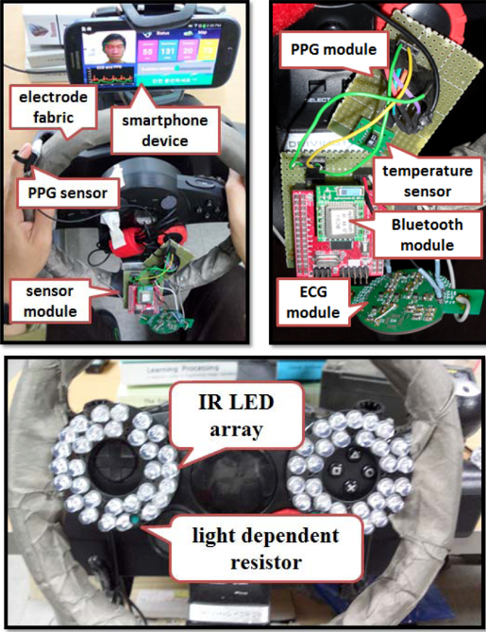

Figure 3: Experiment set-up (Lee and Chung, 2012)

A study by Fu, Wang and Zhao (2016) investigated the dynamic driver fatigue detection using hidden Markov modelling in real driving condition. It uses brainwaves, muscle electrical activity and respiration signals to establish a fatigue inference model. This study aimed to test the model using real-world data and 12 bus drivers were tested over 3.5 hours of real highway and urban driving with signals transmitted via cordless Bluetooth connection. The driver state was self-informed and categorised as; alert, mild fatigue and fatigue. The Karolinska Sleepiness Scale was used as the subjective basis for the estimation of fatigue which has been used in similar papers. This paper effectively proved that brainwaves, muscle electrical activity and heart rate data can contribute to predicting fatigue in drivers and it proposed an easy understanding way of physiological fusion. The relationship between fatigue and physiological factors was further solidified and it provided a good basis to develop research further. By engaging the relationship between physiological factors and fatigue, ADB occurrences could be predicted using HRV tracking. Increasing data availability by using more drivers and longer testing times will further improve the accuracy of fatigue prediction in real-world driving. Segerstrom and Nes (2007) experimented the idea that self-regulatory deficits are a consequence of prior self-regulatory effort. Although people understand when they are vulnerable to doing the wrong things, they sometimes cannot self-regulate. The brain is responsible for self-regulation and autonomic regulation, and HRV is a useful measure for self-regulatory strength during activity due to its link with the ANS explained earlier. The study effectively showed that baseline HRV was elevated when self-regulatory effort was required (eating carrots and trying to resist cookies) whereas HRV was lower when less self-regulatory effort was required (eating cookies and resisting carrots). Although this portrays a different scenario to driving behaviour, the relationship between self-regulation with HRV is the same. Drivers who experience fatigue or sleepiness will require higher self-regulatory effort to try and stay alert during activity. This may induce higher HRV at baseline. Certain events may also cause sudden increases in HRV and this can be utilised to estimate the occurrence of ADB events. HRV appeared to index self-regulatory strength and so it is possible to study human behaviour in the field and the lab.

2.2. Machine learning model for ADB

The use of machine learning models to predict ADB events is still in the early stages of development and the application of machine learning techniques for driving behaviour analysis is reviewed by Elamrani Abou Elassad et al. (2020). Driving behaviour is a complex concept describing driver operations in relation to the surrounding environment. A conceptual framework for the use of machine learning models to analyse driving behaviour is supplied. The paper explains that vehicle kinematics including speed, acceleration and steering can be used to understand driving behaviour. However, the use of road infrastructure and weather conditions need also be considered when evaluating the physiological conditions of the driver. Therefore, complete ML models will require input from these categories to fully understand the crash risk. Using only vehicle kinematics, stop-and-go depictions could be influenced by traffic and weather conditions which will reduce the accuracy of the data. Moreover, driver profile data such as education, gender, driving experience and violation history are useful to understand normal driving of test subjects. This allows ADB occurrences to be identified as out-of-normal events. Driver based questionnaires (DBQs) will be necessary in model development. Environment-based measures such as temperature and precipitation can be checked using mobile apps or built-in vehicle measures. In terms of modelling metrics, there are different categories that can affect the robustness of the ML model. These are shown in Figure 4 below. Vehicle-based measures look at the driving performance and kinematics. These are easy to obtain with vehicle sensors when considering the driver input to the vehicle and the vehicle response to driver input. Physiological-based measures include recording the driver’s physiological state using ECG and heart rate variability. With advancements in technology, these sensors can be relatively easily attached to the subject with wristwatches or chest patches to obtain measurements. For this, motion artifact noises can have a huge impact on the sensor readings so it is important to use signal conditioning and filtering operations to reduce the effect of these on machine learning models. Behaviour-based measures can be identified using image and audio processing techniques. These are non-intrusive and have less effect on the drivers. However, detecting head movements, expressions and voice activity can be difficult. They require expensive computational methods and, despite high image processing sophistication with deep learning, these measures have returned unreliable results due to the impact of environmental factors on detection. Lighting, facial coverage or personal affects can cause inaccuracies. Finally, subject-based measures with self-reports on sleep and mood are widely used and are considered validated. However, social bias can limit the use of this subjective metric and a lack of real-time measure prevents the monitoring of sudden ADB events. Machine learning models use simulations of human learning in computers to improve the performance of experiments where data from the real world is used to build algorithms. Different machine learning models can be used for ADB predictions and, of those researched in this paper, Support vector machines, Neural networks, Bayesian learners and Ensemble learners were the four most frequently used ones. The use of different metrics was also shown and a combination of all metrics was the most effective. In comparison with conventional models, ML models outperformed in accuracy. The findings from this review of 82 studies including 8 using ML models prove that ML techniques outperformed conventional approaches. However, the application of ML models relating to ADB need more effort to produce new contributions. Talebloo, Mohammed and Far (2021) use deep learning approaches for ADB detection. They identify the timesteps at which a driver begins to drive aggressively in reaction to different circumstances. GPS sensors from a smartphone are used to locate the drivers every 3 minutes. Time-series models are used through Gated Recurrent Unit (GRU) and Long Short-Term Memory (LSTM). It concludes that 3 minutes of driving is sufficient to identify aggressive driving behaviour. This supervised deep learning method uses previous step’s outputs as input for subsequent phases. Since the data is sequential in time and continuous, recurrent neural networks (RNN) are useful. Rather than using individual points in time, windows are used so a batch of rows can be analysed. This is to show the changes in GPS signal which are more relevant as opposed to GPS results at a given time. In conclusion, this study shows that time-series data and algorithms can be used to predict driving behaviour in a 3 minute window. This is a development on conventional machine learning models due to its ability to identify time-series changes. Some dataset challenges included using a public repository for data collection. This used various testers in different conditions. Only six drivers and vehicles were used and the behaviour was set to normal, drowsy and aggressive. Only 500 minutes of naturalistic driving was tested. More drivers need to be examined and a comparison to their normal heart activity needs to be conducted to fully understand the extent of aggressive driving behaviour exhibited. Each driver’s behaviour differed from one another and so the system had to be split into smaller batches for learning. By using a larger dataset, the average behaviour of drivers would relate more to each driver and therefore a larger batch can be used for system learning. This should improve the accuracy of the model. Also different routes were specified with different road lengths. This also required redistribution of the data.

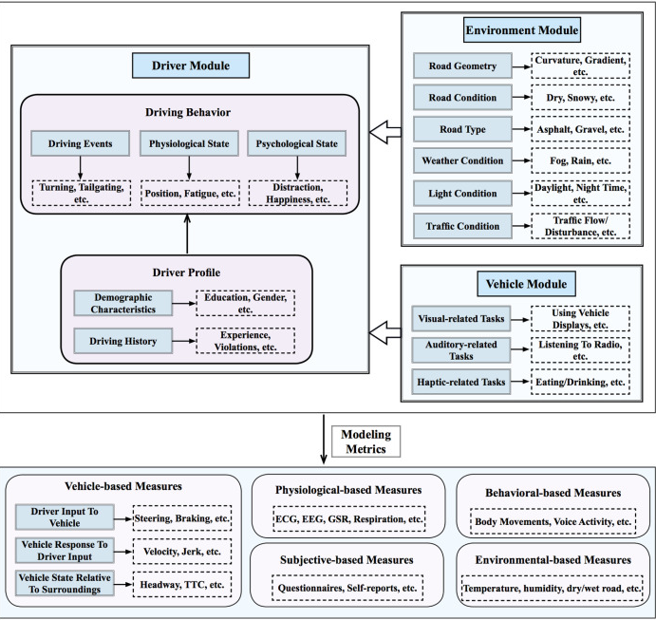
Figure 4: Data collection for machine learning model (Elamrani Abou Elassad et al, 2020)

Using GPS data, focusing on speeding, abrupt steering, hard braking and aggressive acceleration, (Tsai et al., 2022) used machine learning approaches incorporating heart rate variability to predict ADB occurrence. 10 highway bus drivers were monitored for driving data over 4 consecutive days. The driving behaviour was obtained using a mobile application and the physiological data was obtained using a heart rate watch. The sleep quality of drivers was self-reported by participants while driver-related experience, weather data and traffic conditions were also recorded. Using logistic regression, random forest, naïve Bayes, support vector machine and gated recurrent unit, predictions of ADB were made. The study concluded that most drivers with ADB, self-reported low sleep efficiency. Increased fatigue levels resulted in higher ADB occurrence from HRV-based models among bus drivers. The gated recurrent unit model was the most accurate achieving 81.16-84.22%. This is an improvement on previous studies as real-world data was used over a sufficient working period. However, the heart rate is tracked using a wristwatch which can be effected by natural wrist movements when driving. The accuracy of a chest patch is higher and can be used to improve the results. This approach also uses a self-rated questionnaire to monitor sleep quality. This is subjective and can be improved by monitoring heart activity throughout sleep. This can be done using a chest patch which is comfortable and accurate. A rolling calculation for the heart rate variability will also increase the accuracy of a machine learning model by evaluating the continuous changes in heart activity.

2.3. RootiRx chest patch

Traditional methods of tracking the heart rhythm and electrical activity include using devices such as electrode fabrics where contact would be required with both hands at all times. Other devices include wristwatches that can be worn during driving activity. This is more practical as it allows drivers to move more freely. In a study by (Tsai et al., 2022), the heart rate variability is tracked using a wristwatch with embedded photoplethysmography. However, the accuracy could be compromised through extensive wrist movements throughout the day. Signal from the watch may be lost if the watch does not make appropriate contact on the wrist. Drivers will constantly move their hands when driving and therefore using a chest patch may increase data capture and accuracy of results. A study conducted by (Hsu et al., 2020) explored the accuracy and tolerability of a single electrocardiogram lead to screen for sleep apnea. Using the data of 119 patients who snored, a RootiRx patch was attached on the chest and cyclic variation of heartrate and chest effort index was calculated. The study concluded that the RootiRx patch was effective in screening obstructive sleep apnoea in patients using ECG and 3-axis accelerometer. It can be worn constantly and is able to produce accurate readings while also providing comfortability. Driving will not be affected as no wires or machinery will get in the way. Using sleep tests, obstructive sleep apnoea can be identified so that taxi drivers can be diagnosed and re-evaluated to deduce the impact of sleep quality on ADB events. This is used in the second part of the study where patients who struggle with sleep quality are fitted with a CPAP machine and revaluated to identify any improvements in sleep and how this can reduce ADB occurrence.

3. Provisional content outline
This section provides a provisional outline of the final paper with section titles and a short explanation of each sub-section.

3.1 Abstract
A concise summary of the research paper, including what the paper examined, how the model was developed and the results.

3.2 Introduction
An introduction to the subject area researching the scope, rationale and aims and objectives of the paper

3.3 Literature review
An insight to existing papers researching the same subject. Investigating current methods of identifying ADB and the results. Finding good practices and ways to improve future experiments.

3.4 Method
Explanation of the method of the experiment, where and what was conducted and how the data was collected. Information on statistical analysis and which machine learning models were used.

3.5 Results
Identify the results from the questionnaires and ADB data. Understanding of surrounding environment impacts and HRV data. Explain results from machine learning models and how accurate they are.

3.6 Discussion
Discussion on what the results from the experiment mean in terms of ADB prediction based on the models. Discuss the accuracy of the different models, which physiological indicators were most effective and which ADB events were the most frequent

3.7 Conclusions
Conclude the relationships of fatigue with ADB and how effective the machine learning models were. Look at what should be done in future and what this study has provided.

4. Gantt chart

A Gantt chart is shown below with planned steps for each phase of the project. Currently the preliminary review has been completed and some initial calculations of HRV have been conducted. The HRV analysis for 30 second windows is planned to be completed by the end of this week before starting on the machine learning models. Currently code is being written for the data of a single driver however, it is easily transferable to all data. The next phase is to develop machine learning model based on the calculation results. Finally, the report will be written in the remaining time leaving space for review of the project to make any changes or fix any issues.

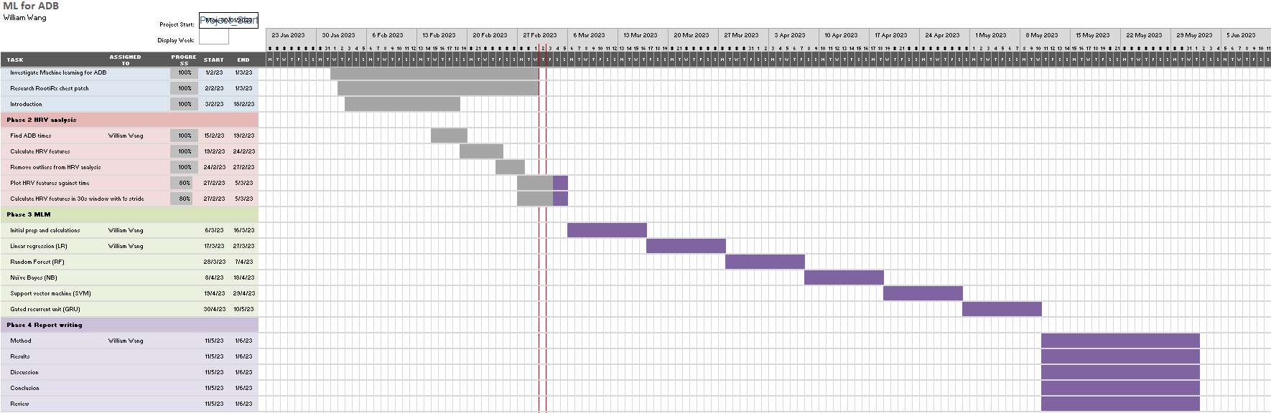
Figure 5: Gantt chart for project activities and time plan

5. Current progress and written code

An initial code has been written to import the driving trip data and identify the rows where aggressive steering, hard acceleration, hard braking and speeding occur. The corresponding times of these events is found using the indices. An array is created, consisting of all the Unix timestamps of the folders containing the heart rate data. A function is developed to find the closest folder that holds the information for the ADB event. The ECG data can then be extracted for a chosen time interval before the ADB event occurs. The results are shown in Figure 6.
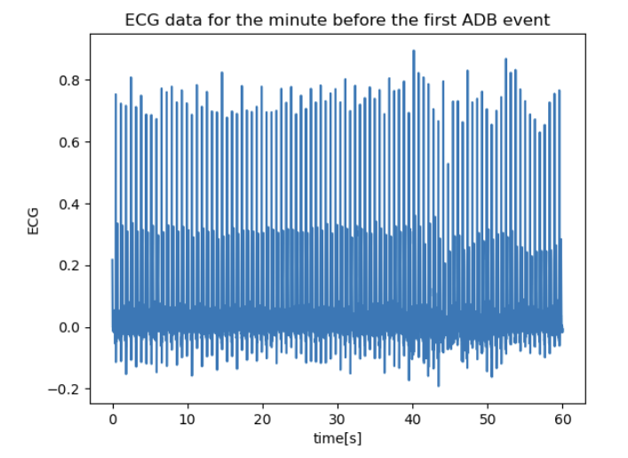
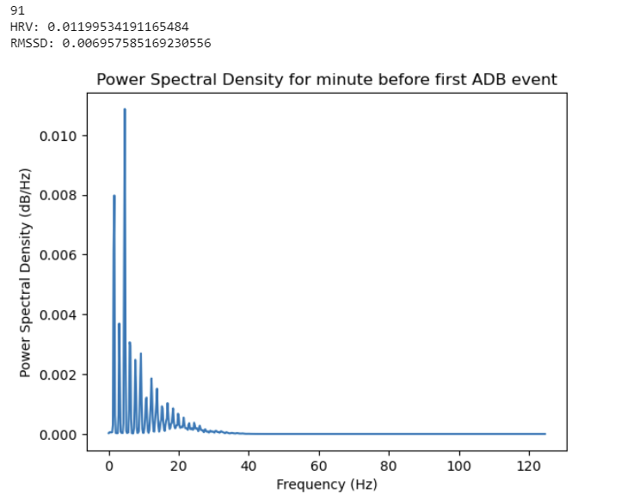
Figure 6: ECG data and HRV analysis for 1 minute interval before first ADB event

The next code that has been written focuses on attaining full time and frequency domain features. This is also done in 30 second intervals with a 1 second stride. This improvement allows for a continuous plot of HRV analysis against time. Each window of data differs by only 1 second. Patterns in the HRV can be identified and visualized in a more complete manor compared to extracting only the data before the event occurs. This has proved difficult to run especially considering all the points of data throughout the 5 days that have been measured. There are around 250 points per second and each person has over 107 million ECG points overall. The code has been extremely hard to run and therefore a tester code has been used for only 1-hour intervals. This allows for focus on correcting the code which should then be accurately used for the complete time interval. This code also deletes outliers and removes artifacts for each window to prevent them effecting the results. The HRV analysis relies on RR intervals which are then corrected to produce NN intervals. To do this, a minimum of 300ms and a maximum of 200ms are used to remove any impossible intervals.

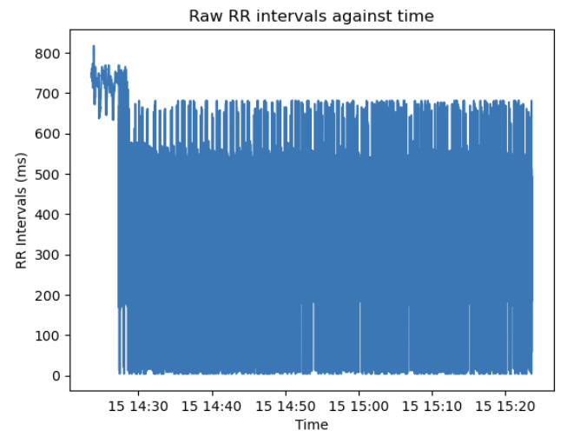
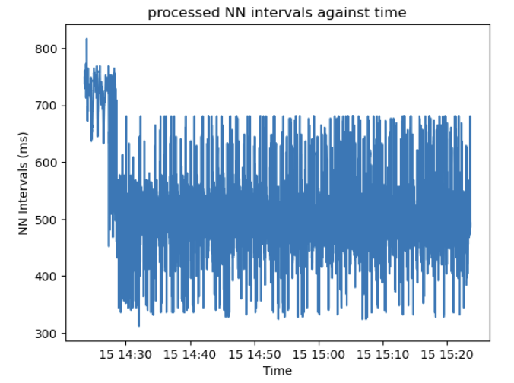
Figure 7: Filtered NN intervals compared to raw RR intervals for a random minute of data

References

Abdullah, P. & Sipos, T. (2022) Drivers’ Behavior and Traffic Accident Analysis Using Decision Tree Method. Sustainability (Basel, Switzerland). 14 (18), 11339. 10.3390/su141811339.

Csiszár, C. & Földes, D. (2018) System Model for Autonomous Road Freight Transportation. Promet. 30 (1), 93-103. 10.7307/ptt.v30i1.2566.

Duong, H.T.H., Tadesse, G.A., Nhat, P.T.H., Hao, N.V., Prince, J., Duong, T.D., Kien, T.T., Nhat, L.T.H., Tan, L.V., Pugh, C., Loan, H.T., Chau, N.V.V., Minh Yen, L., Zhu, T., Clifton, D. and Thwaites, L. (2020). Heart Rate Variability as an Indicator of Autonomic Nervous System Disturbance in Tetanus. The American Journal of Tropical Medicine and Hygiene, 102(2), pp.403–407. doi:https://doi.org/10.4269/ajtmh.19-0720.

Elamrani Abou Elassad, Z., Mousannif, H., Al Moatassime, H. & Karkouch, A. (2020) The application of machine learning techniques for driving behavior analysis: A conceptual framework and a systematic literature review. Engineering Applications of Artificial Intelligence. 87 103312. 10.1016/j.engappai.2019.103312.

Fu, R., Wang, H. and Zhao, W. (2016). Dynamic driver fatigue detection using hidden Markov model in real driving condition. Expert Systems with Applications, 63, pp.397–411. doi:https://doi.org/10.1016/j.eswa.2016.06.042.

Havarneanu, C., Mairean, C. & Popusoi, S. (2019) Workplace stress as predictor of risky driving behavior among taxi drivers. The role of job-related affective state and taxi driving experience. Safety Science. 111 264-270. 10.1016/j.ssci.2018.07.020.

Hsu, Y., Chen, T., Wu, D., Lin, C., Juang, J. & Liu, W. (2020) Screening of obstructive sleep apnea in patients who snore using a patch-type device with electrocardiogram and 3-axis accelerometer. American Academy of Sleep Medicine (AASM).

Jung, S.-J., Shin, H.-S. and Chung, W.-Y. (2014). Driver fatigue and drowsiness monitoring system with embedded electrocardiogram sensor on steering wheel. IET Intelligent Transport Systems, 8(1), pp.43–50. doi:https://doi.org/10.1049/iet-its.2012.0032.

Kim, H.-G., Cheon, E.-J., Bai, D.-S., Lee, Y.H. and Koo, B.-H. (2018). Stress and Heart Rate Variability: A Meta-Analysis and Review of the Literature. Psychiatry Investigation, [online] 15(3), pp.235–245. doi:https://doi.org/10.30773/pi.2017.08.17.

Li, Z., Chen, L., Peng, J. and Wu, Y. (2017). Automatic Detection of Driver Fatigue Using Driving Operation Information for Transportation Safety. Sensors, 17(6), p.1212. doi:https://doi.org/10.3390/s17061212.

Lee, B.-G. and Chung, W.-Y. (2012). A Smartphone-Based Driver Safety Monitoring System Using Data Fusion. Sensors, 12(12), pp.17536–17552. doi:https://doi.org/10.3390/s121217536.

Organization, W. H. (2018a) Global status report on road safety 2018. Geneva, Switzerland, World Health Organization. https://ebookcentral.proquest.com/lib/[SITE_ID]/detail.action?docID&#61;5910092.
.
Pan, H., Wang, Y. & Szűcs, G. (2022) Work-traffic crashes and aberrant driving behaviors among full-time ride-hailing and taxi drivers: a comparative study. Informa UK Limited.

Peppes, N., Alexakis, T., Adamopoulou, E. & Demestichas, K. (2021) Driving Behaviour Analysis Using Machine and Deep Learning Methods for Continuous Streams of Vehicular Data. Sensors (Basel, Switzerland). 21 (14), 4704. 10.3390/s21144704.

Segerstrom, S.C. and Nes, L.S. (2007). Heart Rate Variability Reflects Self-Regulatory Strength, Effort, and Fatigue. Psychological Science, 18(3), pp.275–281. doi:https://doi.org/10.1111/j.1467-9280.2007.01888.x.

Talebloo, F., Mohammed, E.A. and Far, B. (2021). Deep Learning Approach for Aggressive Driving Behaviour Detection. arXiv:2111.04794 [cs]. [online] Available at: https://arxiv.org/abs/2111.04794 [Accessed 2 Mar. 2023].

Tsai, C., Lin, Y., Liu, W., Cheong, H., Houghton, R., Hsu, W., Iulia, M., Liu, Y., Kang, J., Lee, K., Kuan, Y., Lee, H., Wu, C., Joyce Li, L., Cheng, W., Ho, S., Lin, S. & Majumdar, A. (2022). Aberrant Driving Behavior Prediction for Urban Bus Drivers in Taiwan Using Heart Rate Variability and Various Machine Learning Approaches: A Pilot Study. Transportation Research Record. 36119812211238. 10.1177/03611981221123802.

Tsai, C., Majumdar, A., Wang, Y., Hsu, W., Kang, J., Lee, K., Tseng, C., Kuan, Y., Lee, H., Wu, C., Houghton, R., Cheong, H., Manole, I., Lin, Y., Li, L. J. J. & Liu, W. (2022) Machine learning model for aberrant driving behaviour prediction using heart rate variability: a pilot study involving highway bus drivers. Informa UK Limited.

Zhao, C., Zhao, M., Liu, J. and Zheng, C. (2012). Electroencephalogram and electrocardiograph assessment of mental fatigue in a driving simulator. Accident Analysis & Prevention, 45, pp.83–90. doi:https://doi.org/10.1016/j.aap.2011.11.019.

Introduction: Road traffic crashes have emerged as a significant global concern, ranking as the eighth leading cause of death worldwide, with an estimated 1.35 million lives lost annually and 50 million non-fatal injuries resulting in disabilities (Rosen et al., 2022). As population growth and urbanization continue at a rapid pace, ensuring transportation safety becomes paramount, necessitating ongoing development of safety standards. However, the integration of automation and the expanding number of vehicles pose challenges for future transport networks, emphasizing the need for extensive research on human interactions to maximize safety in this evolving technological landscape.
Analyzing driver behavior plays a crucial role in reducing traffic accidents, given that over 95% of accidents are attributed to human error and imperfections (Csiszár and Földes, 2018). Fatigue and sleepiness are among the primary causes of traffic accidents, prompting the use of driver-based questionnaires to identify underlying factors contributing to erratic driving behavior (Vahedi et al., 2018). Studies have indicated a positive association between high annual driving mileage, a high number of daily taxi trips, and accident involvement (Vahedi et al., 2018). Additionally, a correlation has been observed between traffic violations and accident rates. Taxi drivers, motivated by economic incentives tied to driving duration and quick trip times, are more likely to exhibit aggressive driving behaviors and engage in aberrant driving behaviors (Useche et al., 2020).
Research focusing on taxi drivers has shed light on the factors influencing their driving behaviors. For instance, a study conducted in Taiwan revealed that male taxi drivers with lower levels of education, longer daily working hours, and fewer rest days per month had a higher likelihood of speeding violations (Tseng, 2013). Another study explored the relationship between workplace conflicts and risky driving behavior among taxi drivers, demonstrating a direct association between job-related affective states and risky driving behavior, taking into account driver experience (Havărneanu et al., 2019). Given the nature of their work, taxi drivers may exhibit more aberrant driving behavior, increasing the potential for dangerous driving situations.
To mitigate the risks associated with aberrant driving behavior and reduce the likelihood of accidents and incidents, further evaluation of the relationship between fatigue, sleepiness, and aberrant driving behavior is crucial. Recent advancements in utilizing physiological factors such as brain activity, heart rate variability, and muscle electric activity have allowed for the detection of fatigue and sleepiness in drivers (Havărneanu et al., 2019). Moreover, the integration of artificial intelligence and machine learning techniques has facilitated the development of predictive models to identify aberrant driving behavior among taxi drivers, thereby enhancing road safety and mitigating the risk of crashes (Peppes et al., 2021).
This study aims to investigate the relationship between fatigue, sleepiness, and occurrences of aberrant driving behavior. By comparing alterations in heart rate (HR) and heart-rate variability (HRV) measurements between baseline and moments preceding aberrant driving behavior incidents, it is possible to predict future instances of aberrant driving behavior (Tsai, Lin, Liu, Cheong, Houghton, Hsu, Iulia, Liu, Kang, Lee, Kuan, Lee, Wu, Li, Cheng, Ho, Lin, Lin and Majumdar, 2022). HRV parameters derived from time and frequency domain analysis offer insights into the relationship between the autonomic nervous system (ANS) and peripheral nervous system (PNS) and can be employed to develop robust machine learning models (Kim et al., 2018). The ANS, composed of the sympathetic and parasympathetic nervous systems, regulates HR, and variations in HR reflect autonomic nervous system activity (Duong et al., 2020). Time-domain and frequency-domain variables derived from HRV analysis provide valuable information on physiological states and the balance between sympathetic and parasympathetic influences (Tsai, Lin, Liu, Cheong, Houghton, Hsu, Iulia, Liu, Kang, Lee, Kuan, Lee, Wu, Li, Cheng, Ho, Lin, Lin and Majumdar, 2022). Furthermore, data collected from participants using continuous positive airway pressure (CPAP) machines for sleep apnea treatment can shed light on the impact of improved sleep quality on driving behavior, potentially reducing occurrences of aberrant driving behavior and fatigue levels.
The availability of an abundance of data, coupled with advancements in computing technology and the commercialization of machine learning methods, holds immense potential for investigating driver behavior analysis and further enhancing road safety (Peppes et al., 2021). By comprehensively understanding the relationship between fatigue, sleepiness, and aberrant driving behavior, this study seeks to contribute to the ongoing efforts in promoting safe driving practices and reducing the risks associated with traffic accidents.

This study examines the development of machine learning models for predicting aberrant driving behavior (ADB). ADB plays a significant role in road traffic accidents, often attributed to human factors such as fatigue and sleepiness. Taxi drivers, in particular, face heightened ADB risks due to long working hours and demanding environments. Recent research has explored physiological factors, specifically heart rate variability (HRV), as potential indicators for ADB prediction. This paper aims to investigate the feasibility of utilizing HRV and previous night's sleep data to assess the impact of fatigue and sleepiness on ADB among taxi drivers.

Naturalistic driving data of 32 Taiwan taxi drivers have been collected using a mmobile application that records driving behaviour. A RootiRx chest patch was provided to drivers to continuously record ECG signals throughout the day. Self-reported driving information and questionnaires were used to analyse driver mental states. Environmental factors were accessed from public databases. Six machine learning models were developed comparing 5-minute intervals of pre-ADB and normal driving behaviour: logistic regression, naive Bayes, random forest, support vector machine, k-nearest neighbour and extreme gradient boosting.

The time and frequency-domain HRV parameters showed significant differences between baseline and pre-ADB events and the models were able to differentiate ADB intervals from normal driving up to an accuracy of 98.1\%. Previous night sleep data in conjunction with the driver questionnaires showed that sleep quality had an important impact on fatigue.

Poor sleep quality and long driving hours in challenging environments causes high fatigue in taxi drivers leading to ADB events. HRV parameters and previous night sleep data can serve as indicators to evaluate drivers' mental status and predict ADB.

