暨南大学本科实验报告专用纸
指导教师 操作系统原理 成绩
实验项目名称 动态分区分配方式 实验项目编号 0806002905
实验项目类型 验证 实验地点 学院 智能科学与工程学院 专业 人工智能
学生姓名 王志涛 学号 2021102259 实验时间 2023年 3 月 1 日

一、实验目的
了解动态分区分配方式中使用的数据结构和分配算法，进一步加深对动态分区存储管理方式及其实现过程的理解。提高学生设计实验、发现问题、分析问题和解决问题的能力，并学习撰写规范的科学研究报告。
设计思路：
1．用C或其他语言分别实现采用首次适应算法和最佳适应算法的动态分区分配过程和回收过程。
2．设置初始状态，每次分配和回收后显示出空闲内存分区链的情况。

二、实验原理
该实验涉及的知识点包括：分区分配，首次适应算法，最佳适应算法等。

三、实验结果
代码如下，有详细的代码注释
首次适应算法代码如下：
- #include<stdio.h>
- #include<malloc.h>
- #include<stdlib.h>

- #define ALL_SIZE 100 //内存总大小
- #define MIN_SIZE 1 //最小分区大小

- //首次适应算法
- //内存分区结构体
- typedef struct MemoryBlock
- {
- int begin_address;//起始地址
- int size; //内存块大小
- struct MemoryBlock *next; //指向下一个结构体
- }MemoryBlock;
- //记录已经分配内存的内存块
- typedef struct UsedMemory
- {
- int begin_address;//起始地址
- int size;//内存块大小
- struct UsedMemory *next;
- }UsedMemory;

- //创建空闲内存链表
- void Create(MemoryBlock* &p)
- {
- p=(MemoryBlock*)malloc(sizeof(MemoryBlock));
- p->begin_address = 0;//初始地址为0
- p->size = ALL_SIZE ;
- p->next = NULL;
- }
- //创建已分配内存链表
- void Create(UsedMemory* &used)
- {
- used = (UsedMemory *)malloc(sizeof(UsedMemory));
- used->next = NULL;
- }
- //输出链表
- void My_Print(MemoryBlock *p)
- {
- printf("空闲内存链表：\n");
- while(p!=NULL)
- {
- printf("起始地址：%d\t",p->begin_address);
- printf("内存块大小：%d\n",p->size);
- p = p->next;
- }
- printf("\n");
- }
- void My_Print(UsedMemory *t)
- {
- t=t->next;
- printf("已分配内存链表：\n");
- while(t!=NULL)
- {
- printf("起始地址：%d\t",t->begin_address);
- printf("内存块大小：%d\n",t->size);
- t = t->next;
- }
- printf("\n");
- printf("*************************************\n");
- }
- void My_Print(MemoryBlock *p,UsedMemory *t)
- {
- My_Print(p);
- My_Print(t);
- }

- //分配过程
- void allocate(MemoryBlock* &p,UsedMemory* &used,int size)//用大小分配
- {
- //开始分配
- printf("开始分配大小为 %d 的内存块\n",size);
- MemoryBlock *temp = p;
- MemoryBlock *pre=NULL;//记录前一个节点地址
- int i = 0;//判断内存是否分配成功
- while(temp!=NULL)
- {
- if(temp->size >= size)
- {
- i = 1;
- int address = temp->begin_address;
- //更新已分配内存链表
- UsedMemory *t = (UsedMemory *)malloc(sizeof(UsedMemory));
- t->begin_address = temp->begin_address;
- t->size = size;
- if(used->next == NULL)
- {
- used->next = t;
- t->next = NULL;
- }
- else
- {
- t->next = used->next;//头插法
- used->next = t;
- }
- //空闲内存链更新
- if(temp->size == size)
- {
- if(pre == NULL)
- {
- p=p->next;
- free(temp);
- }
- else
- {
- pre->next = temp->next;
- }
- }
- else
- {
- temp->begin_address = temp->begin_address+size;
- temp->size = temp->size - size;
- }
- //分配成功，返回初始地址
- printf("分配成功，初始地址为：%d\n\n",address);
- break;
- }
- pre = temp;
- temp = temp->next;
- }
- //没有足够大小内存分配，分配失败
- if(i == 0)
- {
- printf("没有足够大小内存分配，分配失败\n");
- }
- }
- //回收过程
- void deallocate(MemoryBlock* &p,UsedMemory* &used,int begin_address)//用起始地址回收
- {
- //开始回收
- MemoryBlock *upmemory=NULL;//记录回收内存的上一块内存
- MemoryBlock *downmemory;//记录回收内存的下一块内存
- int up = 1;//1代表回收内存的上一块内存是空闲的，0代表已分配
- int down = 1;//1代表回收内存的下一块内存是空闲的，0代表已分配
- UsedMemory *find = used;
- int size;//内存块大小
- //查找内存块的大小,并更新已分配内存链表
- while(find !=NULL)
- {
- //没有找到该内存
- if(find->next == NULL)
- {
- printf("没有找到起始地址为 %d 的内存,查找失败\n",begin_address);
- return;
- }
- if(find->next->begin_address == begin_address)
- {
- size = find->next->size;
- //删除节点，回收内存
- UsedMemory *temp = find->next;
- find->next = find->next->next;
- free(temp);
- break;
- }
- find = find->next;
- }
- //回收内存，更新空闲内存链表
- downmemory = p;
- while(downmemory != NULL && downmemory->begin_address < begin_address)
- {
- upmemory = downmemory;
- downmemory = downmemory->next;
- }
- //这种情况代表回收内存的上一块内存不是空闲的，不需要合并
- if(upmemory == NULL || upmemory->begin_address + upmemory->size != begin_address)
- {
- up = 0;
- }
- //这种情况代表回收内存的下一块内存不是空闲的，不需要合并
- if(downmemory == NULL || downmemory->begin_address != begin_address + size)
- {
- down = 0;
- }
- //回收会遇到的四种情况
- if(up == 0 && down ==0)
- {
- MemoryBlock *mynew=(MemoryBlock *)malloc(sizeof(MemoryBlock));
- mynew->begin_address = begin_address;
- mynew->size = size;
- if(upmemory == NULL)
- {
- mynew->next = downmemory;
- p=mynew;
- }
- else
- {
- mynew->next = upmemory->next;
- upmemory->next = mynew;
- }
- }
- else if(up == 0 && down == 1)
- {
- downmemory->begin_address = begin_address;
- downmemory->size = downmemory->size + size;
- }
- else if(up == 1 && down == 0)
- {
- upmemory->size = upmemory->size + size;
- }
- else if(up == 1 && down ==1)
- {
- upmemory->size = upmemory->size + downmemory->size +size;
- upmemory->next = downmemory->next;
- free(downmemory);
- }
- }

- int main()
- {
- MemoryBlock *p;
- UsedMemory *used;
- Create(p);
- Create(used);
- int h = 1;//用来处理while的停止条件
- while(h)
- {
- My_Print(p,used);
- printf("按 1 分配内存\n");
- printf("按 2 回收内存\n");
- printf("按 3 退出\n");
- printf("输入：\n");
- int num;
- scanf("%d",&num);
- switch(num)
- {
- case 1:
- printf("输入需要分配的内存：\n");
- int size;
- scanf("%d",&size);
- allocate(p,used,size);
- break;
- case 2:
- printf("输入需要回收内存的初始地址：\n");
- int address;
- scanf("%d",&address);
- deallocate(p,used,address);
- break;
- case 3:
- h=0;
- break;
- default:
- printf("输入有误！\n");
- }
- }

- return 0;
- }
运行结果如下：
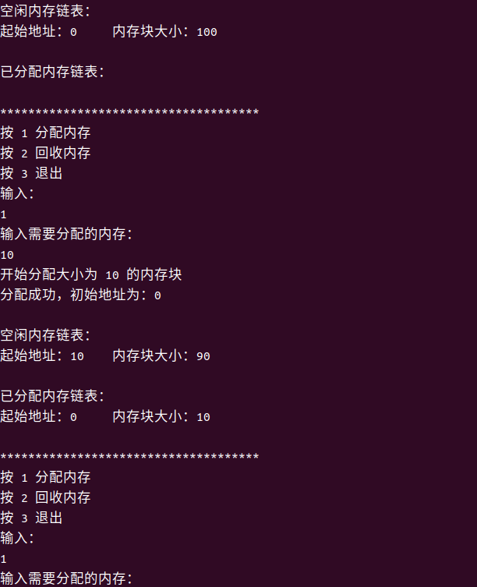

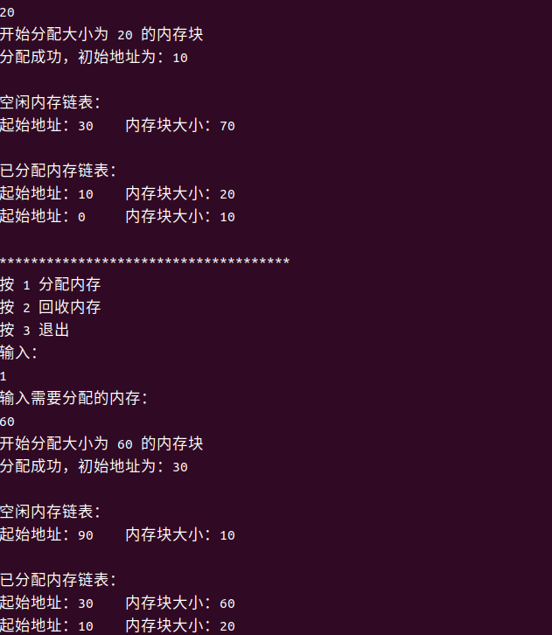
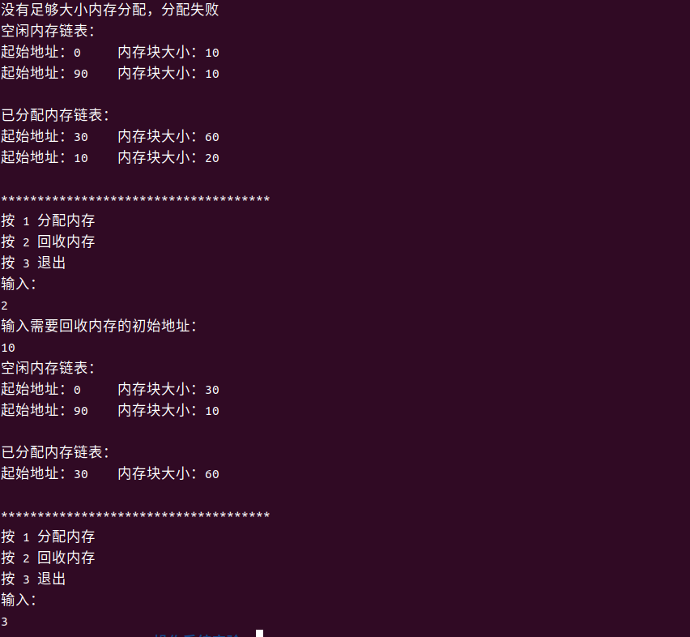
最佳适应算法：
- #include<stdio.h>
- #include<malloc.h>
- #include<stdlib.h>

- #define ALL_SIZE 100 //内存总大小
- #define MIN_SIZE 1 //最小分区大小

- //首次适应算法
- //内存分区结构体
- typedef struct MemoryBlock
- {
- int begin_address;//起始地址
- int size; //内存块大小
- struct MemoryBlock *next; //指向下一个结构体
- }MemoryBlock;
- //记录已经分配内存的内存块
- typedef struct UsedMemory
- {
- int begin_address;//起始地址
- int size;//内存块大小
- struct UsedMemory *next;
- }UsedMemory;

- //创建空闲内存链表
- void Create(MemoryBlock* &p)
- {
- p=(MemoryBlock*)malloc(sizeof(MemoryBlock));
- p->begin_address = 0;//初始地址为0
- p->size = ALL_SIZE ;
- p->next = NULL;
- }
- //创建已分配内存链表
- void Create(UsedMemory* &used)
- {
- used = (UsedMemory *)malloc(sizeof(UsedMemory));
- used->next = NULL;
- }
- //输出链表
- void My_Print(MemoryBlock *p)
- {
- printf("空闲内存链表：\n");
- while(p!=NULL)
- {
- printf("起始地址：%d\t",p->begin_address);
- printf("内存块大小：%d\n",p->size);
- p = p->next;
- }
- printf("\n");
- }
- void My_Print(UsedMemory *t)
- {
- t=t->next;
- printf("已分配内存链表：\n");
- while(t!=NULL)
- {
- printf("起始地址：%d\t",t->begin_address);
- printf("内存块大小：%d\n",t->size);
- t = t->next;
- }
- printf("\n");
- printf("*************************************\n");
- }
- void My_Print(MemoryBlock *p,UsedMemory *t)
- {
- My_Print(p);
- My_Print(t);
- }
- //链表从小到大排序算法,用冒泡排序
- void My_Sort(MemoryBlock* &p)
- {
- MemoryBlock *h = p;
- if(h == NULL)
- {
- return;
- }
- while(h != NULL)
- {
- MemoryBlock *t = p;
- while(t->next != NULL)
- {
- if(t->next->size < t->size)
- {
- int address = t->begin_address;
- int size = t->size;
- t->begin_address = t->next->begin_address;
- t->size = t->next->size;
- t->next->begin_address = address;
- t->next->size = size;
- }
- t=t->next;
- }
- h = h->next;
- }
- }
- //分配过程
- void allocate(MemoryBlock* &p,UsedMemory* &used,int size)//用大小分配
- {
- //开始分配
- printf("开始分配大小为 %d 的内存块\n",size);
- MemoryBlock *temp = p;
- MemoryBlock *pre=NULL;//记录前一个节点地址
- int i = 0;//判断内存是否分配成功
- while(temp!=NULL)
- {
- if(temp->size >= size)
- {
- i = 1;
- int address = temp->begin_address;
- //更新已分配内存链表
- UsedMemory *t = (UsedMemory *)malloc(sizeof(UsedMemory));
- t->begin_address = temp->begin_address;
- t->size = size;
- if(used->next == NULL)
- {
- used->next = t;
- t->next = NULL;
- }
- else
- {
- t->next = used->next;//头插法
- used->next = t;
- }
- //空闲内存链更新
- if(temp->size == size)
- {
- if(pre == NULL)
- {
- p=p->next;
- free(temp);
- }
- else
- {
- pre->next = temp->next;
- }
- }
- else
- {
- temp->begin_address = temp->begin_address+size;
- temp->size = temp->size - size;
- }
- //分配成功，返回初始地址
- printf("分配成功，初始地址为：%d\n\n",address);
- break;
- }
- pre = temp;
- temp = temp->next;
- }
- //没有足够大小内存分配，分配失败
- if(i == 0)
- {
- printf("没有足够大小内存分配，分配失败\n");
- }
- //排序链表
- My_Sort(p);
- }
- //回收过程
- void deallocate(MemoryBlock* &p,UsedMemory* &used,int begin_address)//用起始地址回收
- {
- //开始回收
- MemoryBlock *upmemory=NULL;//记录回收内存的上一块内存
- MemoryBlock *downmemory;//记录回收内存的下一块内存
- int up = 1;//1代表回收内存的上一块内存是空闲的，0代表已分配
- int down = 1;//1代表回收内存的下一块内存是空闲的，0代表已分配
- UsedMemory *find = used;
- int size;//内存块大小
- //查找内存块的大小,并更新已分配内存链表
- while(find !=NULL)
- {
- //没有找到该内存
- if(find->next == NULL)
- {
- printf("没有找到起始地址为 %d 的内存,查找失败\n",begin_address);
- return;
- }
- if(find->next->begin_address == begin_address)
- {
- size = find->next->size;
- //删除节点，回收内存
- UsedMemory *temp = find->next;
- find->next = find->next->next;
- free(temp);
- break;
- }
- find = find->next;
- }
- //回收内存，更新空闲内存链表
- downmemory = p;
- while(downmemory != NULL && downmemory->begin_address < begin_address)
- {
- upmemory = downmemory;
- downmemory = downmemory->next;
- }
- //这种情况代表回收内存的上一块内存不是空闲的，不需要合并
- if(upmemory == NULL || upmemory->begin_address + upmemory->size != begin_address)
- {
- up = 0;
- }
- //这种情况代表回收内存的下一块内存不是空闲的，不需要合并
- if(downmemory == NULL || downmemory->begin_address != begin_address + size)
- {
- down = 0;
- }
- //回收会遇到的四种情况
- if(up == 0 && down ==0)
- {
- MemoryBlock *mynew=(MemoryBlock *)malloc(sizeof(MemoryBlock));
- mynew->begin_address = begin_address;
- mynew->size = size;
- if(upmemory == NULL)
- {
- mynew->next = downmemory;
- p=mynew;
- }
- else
- {
- mynew->next = upmemory->next;
- upmemory->next = mynew;
- }
- }
- else if(up == 0 && down == 1)
- {
- downmemory->begin_address = begin_address;
- downmemory->size = downmemory->size + size;
- }
- else if(up == 1 && down == 0)
- {
- upmemory->size = upmemory->size + size;
- }
- else if(up == 1 && down ==1)
- {
- upmemory->size = upmemory->size + downmemory->size +size;
- upmemory->next = downmemory->next;
- free(downmemory);
- }
- //将链表排序
- My_Sort(p);
- }

- int main()
- {
- MemoryBlock *p;
- UsedMemory *used;
- Create(p);
- Create(used);
- int h = 1;//用来处理while的停止条件
- while(h)
- {
- My_Print(p,used);
- printf("按 1 分配内存\n");
- printf("按 2 回收内存\n");
- printf("按 3 退出\n");
- printf("输入：\n");
- int num;
- scanf("%d",&num);
- switch(num)
- {
- case 1:
- printf("输入需要分配的内存：\n");
- int size;
- scanf("%d",&size);
- allocate(p,used,size);
- break;
- case 2:
- printf("输入需要回收内存的初始地址：\n");
- int address;
- scanf("%d",&address);
- deallocate(p,used,address);
- break;
- case 3:
- h=0;
- break;
- default:
- printf("输入有误！\n");
- }
- }

- return 0;
- }

