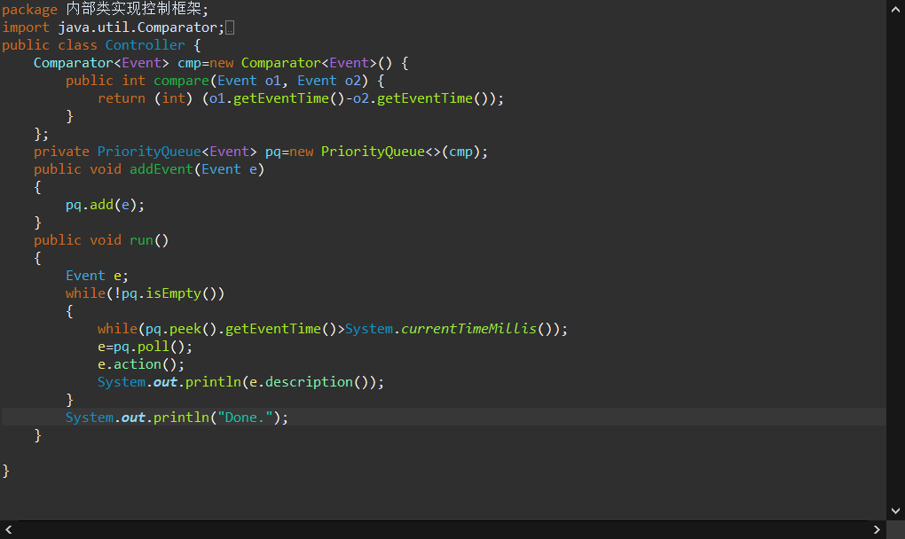

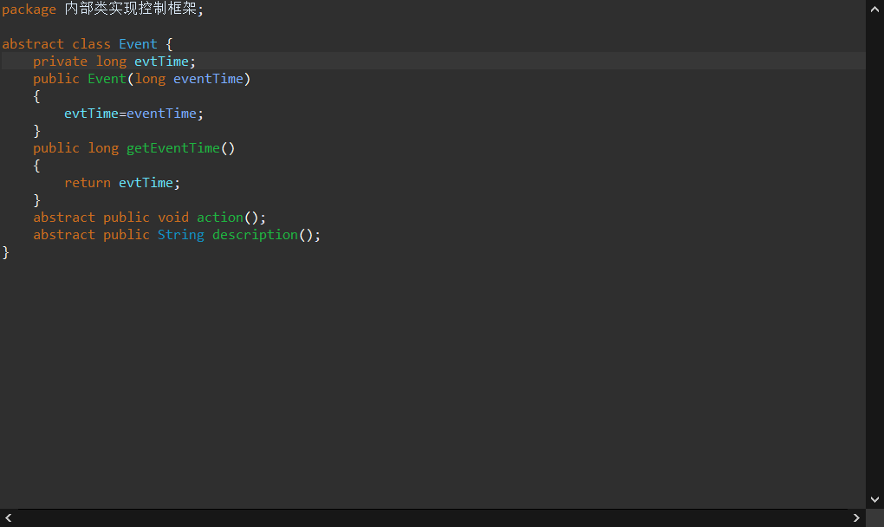

package 内部类实现控制框架;

public class HouseController extends Controller{

private boolean light=false;

private static int *a*=26;

private class SunRise extends Event{

public SunRise(long eventTime) {

super(eventTime);

}

public void action()

{

light=true;

}

public String description()

{

return "Light turned on ";

}

};

private class SunSet extends Event{

public SunSet(long eventTime) {

super(eventTime);

}

public void action()

{

light=false;

}

public String description()

{

return "Light turned off";

};

};

private class Temperature extends Event{

public Temperature(long eventTime)

{

super(eventTime);

}

public void action()

{

if(*a*<=22)

{

*a*=25;

}else

{

*a*--;

}

}

public String description()

{

if(*a*==25)

{

return "开启超级空调,温度立刻变为:"+*a*;

}

else {

return "当前的温度为:"+*a*;

}

};

}

public static void main(String[] args)

{

long day=2400;

HouseController hc=new HouseController();

long currentTime=System.*currentTimeMillis*();

int temperature=25;

for(int i=0;i<3;i++)

{

SunSet sunset=hc.new SunSet(currentTime+i\*day);

hc.addEvent(sunset);

SunRise sunRise=hc.new SunRise(currentTime+i\*day+day/2);

hc.addEvent(sunRise);

for(int k=0;k<=2400;k+=300)

{

Temperature tempreaturee=hc.new Temperature(currentTime+k+i\*day);

hc.addEvent(tempreaturee);

}

}

hc.run();

}

}