**日期排序：**

package 日期排序;

import java.util.Random;

public class getTime {

public int years=2021;

public int month;

public int day;

Random random=new Random();

getTime()

{

month=random.nextInt(11)+1;

day=random.nextInt(30)+1;

if(month==2)

{

if(day>29)

{

day=29;

}

}else if(month==4||month==6||month==9||month==11)

{

if(day>30)

{

day=30;

}

}

}

void show()

{

System.***out***.println("时间:"+years+"."+month+"."+day);

}

}

package 日期排序;

import java.util.*;

public class Time_sort {

public static void main(String[] args)

{

getTime[] my_day=new getTime[5];

for(int k=0;k<5;k++)

{

my_day[k]=new getTime();

}

Arrays.*sort*(my_day,(e1,e2)->e2.day-e1.day);

Arrays.*sort*(my_day,(e1,e2)->e2.month-e1.month);

for(int k=0;k<5;k++)

{

my_day[k].show();

}

}

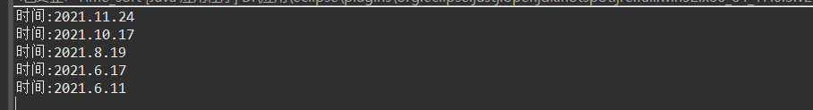

}

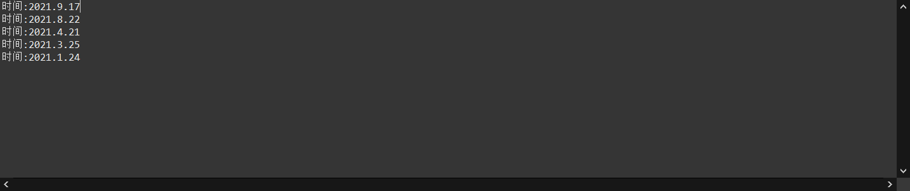

测量字符串比较的时间：

package 测量字符串比较的时间;

public class A {

public long time_1=0;

public long time_2=0;

String[] a= {"January","February","March","April","May","June",

"July","August","September","Ocrober","November","December"};

String []b;

A()

{

b=new String[a.length];

for(int i=0;i<a.length;i++)

{

b[i]=new String(a[i]);

}

}

public int f1()

{

Elapse elaspae=new Elapse();

for(int i=0;i<a.length;i++)

{

if(a[i]=="December")

{

time_1+=elaspae.getElapseTime();

elaspae=null;

return i+1;

}

}

return 0;

}

public int f2()

{

Elapse elaspae=new Elapse();

for(int i=0;i<a.length;i++)

{

if(b[i].equals("December"))

{

time_2+=elaspae.getElapseTime();

elaspae=null;

return i+1;

}

}

return 0;

}

public static void main(String args[])

{

int i=0;

A girl=new A();

girl.f1();

while(i<2*10*10*10*10*10*100)

{

girl.f1();

girl.f2();

i++;

}

System.***out***.println("用==符号所需的时间:"+girl.time_1);

System.***out***.println("用equals()所需的时间:"+girl.time_2);

}

}

package 测量字符串比较的时间;

public class Elapse {

private long Time;

Elapse(){

Time=System.*currentTimeMillis*();

}

long getElapseTime()

{

long Time_1;

Time_1=System.*currentTimeMillis*();

return Time_1-Time;

}

}

