3/25/2019

Progress Project Report

Job availability

Web Client Development

Submitted by:

Ayoub Yousef

Maitree Nareshbhai Gajjar

Manushi Pareshbhai Patel

Poojan Sureshkumar Pendal

Saiful Islam

Zun Wang

Submitted to:

Mirmohammad Saadati

**Introduction**

The main objective of the project is to design a dynamic website for searching available jobs in the market, using some trending technologies in the market with maximum functionalities, efficiency, optimal speed on web application. This report is going to represent the task of the project and which contain the creation of a **Welcome Page**.

In this page you will find the current scenarios of the jobs in market. People can search for the jobs in the different fields which is the main task and there will be another feature which is posting a job. You have to register yourself if you want to post a job after that you can login in your account and then you can post a job for the job seekers.

**Development Tools**

* Languages: HTML, CSS
* Framework and library: Bootstrap
* Text Editor: Visual Code
* Web Browser: Google chrome, Mozilla Firefox, Safari

**Features**

* Current scenarios about job availability
* Search for the jobs
* Option for the posting a job(s)
* Informative with the latest details
* User friendly GUI

**Sample page for website**

The following page is a sample page for our progress report. We will continue to work to make it perfect and add the other features.

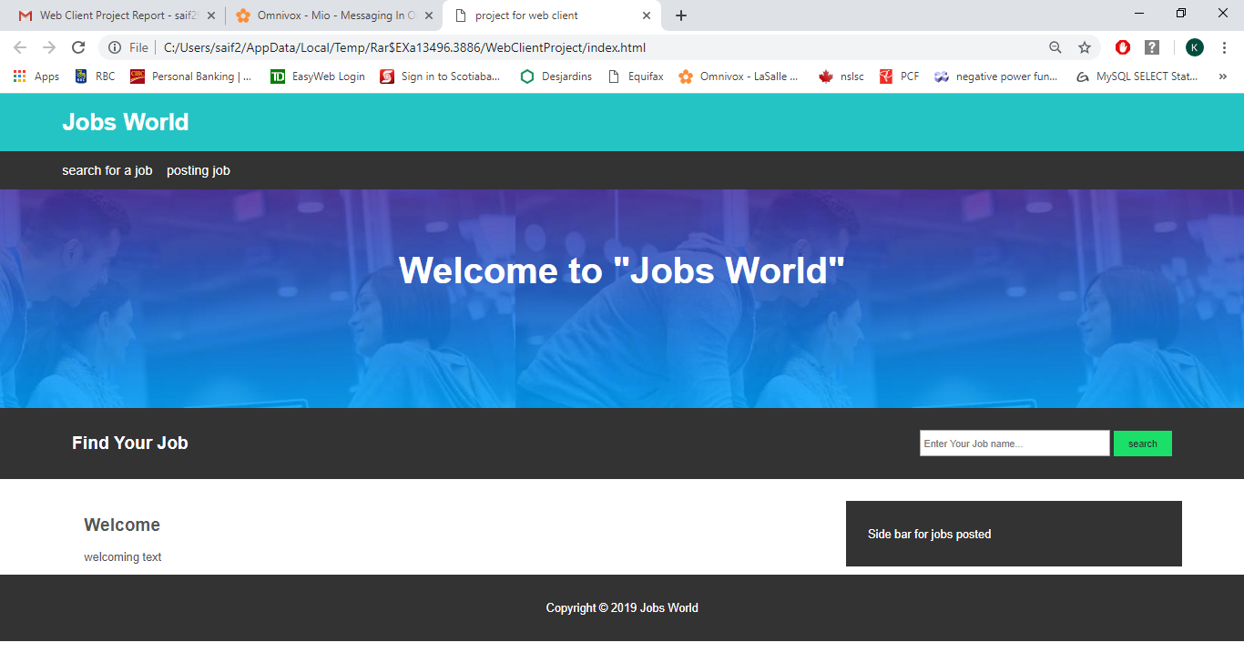

**HTML and CSS codes**

A separate zip file was added for the codes.