

Double backhand

Easier graphic operating controls for GCC .

It’s written on Devcpp 4.9.2 and can supports all versions below 5.1.1.

**Here are the available functions in the lib:**

The function supported always formed by subjects below:

Dbh**::**describe_function**(int** cx**,int** fy**,int** difnumb**,**WORD wttu**,**WORD wttd**,int** r_ox**,int** g_ox**,int** b_ox**,char** lsig**,char** rsig**,int** width**)**

►“cx” and “fy” represent to the position of the controls on the consoles;

►“difnumb” represents to the very first value of the controls;

►“wttu” and “wttd” represent to the different type of a button when it was clicked or not, and must go as “0x**”;

►“r_ox”, “g_ox” and “b_ox” represent to the color of the controls if there is a need, and the value of it must smaller than 255 while bigger than 0;

►“lsig” and “rsig” represent to the signals between the controls and not every control have one.The value of it must be UTF-8 or mistake will occurred;

►“width” represents to the width of the controls.

**And the original function is listed as follow:**

|  |  |  |
| --- | --- | --- |
| name | required value | default value |
| adjustment _button | int cx,int fy,int difnumb | WORD wttu=0xB0,WORD wttd=0x0B, int r_ox=173,int g_ox=17, int b_ox=255,char lsig='<', char rsig='>',int width=4 |
| slider_bar | int cx,int fy,int difnumb | WORD wttu=0xB0,WORD wttd=0x0B, int r_ox=145,int g_ox=215,int b_ox=37 |
| input_box | int cx,int fy,int areat | int r_ox=173,int g_ox=202,int b_ox=255 |
| color_box | int cx,int fy,int r, int g,int b |  |
| text_box | int cx,int fy, int txtin,int length |  |
| contact_button | int cx,int sx,int fy |  |
| clearp |  | HANDLE hConsole =GetStdHandle(STD_INPUT_HANDLE) |

**Questions and how to use**

**How to add it to GCC compiler linker：**

First ,as you download a zip ,there will be as follow in the package.



Second ,you should copy the subject to the certain folder.



->Dev-Cpp\MinGW64\lib

->Dev-Cpp\MinGW64\include



Last ,you should add “-lDbh” to

Tools->Compiler option->General->add the following command when calling the linker

as following picture:

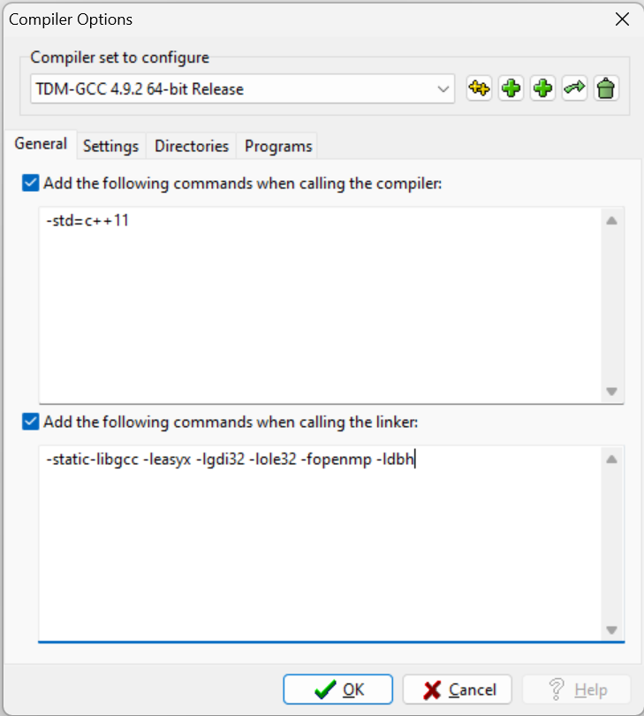

**How to use the lib when coding**

add the heading as

#include "Dbh.h"

#include<conio.h>

#include<cstdio>

#define KEY_DOWN(VK_NONAME) ((GetAsyncKeyState(VK_NONAME) & 0x8000) ? 1:0)

And use openMP to combine controls as