# 排错方法

## 架构必知

step01:理解层次关系

Atlas------依赖于------》MHA-------依赖于------》1主2从，ssh,binlog,vip,send(发邮件)

step02：依照层次顺序去排错

1）检查ssh：一般不用

2）检查1主2从：通过show slave/master status\G 查看主从状态

3）查看日志的报错

## 排错检查项目

### ssh检查

ssh 10.0.0.51 date

ssh 10.0.0.51 date

ssh 10.0.0.51 date

### 检查1主2从状态

show slave | master status\G

### MHA配置文件

[root@db03 ~]# cat /etc/mha/app1.cnf

[binlog1]

hostname=10.0.0.53

master_binlog_dir=/data/mysql/binlog

no_master=1

[server default]

manager_log=/var/log/mha/app1/manager

manager_workdir=/var/log/mha/app1

master_binlog_dir=/data/mysql/

master_ip_failover_script=/usr/local/bin/master_ip_failover

password=mha

ping_interval=2

repl_password=123

repl_user=repl

report_script=/usr/local/bin/send

ssh_user=root

user=mha

[server1]

hostname=10.0.0.51

port=3306

[server2]

hostname=10.0.0.52

port=3306

[server3]

hostname=10.0.0.53

port=3306

#### 报错列表总结

|  |  |  |
| --- | --- | --- |
| phenomenon | causes | solution |
| 日志中出现‘is not defined’ | #少一个server  [server1]  hostname=10.0.0.51  port=3306 |  |
|  |  |  |
|  |  |  |
|  |  |  |
|  |  |  |
|  |  |  |

### binlogserver配置文件

[root@db03 ~]# vi /etc/mha/app1.cnf

[binlog1]

hostname=10.0.0.53

master_binlog_dir=/data/mysql/binlog

no_master=1

### Atlas的配置文件检查

[root@db03 ~]# vim /etc/mysql-proxy/mysql-proxy.cnf

[mysql-proxy]

admin-username = user

admin-password = pwd

proxy-backend-addresses = 10.0.0.55:3306

proxy-read-only-backend-addresses = 10.0.0.52:3306,10.0.0.53:3306

pwds = root:3yb5jEku5h4=,oldboy:3yb5jEku5h4=

daemon = true

keepalive = true

event-threads = 8

log-level = message

log-path = /var/log/mysql-proxy/

sql-log=ON

proxy-address = 0.0.0.0:33060

admin-address = 0.0.0.0:2345

charset=utf8

tables = school.stu.id.3

### 错误提示信息

[root@db01 bin]# mysql

ERROR 2002 (HY000): Can't connect to local MySQL server through socket '/application/mysql-5.6.38/tmp/mysql.sock' (2)

#出现以上错误，只有两种可能性：

①/application/mysql-5.6.38/tmp/文件不存在

②/application/mysql-5.6.38/tmp/mysql.sock没有启动

### 日志检查

#### mysql log

2）错误日志==状态日志==记录mysql启动关闭、报错等事件

2.1）日志标识==[error]==错误提醒

2.2)日志上下文中==含有标识的

/application/mysaql/data/db02.err

#db02.err中的db02根据主机名命名

#### mha架构日志

#mysql

log-error=/var/log/mysql.log

#binlogserver

master_binlog_dir=/data/mysql/binlog

#MHA

manager_log=/var/log/mha/app1/manager

manager_workdir=/var/log/mha/app1

master_binlog_dir=/data/mysql/

#atlas

log-path = /var/log/mysql-proxy/

## 经典案例-MHA-atlas架构vip切换模拟

### 【环境】

1）db02:10.0.0.52主，2从：db01---10.0.0.51，db03---10.0.0.53

2)binlogserver配置

[root@db03 binlog]# cat /etc/mha/app1.cnf

[binlog1]

hostname=10.0.0.53

master_binlog_dir=/data/mysql/binlog

no_master=1

3）atlas配置

[root@db03 binlog]# cat /etc/mysql-proxy/mysql-proxy.cnf

[mysql-proxy]

admin-username = user

admin-password = pwd

proxy-backend-addresses = 10.0.0.55:3306

proxy-read-only-backend-addresses = 10.0.0.52:3306,10.0.0.53:3306

pwds = root:3yb5jEku5h4=,oldboy:3yb5jEku5h4=

daemon = true

keepalive = true

event-threads = 8

log-level = message

log-path = /var/log/mysql-proxy/

sql-log=ON

proxy-address = 0.0.0.0:33060

admin-address = 0.0.0.0:2345

charset=utf8

tables = school.stu.id.3

### 【需求】

停掉db02，db02上的vip会自动切换到db01上面

### 【配置过程】

1.db02

/etc/init.d/mysqld stop---stop slave-----change master to（cat /var/log/mha/app1/manager|grep CHANGE）---start slave;

2.db01

3.db03—manager

3.1#添加[server2]

[root@db03 binlog]# vim /etc/mha/app1.cnf

[server2]

hostname=10.0.0.52

port=3306

3.2拉取日志操作===使得主库与从库的数据能够通过binlog恢复成一致

cd /data/mysql/binlog/

mysqlbinlog -R --host=10.0.0.52 --user=mha --password=mha --raw --stop-never mysql-bin.000001 &

3.3配置mysql-proxy中的从库IP地址

[root@db03 binlog]# vim /etc/mysql-proxy/mysql-proxy.cnf

……

proxy-read-only-backend-addresses = 10.0.0.52:3306,10.0.0.53:3306

……

【出现的报错】

【现象一】

#启动MHA时会现象如下报错

[root@db03 binlog]#nohup masterha_manager --conf=/etc/mha/app1.cnf --remove_dead_master_conf --ignore_last_failover < /dev/null > /var/log/mha/app1/manager.log 2>&1 &

[root@db03 binlog]# tail -f /var/log/mha/app1/manager

……

main::main() called at /usr/bin/save_binary_logs line 66

Tue Nov 27 22:13:49 2018 - [error][/usr/share/perl5/vendor_perl/MHA/MasterMonitor.pm, ln161] Binlog setting check failed!

Tue Nov 27 22:13:49 2018 - [error][/usr/share/perl5/vendor_perl/MHA/MasterMonitor.pm, ln267] Binlog server configuration failed.

Tue Nov 27 22:13:49 2018 - [error][/usr/share/perl5/vendor_perl/MHA/MasterMonitor.pm, ln427] Error happened on checking configurations. at /usr/bin/masterha_manager line 50.

Tue Nov 27 22:13:49 2018 - [error][/usr/share/perl5/vendor_perl/MHA/MasterMonitor.pm, ln525] Error happened on monitoring servers.

【原因一】

#如果没有配置

[root@db03 binlog]# vim /etc/mha/app1.cnf

[server2]

hostname=10.0.0.52

port=3306

【现象二】

[root@db03 binlog]# cat /var/log/mha/app1/manager|grep error

Tue Nov 27 22:11:44 2018 - [error][/usr/share/perl5/vendor_perl/MHA/MasterMonitor.pm, ln525] Error happened on monitoring servers.

Failed to save binary log: Binlog not found from /data/mysql/binlog! If you got thiserror at MHA Manager, please set "master_binlog_dir=/path/to/binlog_directory_of_the_master" correctly in the MHA Manager's configuration file and try again.

【原因二】

#如果没有配置

[root@db03 binlog]# vim /etc/mha/app1.cnf

[server2]

hostname=10.0.0.52

port=3306

# mysql错误

## 使用chown，需要添加/

#如果没有添加/，就不能正常修改属主和属组

[root@db01 mysql]# chown -R mysql.mysql /application/mysql

[root@db01 mysql]# ll

total 48

drwxr-xr-x 2 root root 4096 Nov 14 12:08 bin

-rw-r--r-- 1 root root 17987 Sep 13 2017 COPYING

drwxr-xr-x 5 mysql mysql 110 Nov 14 13:52 data

drwxr-xr-x 2 root root 55 Nov 14 12:08 docs

drwxr-xr-x 3 root root 4096 Nov 14 12:08 include

drwxr-xr-x 3 root root 291 Nov 14 12:08 lib

drwxr-xr-x 4 root root 30 Nov 14 12:08 man

-rw-r--r-- 1 root root 943 Nov 14 13:52 my.cnf

drwxr-xr-x 10 root root 4096 Nov 14 12:08 mysql-test

-rw-r--r-- 1 root root 2496 Sep 13 2017 README

drwxr-xr-x 2 root root 30 Nov 14 12:08 scripts

drwxr-xr-x 28 root root 4096 Nov 14 12:08 share

drwxr-xr-x 4 root root 4096 Nov 14 12:08 sql-bench

drwxr-xr-x 2 root root 136 Nov 14 12:08 support-files

drwxr-xr-x 2 root root 6 Nov 14 13:57 tmp

#添加以后，就正常

[root@db01 mysql]# chown -R mysql.mysql /application/mysql/

[root@db01 mysql]# ll

total 48

drwxr-xr-x 2 mysql mysql 4096 Nov 14 12:08 bin

-rw-r--r-- 1 mysql mysql 17987 Sep 13 2017 COPYING

drwxr-xr-x 5 mysql mysql 110 Nov 14 13:52 data

drwxr-xr-x 2 mysql mysql 55 Nov 14 12:08 docs

drwxr-xr-x 3 mysql mysql 4096 Nov 14 12:08 include

drwxr-xr-x 3 mysql mysql 291 Nov 14 12:08 lib

drwxr-xr-x 4 mysql mysql 30 Nov 14 12:08 man

-rw-r--r-- 1 mysql mysql 943 Nov 14 13:52 my.cnf

drwxr-xr-x 10 mysql mysql 4096 Nov 14 12:08 mysql-test

-rw-r--r-- 1 mysql mysql 2496 Sep 13 2017 README

drwxr-xr-x 2 mysql mysql 30 Nov 14 12:08 scripts

drwxr-xr-x 28 mysql mysql 4096 Nov 14 12:08 share

drwxr-xr-x 4 mysql mysql 4096 Nov 14 12:08 sql-bench

drwxr-xr-x 2 mysql mysql 136 Nov 14 12:08 support-files

drwxr-xr-x 2 mysql mysql 6 Nov 14 13:57 tmp

## /etc/init.d/mysqld和/application/mysql/bin/mysqld_safe区别

前者只有stop|start|restart|status选项

后者可以添加参数

如下列的忘记密码，该怎么处理

## 未解决问题（总结-须手打）忘记密码了，如何处理

第一步：

关闭数据库/etc/init.d/mysqld stop

第二步：

取消mysql的认证模块

mysqld_safe –skip-grant-tables –skip-networking &

第三步：进入数据库，对指定的用户的密码进行更改

update

第四步：重启数据库

/etc/init.d/mysqld restart

## 安装报错“启动异常：socket file don't exists”

【现象】

[root@db02 support-files]# /etc/init.d/mysqld start

Starting MySQL.181002 16:27:35 mysqld_safe Directory '/var/lib/mysql' for UNIX socket file don't exists.

ERROR! The server quit without updating PID file (/var/lib/mysql/db02.pid).

[root@db02 support-files]# cd /application/mysql/bin/

【原因】

1）vim /application/mysql/bin/mysqld_safe

safe_mysql_unix_port=${mysql_unix_port:-${MYSQL_UNIX_PORT:-/application/mysql-5.6.38/tmp/mysql.sock}}

#将来写socket文件的时候，会往/application/mysql-5.6.38/tmp/mysql.sock路径写socket文件，cmake的参数直接对启动程序有影响，如果tmp目录不存在，就没法写入。

# Check that directory for $safe_mysql_unix_port exists

mysql_unix_port_dir=`dirname $safe_mysql_unix_port`

if [ ! -d $mysql_unix_port_dir ]

then

log_error "Directory '$mysql_unix_port_dir' for UNIX socket file don't exists."

exit 1

fi

2）cp support-files/my*.cnf /etc/my.cnf

复制的时候使用相对路径，导致出错

【解决办法】

第一步：

[root@db02 bin]# mkdir /application/mysql/tmp -p

[root@db02 bin]# /etc/init.d/mysqld start

Starting MySQL.181002 16:40:36 mysqld_safe Directory '/var/lib/mysql' for UNIX socket file don't exists.

ERROR! The server quit without updating PID file (/var/lib/mysql/db02.pid).

[root@db02 bin]#

第二步：

复制的时候

cp /server/tools/mysql-5.6.38/support-files/my*.cnf /etc/my.cnf

## mysql不能正常启动

【背景知识】

mysql启动后，会自动生成pid和mysql.sock文件，但是如果pid和mysql.sock文件已经存在，就会造成mysql启动不了的现象

【解决办法】

删除掉已经存在的pid和mysql.sock文件，然后再次启动mysql即可

## mysql启动报错实战举例

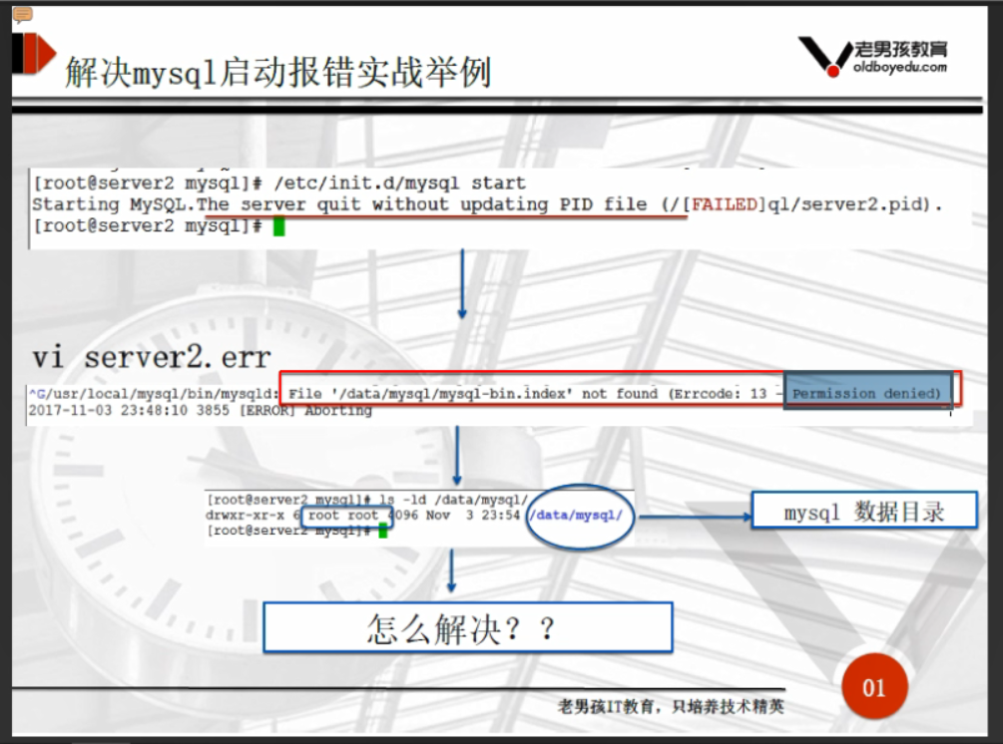

perror的作用（错误保存啊在/application/mysql/data/db02.err文件中）

[root@db02 ~]# cd /application/mysql/bin/

[root@db02 bin]# perror 1

OS error code 1: Operation not permitted

[root@db02 bin]# perror 1024

MySQL error code 1024 (ER_ERROR_ON_READ): Error reading file '%-.200s' (errno: %d - %s)

[root@db02 bin]# perror 1000

MySQL error code 1000 (ER_HASHCHK): hashchk

[root@db02 bin]#

【现象】

[root@db01 mysql]# /etc/init.d/mysqld start

Starting MySQL. ERROR! The server quit without updating PID file (/application/mysql/data/db01.pid).

【解决办法】

[root@db01 mysql]# mkdir /data/mysql

[root@db01 mysql]# chown -R mysql. /data/mysql

## 使用select语句导入course表时，报错

ymq [school]>select * from course into outfile '/tmp/course.txt';

ERROR 1290 (HY000): The MySQL server is running with the --secure-file-priv option so it cannot execute this statement

ymq [school]>

## 表空间的操作，出现ibddata带下与配置文件中.cnf大小不一致

【现象】

【日志中的错误信息】

[root@db01 scripts]# cat /var/log/mysql.log

2018-11-20 16:59:09 115600 [Note] InnoDB: Completed initialization of buffer pool

2018-11-20 16:59:09 115600 [ERROR] InnoDB: Data file ./ibdata1 is of a different size 4864 pages (rounded down to MB) than specified in the .cnf file 3200 pages!

#数据文件./ibdata1有4864页，与配置文件.cnf中定义的3206pages大小不同（PS：每一个page16KB）

2018-11-20 16:59:09 115600 [ERROR] InnoDB: Could not open or create the system tablespace. If you tried to add new data files to the system tablespace, and it failed here, you should now edit innodb_data_file_path in my.cnf back to what it was, and remove the new ibdata files InnoDB created in this failed attempt. InnoDB only wrote those files full of zeros, but did not yet use them in any way. But be careful: do not remove old data files which contain your precious data!

2018-11-20 16:59:09 115600 [ERROR] Plugin 'InnoDB' init function returned error.

2018-11-20 16:59:09 115600 [ERROR] Plugin 'InnoDB' registration as a STORAGE ENGINE failed.

2018-11-20 16:59:09 115600 [ERROR] Unknown/unsupported storage engine: InnoDB

2018-11-20 16:59:09 115600 [ERROR] Aborting

2018-11-20 16:59:09 115600 [Note] Binlog end

【解决办法】

#step01:计算出ibddata文件的大小

[root@db01 scripts]# bc

bc 1.06.95

Copyright 1991-1994, 1997, 1998, 2000, 2004, 2006 Free Software Foundation, Inc.

This is free software with ABSOLUTELY NO WARRANTY.

For details type `warranty'.

4864*16/1024

76

#step02：将/etc/my.cnf文件中的innodb_data_file_path=ibdata1:12M;ibdata2:50M:autoextend改为76M

#step03:重启mysql即可

/etc/init.d/mysqld restart