南京信息工程大学 实验（实习）报告

1. 实验目的
本实验的目的是通过请求页式存储管理中页面置换算法模拟设计，了解虚拟存储技术的特点，掌握请求页式存储管理的页面置换算法，此外通过实验了解HASH表数据结构的使用。
2. 实验准备
⑴ 数据结构HASH表查找方式。
⑵ 操作系统相关内存交换知识。
⑶ 阅读第四章。
3. 实验内容
设计一个虚拟存储区和内存工作区，并分别编程实现使用先进先出置换算法（FIFO）和最近最少使用页面置换算法（LRU）计算访问命中率。
程序代码：
#include <stdio.h>
#include <stdlib.h>
#include <stdbool.h>
#include <time.h>

#define VIRTUAL_MEMORY_SIZE 32
#define PHYSICAL_MEMORY_SIZE 8
#define ACCESS_SEQUENCE_LENGTH 1000
#define TEST_RUNS 10 // 测试运行次数

typedef struct {
int page_id;
int last_used;
bool valid;
} Page;

typedef struct {
Page pages[PHYSICAL_MEMORY_SIZE];
int page_count;
int clock;
} Memory;

typedef struct {
double fifo_hit_rate;
double lru_hit_rate;
double performance_gap;
} TestResult;

void init_memory(Memory *mem) {
mem->page_count = 0;
mem->clock = 0;
for (int i = 0; i < PHYSICAL_MEMORY_SIZE; i++) {
mem->pages[i].valid = false;
mem->pages[i].page_id = -1;
mem->pages[i].last_used = -1;
}
}

bool is_page_in_memory(const Memory *mem, int page_id) {
for (int i = 0; i < PHYSICAL_MEMORY_SIZE; i++) {
if (mem->pages[i].valid && mem->pages[i].page_id == page_id) {
return true;
}
}
return false;
}

double fifo_page_replacement(int access_sequence[], int sequence_length) {
Memory mem;
init_memory(&mem);
int hits = 0;
int fifo_pointer = 0;

for (int i = 0; i < sequence_length; i++) {
int current_page = access_sequence[i];

if (is_page_in_memory(&mem, current_page)) {
hits++;
} else {
if (mem.page_count < PHYSICAL_MEMORY_SIZE) {
for (int j = 0; j < PHYSICAL_MEMORY_SIZE; j++) {
if (!mem.pages[j].valid) {
mem.pages[j].page_id = current_page;
mem.pages[j].valid = true;
mem.pages[j].last_used = mem.clock;
mem.page_count++;
break;
}
}
} else {
mem.pages[fifo_pointer].page_id = current_page;
mem.pages[fifo_pointer].last_used = mem.clock;
fifo_pointer = (fifo_pointer + 1) % PHYSICAL_MEMORY_SIZE;
}
}
mem.clock++;
}

return (double)hits / sequence_length * 100;
}

double lru_page_replacement(int access_sequence[], int sequence_length) {
Memory mem;
init_memory(&mem);
int hits = 0;

for (int i = 0; i < sequence_length; i++) {
int current_page = access_sequence[i];
if (is_page_in_memory(&mem, current_page)) {
hits++;
for (int j = 0; j < PHYSICAL_MEMORY_SIZE; j++) {
if (mem.pages[j].valid && mem.pages[j].page_id == current_page) {
mem.pages[j].last_used = mem.clock;
break;
}
}
} else {
if (mem.page_count < PHYSICAL_MEMORY_SIZE) {
for (int j = 0; j < PHYSICAL_MEMORY_SIZE; j++) {
if (!mem.pages[j].valid) {
mem.pages[j].page_id = current_page;
mem.pages[j].valid = true;
mem.pages[j].last_used = mem.clock;
mem.page_count++;
break;
}
}
} else {
int lru_index = 0;
int min_time = mem.pages[0].last_used;

for (int j = 1; j < PHYSICAL_MEMORY_SIZE; j++) {
if (mem.pages[j].last_used < min_time) {
min_time = mem.pages[j].last_used;
lru_index = j;
}
}

mem.pages[lru_index].page_id = current_page;
mem.pages[lru_index].last_used = mem.clock;
}
}
mem.clock++;
}
return (double)hits / sequence_length *100;
}

void generate_locality_sequence(int sequence[], int length) {
int base = rand() % VIRTUAL_MEMORY_SIZE;
for (int i = 0; i < length; i++) {
// 85%的概率访问附近页面，15%的概率随机访问
if (rand() % 100 < 85) {
sequence[i] = (base + rand() % 7 - 3 + VIRTUAL_MEMORY_SIZE) % VIRTUAL_MEMORY_SIZE;
} else {
sequence[i] = rand() % VIRTUAL_MEMORY_SIZE;
base = sequence[i];
}
}
}

void run_comparison_tests(TestResult results[]) {
int access_sequence[ACCESS_SEQUENCE_LENGTH];

for (int run = 0; run < TEST_RUNS; run++) {
generate_locality_sequence(access_sequence, ACCESS_SEQUENCE_LENGTH);

double fifo_hit_rate = fifo_page_replacement(access_sequence, ACCESS_SEQUENCE_LENGTH);
double lru_hit_rate = lru_page_replacement(access_sequence, ACCESS_SEQUENCE_LENGTH);
results[run].fifo_hit_rate = fifo_hit_rate;
results[run].lru_hit_rate = lru_hit_rate;
results[run].performance_gap = lru_hit_rate - fifo_hit_rate;
printf("测试 %2d: FIFO=%.2f%%, LRU=%.2f%%, 差距=%.2f%%\n",
run+1, fifo_hit_rate, lru_hit_rate, results[run].performance_gap);
}
}

void calculate_statistics(TestResult results[], double *avg_fifo, double *avg_lru, double *avg_gap, double *max_gap, double *min_gap) {
*avg_fifo = 0;
*avg_lru = 0;
*avg_gap = 0;
*max_gap = results[0].performance_gap;
*min_gap = results[0].performance_gap;

for (int i = 0; i < TEST_RUNS; i++) {
*avg_fifo += results[i].fifo_hit_rate;
*avg_lru += results[i].lru_hit_rate;
*avg_gap += results[i].performance_gap;

if (results[i].performance_gap > *max_gap) {
*max_gap = results[i].performance_gap;
}
if (results[i].performance_gap < *min_gap) {
*min_gap = results[i].performance_gap;
}
}

*avg_fifo /= TEST_RUNS;
*avg_lru /= TEST_RUNS;
*avg_gap /= TEST_RUNS;
}

int main() {
srand(time(NULL));

printf("========================================\n");
printf(" 页面置换算法多轮性能对比测试\n");
printf("========================================\n");
printf("虚拟存储区大小: %d 页\n", VIRTUAL_MEMORY_SIZE);
printf("物理内存大小: %d 页\n", PHYSICAL_MEMORY_SIZE);
printf("访问序列长度: %d\n", ACCESS_SEQUENCE_LENGTH);
printf("测试轮次: %d\n", TEST_RUNS);
printf("序列类型: 具有强局部性的访问序列\n");
printf("========================================\n\n");
TestResult results[TEST_RUNS];

printf("开始进行%d轮测试...\n\n", TEST_RUNS);
run_comparison_tests(results);

double avg_fifo, avg_lru, avg_gap, max_gap, min_gap;
calculate_statistics(results, &avg_fifo, &avg_lru, &avg_gap, &max_gap, &min_gap);

printf("\n========================================\n");
printf(" 统计结果汇总\n");
printf("========================================\n");
printf("平均FIFO命中率: %.2f%%\n", avg_fifo);
printf("平均LRU命中率: %.2f%%\n", avg_lru);
printf("平均性能差距: %.2f%%\n", avg_gap);
printf("最大性能差距: %.2f%%\n", max_gap);
printf("最小性能差距: %.2f%%\n", min_gap);
printf("LRU相对性能提升: %.2f%%\n", (avg_lru - avg_fifo) / avg_fifo * 100);

// 计算LRU胜出的次数
int lru_wins = 0;
for (int i = 0; i < TEST_RUNS; i++) {
if (results[i].lru_hit_rate > results[i].fifo_hit_rate) {
lru_wins++;
}
}
printf("LRU胜出轮次: %d/%d\n", lru_wins, TEST_RUNS);
printf("========================================\n");

return 0;
}

实验结果：
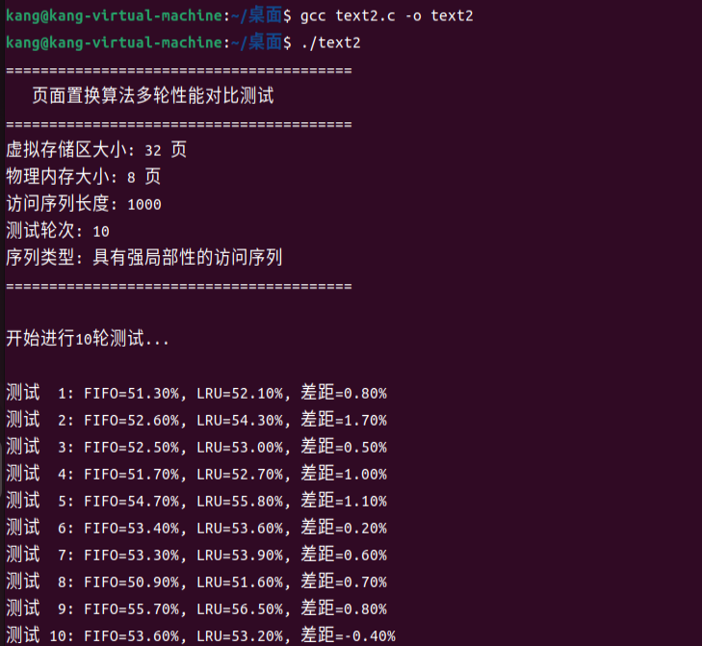
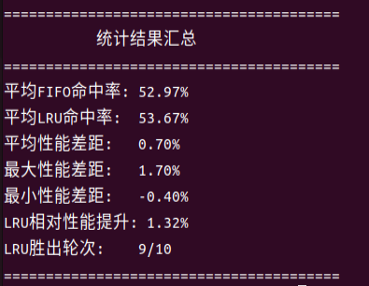

实验结果分析：
通过多轮对比实验结果可以看出，当访问序列具有较强局部性、且系统内存配置相对充足（8页物理内存、32页虚拟存储）时，虽然 LRU 算法在 10 次测试中有 9 次表现优于 FIFO，但总体性能差距十分有限——平均命中率仅高出 0.70%，相对性能提升仅为 1.32%。
这一结果表明，页面置换算法的性能高度依赖具体应用场景：在内存资源充裕、访问模式简单的情况下，LRU 通过记录最近使用历史所带来的优势被显著削弱，而 FIFO 的简单队列策略仍能保持近似性能。
此外，实验中两者的性能波动范围较窄（-0.40%～1.70%），进一步说明在此类条件下复杂算法相较简单算法的边际收益极低。因此，在实际系统设计中，如果资源分配充足且访问规律较为稳定，采用实现简单、开销较低的 FIFO 算法可能更具性价比；而在追求极致性能的场景下，才需权衡 LRU 算法带来的微小性能提升与其实现复杂度之间的取舍。

