5.2.1 登录界面

图9 主界面

5.2.2 登陆界面

登陆界面使用我们自己设计的登陆界面并且通过连接数据库实现用户登陆。

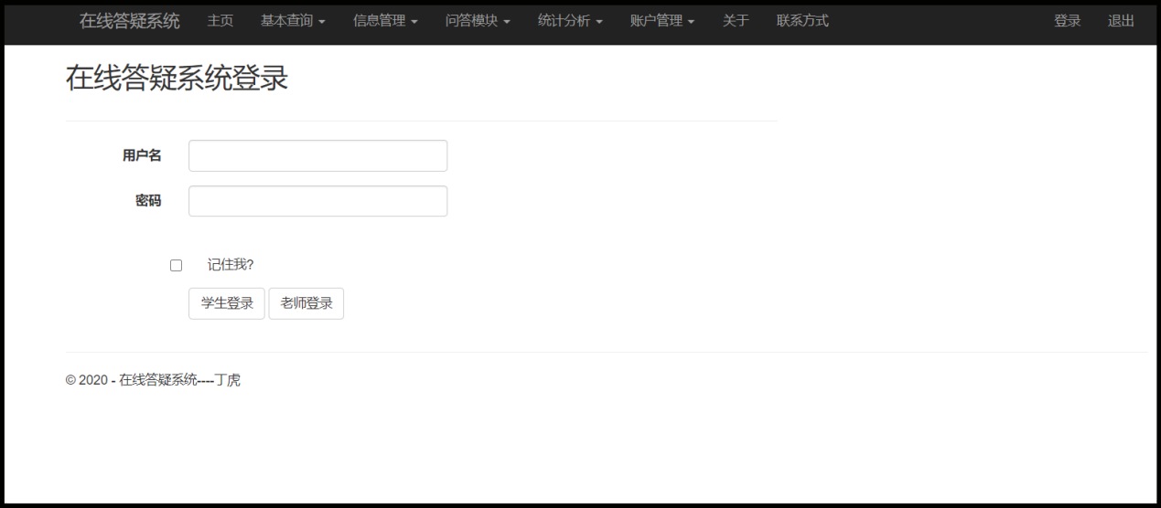

图10 登陆界面

登陆功能实现

|  |
| --- |
| protected void LogIn(object sender, EventArgs e)  {  //Data Source = localhost; Initial Catalog = 在线答疑系统; Integrated Security = True  string connStr = "Data Source=localhost;Initial Catalog=在线答疑系统;Integrated Security=True";  string sql = "Select * from student where name='" + this.UserName.Text.Trim() + "' and password='" + this.Password.Text.Trim() + "'";  SqlConnection con = new SqlConnection(connStr);  con.Open();  SqlCommand cmd = new SqlCommand(sql,con);  SqlDataReader sdr = cmd.ExecuteReader();  sdr.Read();  if (sdr.HasRows)  {  con.Close();  Response.Write("<script language='javascript'>alert('登录成功！');window.location.href='../Default.aspx';</script>");  }  else  {  con.Close();  Response.Write("<script language='javascript'>alert('用户名或密码错误！');window.location.href='Login.aspx';</script>");  }  }  protected void TeacherLogIn(object sender, EventArgs e)  {  //Data Source = localhost; Initial Catalog = 在线答疑系统; Integrated Security = True  string connStr = "Data Source=localhost;Initial Catalog=在线答疑系统;Integrated Security=True";  string sql = "Select * from teacher where name='" + this.UserName.Text.Trim() + "' and password='" + this.Password.Text.Trim() + "'";  SqlConnection con = new SqlConnection(connStr);  con.Open();  SqlCommand cmd = new SqlCommand(sql, con);  SqlDataReader sdr = cmd.ExecuteReader();  sdr.Read();  if (sdr.HasRows)  {  con.Close();  //Response.Redirect("~/Default.aspx");  Response.Write("<script language='javascript'>alert('登录成功！');window.location.href='../Default.aspx';</script>");  }  else  {  con.Close();  Response.Write("<script language='javascript'>alert('用户名或密码错误！');window.location.href='Login.aspx';</script>");  }  } |

5.2.3 查询界面

一定要有多表查询（视图）功能……

5.2.7 问答界面

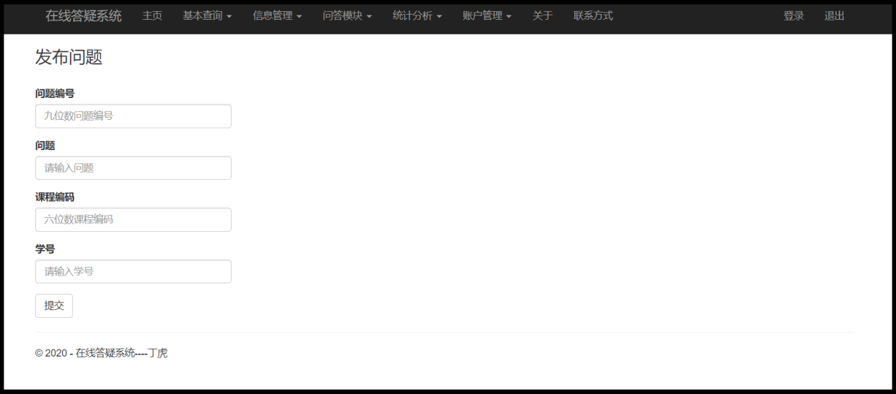

图25 发布问题

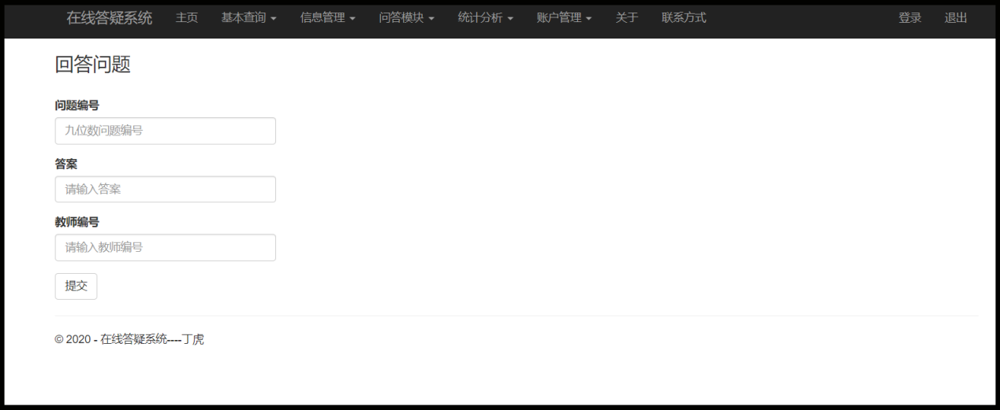

图26 回答问题

部分功能代码

|  |
| --- |
| public partial class PostQuestion : System.Web.UI.Page  {  protected void Page_Load(object sender, EventArgs e)  {  }  protected void postQuestion(object sender, EventArgs e)  {  string connStr = "Data Source=localhost;Initial Catalog=在线答疑系统;Integrated Security=True";  string date = DateTime.Now.ToString("yyyy-MM-dd HH:mm:ss");  string sql = "insert into question (questionCode,question,postTime,courseCode,studentCode) values('" + this.questionCode.Text.Trim() + "','" + this.question.Text.Trim() + "','"  + date + "','" + this.courseCode.Text.Trim() +"','" + this.studentCode.Text.Trim() + "')";  SqlConnection conn = new SqlConnection(connStr);  conn.Open();  SqlCommand cmd = new SqlCommand(sql, conn);  cmd.ExecuteNonQuery();  conn.Close(); //关闭数据库连接  Response.Write("<script language='javascript'>alert('发布问题成功！');window.location.href='../User/PostQuestion.aspx';</script>");  }  } |