Career Exhibition Report

武洲印、软国1805、201894156

**1.Introduction**

Fortunately I was able to attend a career development course at the school. This course provided a detailed overview of the information services industry, international trends, specific jobs, types of professions and related tests. I learned a lot from that. There is also enlightenment. The following is my enlightenment.

Keywords: job hunting concept, job hunting status, study abroad plan, job hunting direction.

**2. Concept of job hunting**

First of all, career planning should give you a thorough understanding of what you are good at and what you are not good at, then set your clear vocational goals and achieve your vocational goals through your efforts and actions. I think that's what you do. I think that everyone's career goals change over time. Different ages have different requirements for us. There is a different perspective on things. So a career plan is a process. As we all know, job hunting is not a smooth sailing and we are always faced with many setbacks and challenges. For us, being fully aware of yourself in the future and maintaining a good psychological state will be of great help to the successful development of your career. Master self-regulation to maintain a healthy psychological state.

First, understand the psychology of the character, identify yourself clearly, and find the right position. For me, I like to interact and collaborate with others, and to guide everyone. So I'm not good at science research work.

While choosing a profession next, some college students do not always appreciate themselves and want to engage in basic, regular work. Before we get a job, we set a desired bottom line, and it is just idealization, dependence, and blindness, and we expect "a job once in a lifetime". Some college students do not find jobs, not because they can't find the ideal job in a subjective setting. University graduates' idea of employment should follow the changes in the actual social environment.College students are constantly self-adjusting, studying methods and techniques of self-adjustment, improving their personality and psychological state, actively choosing their profession with optimistic psychological state based on their efforts, seeing life Find your position on the broad talent market.

**3. Employment status**

In the market environment, traditional industries such as banking and manufacturing are declining. Industries such as the Internet and finance are booming. The concept of "Internet+" was first proposed in November 2012. China's Internet industry is developing rapidly. As of December 31, 2017, the China Internet Information Center (CNNIC) published the 41st "China Internet Development Statistics Report". As of December 2017, the number of Internet users in China reached 7.77 million. 40.74 million new users registered to use the Internet throughout the year. The Internet penetration rate was 55.8%, an increase of 2.6% from the end of 2016. As of December 2017, the number of mobile phone users in China reached 753 million, an increase of 57.34 million from the end of 2016. 2018 is the 24th year of Internet access in China. From the first meeting with the Chinese to integrating into all aspects of our lives, the Internet has really changed our way of life. As an emerging industry other than the traditional industry, the Internet industry has attracted people's attention and has a huge demand for talents. According to domestic authoritative statistics, China's total demand for computer talents will reach 15-20 million in the next five years.

By innovating each field for the time being and the future, science and technology in the related fields have already penetrated and revolutionized each industry. The main speakers also present some problems that present students have, and at the very important 1 o'clock (point), many people lack independent thinking, selection and long acting power. For us Chinese students, we may be lacking in independent thinking ability. We should be more careful in developing this capacity in our learning lives.

The information service industry becomes more and more important for the development of the country. The international labor market has become globalized due to the shortage of advanced IT engineers. Recipients of services like Japan require a large amount of IT human resources. I have an international information and software academy platform, I was able to study Japanese and broaden my international perspective.

As shown in the figure below, the prospect of finding a job in software is bright. However, this means that competition is fierce, and only those with top technology will have the most talent. So we can learn more, increase the depth of knowledge, and this can also be an advantage in choosing a job.

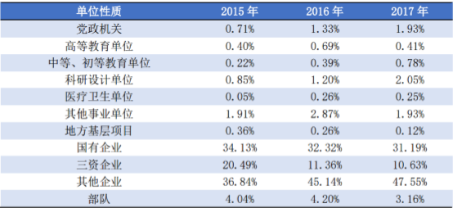

**Fig.1** The nature of employment of undergraduate graduates in the past three years

As shown in Fig. 1, about 20% of the graduates who entered the university in the last three years entered the university or research institute. And 70% of other institutions, nine students and graduate students, enter various types of companies.

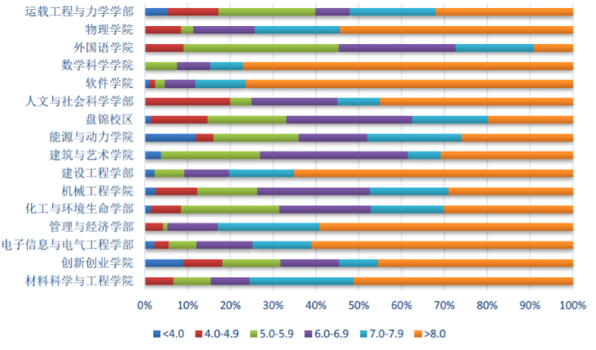

**Fig.2** Annual salary distribution of undergraduates who signed employment agreement in 2017

As shown in Fig. 2, in the 2017 full-caliber questionnaire survey for university students, bachelors signed employment contracts.

The annual salary of students is as shown in the figure, and the average annual salary is 71,000 yuan.

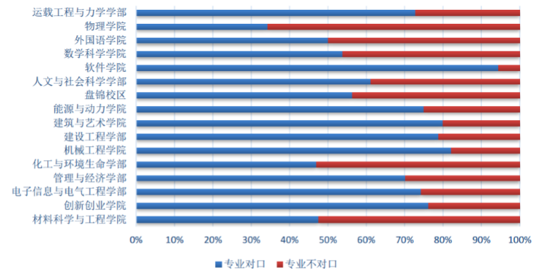

**Fig.3** Professional counterparts in 2017

In a 2017 full-calibre survey for college students, 72.41% of students signed a employment contract. Specialties are matched, and 27.57% do not match.

At the present stage of our country, almost every one of the hundreds of colleges and universities in the country has a computer department, especially a software major. Thousands of professional and college graduates flood the talent market every year. Although the Internet is a popular profession, under this situation, ordinary and junior staff are obviously in oversupply.

But high-end computer talents are hard to find. As a professional with strong technicality and relatively high requirements for personal qualities, it is the most important economic information system and control system for enterprises and institutions. More and more companies are beginning to have new expectations and requirements for their employees. These conditions make the job market increasingly competitive. Faced with this situation, as contemporary college students, they should plan their own future and make reasonable plans.

In addition, the demand for international professionals is gradually heating up. According to statistics from relevant departments, as of now, China still lacks 90,000 international computer professionals who are in line with the international market. The huge gap in professional talents means that we are facing the need to broaden our international horizons and response capabilities, and move towards internationalization and specialization. New challenges. College students can also develop in this area.

**4. Study Abroad Plan**

Chinese students already account for 31.5% of international students in the United States. A rough explanation of working in North America is very enviable to the highly paid treatment of the US Internet industry. For me, who has a plan to study abroad, I should make a proper vocational plan. You cannot study abroad just to study abroad. In other words, plan your future altitude and define your new study abroad goals.

One important point is the preparation for study abroad. First, the language proof needs to be cleared. This is mandatory. If you want to apply for a good school, you need experience in related projects. This is something I have to be careful of while studying. I want to participate in many projects like this.

**5. Direction of employment**

Above, please prepare the manuscript according to this template. In terms of uncertainties, according to JiLun data, 37% of all people see the future of the Internet. This is an amazing number. Where is the internet? There are engineers on the front end of the web. Similarly, the outlook for the front end of the web is also expected. Second, the salary treatment for WEB front-end engineers is skyrocketing, and as one of the core engineers in the Internet industry, salary treatment is naturally low. Recruitment of Baidu According to authoritative data in the first half of 2017, the average wages of WEB front-end engineers in the front-line cities have already exceeded 10,000 yuan, and the second-line cities have already reached 7,000 yuan. Unfortunately, many well-known companies were unable to find talent. The salary treatment of WEB front-end engineers is, of course, inflated as the number of working years increases.

Product managers need to consider many factors, such as target user characteristics, competitive products, and how the product fits the company's business model. Generally, a product manager manages one or more tangible products. However, product managers are also used by people who manage intangible products such as music, information and services. The role of a product manager in the tangible product industry is similar to that of a project director in the service industry.

What are the advantages of going to graduate school? Acquire specialized knowledge. The first advantage of going on to graduate school is

Means "to acquire specialized knowledge". After all, when I go on to graduate school, I specialized in a specialized field when I was a university student.

I will study and research in more detail. It's natural for that knowledge to be acquired. Human resources specialized in one specialized field

Should be useful after coming out to society. In addition, employment options will surely increase. If you go to graduate school,

One of the advantages is that there are surely more choices when you get a job after work. graduate School

Depending on your field, you may be able to get ready immediately if you start employment after graduating from. This is one of the advantages of going on to graduate school

I can say that. Starting salary is higher than college graduates. Other important factors for working and working

There will be a difference in the "salary" that comes up. The Ministry of Health, Labor and Welfare announced the 2016 Basic Survey on Wage Structure

According to the result (starting salary)” , the starting salary for university graduates is as follows. 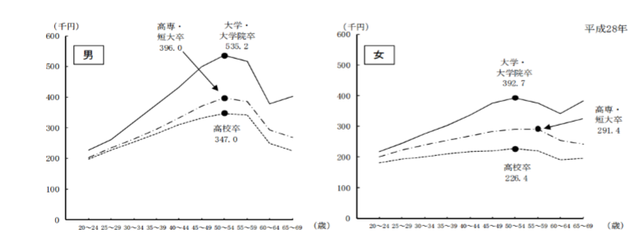

**Fig.4** Wages seen by educational background

**6. Make a career plan**

I learned a lot.First, consider the ideal job for you, five years from now, not now. Where and what do you want to do?How much do you want to earn? For example, what would it be if you posted the job on a job change site.

Second, try moving the hands of the clock forward for 4 to 5 years. I have the ideal job. The curriculum vitae at that time is. What is the content like? What did you do in the meantime to get that ideal job?

Third, try to evaluate your strengths and weaknesses while considering your ideal job. Get the job which skills do you need to hone? How can I get a job? What kind of need training and hands-on experience? Input from others is required here.

**7.Self-assessment**

I am currently in my sophomore year. My personality is generally outgoing, but sometimes I am quiet and introverted. I like to watch movies and listen to music in my spare time. I also read books online. I prefer Chinese history. I like to use my poor language to analyze the events in history, and occasionally publish some articles. My opinions are sometimes extreme. Usually get along with people friendly, but because of his straight personality, often because of his straightforwardness, he inadvertently angers his friends, resulting in not too many close friends. My advantage is that I can form my own opinion on the problem, and after theoretically proving that it is correct, I will continue to go on, stick to my opinion, and never follow the trend. Fortunately, I'm not a stubborn person. I will sincerely apologize and accept the teaching modestly after discovering that I do have some deviations in understanding and theoretical errors in this area. My shortcoming is the lack of enterprising spirit. I often put "satisfaction of the contented person" in my mouth, so the enthusiasm is poor, which leads to the failure to achieve the results that I should be good at. Poor verbal communication makes me often passive in communicating with people; I am not very active, and not participating in activities with high enthusiasm can broaden my interpersonal communication circle such as evening parties and competitions. There are some emotional concerns, and you can't chase your dreams freely like other students. On the way to choose a career in the future, I am the only child in the family. What I need to worry about is that my father and mother are far away from home. I cannot leave them. At the same time, it limits the direction and location of your job search to a certain extent.

**8. Summary**

Through this course, I now understand that career planning is important for future employment. So plan your career early and articulate your goals. In the teacher's class, he actively guided his thoughts on himself and gave many examples. We have become more aware of vocational development. I think that a vocational development plan requires not only our efforts but also diligence. But we should stand higher, look far, start from our angle, take action, and paint our future a great deal. As I was writing, my future plan became clearer than before. I thought about myself seriously through this plan. This made it clearer what I wanted. What can I do to achieve this goal. I thanked the teacher for his enthusiasm for employment development and gave me the opportunity to ponder my future and clarify my goals.

**Reference:**

[1] Dalian University of Technology 2017 University Employment Quality Report , 5-6,9-10 ,2017

[2] Summary of the results of the 2016 Basic Survey on Wage Structure

[3] Eric Schmidt Jonathan Rosenberg Alan Eagle Larry Page: How Google works. Nihon Keizai Shimbun Publisher, Number of Pages Unknown, 2014