OLIST BUSINESS DISCOVERY
HVIA Data & AI Solutions Internship — Task 01
Prepared by Wassim Elshamy

Purpose
Understand Olist, analyze the public e-commerce dataset, identify business frictions, and propose a practical HVIA solution.

1. Executive Summary
- Olist is a Brazilian retail technology company that helps sellers operate online through a connected ecosystem of marketplaces, e-commerce tools, logistics, payments, and business services.
- The dataset contains 99,441 orders from 2016-09-04 to 2018-10-17; 96,478 orders were delivered.
- The strongest business pattern found is the connection between delivery performance and customer satisfaction.
- Late delivered orders had an average review score of 2.57, compared with 4.29 for on-time/early delivered orders.
- The proposed HVIA opportunity is a Logistics & Customer Satisfaction Intelligence Dashboard that connects delivery timing, seller performance, geography, categories, freight burden, and reviews.

Key finding
Orders delivered late average a 2.57 review score, versus 4.29 for on-time or early orders — a 1.72-point gap on a 5-point scale.

2. Company Understanding
Olist operates as a retail technology ecosystem for sellers. The core business idea is to help small and medium sellers sell online and manage operations without needing to build all systems by themselves.
From a business discovery perspective, the key Olist stakeholders are sellers, customers, logistics partners, marketplaces, and internal operations teams. Seller success depends on marketplace access, smooth order management, reliable delivery, payment processing, and customer satisfaction.
This makes the dataset useful because it includes orders, customers, sellers, products, payments, freight, delivery timestamps, and reviews. These areas are directly connected to seller growth and customer experience.

3. Dataset Understanding
A key technical lesson in this dataset is row level. Not every table represents the same thing. Some tables are one row per order, while others can have multiple rows per order. This affects how tables should be joined.
Table | One row represents | Important keys
orders | One order with status and timeline | order_id, customer_id
customers | Customer record linked to an order | customer_id, customer_unique_id
order_items | One item inside an order | order_id, product_id, seller_id
products | One product and its category/details | product_id
sellers | One seller and seller location | seller_id
payments | One payment record for an order | order_id
reviews | One review record for an order | order_id
category_translation | Portuguese category to English category | product_category_name

Important join warning
order_items and payments can contain multiple rows per order. Joining them directly to orders can duplicate payment or freight values. To avoid this, item, payment, and review data were aggregated to order level before joining.

4. Technical Method
Step | What was done | Why it matters
1 | Loaded all CSV files using pandas | Created a reproducible workflow
2 | Checked row counts and unique IDs | Identified row level and repeated IDs
3 | Converted timestamp columns to datetime | Allowed delivery and delay calculations
4 | Merged product categories and seller locations onto item rows | Enabled category and seller analysis
5 | Aggregated item/payment/review tables to order level | Avoided duplicated metrics
6 | Built one order-level analysis table | Made business metrics reliable
7 | Calculated delivery days, delay days, late flag, freight ratio | Created business-ready metrics

5. Business Overview
Total orders | 99,441 | Delivered orders | 96,478
Canceled orders | 625 | Unavailable orders | 609
Total payment value | 16,008,872.12 | Average payment value | 160.99
Unique customers | 96,096 | Unique sellers | 3,095
Average review score | 4.09 | Avg. delivery days (delivered) | 12.56
Late delivery rate (delivered) | 8.11% | Repeat customer rate | 3.12%
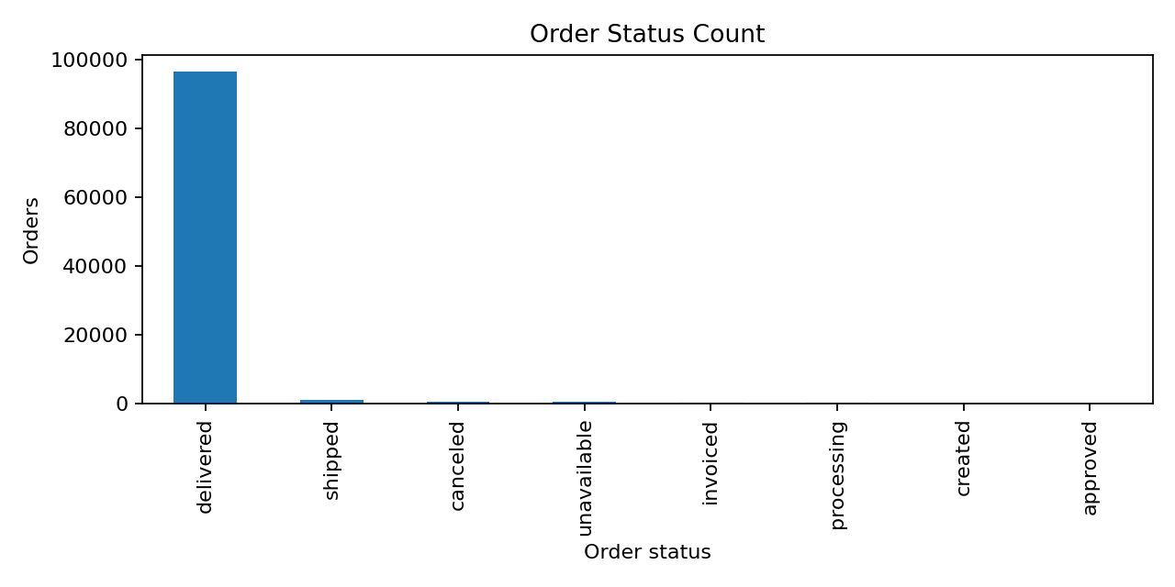
Figure 1. Order status distribution across all 99,441 orders in the dataset.
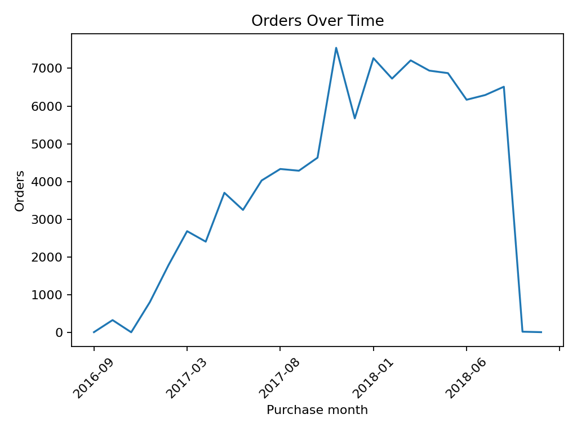
Figure 2. Monthly order volume from September 2016 to October 2018.

6. Location and Category Patterns

Customer location concentration
Order demand is highly concentrated in a few Brazilian states. SP is the largest customer state by order volume, followed by RJ and MG. This matters because operational improvements in high-volume states may affect a large share of orders.
Customer state | Orders
SP | 41,746
RJ | 12,852
MG | 11,635
RS | 5,466
PR | 5,045
SC | 3,637
BA | 3,380
DF | 2,140
ES | 2,033
GO | 2,020
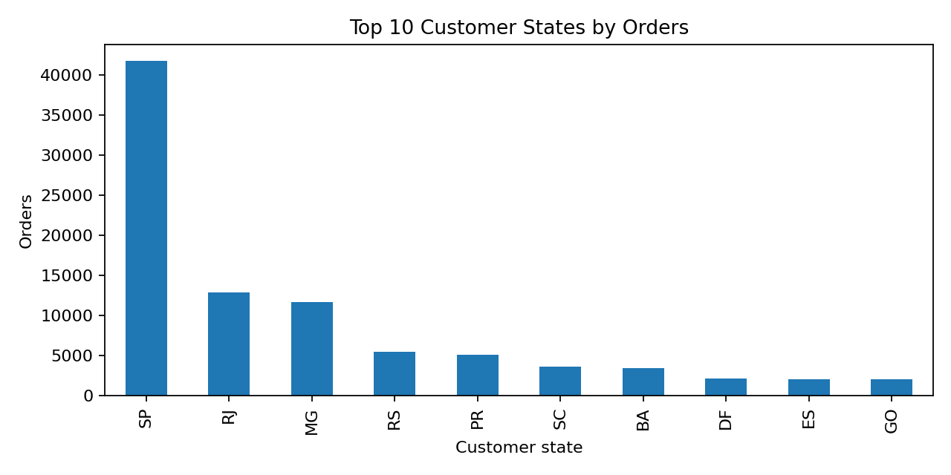
Figure 3. The ten customer states with the highest order volume.

Category performance
Category analysis shows which product areas drive item revenue. This is useful because operational issues may not affect every category equally; some categories may have higher freight burden or stronger revenue importance.
Category | Unique orders | Item revenue | Freight ratio
health_beauty | 8,836 | 1,258,681.34 | 0.15
watches_gifts | 5,624 | 1,205,005.68 | 0.08
bed_bath_table | 9,417 | 1,036,988.68 | 0.20
sports_leisure | 7,720 | 988,048.97 | 0.17
computers_accessories | 6,689 | 911,954.32 | 0.16
furniture_decor | 6,449 | 729,762.49 | 0.24
cool_stuff | 3,632 | 635,290.85 | 0.13
housewares | 5,884 | 632,248.66 | 0.23
auto | 3,897 | 592,720.11 | 0.16
garden_tools | 3,518 | 485,256.46 | 0.20
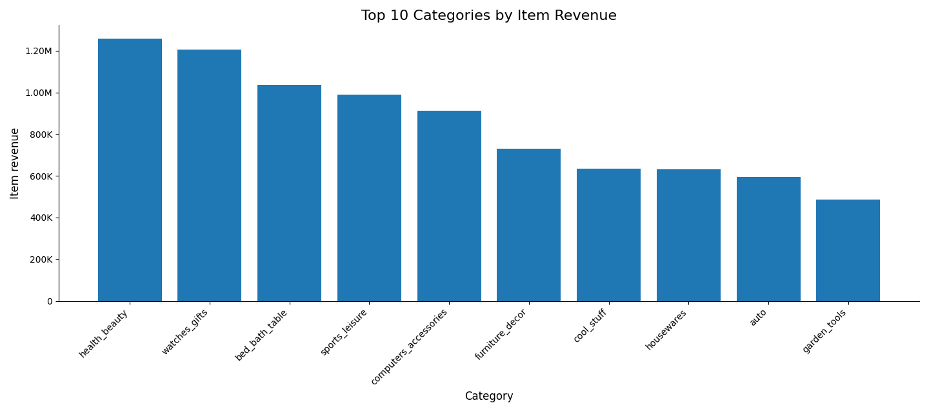
Figure 4. The ten product categories generating the highest item revenue.

7. Main Finding: Delivery Performance and Reviews
The strongest finding is that late delivered orders have much lower review scores than on-time or early delivered orders. This does not prove delivery delay is the only cause of bad reviews, but it is a strong operational signal worth monitoring.
Delivery status | Orders | Avg review score | Avg delivery days | Avg delay days
Late | 7,826 | 2.57 | 31.52 | 9.55
On time / early | 88,652 | 4.29 | 10.88 | -13.01
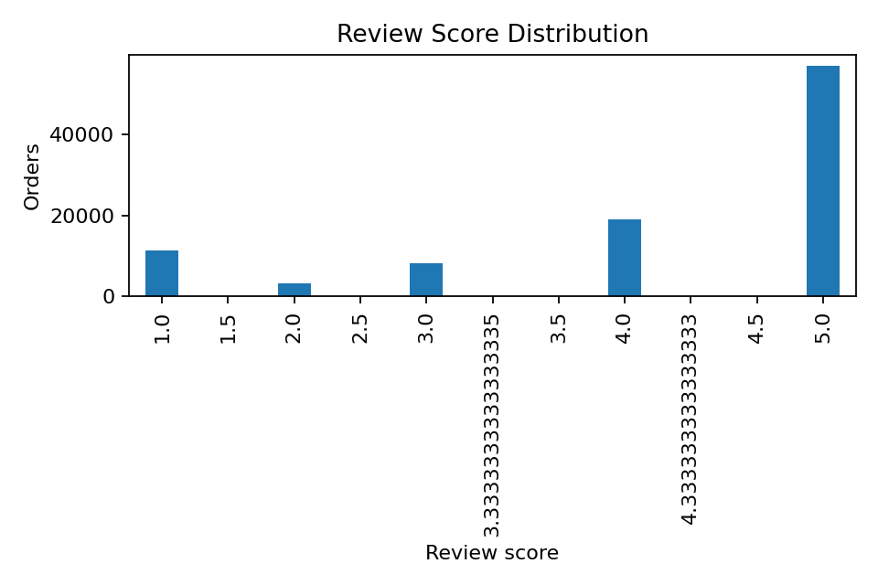
Figure 5. Distribution of review scores across delivered orders.
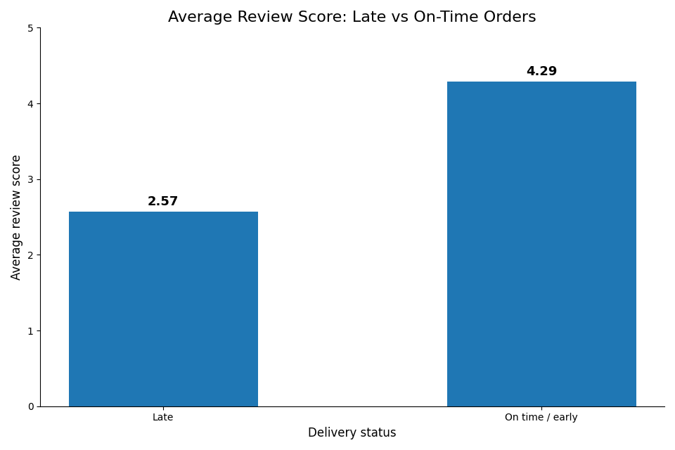
Figure 6. Average review score for late versus on-time/early deliveries.

Late delivery by state
Late delivery rates also vary by customer state. This suggests a possible logistics intelligence use case: identify states, sellers, or routes where delivery risk is higher and customer satisfaction may be affected.
State | Orders | Avg delivery days | Late rate % | Avg review
AL | 397 | 24.54 | 23.93 | 3.85
MA | 717 | 21.57 | 19.67 | 3.83
PI | 476 | 19.46 | 15.97 | 3.99
CE | 1,279 | 21.27 | 15.32 | 3.94
SE | 335 | 21.52 | 15.22 | 3.91
BA | 3,256 | 19.34 | 14.04 | 3.93
RJ | 12,350 | 15.31 | 13.47 | 3.97
TO | 274 | 17.66 | 12.77 | 4.15
PA | 946 | 23.77 | 12.37 | 3.91
ES | 1,995 | 15.79 | 12.23 | 4.08
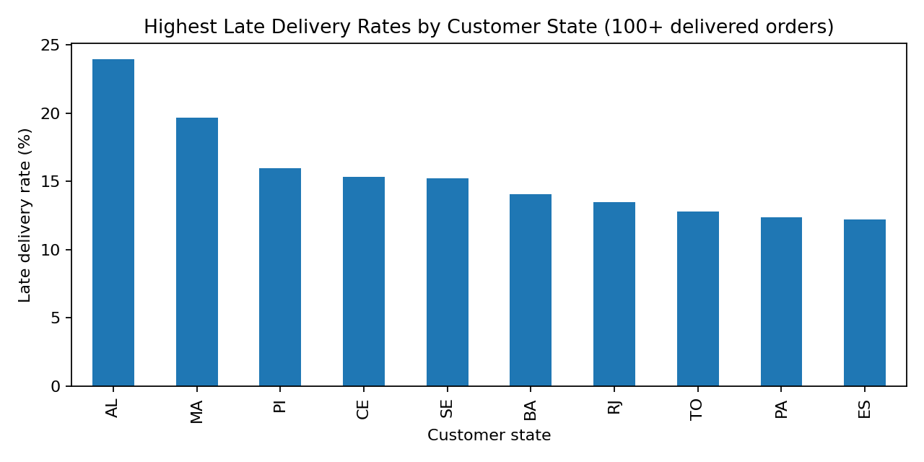
Figure 7. Customer states with the highest late-delivery rates (100+ delivered orders).

8. Freight Burden
Freight burden was measured as freight value divided by item revenue. This is not a full profitability metric because internal cost/margin data is missing, but it is useful as a friction signal. High freight ratio categories may need closer logistics or pricing review.
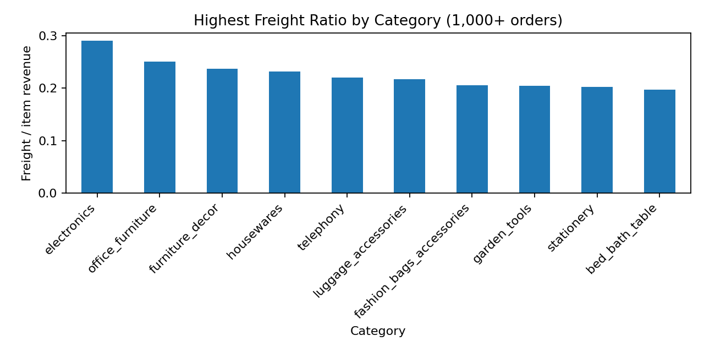
Figure 8. Product categories with the highest freight-to-revenue ratio (1,000+ orders).

9. Business Story
Olist is a seller-focused retail technology ecosystem, so its business depends on reliable operations across sellers, orders, logistics, payments, and customer experience. The analysis suggests that delivery performance is a major customer-experience signal. Late deliveries are associated with much lower review scores, and delivery risk varies by geography and possibly by seller/category combinations.
This creates a practical business opportunity: instead of only looking at past orders, Olist could monitor operational risk earlier. HVIA could help by building analytics that connect delivery timing, reviews, seller performance, category data, freight burden, and location patterns into one decision system.

10. Proposed HVIA Solution

Logistics & Customer Satisfaction Intelligence Dashboard
The proposed solution is a dashboard and analytics layer that helps Olist monitor operational risk and customer satisfaction. It would start as descriptive analytics and could later become predictive.
- Track late delivery rate by state, seller, category, and month.
- Compare review scores for late vs on-time orders.
- Identify sellers or categories with high order volume but weak satisfaction signals.
- Monitor freight ratio by category and location as a friction indicator.
- Flag risky seller/category/location combinations for deeper review.
- Give management a weekly view of operational bottlenecks and customer experience risks.

11. Outreach Message Draft
Hi Olist team,
I reviewed the public Olist e-commerce dataset and noticed a clear opportunity around delivery performance and customer satisfaction. By connecting order timelines, seller data, freight information, and review scores, it is possible to identify where late deliveries and operational issues may be affecting customer experience.
HVIA could help build a logistics and customer satisfaction intelligence dashboard that monitors delivery risk, seller performance, category-level issues, and review trends in one place. This could help Olist detect problems earlier and support sellers more effectively.
Would you be open to a short discovery call to explore this idea?

12. Limitations
- The dataset is public and historical, covering 2016-2018, so it may not represent Olist today.
- The analysis shows relationships, not guaranteed causation.
- Internal business data such as margin, operating cost, support tickets, and current strategy is not available.
- Seller and route analysis could be deeper with current logistics partner data and real internal order events.
- A production solution would need current data, stakeholder interviews, and business validation.

