Chapter 2: Cardiology
Acute Rheumatic Fever and Rheumatic Heart Disease 3
Definition 3
Risk factors 3
Prevention/promotion 4
Signs and symptoms 5
Investigations 6
Differential diagnosis 6
Management 6
Myocarditis 8
Definition 8
Risk factors/causes 8
Prevention/promotion 8
Signs/symptoms 8
Investigations 8
Management 8
Follow up 9
Dilated Cardiomyopathy 10
Definition 10
Risk factors/causes 10
Prevention/promotion 10
Investigations 10
Management 10
Pulmonary Hypertension 12
Definition 12
Risk factors/causes 12
Prevention/promotion 12
Signs and symptoms 12
Investigations 13
Management 13
Congenital heart diseases 14
Definition 14
Risk factors/causes 14
Prevention/promotion 14
Signs and symptoms 14
Investigations 14
Management 17
Follow up 17
Hypercyanotic spell in tetralogy of fallot 18
Definition 18
Risk factors for spells 18
Prevention/promotion 18
Signs and symptoms (clinical features) 18
Management 19
Follow up 19
Congestive heart failure 21
Definition 21
Risk factors/causes 21
Prevention/promotion 21
Signs and symptoms 21
Investigations 21
Differential diagnosis 22
Management 22
Follow up 24
Paediatric arrhythmias 25
Atrioventricular blocks 25
Definition 25
Criteria for bradycardia 25
Risk factors/causes 27
Prevention/promotion 27
Signs and symptoms 27
Investigations 27
Differential diagnosis 27
Management 28
Primary level 28
See the secondary-level guidance below 28
Secondary level 28
Supraventricular tachycardia 29
Definition 29
Causes/risk factors 29
Signs and symptoms/clinical features 29
Management 29
Chest pain 31
Causes/risk factors (non-cardiac causes): 31
Causes/risk factors (cardiac causes): 31
Health promotion 32
Investigations 32
Differential diagnosis 32
Management 32
Syncope 34
Definition 34
Causes/risk factors 34
Investigations 34
Differential diagnosis 35
Management 35
References 36

Acute Rheumatic Fever and Rheumatic Heart Disease

Definition
Acute Rheumatic Fever (ARF) is an inflammatory disease of childhood resulting from Streptococcus pyogenes (group A streptococcus) pharyngeal or skin infections. Rheumatic Heart Disease (RHD) results from recurrent attacks of acute rheumatic fever causing scarring of mitral and aortic valves. It commonly presents with congestive cardiac failure (CCF) and mitral regurgitation. It commonly occurs between the ages of 5 to 18 years, with a female predominance.

Risk factors
- Over crowding
- Low social economic status
- Genetic predisposition

Prevention/promotion
- Four weekly intramuscular benzathine penicillin prophylaxis up to 21 years of age in mild cases of rheumatic heart disease and lifelong in moderate to severe cases
- Oral penicillin VK or macrolides in people with elevated risk of adverse reactions i.e.
Severe aortic insufficiency,
Severe mitral stenosis,
Severe aortic stenosis,
Ventricular dysfunction (EF <50%), or
Severe symptoms (NYHA class III or IV))
- Health education & advocacy
- Screening (as health system permits)

Signs and symptoms
Acute Rheumatic Fever* | Rheumatic Heart Disease
- Fever  - Carditis (presence of a murmur)  - Arthritis or arthralgia (joint pain/swelling)  - Skin rash  - Nodules  - Chorea (abnormal movement) | - Clinical features of cardiac failure  - Respiratory distress  - Tachypnoea  - Hepatomegaly
*Also see Modified Jones Criteria below

Diagnosis of Acute Rheumatic Fever

Modified 2015 Jones criteria for High-Risk population

Major Criteria
- Carditis (clinical or subclinical)
- Arthritis (Monoarthritis or Polyarthritis or polyarthralgia)
- Sydenham’s chorea
- Erythema marginatum
- Subcutaneous nodules
Minor Criteria
- Monoarthralgia
- Fever (≥ 38.0◦C)
- ESR ≥ 30mm/h or CRP ≥3.0mg/dl
- Prolonged PR interval (after taking into account the differences related to age, if there is no carditis as a major criterion)
Making a Diagnosis
- Initial episode of ARF: Evidence of preceding group A β-haemolytic streptococcal infection + 2 major criteria or 1 major and 2 minor criteria
- Recurrent attack of ARF (Past ARF or known RHD): 2 major criteria or 1 major and 2 minor criteria or 3 minor criteria

In the Malawi setting, it is reasonable to make a diagnosis of ARF without evidence of preceding group A strep infection or supporting lab criteria given the lack of access to lab tests.

Investigations
- Acute Rheumatic fever
  - C-reactive protein (CRP)
  - Erythrocyte sedimentation rate (ESR)
  - Antistreptolysin O Titre (ASOT)
  - Throat swab
  - Cardiac echo
  - Electrocardiogram (ECG)
- Rheumatic Heart Disease
  - Electrocardiogram (ECG)
  - Cardiac echo

Differential diagnosis
- Juvenile idiopathic arthritis
- Septic arthritis
- Post streptococcal reactive arthritis
- Malaria

Management
Primary level
- Give a stat dose of I.M. benzathine penicillin, stabilize and refer to secondary level

Secondary level
- Anti-streptococcal therapy
  - STAT dose IM benzathine Penicillin (600,000 IU IM< 25kg; 1,200,000 IU IM > 25kg) then 4-weekly
- Ibuprofen 10 mg/kg TDS for 7 days (until joint pains resolve)
- Chorea
  - Severe/ distressing chorea: Haloperidol 0.02mg/kg once daily (Max 1mg) or sodium valproate 5mg/kg twice daily (Max 600mg/day). Mild cases of chorea do not require specific treatment.
  - Steroids e.g. prednisone can be added in severe/distressing chorea (prednisone 2mg/ kg daily for 2 weeks then taper over 1 to 2 weeks)
- If signs of heart failure, give Furosemide1 mg/kg BD

Duration of prophylaxis
21 years of age in mild cases of rheumatic heart diseases and lifelong in moderate to severe cases.
Note: All patients should be referred to a tertiary facility

Tertiary level
- Treat as above
- Referral for cardiology review

Follow up
- Regular follow up for benzathine penicillin prophylaxis and management of cardiac failure in PEN-Plus Clinic

Myocarditis

Definition
Inflammation of myocardium causing poor contractility of heart muscle.

Risk factors/causes
- Idiopathic
- Viruses e.g. Adenovirus, Coxsackie
- Bacterial infections
- Fungal infections

Prevention/promotion
- Health education

Signs/symptoms
- Signs of heart failure
- A low-grade fever
- Other features of a viral infection, e.g. rhinorrhoea
- Regurgitant murmurs (e.g. pansystolic murmur of mitral regurgitation)
- Myocarditis in children presents with unexplained shortness of breath

Investigations
- Chest X-Ray
- Echocardiogram
- Electrocardiogram
- HIV test
- Viral screening
- Blood culture

Management
Primary level
- Stabilise the patient and refer

Secondary level
- Stabilise the patient
- Treat as heart failure if symptoms present
- Start antibiotics, if any signs of bacterial infection
- Refer to tertiary level

Tertiary level
- Stabilise the patient
- Treat as heart failure if symptoms present.
- Start antibiotics, if any signs of bacterial infection
- Cardiology review

Follow up
- Medication
- Growth
- Review symptoms

Dilated Cardiomyopathy

Definition
Dilated cardiomyopathy (DCMO) is defined as left ventricular dilation with systolic dysfunction

Risk factors/causes
- Idiopathic
- Drugs e.g. Doxorubicin, HAART
- Infections e.g. HIV and other viruses
- Malnutrition
- Hypertension
- Genetic causes

Prevention/promotion
- Health education
- Signs and symptoms
- Signs of heart failure
- Regurgitant murmurs (e.g. pansystolic murmur of mitral regurgitation)

Investigations
- Chest X-Ray
- Echocardiogram
- Electrocardiogram
- HIV test

Management
Primary level
- Stabilize the patient and refer

Secondary level
- Stabilize the patient
- Treat as heart failure if symptoms present. See section on heart failure
- Refer to tertiary level

Tertiary level
- Stabilize the patient
- Treat as heart failure if symptoms present. See section on heart failure
- Cardiology review

Follow up
- Medication
- Growth
- Review of symptoms

Pulmonary Hypertension

Definition
Pulmonary hypertension (PH) is a disease characterized by elevated pulmonary arterial pressure, which can result in right ventricular (RV) failure

Risk factors/causes
The NICE (2013) Updated Classification of Pulmonary Hypertension

- Pulmonary Arterial Hypertension (PAH)
  - Idiopathic PAH
  - Heritable PAH
  - Drug and toxin induced
  - Associated with connective tissue disease, HIV infection, congenital heart diseases, schistosomiasis
- PH due to left heart disease
  - Left ventricular systolic dysfunction
  - Left ventricular diastolic dysfunction
  - Valvular disease
3. Chronic thromboembolic PH
- PH with unclear multifactorial mechanisms
  - Haematological disorders e.g. chronic haemolytic anaemia
  - Metabolic disorders e.g. thyroid diseases
  - Systemic diseases and Others e.g. chronic renal failure

Prevention/promotion
- Appropriate management of treatable diseases
- Surgical management of congenital heart diseases in children
- Health awareness and advocacy

Signs and symptoms
The presentation of PH varies considerably based upon the following; age of the patient, presence and absence of associated medical conditions, and severity of PH and right ventricular function. Signs and Symptoms include:
- Difficulty feeding or shortness of breath on activity
- Fatigue
- Syncope
- Cyanosis
- Failure to thrive
- Cough
- Chest Pains
- Signs of heart Failure
- Right ventricular dilatation/dysfunction: Loud P2, left parasternal heave, systolic/ diastolic murmurs, hepatomegaly

Investigations
Investigations are aimed at identifying the underlying cause and include:
- Echocardiogram: Most helpful in the initial assessment and follow-up of PH
- Chest X-ray
- ECG

Management
Primary level
- Stabilize patient
- Refer to secondary/tertiary facility for pulmonologist and/or Cardiologist review

Secondary level
- Stabilize the patient
- Bedrest: avoid strenuous exercise
- Supplemental oxygen
- If presents with signs of heart failure, manage appropriately (see section
- on Heart failure Management)
- Treat underlying cause of pulmonary hypertension if possible
- Refer to tertiary facility for pulmonology and/or cardiology review

Tertiary level
- Manage as above
- Pulmonologist and/or Cardiologist review
- Treat underlying cause of pulmonary hypertension if possible
- Vasodilators e.g. Sildenafil can be considered with pulmonology and/or cardiology
- consultation
- Involve palliative care

Follow up
- Regular pulmonology and/or cardiology review

Congenital heart diseases

Definition
Congenital heart diseases (CHD) encompass a spectrum of structural abnormalities of the heart or intrathoracic vessels.

Risk factors/causes
- Majority of the cases occur sporadically
- Exposure to teratogenic drugs (e.g. warfarin, sodium valproate)
- Maternal illness: diabetes mellitus and rubella
- Advanced maternal age
- Family history
- Genetic syndromes

Prevention/promotion
- Avoid drugs that predispose to development of heart defects during pregnancy
- Antenatal screening
- Health education
- Increased awareness of common presentations of congenital heart disease

Signs and symptoms
- Sweating and/or difficulties breast feeding
- Respiratory distress
- Wheeze/crepitations
- Poor weight gain
- Squatting
- Recurrent chest infections
- Cyanosis
- Effort intolerance, e.g. during play.
- Finger clubbing
- Chest deformity
- Differential saturations (SpO₂ lower limbs < upper limbs)
- Oedema
- Weak or unequal pulses
- Heart murmur
- Hepatomegaly

Investigations
- Full blood count
- Chest X-ray
- Electrocardiogram
- Echocardiography

Algorithm for New-born screening
Newborn screening
Congenital Heart Defects (CHD) are the most common and severe types of congenital anomalies. Pulse oximetry is an effective and reliable tool for screening and early detection of cyanotic congenital cardiac defects with a sensitivity of 75-83% and specificity of 99%. Pulse oximetry may not detect severe acyanotic lesions in the new-born period. Cardiac auscultation may detect these lesions if a murmur is present.

Algorithm for new-born screening
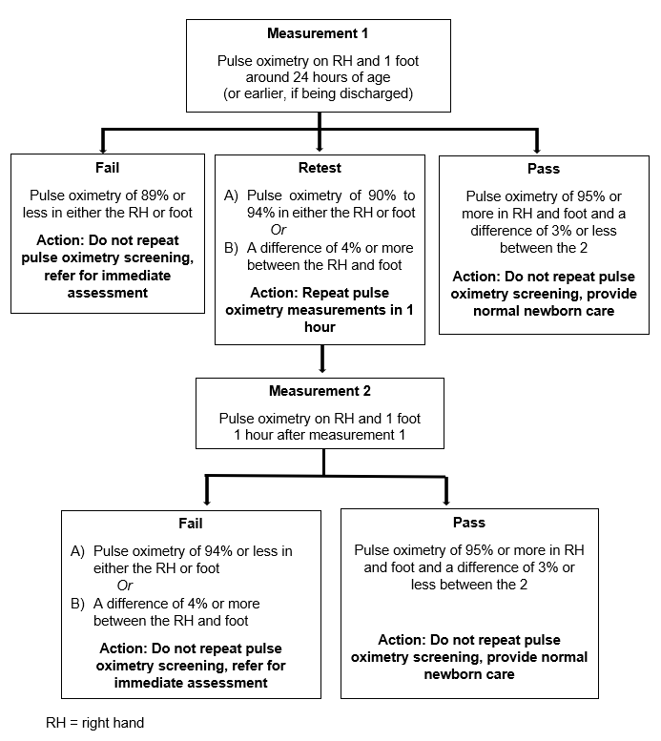

A failed pulse oximetry screen should be referred to a secondary/tertiary level facility for further evaluation. Presence of a murmur on auscultation should prompt referral to secondary/tertiary level facility for further evaluation.

Management
Primary level
- Stabilize using ABCDE
- Refer to secondary level

Secondary level
- Stabilize using ABCDE
- Treat heart failure if present (see section on heart failure)
  - Furosemide 1-2 mg/kg/dose IV BD (use oral furosemide if IV not available)
and
  - Spironolactone 1-2 mg/kg/dose PO BD (maximum 25mg/dose)
- Virtual consultation and refer to tertiary centre

Tertiary level
- Stabilize using ABCDE
- Can use CPAP if severely distressed/hypoxic
- Treat heart failure if present (see section on heart failure)
  - Furosemide 1-2 mg/kg/dose IV BD (use oral furosemide if IV not available)
and
  - Spironolactone 1-2 mg/kg/dose PO BD (maximum 25mg/dose)
- Nutritionist/Dietician review
- Cardiologist review and possible corrective surgery referral
- Palliative care team when necessary

Follow up
- Once diagnosis is confirmed, the child must be followed up in a PEN-Plus clinic regularly
- Ensure child has adequate stock of medications for home use at each visit
- Monitor growth and development
- Ongoing counselling and education

Hypercyanotic spell in tetralogy of fallot

Definition
Sudden severe episodes of intense cyanosis caused by reduction of pulmonary flow in patients with underlying Tetralogy of Fallot or other cyanotic heart lesions.

Risk factors for spells
- Hypovolaemia, e.g. diarrhoea and vomiting
- Febrile illness
- Pain/agitation
- Anaemia
- Crying, feeding, defaecation
- Cold weather

Prevention/promotion
- Educate parent/guardian on home measures when child is in spell (knee chest position)
- Early health seeking behaviour if acutely unwell
- Avoid unfavourable conditions (pain, cold, agitation, dehydration)
  - Adherence to prescribed medications

Signs and symptoms (clinical features)
- Severe hypoxia/cyanosis
- Hyperpnoea
- Syncope
- Seizure
- Stroke
- Reduced intensity or absence of systolic murmur during spell

Management
Primary level
- Keep the child with the parent/guardian and place in a knee chest position
- Place the baby on the mother’s shoulder with the knees tucked up underneath.
  - This provides a calming effect, reduces systemic venous return and increases systemic vascular resistance
- Stabilize with ABCDE approach
- Place on oxygen (preferably 100% oxygen)
- Give bolus RL or NS 20 ml/kg rapid IV over 30 minutes to increase preload. Can repeat another bolus if not improving (max 2 boluses)
- Consult and refer to secondary level

Secondary level
- As above
- Give PO morphine 0.1mg/kg to reduce distress and hyperpnoea.
- Propranolol 0.5 - 1mg/kg/dose PO TDS
- Consult and refer to tertiary level

Tertiary level
- Put on knee chest position
- Place on oxygen (preferably 100% oxygen)
- Give bolus RL or NS 20 ml/kg rapid IV over 30 minutes to increase preload. Can repeat another bolus if not improving (max 3 boluses)
- Give PO/IV morphine 0.1 mg/kg to reduce distress and hyperpnoea
- Do arterial blood gas. If there is severe metabolic acidosis:
  - Give IV sodium bicarbonate 1 mEq/kg STAT to correct
- In resistant cases consider PICU admission for IV Phenylephrine / IV Ketamine in
- consultation with cardiologist
- Long Term medical management
  - Propranolol 0.5 - 1 mg/kg/dose PO TDS
  - Aspirin 3-5 mg/kg PO daily
  - Ferrous Sulphate and Folic Acid (Fefol) supplement according to weight
- Cardiology and dietician/nutritionist review

Refer for surgical repair if appropriate

Follow up
- Once diagnosis is confirmed, the child must be followed up in a PEN-Plus clinic regularly
- Ensure child has adequate stock of medications for home use at each visit
- Monitor growth and development
- Ongoing counselling and education

Congestive heart failure

Definition
Congestive heart failure (CHF) is a clinical condition in which the heart is unable to pump enough blood to the body to meet its needs, to dispose of systemic or pulmonary venous return adequately, or a combination of the two.

Risk factors/causes
- Cardiac causes
  - Congenital heart diseases
  - Acquired heart diseases
  - Arrhythmias
- Non-cardiac causes:
  - Anaemia
  - Sepsis
  - Chronic kidney disease
  - Auto-immune

Prevention/promotion
- Health education on early health seeking behaviour
- Early referral of patients with suspected heart disease with or without heart failure.
- Early detection and treatment of anaemia
CARDIOLOGY

Signs and symptoms
- In infants, tachycardia, tachypnoea and hepatomegaly are the most common signs
- Respiratory distress
- Cardiomegaly (displaced apex beat)
- Exertional dyspnoea/sweating during breastfeeding in infants
- Presence of bibasal crepitations
- Signs of shock; reduced pulse volume, delayed capillary refill time, tachycardia, hypotension
- Gallop rhythm
- Raised JVP (older child)
- Peripheral/sacral oedema (oedema will be in dependant area)
- Failure to thrive/severe malnutrition

Investigations
- Imaging
  - Chest x-ray
  - Echocardiogram
  - ECG
- Blood tests
  - HIV test
  - Full blood count
  - Urea and electrolytes
  - Liver function tests
- Urine dipstick
- Other investigations according to suspected aetiology

Differential diagnosis
- Pneumonia
- Bronchiolitis
- Asthma
- Nephrotic/nephritic syndrome
- Renal failure
- Chronic liver failure

Management
Primary level
- Stabilize using ABCDE
  - If available give a single dose of Frusemide 1mg/kg IV stat (use oral furosemide if IV not available)
- Refer to secondary level

Secondary level
- Stabilize using ABCDE
- Treat heart failure if present (see section on heart failure)
  - Furosemide 1-2 mg/kg/dose IV BD (use oral furosemide if IV not available)
and
  - Spironolactone 1-2 mg/kg/dose PO BD (maximum 25mg/dose)
- Virtual consultation and refer to tertiary centre

Tertiary level
- Stabilize using ABCDE
- Can use CPAP if severely distressed/hypoxic
- Treat heart failure if present (see section on heart failure)
  - Furosemide 1-2 mg/kg/dose IV BD (use oral furosemide if IV not available)
and
  - Spironolactone 1-2 mg/kg/dose PO BD (maximum 25mg/dose)
- Nutritionist/Dietician review
- Cardiologist review and possible corrective surgery referral
- Palliative care team when necessary

Spironolactone (potassium sparing diuretic, modest diuretic effect)
- Dose: 1 mg/kg/dose BD

Afterload reduction: second line
(Discuss with Paediatrician before use)

Angiotensin converting enzyme inhibitor
Enalapril 0.1mg/kg/dose PO OD
or
Captopril 0.1mg/kg/dose PO TDS, gradually increase up to 1 mg/kg/dose TDS Monitor blood pressure and potassium level (risk of hyperkalaemia)

Third line drugs
Digoxin (Discuss with Paediatrician/Cardiologist before use)
  - Useful in heart failure with excessive tachycardia, supraventricular tachyarrhythmias.
  - In practice: Don’t “digitalize” with high-dose digoxin. Start with maintenance dose:
    - 2-17 years: 10mcg/kg/day OD (maximum 0.25 mg daily)

IV inotropic agents - Adrenaline, dobutamine (discuss with cardiologist)

Beta blockers (Carvedilol) - To be considered in acute heart failure with cardiogenic shock (discuss with cardiologist)

- Pericardiocentesis - May be necessary if:
  - Large pericardial effusion (>3cm on echo) and/or
  - Signs of cardiac tamponade (Tachycardia, elevated JVP, hypotension, pulsus paradoxus muffled heart sounds)
  - Pericardiocentesis should only be done in consultation with the cardiologist
- Nutritionist/dietician review
- Cardiology review and possible corrective surgery referral
- Palliative care team when necessary
  - Palliative care involvement early if in terminal chronic cardiac failure
  - Morphine is a venodilator reducing preload in children in cardiac failure and improves pulmonary oedema (Morphine dosing: 200-400 mcg/kg
every 4 hours)

Follow up
- Once diagnosis is confirmed, the child must be followed up in a PEN-Plus clinic regularly
- Ensure child has adequate stock of medications for home use at each visit
- Monitor for complications of medications
- Monitor growth and development
- Ongoing counselling and education

Paediatric arrhythmias

Atrioventricular blocks

Definition
An interruption or delay of electrical conduction from the atria to the ventricles leading to abnormally slow heart rate and irregular rhythm.

Criteria for bradycardia
Age Group | Heart Rate
Infants to < 3 years | < 100 bpm
Children 3-9 years | < 60 bpm
Children 9-16 years | < 50 bpm
Adolescents > 16years | < 40bpm

Types of conduction defects
1st degree - prolonged PR interval

2nd degree
- Mobitz type 1 (Wenckebach): progressive PR prolongation before
  - Dropped AV conduction
  - Generally not pathologic
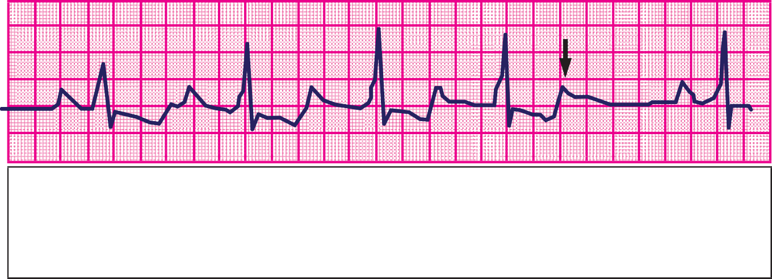















- Mobitz type 2: abrupt failure of AV conduction without prior PR prolongation
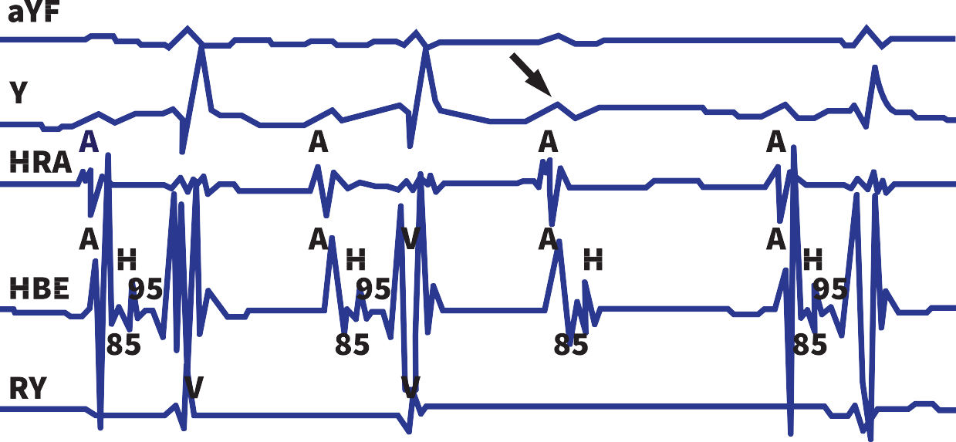
- 3rd degree (complete heart block): AV dissociation with no atrial impulses conducted to ventricles
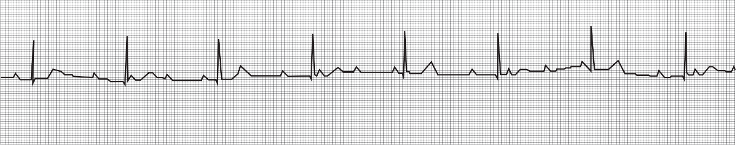
Note: 2nd degree (Type 2 and above) and 3rd degree heart block are always pathological

Risk factors/causes
- Hypoxia
- Sepsis
- Acidosis
- Hypothyroidism
- Electrolyte abnormalities i.e. hypokalaemia, hypocalcaemia
- Maternal Lupus (anti Ro/La positive); mother frequently asymptomatic
- Structural heart diseases: AVSD, congenital corrected transposition of great arteries (L-TGA), left atrial isomerism
- Long QT syndrome
- Surgical trauma: Especially in VSD closure, TOF repair, AVSD repair
- Infection: Rheumatic fever, endocarditis, viral myocarditis
- Drugs e.g. quinine

Prevention/promotion
- Education and awareness of risk factors
- Screening of immediate family members of a person who suffered sudden cardiac death

Signs and symptoms
- Most patients are asymptomatic
- Syncope
- Hypotension
CARDIOLOGY
- Exercise intolerance
- Fatigue
- Dyspnoea
- Dizziness
- Palpitations
- Cardiac arrest

Investigations
- ECG
- Chest X Ray
- Cardiac Echo
- Urea and Electrolytes
- Other tests as clinically indicated

Differential diagnosis
- See causes

Management

Primary level

See the secondary-level guidance below

Secondary level
- If unstable, manage ABC then refer to a tertiary centre
- Hemodynamically stable patients – Refer

Tertiary level
- Treat the underlying systemic causes of bradycardia.
- Hemodynamically stable patient with normal blood pressure:
  - No medical management for the bradycardia
  - Refer to a cardiology specialist
- Symptomatic bradycardia with haemodynamic instability
- Manage ABCDE
  - Cautious fluid resuscitation. Give 10mls/kg bolus if in shock or hypotensive with close monitoring for signs of fluid overload
- Medical management of bradycardia:
  - IV Atropine 0.02mg/kg/dose (maximum 0.6mg) - can repeat doses if remains bradycardic (maximum 3mg)
  - If atropine not working, add IV Adrenaline infusion at 0.02 mcg/kg/min and/or dopamine 2-10mcg/kg/min
- Cardiologist review

Follow up
- Once diagnosis is confirmed, the child must be followed up in a PEN-Plus clinic regularly
- Monitor growth and development
- Ongoing counselling and education

Supraventricular tachycardia

Definition
Abnormally rapid heart rhythm originating above the ventricles, often (but not always) with a narrow QRS complex

Causes/risk factors
- Wolff-Parkinson-White (WPW)
- Congenital heart disease
- Pericarditis
- Idiopathic
- Infections (e.g. sepsis, pneumonia)

Signs and symptoms/clinical features
- Severe tachycardia (> 220bpm)
- Heart palpitations
- Respiratory distress
- Shock

Management
Primary level
- Manage ABCDE
- Consult/refer to secondary level

Secondary level
- Manage ABCDE
- Haemodynamically stable patients, do:
  - Vagal manoeuvres:
- Icepack/iced water for infants: apply to face for a maximum of 30 seconds.
- Valsalva manoeuvres if the child is old enough (blow into a pinched straw)
- Refer to tertiary hospital

Tertiary level
- Haemodynamically stable patients
  - Vagal manoeuvres:
    - Icepack/iced water for infants: apply to face for a maximum of 30 seconds.
    - Valsalva manoeuvres if child is old enough (blow into a pinched straw).
  - For the performance of the following call the paediatric consultant or the cardiologist
    - IV Adenosine: 0.1mg/kg (maximum 6mg) rapid push into a big vein and follow with a flush. Increase by 0.1mg/kg every 2 minutes until tachycardia terminated or up to a maximum of 0.5mg/kg/dose (maximum: 18 mg total)
    - IV Amiodarone: 25mcg/kg/minute for 4 hours then 5 -15mcg/kg/minute until conversion
    - Patient needs to be on a continuous cardiac monitoring in HDU/ICU

- Haemodynamically unstable (in shock)
  - Synchronized DC conversion at 0.5 to 1 joule/kg
  - Cardiologist review

Follow up
CARDIOLOGY
- Once diagnosis is confirmed, the child must be followed up in a PEN-Plus clinic regularly if SVT persistent
- Ensure child has adequate stock of medications for home use at each visit
- Ongoing counselling and education

Chest pain
A complaint of chest pain is frequently encountered in children. Although chest pain does not indicate serious disease of the heart or other systems in most paediatric patients, the clinician should be aware of the differential diagnosis for chest pain

Causes/risk factors (non-cardiac causes):
Psychogenic
- Life stressor (death in family, family discord, divorce, failure in school, nonacceptance from peers, sexual molestation)

Musculoskeletal e.g.
- Costochondritis,
- Trauma to chest wall
- Muscle strains

Abnormalities of the rib cage or thoracic spine

Respiratory e.g.
- Reactive airway disease
- Pneumonia
- Pleural irritation
- Pneumothorax or pneumomediastinum
- Foreign bodies in the airway

Gastrointestinal e.g.
- Gastroesophageal reflux
- Peptic ulcer disease
- Esophagitis
- Gastritis
- Foreign bodies (e.g. coins)
- Cholecystitis

Causes/risk factors (cardiac causes):
- Structural abnormalities of the heart
  - Severe aortic or pulmonary stenosis, hypertrophic obstructive cardiomyopathy, Eisenmenger’s syndrome, MVP
- Coronary artery abnormalities
  - Previous Kawasaki disease, congenital anomaly, coronary heart disease, hypertension, sickle cell disease
- Inflammatory conditions
  - Pericarditis, Myocarditis, Kawasaki disease

Health promotion
- Health education
- Early health seeking behaviour for persistent chest pain

Investigations
The investigations should be done according to the suspected underlying cause. If cardiac cause is suspected do the following:
- Electrocardiogram
- Chest Xray
- Cardiac Echo (There is no need to do an echo if a cardiac cause is not suspected by history and physical examination)

Differential diagnosis
- See causes

Management
Primary level

History and physical examination
The initial history should be directed at determining the probable cause and should include the following:
- Nature of the pain, in terms of the duration, intensity, frequency, location, and points of radiation
- Physical examination should include a complete cardiovascular examination to rule out probable cardiac causes

Refer to secondary level:
- When history reveals that chest pain is triggered or worsened by physical activities
- When there are abnormal findings in the cardiac examination

Secondary level
See the tertiary-level guidance below

Tertiary level
- History and physical examination as above.
- Refer to a cardiologist:
  - When history reveals that chest pain is triggered or worsened by physical activities
  - When there are abnormal findings in the cardiac examination or when abnormalities occur in the chest radiographs or ECG, cardiology referral is clearly indicated
  - When there is a positive family history for cardiomyopathy, long QT syndrome, sudden unexpected death, or other hereditary diseases commonly associated with cardiac abnormalities

Follow up
  - If cardiac cause, patient should be followed up in a PEN-Plus clinic.
  - Medication use and side effects

Syncope

Definition
Syncope is a transient loss of consciousness and muscle tone that results from inadequate cerebral perfusion. Presyncope is the feeling that one is about to pass out but remains conscious with a transient loss of postural tone. It is usually less serious than syncope and is often a manifestation of a benign condition. Dizziness is the most common prodromal symptom of syncope

Causes/risk factors
Autonomic
- Vasovagal syncope
- Orthostatic (postural) hypotension
- Situational syncope
- Postural orthostatic tachycardia syndrome (POTS)

Cardiac arrhythmias
- Tachycardia: SVT, atrial flutter or fibrillation, ventricular tachycardia
- Bradycardia: Sinus bradycardia, asystole, complete heart block

Cardiac obstructive lesions
- Outflow obstruction: Severe aortic/pulmonary stenosis, hypertrophic cardiomyopathy, pulmonary hypertension
- Inflow obstruction: Severe mitral stenosis, cardiac tamponade, constrictive pericarditis

Metabolic
- Dehydration
- Hypoglycaemia
- Electrolyte disorders
Pregnancy

Investigations
- Investigate for underlying conditions.
- Measure blood pressure in the supine and upright position to check for postural hypotension and heart rate changes
- ECG
- Echocardiogram

Differential diagnosis
- Neuropsychiatric disorders
  - Anxiety disorders: panic disorders, phobia
  - Hyperventilation
  - Seizure disorders
  - Brain tumours
  - Conversion disorders (malingering, hysteria etc)

Management
Primary level
Refer to tertiary level for cardiology/neurology review

Secondary level
Refer to tertiary level for cardiology/neurology review

Tertiary level
- Investigate for underlying cause and manage as appropriate
- Consult cardiologist

Follow up
  - If cardiac cause, patient should be followed up in PenPlus clinic

References
Hussain Imam Hj Muhammad Ismail, Ng, H. P., & Thomas, T. (n.d.). Paediatric protocols for Malaysian hospitals (3rd ed.).
Szczygielska, I., Hernik, E., Kołodziejczyk, B., Gazda, A., Maślińska, M., & Gietka, P. (2018). Rheumatic fever: New diagnostic criteria. Rheumatology, 56(1), 37–41. https://doi.org/10.1093/rheumatology/kex456
Park, M. K., & Salamat, M. (2021). Park’s pediatric cardiology for practitioners (7th ed.). Elsevier.
UpToDate. (2023). Newborn screening for critical congenital heart disease using pulse oximetry. https://www.uptodate.com/contents/newborn-screening-for-critical-congenital-heart-disease-using-pulse-oximetry
Dean, S. L., & Singer, H. S. (2017). Treatment of Sydenham’s chorea: A review of the current evidence. Tremor and Other Hyperkinetic Movements, 7, 456. https://doi.org/10.7916/D8W95GJ2
Simonneau, G., Gatzoulis, M. A., Adatia, I., Celermajer, D., Denton, C., Ghofrani, A., Gomez Sanchez, M. A., Krishna Kumar, R., Landzberg, M., Machado, R. F., Olschewski, H., Robbins, I. M., & Souza, R. (2013). Updated clinical classification of pulmonary hypertension. Journal of the American College of Cardiology, 62(25 Suppl), D34–D41. https://doi.org/10.1016/j.jacc.2013.10.029
Beaton, A., & Carapetis, J. (2015). The 2015 revision of the Jones criteria for the diagnosis of acute rheumatic fever: Implications for practice in low-income and middle-income countries. Heart Asia, 7(2), 7–11. https://doi.org/10.1136/heartasia-2015-010648

