Chapter 3: Child Protection
Definitions 1
Risk factors Individual risk factors 2
Family risk factors 3
Community risk factors 4
Prevention, advocacy and health promotion 4
Signs and symptoms 6
Investigations 6
Differential diagnosis 7
History taking 9
Management 12
Guidance for completing the medical report for the police (physical/sexual) 14
Medical report form 16
Follow up 17
References 19

Definitions
Child Protection refers to prevention and response to violence, exploitation and abuse of children in all contexts including child marriage, violence in all forms, female genital mutilation (FGM), child labour, trafficking and lack of official recording of births.
A child is defined as a person below the age of 18 years
Child Sexual abuse is the involvement of a child in sexual activity that:
- The child does not fully comprehend,
- The child is unable to give informed consent,
- The child is not developmentally prepared and cannot give consent,
- Violates the laws or social taboos of society.

Child sexual abuse is evidenced by sexual activity between a child and an adult or another child who by age or development is in a relationship of responsibility, trust or power, the activity being intended to gratify or satisfy the needs of the other person. This may include but is not limited to:
- The inducement or coercion of a child to engage in any unlawful sexual activity.
- The exploitative use of a child in prostitution or other unlawful sexual practices.
- The exploitative use of children in pornographic performance and materials.

Sex with a child (defilement) and indecent assault are defined according to the Laws of Malawi in the Penal Code (Cap 7:01,138) as any person having sexual intercourse, or attempting to have sexual intercourse or indecently assaulting a girl/boy under the age of eighteen years

Physical abuse means any act or omission which causes or is intended to cause physical injury or reasonable apprehension of physical injury. Physical abuse includes physical acts ranging from those which do not leave a physical mark on the child to physical acts which cause permanent disability, disfigurement, or death

Emotional/psychological abuse consists of intentional caregiver behaviour that conveys to a child that he/she is worthless, flawed, unloved, unwanted, endangered, or valued only in meeting another’s needs. Psychological abuse can be continual (e.g. chronic and pervasive) or episodic (e.g. triggered by specific context or situation: caregiver substance use/abuse)

Child Neglect is the failure to provide for a child’s basic physical, emotional, or educational needs or to protect a child from harm or potential harm. Child neglect involves acts of omission for example:
- Failure to provide (physical neglect, emotional neglect, medical neglect and educational neglect)
- Failure to supervise
- Exposure to violent environments

Parent includes an adoptive parent, foster parent or any person acting in whatever way as parent

Guardian means a person who has lawful or legitimate custody, care or control of a child in place of a parent

Place of safety means an appropriate place where a child in need of care and protection can be kept temporarily and includes a safety home or a foster home.

Risk factors Individual risk factors
Caregivers may present a higher risk for child maltreatment if they:
- Are misusing drugs or alcohol
- have mental illness, including depression
- Do not understand children’s needs or development
- Were abused or neglected as children, or witnessed domestic violence
- Are experiencing high levels of parenting stress or economic stress
- Use spanking and other forms of corporal punishment for discipline
- Are not a biological parent
- Have ungoverned access to children in their care (e.g. teachers or religious leaders) Children may be at greater risk of abuse or neglect if they are:
- Living with disabilities
- Living or working on the streets
- Girls (more vulnerable to sexual and emotional abuse)
- Boys (more vulnerable to physical abuse and trafficking for labour)

Family risk factors
CHILD PROTECTION
- Families that have household members in jail or prison
- Families that are isolated from and not connected to other people (extended family, friends, neighbours)
- Families experiencing other types of violence, including relationship violence
- Families with high conflict and negative communication styles

Community risk factors
- Communities with embedded hierarchical misogynistic (oppressive) views of the relationship between men and women
- Communities with high rates of poverty and limited educational and economic opportunities
- Conflict, or any event resulting in an increase in refugees

Prevention, advocacy and health promotion
- A child is determined to be in need of care and protection if there has been or is substantial risk that the child will be physically, psychologically, emotionally or sexually abused, or neglected by a member of the family or any other person.
- Healthcare workers play a role in the protection of children, and should ensure that they do not send a child back to a dangerous/harmful environment. Involvement of social workers, child protection officers and law enforcement officers are key before discharging a survivor out of medical care.
- Malawi has several guiding documents that specifically relate to child protection, namely:
  - Constitution of Malawi (2017)
  - Childcare, Protection and Justice Act number 22 of (2010)
  - Malawi prevention of Domestic Violence Act Chapter 7:05 (2006)
  - National Guidelines for Provision of Services for Physical and Sexual Violence (2021)
  - Malawi Penal Code Amendment Act (2023)
- Rights of the child are outlined in Section 23 of the Constitution of Malawi
- If a health care worker encounters a parent/guardian who is denying care for the child, they should consult social welfare and other required stakeholders. Guidance for procedures to follow are outlined in the Malawi - Child Care, Protection and Justice Act; Act No. 22 of 2010.
- A medical practitioner is required by law to immediately inform the social welfare officer/police officer if he/she believes on reasonable grounds that a child being examined or treated is physically, psychologically or emotionally injured as a result of being ill-treated, neglected, abandoned or exposed, or is sexually abused.
- One-Stop Centres (OSC) are deliberately designed spaces offering multi-sectoral services to survivors of abuse. These centres are located at several health facilities across the country and comprise of a standard multidisciplinary team which includes:
  - Medical practitioners,
  - Social welfare,
  - Mental health,
  - Police and prosecutors,
  - Court,
  - Ministry of gender, community development and social welfare
  - Civil society organizations.

Preventing child abuse and neglect
Strategy | Approach
Strengthen economic support to families | - Strengthening household financial security  - Family-friendly work policies
Change social norms to support parents and positive parenting | - Public engagement and education campaigns  - Legislative approaches to reduce corporal punishment
Female empowerment | - Legislative approaches such as increasing the age of consent to marry  - Female empowerment programmes in schools including self-defence  - lessons
Provide quality care and  education early in life | - Preschool enrichment with family engagement  - Improved quality of childcare through licensing and  - Accreditation
Enhance parenting skills to promote healthy child development | - Early childhood home visitation  - Parenting skill and family relationship approaches
Intervene to reduce harms and prevent future risk | - Enhanced primary care  - Behavioural parent training programmes  - Treatment to mitigate harms of abuse and neglect exposure (such as through a One-Stop Centre)  - Treatment to prevent problem behaviour and later involvement in violence

- In the absence of One-Stop centres, survivors should access the appropriate care and support through the various health facilities namely central hospitals, district hospitals, community hospitals, health centres and clinics.

Signs and symptoms
Findings that raise the suspicion of child abuse include:
- Injuries with patterns that suggest deliberate injury
- Slap, belt, loop of cord, and other shaped bruises
- Cigarette, iron, spatula and other shaped burns
- Immersion burns
- Multiple fractures in various stages of healing or different types of injuries coexisting (e.g. bruises, burns and fractures)
- Metaphyseal fractures of long bones.
- Bruises of the trunk, ear, neck, angle of the jaw, fleshy cheek and eyelid
- Bruises in children who cannot cruise
- Frenulum tears and subconjunctival haemorrhages, especially in children <2 years old and those who are not yet walking independently
- Long bone fractures in children who do not walk
- Rib fractures in infants younger than one year of age
- Subdural haematoma in infants younger than one year of age
- Hollow viscus injury in children younger than four years of age
- Injuries that are epidemiologically or biomechanically unlikely to arise from the reported trauma event
CHILD PROTECTION
- Evidence of poor caretaking (a child who is dirty or inadequately clothed) may raise suspicion of abuse; however, these factors correlate more strongly with neglect or poverty than with abuse and abuse may be present in the absence of these signs
- Sudden onset of altered mental status not attributable to medical illness or other signs of poisoning
- A history which is out of keeping with the injury and changes
- Injuries to the genitalia: bruising, bleeding, grazes, lacerations to the posterior fourchette or/ and hymen

Investigations
- HIV test after counselling
- Urine dipstick if there are concerns for renal injury
- Pregnancy test if post-menarche
- Imaging
  - Skeletal survey radiographs: Humeri (AP), Forearms (AP), Hands (PA), Femurs (AP), Lower legs (AP), Feet (AP), Thorax (AP, Lateral, R & L oblique), Abdomen with pelvis (AP), Lumbosacral spine (Lateral), Skull (Frontal & lateral) and Cervical-spine (lateral). Indications are:
  - All children <2 years
  - Children with neurological impairment OR distracting injury or suspicious index fracture
  - Concern for abuse in children with impaired mobility or impaired communication skills
  - Neuroimaging (cranial USS/head CT) indications are:
  - All infants < 6 months old regardless of physical findings.
  - Infants aged 6 to under 12-month-old with external head injuries on examination or skull fracture OR fracture highly suggestive of abuse (e.g. rib fractures or metaphyseal fractures)
  - Child of any age with signs suggesting intracranial injury.
- Serum and urine toxicology screen in children with suspected drug exposure, poisoning, or symptoms suggesting drug toxicity
- Fundoscopy and ophthalmology consultation in children with abusive head trauma, periorbital bruising, or eye injury
- Optional - Swab fluid/pus for microscopy for STI or sperm if available (rarely useful)
- Other tests if indicated:
  - PT, INR, aPTT, VWF, Factors VIII/IX/XIII, D-dimer, fibrinogen
- Screening for bleeding disorder in children with bruising/bleeding
  - AST, ALT, Lipase
    - Screening for abdominal injury
  - Serum electrolytes and osmolality
    - In the setting of abusive head trauma, dehydration, water intoxication or drowning
  - Calcium, phosphorous, alkaline phosphatase, PTH level, 25-OH vitamin D level
    - Screening for metabolic bone disease in children with multiple fractures
  - Osteogenesis imperfecta genotype/phenotype testing

Differential diagnosis
Type of abuse | Signs and symptoms | Differential diagnosis
Physical abuse | Bruising | Coagulopathies e.g. Von Willebrand disease
Physical abuse | Fractures | Osteogenesis imperfecta, metabolic bone  diseases
Physical abuse | Scalp swelling | Subdural haematoma, subgaleal haemorrhage
Sexual abuse | Vaginal/urethral discharge Genital Ulcers/sexually transmitted infections | Allergies to fabric, pinworms, foreign bodies,  urinary tract infections
Sexual abuse | Bruising/bleeding/discharge/  pain from genital areas. Difficulty in sitting/walking | Trauma, urethral prolapse
Emotional abuse | Lack of energy, sadness,  sleeping and eating changes | Mood disorders, anxiety disorders, substance use/abuse
Child neglect | Poor appearance and hygiene, change in behaviour, developmental problems, frequent absent from school. | Poverty, rule out medical conditions e.g. malnutrition

Management approach in suspected child abuse General principles
CHILD PROTECTION
- A survivor of sexual or physical abuse must be attended to as soon as possible upon arrival in the health facility.
  - The survivor is not required by law to produce a letter from the police before they can be attended to. Insisting on a police letter will cause a great burden on the survivor and cause unnecessary delays, and must be avoided at all times
- It is not the health care worker’s responsibility to determine whether or not a person has been abused, this is a legal determination. The health care worker’s responsibility is to provide appropriate care, to record the history, examination and other relevant information which can be provided to the police and used for their investigations.
- Service providers are also encouraged to provide suitable temporary shelter to survivors of abuse, as well as ensuring that the survivor has access to information about the range of service providers and the kind of support that may be provided by any service provider.
- All survivors who are suspected victims of abuse should receive a medical evaluation by a health provider who has received training in the diagnosis and treatment of sexual and physical abuse.
- It is rarely possible to definitively conclude that physical abuse has occurred in the first few hours of an evaluation. When physical abuse is suspected, clinicians should emphasize the need for further evaluation and avoid making accusations.

History taking
- In most cases, the history will be more important than the examination
- History and examination should take place in a place of privacy
  - Aim to limit the number of health care workers attending to the survivor: ‘one-on-one’ care works best in sexual assault cases during interviewing
- Interview the parent alone, then the child alone (if possible) as the adult’s presence might influence the child.
  - In the setting of acute trauma, it may be difficult to separate the child from the caregiver, and the questioning of the child can be deferred till later
  - Age-appropriate questioning of the child needs to be instituted to avoid misleading information
  - Ask the survivor if she/he wants to have a specific person present for support
- Introduce yourself and build rapport (e.g. “Tell me about school”)
- Maintain eye contact. Be empathetic and non-judgmental as your survivor recounts her/his experiences.
- Interview rules (optional);
Establish the need to tell the truth:
“If I ask you something, and you don’t know the answer – that’s o.k. just say ‘I don’t know.’”
Introducing the topic of concern
“Do you know why you are here today?”
“I am and I talk to children about things that happen to them. Do you want to talk to me about things that happened to you?”
Older children:
“Part of my job is to take care of children who had really bad things happen to them… so don’t worry that you will say something that will surprise me – That won’t surprise me. And don’t worry that you will say something that will make me think bad of you”
Free narrative
“Tell me everything that happened, starting from the beginning” Do not interrupt
Open questioning
Who/when/where/what
“How did you know it was over?”
Avoid ‘multiple choice’ questions, or one-word answer questions
Probe for behavioural or emotional problems and physical symptoms which may occur after abuse and can serve as corroborating evidence in court (fill this in the appropriate section on the medical report):
  - Change in behaviour
  - Suicidal thoughts
  - Headaches
  - Abdominal pain
  - Dysuria
  - Vaginal discharge
  - Constipation
  - Anal bleeding
  - Secondary enuresis (bedwetting after having been dry)

- When physical injury is identified, the history should ascertain how the injury came about. Detailed history of events should include:
  - Preceding activity, elevation and motion
  - Events leading up to the trauma event
  - Mechanics of the injurious circumstances
  - Subsequent actions and symptoms of the patient
- While an accurate summary or paraphrasing of given answers may be adequate, when particularly important statements are made, quoting the exact words of the reporter will avoid concerns of inaccurate interpretation by the clinician and serve any subsequent legal proceeding better
- Ask the survivor if she/he has any questions
- Conclusion of interview – assure them of safety
CHILD PROTECTION
- Red flags in the history include:
  - Caregiver offering no history or specifically denying history of trauma despite severe injury
  - The history being inconsistent with the degree or type of injury
  - Unexplained or excessive delay in seeking care
  - Injury attributed to in-home resuscitation efforts
  - Caregiver histories that change with re-telling or conflict with versions from other observers
  - Severe injury explained as self-inflicted or blamed on other young children or pets
  - The history is inconsistent with developmental stage of the child e.g. a 4-month-old who reaches for hot water and gets burnt
  - History of prior bruising or orofacial injury in an infant who is not cruising
- The behaviour of the parents/caregivers and the interaction between family/household members should be observed carefully during the evaluation of the child. Certain behaviours and/or types of interaction may increase the level of suspicion for child abuse. Such behaviours include:
  - Arguing, roughness, or violence
  - Aloofness and lack of emotional interaction between parents/caregivers or between parents/ caregivers and children
  - Negative characterisation of the child by the parent
  - Inappropriate response to the severity of the injury (e.g. lack of appropriate concern)
  - Inappropriate delay in seeking medical care
  - A partial confession by the parent (e.g. “I hit them, but not that hard”) or a frank admission by a parent that injury was inflicted. Such confessions occur occasionally and are an indication that the parent recognises that abuse is a problem and is seeking help

Physical Examination (Secondary/tertiary health facilities only)
- Should be performed by somebody trained in the evaluation of such cases
- While a careful physical examination can raise suspicion of abuse, many abusive injuries remain hidden. Occult abdominal injuries, fractures, and brain injury have been well described in children with normal examinations
- The examination room should be equipped with a table and chairs, a lockable door, examination couch with a light source and handwashing facilities
- Ideally, blood sampling, HIV testing, history taking, physical examination and treatment provision should take place in the same room
- During examination it is recommended to have another health care provider or a family member of the same sex as the client present
- If the child is seen shortly after the assault and still wearing the same clothes, all clothes should be carefully examined for stains of semen or blood and for rips and tears suggestive of aggression
- Remove the child’s clothing to fully expose all areas (This may be done sequentially)
  - Examine the entire body for signs of injury – not just the perineum
  - Look for finger imprints on the arms and/or legs where the child may have been held down or stopped from screaming
  - Look in the mouth for evidence of injury from forced oral-penile penetration and the breasts which may have been bitten or squeezed
  - Characteristic skin lesions, swelling/deformity, bone tenderness or reluctance to use an extremity should be looked for
- Technique for perineal exam:
  - The hymen can be viewed by gently separating the labia majora. For young children, the examination can be performed while they lay on their family member’s lap in a frog leg position (see below)

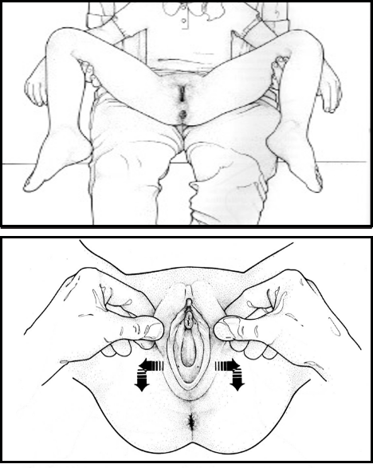

Frog – Leg position. Labial separation
  - The shape, size and edges of hymen should be recorded.
  - Anal findings may vary from no visible abnormality, to a wheel of oedema around a recently injured anus with anal incontinence, to a dilated, partially incontinent anus
- Findings suggesting or confirming sexual abuse in females include:
  - Acute abrasions, lacerations or bruising of the labia, perihymenal tissues, penis, scrotum, or perineum.
  - Hymenal notch or cleft extending through more than 50% of the width of the hymenal rim, usually located between the 4 o’clock to 8 o’clock positions
  - Scarring or fresh laceration of the posterior fourchette
  - Presence of sperm confirmed on microscopy
  - presence of sexually transmitted disease
- Normal and non-specific vaginal findings include:
  - Hymenal bumps, ridges and tags
  - V-shaped notches located superior and lateral to the orifice, not extending to the base of the hymen
  - Vulvovaginitis
  - Labial agglutination
  - Vaginal discharge
The presence of multiple types of injuries suggests abuse because conditions that mimic abuse typically only cause one type of finding

Management
Primary level
- Use ABCDE approach if patient is unstable
- Take brief history
- Refer all patients, do not examine

Secondary level
See the tertiary-level guidance below
Tertiary level
- Use ABCDE approach if patient is unstable
- Conduct history taking and physical examination as outlined above
- Identify and treat all injuries. Hospitalise for serious injuries or if the child does not have a safe space to go back to
- Involve available seniors in the evaluation and management
- For suspected sexual abuse give:

  - Post-exposure prophylaxis (PEP)
  - The child is eligible for PEP if the child has presented within 72 hours of the assault and they are HIV negative and the family agrees to comply with the treatment
  - The survivor should be given PEP regardless of the serostatus of the assailant, as the assailant may be in the window period during the time of a negative test outcome
  - Test for HIV and give PEP at the same time the child is seen – do not delay
  - Give Abacavir (ABC)/Lamivudine(3TC) + Dolutegravir (DTG) according to body weight
or
Tenofovir/lamivudine (3TC) + dolutegravir (DTG)(for those >30 kg)
  - Treat for 30 days. A repeat HIV test is required at 1, 3 and 6 months

- Antibiotics to prevent or treat STI
  - Metronidazole 5 mg/kg PO, TDS for 7 days (maximum 2 g/day)
and
  - Erythromycin 12.5 mg/kg PO, QID for 7 days (maximum 500mg/dose) or Azithromycin 20 mg/kg PO, daily for 3 days and
  - Gentamicin 7.5 mg/kg STAT IM (maximum 240mg) and
  - Intramuscular Benzathine penicillin STAT (< 25 kg give 0.6 MU; > 25 kg give 1.2 MU)

- Tetanus Toxoid Vaccine 0.5 ml IM STAT if indicated
- Consider emergency contraception if post- menarchal and <72 hours
  - Postinor (Levonorgestrel 750 mcg) 2 tablets STAT
or
  - Lo-femenal / Microgynon 4 tablets STAT then 4 tablets 12 hours later

- Inform and involve social workers and police early. Refer to other medical specialties as indicated e.g. paediatric surgery, urology etc.

Guidance for completing the medical report for the police (physical/sexual)
- Use the ‘Medical examination for suspected physical/sexual abuse’ forms (see below) and keep
- copies of the records
  - These documents may be used as evidence, so ensure legibility
  - Briefly summarise the history
  - Use the child’s words if possible
  - Recording of history should be factual
  - Statements from the child/parent/caregivers should be recorded as direct quotations
- Summarise and document the physical findings
  - Injuries should be described in as much detail as possible
  - Sketches of injuries are helpful in documenting extensive injuries
  - Avoid vague terms such as ‘hymen intact’ or ‘hymen perforated’– better ‘no signs of injury to the hymen’ or ‘evidence of injury to the hymen’
- Write a conclusion or opinion:
  - Begin with: “In my opinion…..”
  - State if you think the child’s history is clear, logical and credible
  - If the physical findings are normal, remember this does not exclude the possibility of physical abuse or sexual penetration e.g. ‘the examination is normal, but this does not rule-out the possibility of penetration, and these findings are consistent with the history given to me by the child’
  - If physical findings are present, state if they are consistent with the child’s history given If there is clear physical evidence of penetration in sexual abuse, state this clearly ‘these findings are highly suggestive of penetration/confirm that penetration has taken place’
CHILD PROTECTION
  - Be cautious of interpreting the ages of injuries
  - It is acceptable to state uncertainty, e.g. ‘The child was unable to provide any details in her history that would confirm that physical contact occurred’
  - You are not the judge or jury; however, the prosecutor and the court will benefit from a clear and well-reasoned statement of your medical opinion
- Any person working with people who have been sexually or physically assaulted should be aware of the differences between myths and facts, and personal beliefs and attitudes towards abuse need to be examined and challenged
- It is essential that healthcare workers understand the need for impartiality. It is not the role of the health care worker to make judgments about the veracity of sexual or physical abuse allegations, nor about the innocence or guilt of the alleged perpetrator, this is for the investigators and the courts to decide.

Medical report form
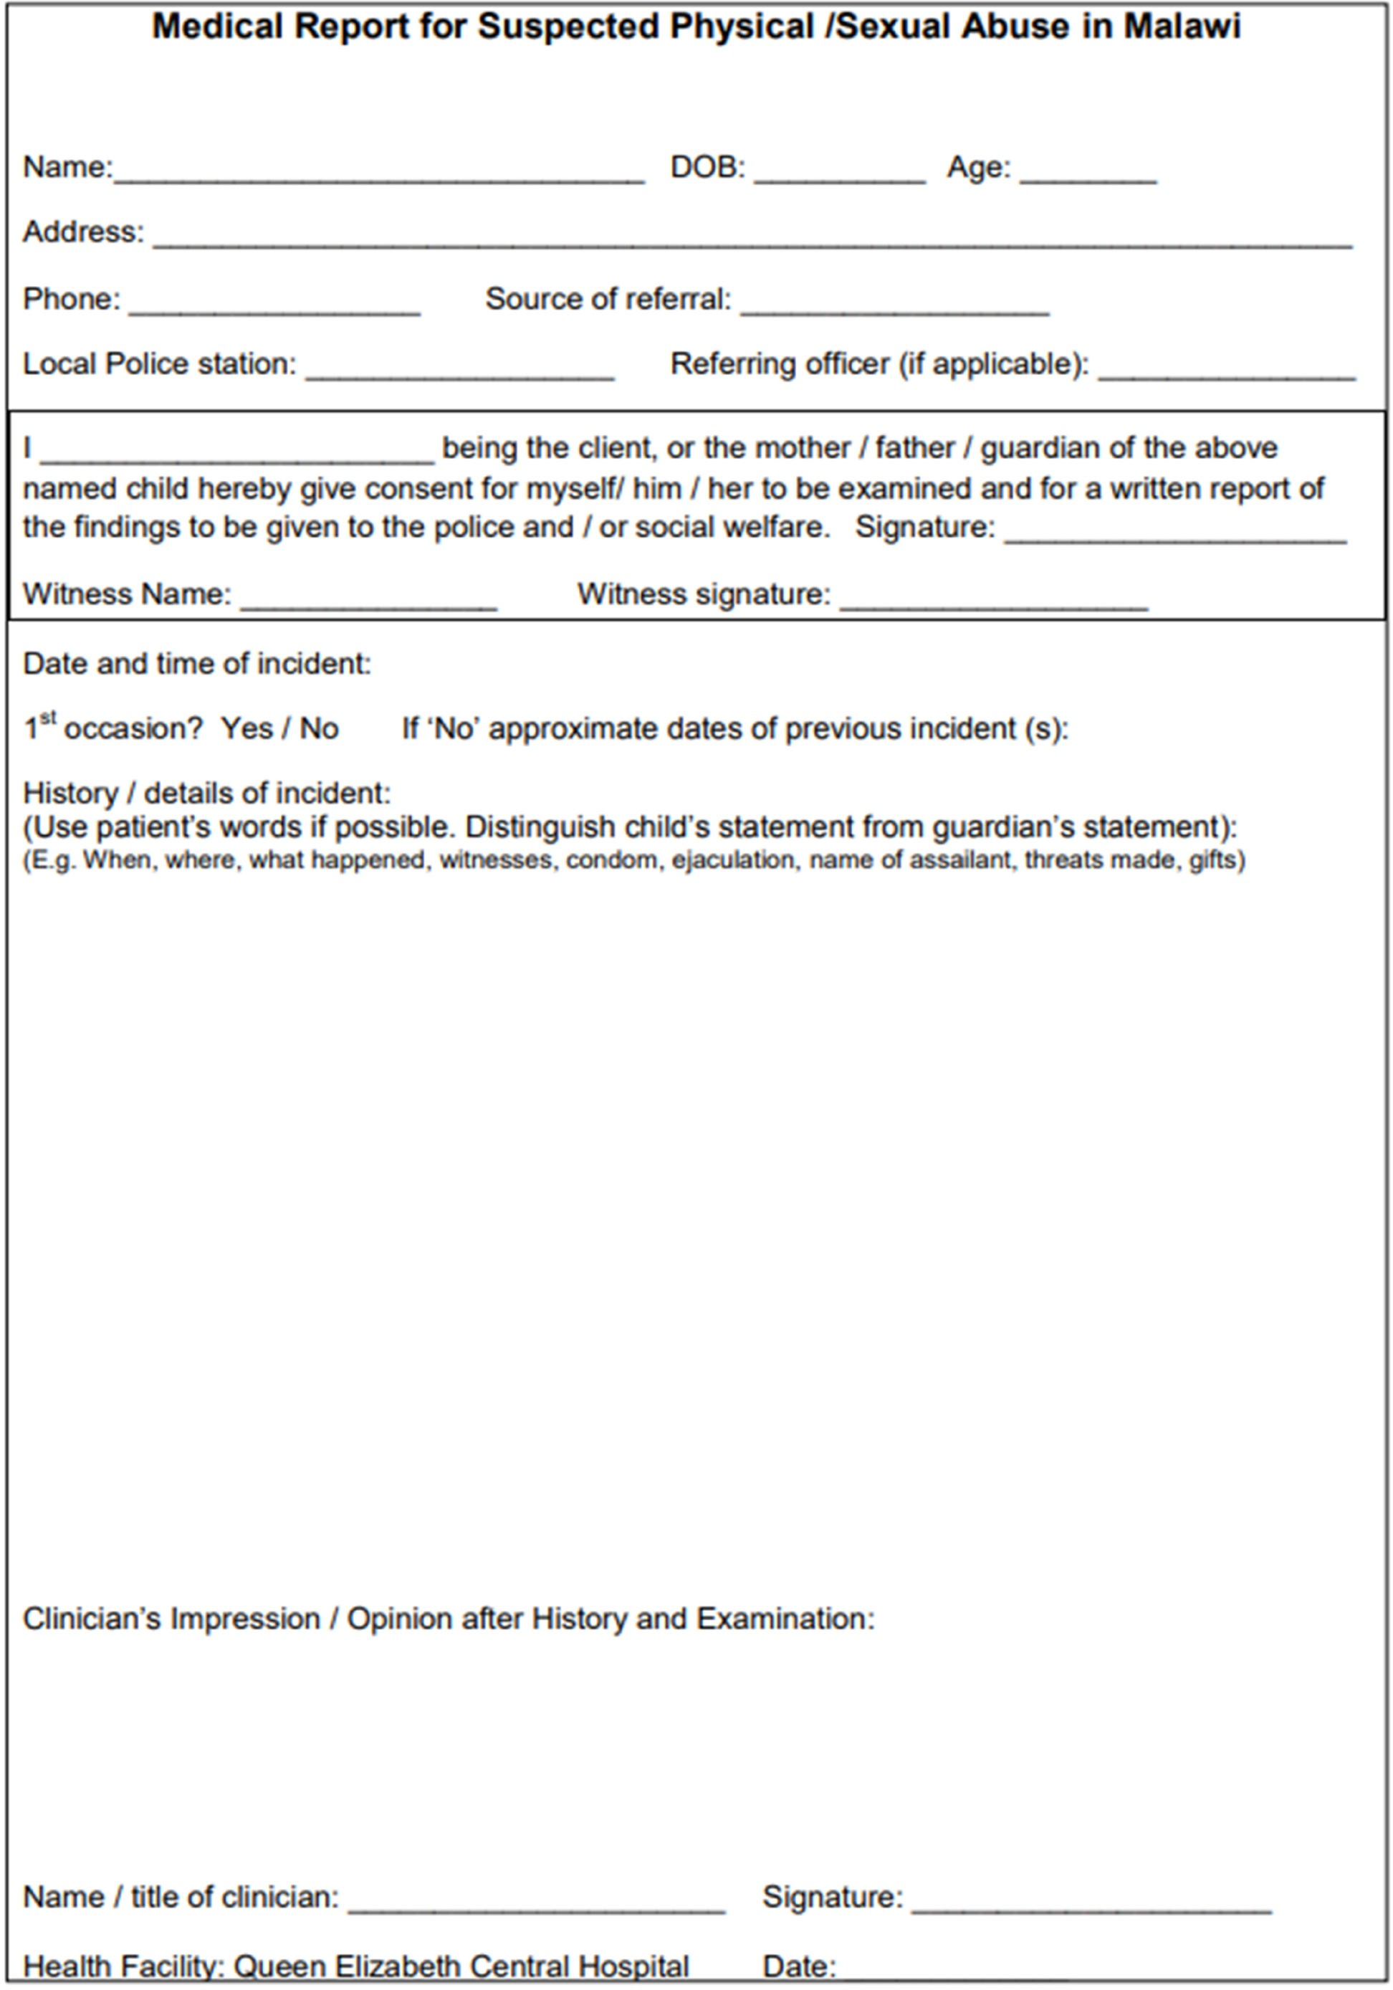

CHILD PROTECTION

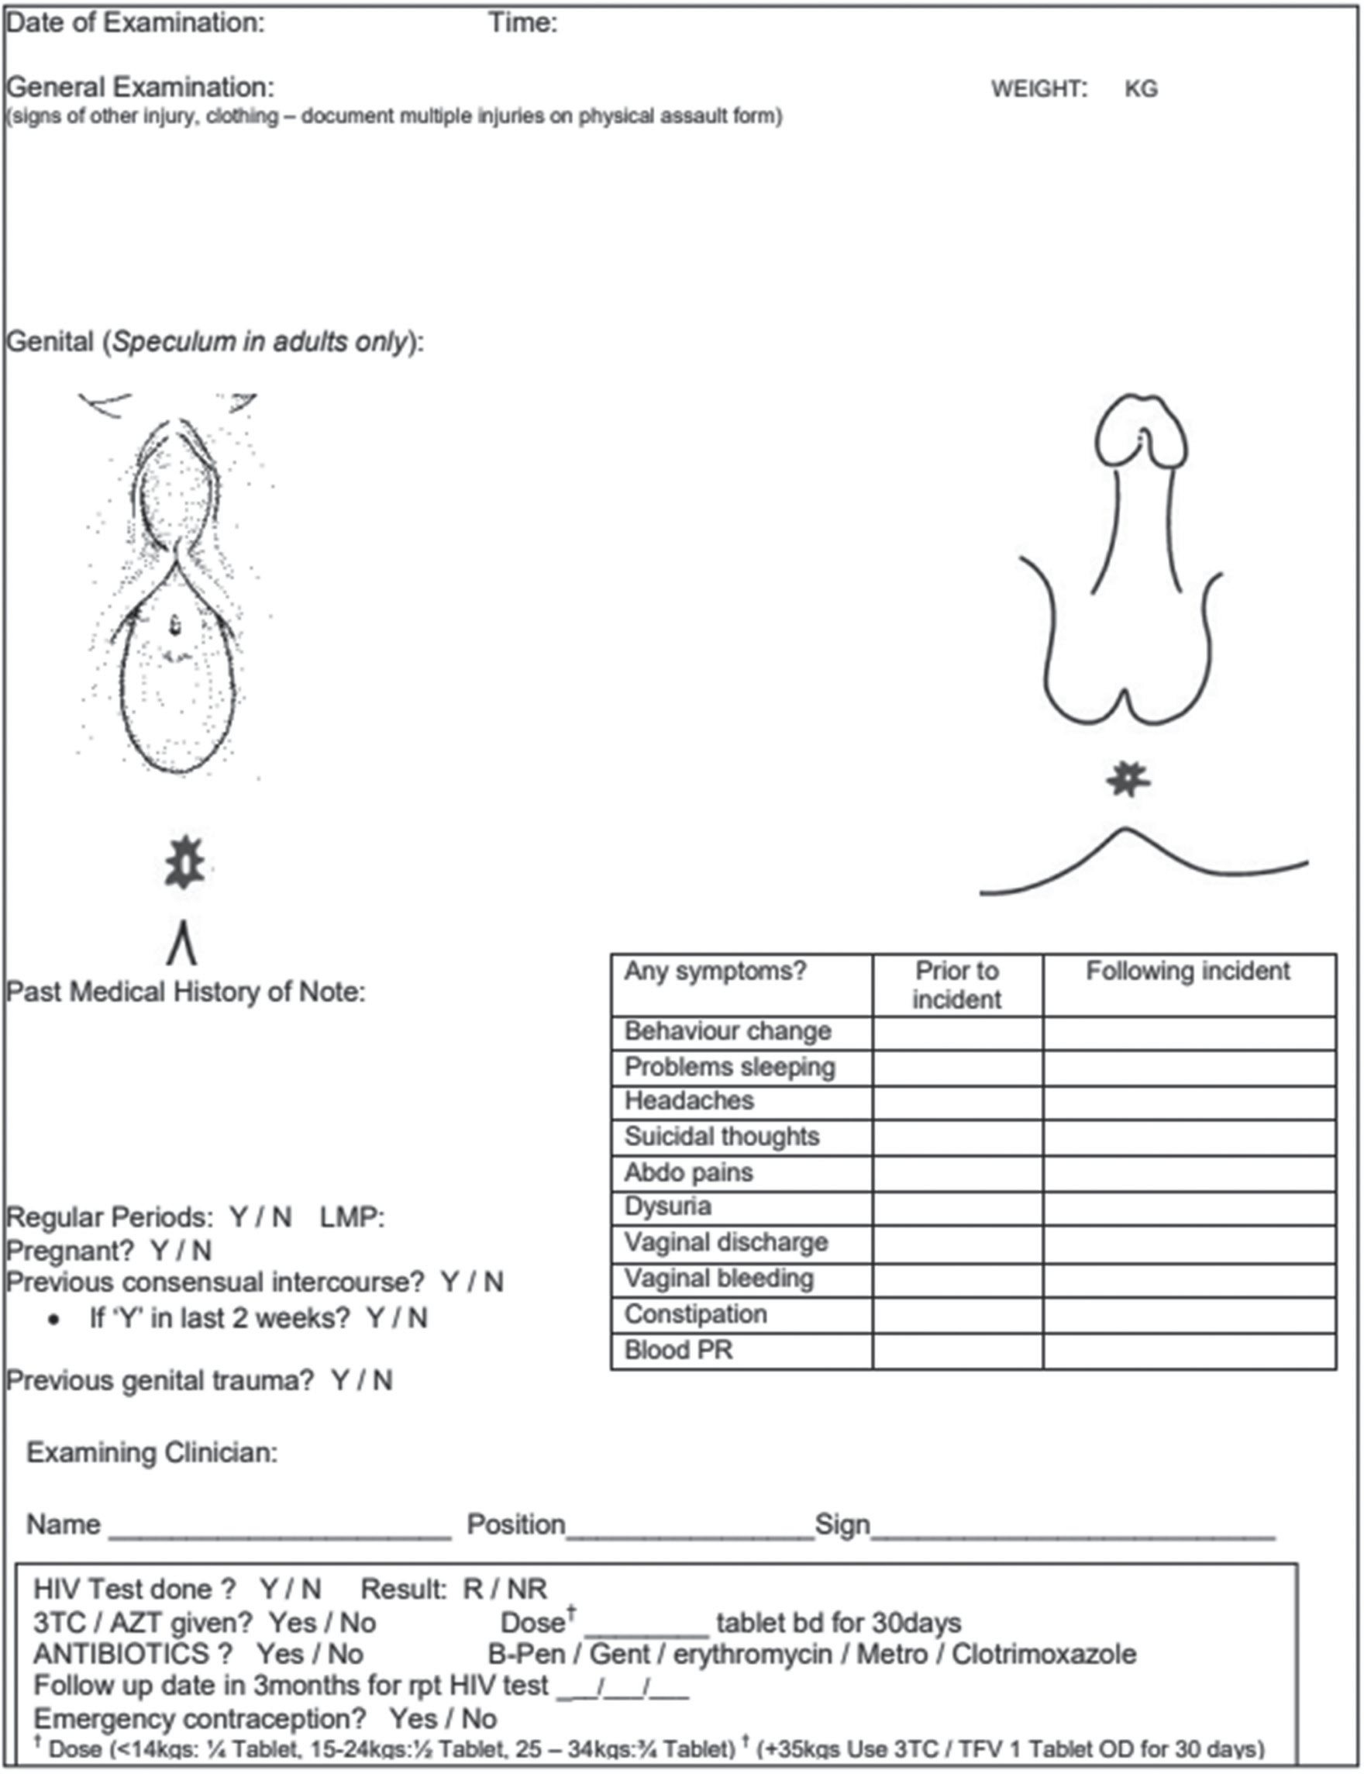

Follow up
Procedures and services for child protection in Malawi are evolving quickly and the up-to-date guidelines
should always be adhered to.
- Guardians should be given the stamped medical report form to take back to the referring police station (they should get all the pages – history, examination and report). A copy of the medical report should be stored securely at the health facility
- After initial evaluation, all children should be seen/referred to the OSC as soon as possible – preferably the same or next working day
  - Each district or catchment area should have an approved referral system with clear communication plans, developed by a multi-disciplinary team made in collaboration with the community with.
  - Information to have ready when you make the referral:
    - The survivor’s name, sex, age, date of birth, address
    - Phone numbers (preferably 2, if possible) of the survivor and/or the accompanying family member
    - Name of the family member who is accompanying them who is helping provide the details
    - Type of abuse: Sexual or physical or both
    - Location where the abuse occurred
    - Date and approximate time of the abuse
- Make the referral to the health facility OSC as soon you identify the need – even if the survivor does not need to go immediately. This way, the OSC team can be aware of the survivor and contact them sooner to ensure a successful referral and prompt medical, legal and social services
- In cases of sexual abuse, ensure that the alleged perpetrator is not bringing the survivor to the OSC. Survivors are unlikely to disclose abuse when the abuser is the one who brought them
- Keep a copy of all the report forms in a safe space for future reference

References
UNICEF Malawi. (2011). Malawi child protection strategy 2012–2016. UNICEF.
https://www.unicef.org/malawi/media/566/file/Malawi-Child-Protection-Strategy-2012-2016.pdf
United Nations Children’s Fund. (2020). A generation to protect: Monitoring violence, exploitation and abuse of children within the SDG framework. UNICEF.
Government of Malawi. (2010). Child care, protection and justice act (Act No. 22 of 2010).
Government of Malawi. (2017). The Constitution of the Republic of Malawi, 1994 (as amended).
https://www.constituteproject.org
World Health Organization. (2003). Guidelines for medico-legal care for victims of sexual violence. World Health Organization.
Ministry of Health (Malawi). (2015). National guidelines for provision of services for physical and sexual violence. Ministry of Health
Government of Malawi. (2014). Prevention of domestic violence act (Chapter 7:05). Laws.Africa.
Leeb, R. T., Paulozzi, L., Melanson, C., Simon, T., & Arias, I. (2008). Child maltreatment surveillance: Uniform definitions for public health and recommended data elements (Version 1.0). Centers for Disease Control and Prevention, National Center for Injury Prevention and Control.
Ministry of Health (Malawi), Department of HIV & AIDS. (2022). Clinical management of HIV in children and adults: Malawi integrated guidelines and standard operating procedures for providing HIV services (5th ed.). Ministry of Health.
Paediatrics and Child Health Department, Queen Elizabeth Central Hospital, & College of Medicine, University of Malawi. (2017). Protocols for the management of common childhood illnesses in Malawi (3rd ed.). Queen Elizabeth Central Hospital.
Centers for Disease Control and Prevention. (n.d.). Preventing child abuse and neglect.
https://www.cdc.gov/child-abuse-neglect/prevention/?CDC_AAref_Val=https://www.cdc.gov/violenceprevention/childabuseandneglect/prevention.html

