CS7646
  - Xing Liu
xliu397@gatech.edu
Abstract— This report investigates the theoretical optimal strategy and indicators to understand how they may be used to generate trading signals. The theoretical optimal strategy helps develop an understanding of the best-case outcome for a given instrument and timeframe. Five indicators were devised and plotted to explore how they may be used to generate trading signals.

Technical Indicators

Relative Strength Index(RSI)
The Relative Strength Index is a momentum oscillator that measures the speed and magnitude of recent prices changes. It helps evaluate whether a stock is overbought or oversold. When a stock has been rising consistently, the average gain dominates the average loss. This would push RSI toward 100. In the opposite scenario, sustained selling pressure push RSI toward 0. This oscillating behavior makes RSI effective at identifying potential reversal points where a stock’s price has moved too far in one direction and may be due for a correction.
Trade Decision / Strategy:
- Long: Enter a long position when RSI crosses below 30, indicating that selling pressure may be exhausted and a price rebound is likely.
- Short: Enter a short position when RSI crosses above 70, indicating that buying pressure may be exhausted and a price decline is likely.
- Cash: Exit positions when RSI returns to the neutral zone between 30 and 70, suggesting no strong directional momentum.
Trade Confirmation: RSI signals can be confirmed by checking whether the price is near a Bollinger Band boundary. For example, an RSI below 30 combined with price near the lower Bollinger Band strengthens the buy signal.
Filters: To avoid whipsaw trades caused by oscillations near the threshold levels, a minimum period hold after entering position can be useful.
Computation:
- For each trading day, compute the daily price change as delta[t] = price[t]-price[t-1].
- Separate the deltas into gains and losses.
  - Gain[t] = delta[t] if delta[t] > 0, else 0.
  - Loss[t] = abs(delta[t]) if delta[t] < 0, else 0.
- Compute the average gain and average loss over a lookback period of 14 days using a simple rolling mean. The Relative Strength becomes RS[t] = avg_gain[t]/avg_loss[t]
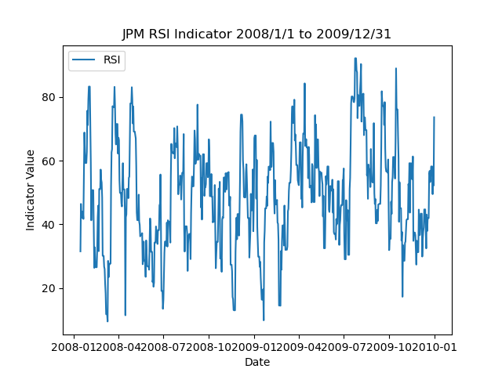
- Get RSI[t] by plugging in the previous RS[t] using equation RS[t] = 100 – (100/(1 + RS[t])).
- JPM RSI Plot from 01/01/2008 to 12/31/2009

Momentum
Momentum measures the rate of price change over a given lookback period. It quantifies how much price has changed relative to its value N days ago. This helps captures the tendency of stocks to continue moving in the same direction over short to medium time horizons. On the reverse, it can also help signal a reversal is imminent, as prices may have overextended.
Trade Decision / Strategy:
- Long: Enter a long position when momentum crosses above 0 from below, indicating that the stock has transitioned from a declining phase to a rising phase.
- Short: Enter a short position when momentum crosses below 0 from above, indicating a transition from rising to falling prices.
- Cash: Move to cash when momentum is near zero and shows no clear directional trend, as the stock lacks strong conviction in either direction.
Trade Confirmation: Momentum signals are stronger when confirmed by RSI. A positive momentum crossover combined with RSI rising from oversold levels provides a higher-confidence long signal.
Filters: N/A
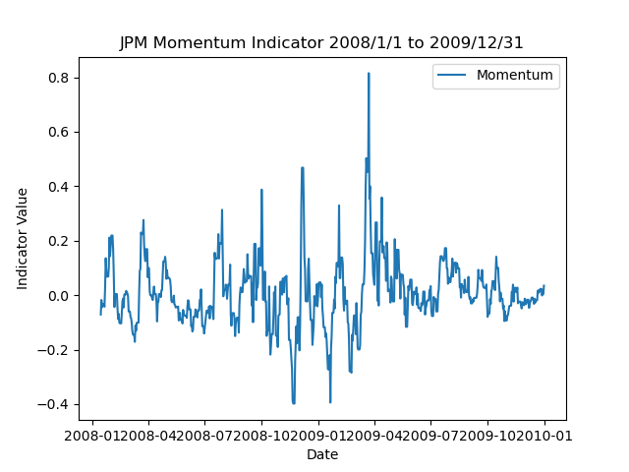
Computation: momentum[t] = (price[t] / price[t - N]) - 1, where N is the lookback window. My implementation used N=14.
- JPM Momentum Plot from 01/01/2008 to 12/31/2009

Price/EMA Ratio
The Price/EMA ratio compares the current stock price to its Exponential Moving Average over a specified lookback period. The EMA is a type of moving average that places greater weight on more recent data points, making it more responsive to new information than a Simple Moving Average.
A ratio greater than 1.0 means the current price is above the EMA, while a ratio below 1.0 means the price is below the EMA. The magnitude of deviation from 1.0 indicates the strength of the trend with bullish being higher and bear lower.
Trade Decision / Strategy:
- Long: Enter a long position when the Price/EMA ratio crosses above 1.0 from below, signaling that the price has moved above its recent average trend and upward momentum is building.
- Short: Enter a short position when the Price/EMA ratio crosses below 1.0 from above, indicating that the price has dropped below its trend and downward pressure is dominant.
- Cash: Move to cash when the ratio oscillates around 1.0 without a clear directional break.
Trade Confirmation: A Price/EMA crossover confirmed by a MACD histogram turning positive (for longs) or negative (for shorts) adds conviction to the trade signal.
Computation:
- Computed recursively: EMA[t] = alpha * price[t] + (1 - alpha) * EMA[t-1], where alpha = 2 / (N + 1) and N is the lookback period (N = 14 in this implementation).
- Obtain the indicator value Price_EMA_Ratio[t] = price[t] / EMA[t].
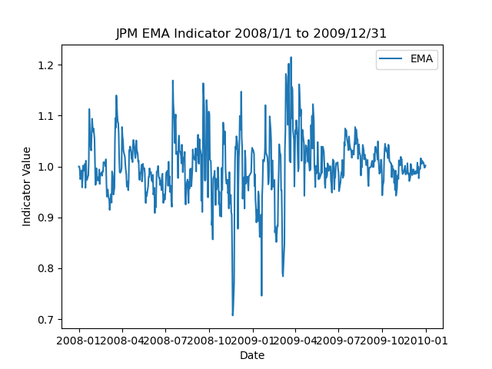
Filters: Small deviations from 1.0 (+/- 0.02) can be filtered out to avoid false signals in low-volatility, sideways-moving markets.
- JPM Price/EMA Plot from 01/01/2008 to 12/31/2009

MACD Histogram
The Moving Average Convergence Divergence is a trend-following momentum indicator that captures the relationship between two exponential moving averages of a stock's price. MACD captures both trend direction and momentum by examining the convergence and divergence of short-term and long-term moving averages. When the short-term EMA (12-period) rises above the long-term EMA (26-period), it signals that recent price momentum is stronger than the longer-term trend. The histogram, by measuring the distance between the MACD and its signal line, provides an early warning of momentum shifts. When the histogram begins shrinking toward zero from a positive value, it suggests bullish momentum is waning before a potential crossover occurs.
Trade Decision / Strategy:
- Long: Enter a long position when the MACD histogram crosses above 0, indicating that the MACD line has crossed above the signal line and bullish momentum is accelerating.
- Short: Enter a short position when the MACD histogram crosses below 0, indicating that the MACD line has crossed below the signal line and bearish momentum is accelerating.
- Cash: Move to cash when the histogram is near zero and oscillating without a decisive crossover, as this suggests the market lacks directional conviction.
Trade Confirmation: MACD histogram signals can be confirmed by checking whether RSI is in a supporting zone (e.g., RSI < 50 for shorts, RSI > 50 for longs), ensuring that the broader momentum environment aligns with the trade.
Filters: Very small histogram values close to zero can be ignored to avoid false crossover signals during sideways markets.
Computation:
- Calculate the MACD line as the difference between the 12-period EMA and the 26-period EMA: MACD_line[t] = EMA(price, 12)[t] - EMA(price, 26)[t].
- Compute the Signal line as a 9-period EMA of the MACD line: Signal[t] = EMA(MACD_line, 9)[t].
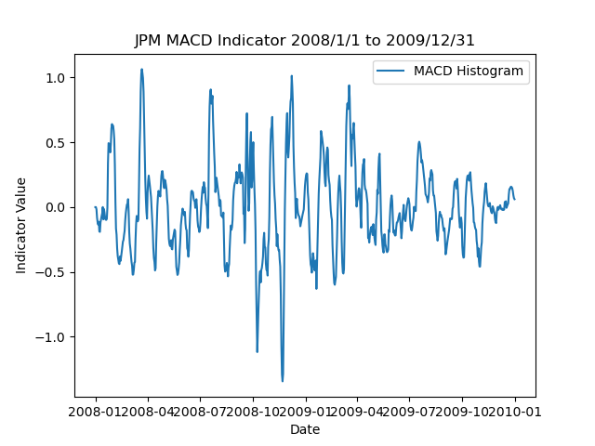
- Histogram[t] = MACD_line[t] - Signal[t].
- JPM MACD Plot from 01/01/2008 to 12/31/2009

Bollinger Band Percentage
Bollinger Bands are grounded in the statistical concept that prices tend to revert to the mean. The bands expand during volatile periods and contract during calm periods, dynamically adapting to market conditions. When the price touches or exceeds the upper band (BB% >= 1.0), it is statistically extended and may be due for a pullback. When it touches or falls below the lower band (BB% <= 0.0), it may be oversold and due for a bounce. BB% converts this information into a single, easily interpretable value that can be directly used as a buy/sell signal.
Trade Decision / Strategy:
- Long: Enter a long position when BB% drops below 0 (price has fallen below the lower Bollinger Band), signaling that the stock is oversold relative to its recent volatility and a mean-reversion bounce is likely.
- Short: Enter a short position when BB% rises above 1.0 (price has exceeded the upper Bollinger Band), signaling that the stock is overbought and may revert.
- Cash: Move to cash when BB% is between 0.2 and 0.8, indicating the price is within the normal range of the bands and no strong mean-reversion signal exists.
Trade Confirmation: A BB% signal below 0 confirmed by RSI below 30 provides a high-confidence oversold signal. Similarly, BB% above 1.0 with RSI above 70 strengthens the overbought signal.
Filters: Rapid band expansion (indicating a volatility breakout) can be used as a filter to avoid entering mean-reversion trades during trending markets, where the price may continue moving outside the bands for an extended period.
Computation:
- Calculate the SMA over N days: SMA[t] = mean(price[t-N+1 : t]).
- Compute the rolling standard deviation: std[t] = stdev(price[t-N+1 : t]).
- Get the upper and lower Bollinger Bands. Upper[t] = SMA[t] + 2 * std[t] and Lower[t] = SMA[t] - 2 * std[t].
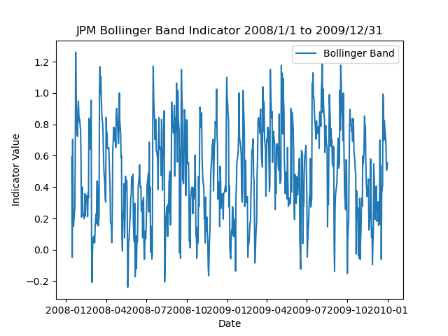
- Calculate Bollinger Band Percentage = (price[t] - Lower[t]) / (Upper[t] - Lower[t]).
- JPM Bollinger Band Percentage Plot from 01/01/2008 to 12/31/2009

Theoretically optimal strategy
The Theoretically Optimal Strategy leverages perfect knowledge of future prices. This assumption is impossible in real trading but useful for establishing an upper bound on portfolio performance. The strategy operates under the following constraints: the maximum position at any time is 1000 shares long or 1000 shares short, commission is $0, and market impact is 0.
The algorithm iterates through each trading day and examines the next day's price. If the next day's price is higher than today's price, the strategy ensures it holds a maximum long position of +1000 shares. If the next day's price is lower, the strategy ensures it holds a maximum short position of -1000 shares. On the final trading day, the strategy closes any open position by trading back to 0 shares.
This approach is optimal because it captures every upward and downward price movement. On any day where the price will rise, the strategy is fully long, and on any day where the price will fall, the strategy is fully short. Since there are no transaction costs, switching positions freely has no downside.
Performance Metrics Table:
Metric | TOS Portfolio | Benchmark
Cumulative Returns | 5.786100 | 0.012300
Stdev of Daily Returns | 0.004170 | 0.014125
Mean of Daily Returns | 0.002635 | 0.000116
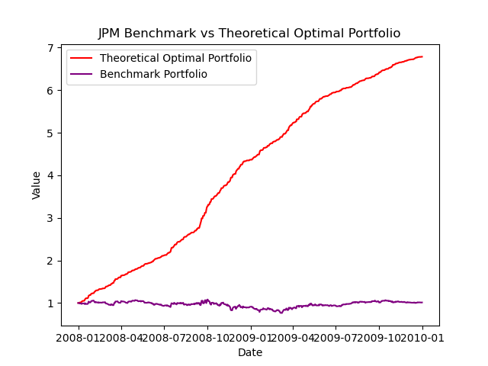
- JPM Benchmark vs Theoretical Optimal Portfolio Plot from 01/01/2008 to 12/31/2009

