CS7646
  - Xing Liu
xliu397@gatech.edu

Introduction
This report compares a rule-based Manual Strategy against a data-driven Random Forest Strategy Learner trading JPM, with a benchmark of buy-and-hold 1000 shares. Both strategies draw on the same three indicators from Project 6. The Manual Strategy outperforms the benchmark in-sample by exploiting mean-reversion. The Strategy Learner beats the Manual Strategy in-sample because it learns from data, but overfits out-of-sample. I found raising market impact degrades Strategy Learner returns monotonically.

Methods
I use three indicators, each with a 14-day lookback. All three generate clear entry thresholds.
- Relative Strength Index (RSI): Computed as “100 − 100/(1+RS)” where “RS = avg_gain / avg_loss” over a 14-day rolling window. Values below 30 indicate oversold conditions (long signal); values above 70 indicate overbought conditions (short signal).
- EMA Ratio: “price / EMA(14)”, where EMA uses pandas “ewm(span=14, adjust=False)”. I interpret it as a mean-reversion signal: ratio above 1.02 means price has stretched above its recent average (short); below 0.98 means price has fallen below (long).
- Bollinger Bands: “(price − lower) / (upper − lower)”, where bands are SMA(14) ± 2*stdev(14). Values below 0 are outside the lower band (long); above 1 are outside the upper band (short).

All three parameters (lookback = 14, Bollinger Band stdev multiplier = 2, RSI thresholds 30/70) are standard technical-analysis defaults and kept identical between Manual and Strategy Learner.

Discussion

Manual Strategy
Each indicator casts a vote in {-1, 0, +1} using the thresholds above. Votes are summed. A sum ≥ +1 targets a long 1000-share position; a sum ≤ -1 targets a short 1000-share position, otherwise no changes. Trades are computed as the first difference of the target series. Entry thresholds are intentionally on opposing ends of the spectrum (RSI 30/70 vs. EMA 0.98/1.02) to capture each indicator's natural extremes. The majority-vote scheme ensures no single indicator can dominate, satisfying the project rule that all three must contribute.
I believe this is effective because the in-sample window (Jan 2008 – Dec 2009) spans the 2008 financial crisis — a regime where mean-reversion dominates. When JPM crashes sharply, all three oversold signals align and produce high-conviction long entries near local bottoms.
In the In-Sample vs Out-of-Sample tests, I use commission = $9.95, impact = 0.005, starting cash = $100,000. Results are below.
Performance Metrics Table:
Metric | Benchmark(In Sample) | Manual(In Sample) | Benchmark(Out of Sample) | Manual(Out of Sample)
Cumulative Return | 0.012325 | 0.297370 | -0.083579 | -0.210421
Sharpe Ratio | 0.130661 | 0.641192 | -0.213250 | -0.813279
Std Dev | 0.014156 | 0.010084 | 0.007059 | 0.005976
Mean Daily Return | 0.000117 | 0.000407 | -0.000095 | -0.000306
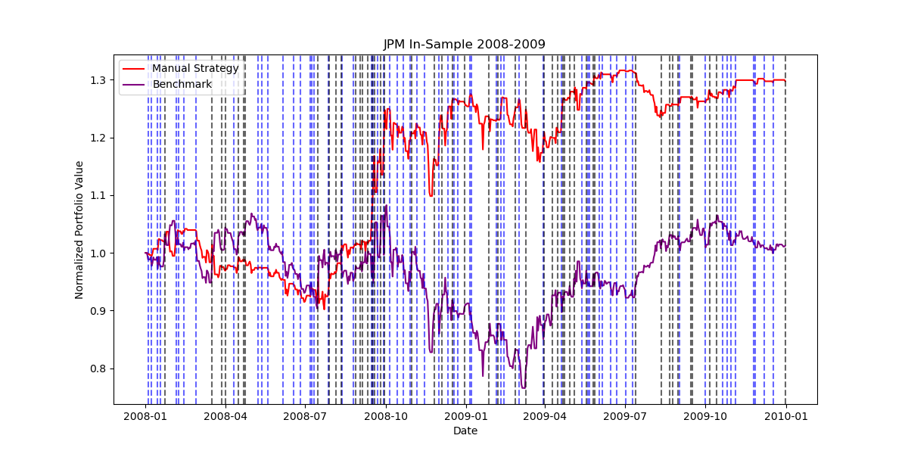
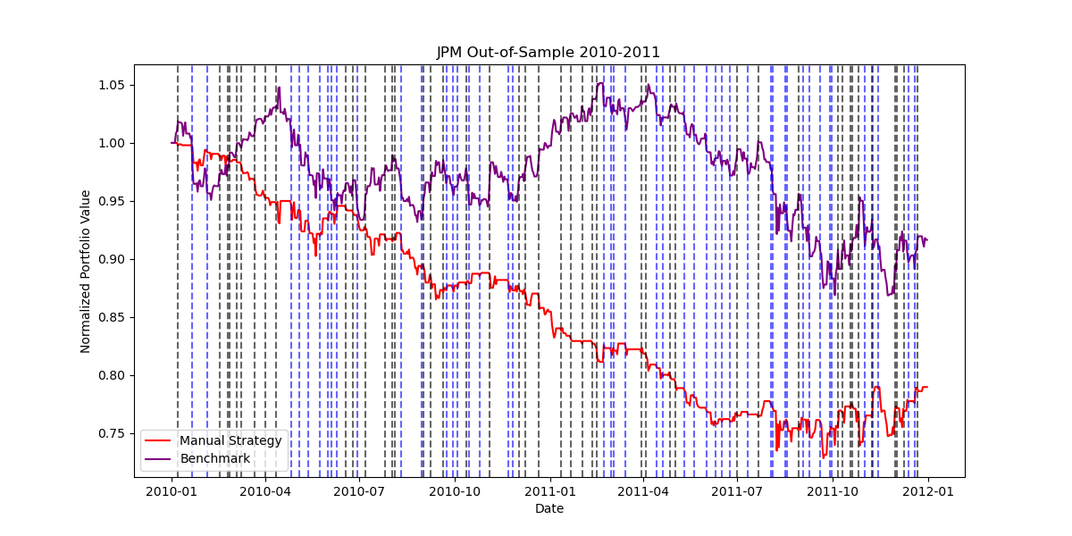
- In sample Benchmark and Manual Strategy from 2008 through 2009. Blue lines are long entries, and black are short entries.
- Out of sample Benchmark and Manual Strategy from 2010 through 2011. Blue lines are long entries, and black are short entries.
The Manual Strategy outperforms the benchmark by about 28.5 percentage points of cumulative return and roughly 5x Sharpe ratio in-sample. Out-of-sample, it underperforms the benchmark by about 12.7 points. This reversal reflects the strategy's implicit assumption that mean-reversion dominates.
The in-sample window contains the 2008 crash, when JPM swung from ~$45 to ~$20 and back. Mean-reversion signals produced high-conviction long entries near the lows and exits near the recovery. The out-of-sample window (Jan 2010 – Dec 2011) is dominated by the European sovereign debt crisis, where JPM declined steadily from ~$45 to ~$30 with lower volatility and weaker mean-reverting behavior. Our indicators kept sending oversold signals into a strategy that no longer seemed to work, and the strategy bled capital. I tuned the rule to a regime that doesn't repeat.

Strategy Learner
We frame the problem as a 3-class classification: for each trading day, predict whether the 10-day forward return will be a “+1”(buy), “-1”(sell), or “0”(hold). Labels are generated by computing “future_ret = prices.shift(-10) / prices – 1” and bucketing: “future_ret > buyHurdle” being +1, “future_ret < -sellHurdle” being -1, otherwise 0. We set “buyHurdle = sellHurdle = 0.02 + impact”. The 0.02 floor represents a noise threshold. Smaller moves are likely random and would teach the learner to trade on meaningless signal. Scaling with impact makes the labels impact-aware: a higher impact environment requires bigger expected moves before committing capital.
Features are the same three indicators as Manual Strategy. No standardization is applied: RSI is already bounded in [0,100], Bollinger Band is roughly in [0,1], and EMA ratio is centered near 1.0. Random Trees split on single features at a time and are scale-invariant in the classification setting we use, so normalization provides no benefit.
Hyperparameters for my strategy learner:
  - Learner: BagLearner(learner=RTLearner, kwargs={"leaf_size": 5}, bags=20) a Random Forest.
  - leaf_size = 5
  - bags = 20
  - Leaf aggregation: Mode per leaf via np.unique + argmax on training labels.
  - Ensemble aggregation: np.sign(sum_across_bags) returns exactly the majority vote over {-1, 0, +1} without floating-point drift.
  - lookAhead = 10 days

Experiment 1: Manual vs Strategy Learner
The Strategy Learner beats the Manual Strategy in-sample because it learns feature combinations from data rather than relying on hand-set thresholds, but it also overfits and underperforms out-of-sample more than the Manual Strategy.
In terms of setup, both strategies trade JPM with commission = $9.95, impact = 0.005, sv = $100,000. The Strategy Learner trains on the in-sample window (2008-01-01 to 2009-12-31) and is then evaluated on both the in-sample and out-of-sample (2010-01-01 to 2011-12-31) windows without retraining. The benchmark is buy-and-hold 1000 shares. Random seed = 903011732 set once in testproject.py.
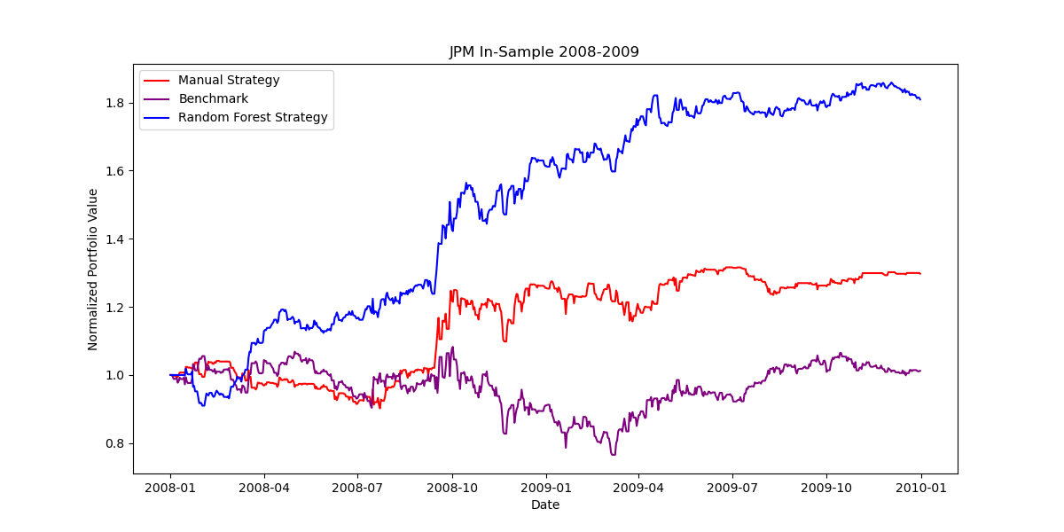
Performance Metrics Table:
Metric | Benchmark | Manual | Strategy Learner
In-Sample Cumulative Return | 0.012325 | 0.297370 | 0.808761
In-Sample Sharpe | 0.130661 | 0.641192 | 1.548721
Out-of-Sample Cumulative Return | −0.083579 | −0.210421 | −0.778761
Out-of-Sample Sharpe | −0.213250 | −0.813279 | −2.295211
- Manual, Benchmark, and Random Forest Strategies all overlayed in-sample period from 2008 through 2009

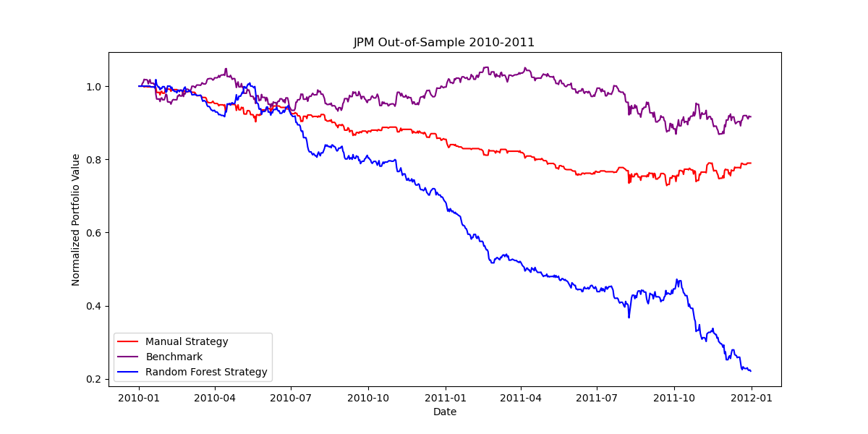
- Manual, Benchmark, and Random Forest Strategies all overlayed out-of-sample period from 2010 through 2011
In-sample, the Strategy Learner produces cumulative return more than 2.7x the Manual Strategy and Sharpe more than 2x. This demonstrates the learner extracts finer feature combinations than the hand-built vote aggregator. However, out-of-sample, the learner's cumulative return collapses to −77.9% versus Manual's −21.0% and Benchmark's −8.4% where the learner loses nearly 9x the benchmark's loss. This reinforces my understanding that data-driven learning wins in-sample but is fragile out of sample due to shifts in the market and overfitting in-sample.
The behavior of the in-sample outperformance depends on the specific bootstrap samples and split features each bag picks. A different seed would shift the numbers modestly, but the directional result (Learner > Manual > Benchmark in-sample) should persist across seeds because both strategies use the same signal-bearing indicators. The out-of-sample degradation ordering is also expected to persist. The learner has 20 trees x multiple decision paths worth of flexibility to memorize the 2008 crash pattern, while the Manual Strategy has only 6 fixed thresholds.

Experiment 2: Impact Sensitivity
As impact rises, the label-generation thresholds “buyHurdle = sellHurdle = 0.02 + impact” grow, fewer training days qualify as confident +1/−1 labels, and the learner's predicted trades respond to a noisier signal. The following occurs:
- Cumulative return decreases monotonically with impact
- The number of trades changes.
In terms of setup, we followed JPM in-sample only (2008-01-01 to 2009-12-31), commission = $0.00, starting value = $100,000. Four impact values tested: 0.0, 0.005, 0.01, 0.05. For each impact, a fresh StrategyLearner is trained and evaluated. I captured four measurements per metric: cumulative return, number of trades, Sharpe, and Standard Deviation.

Impact | Cumulative Return | # Trades | Sharpe | Standard Deviation
0 | 1.923400 | 218 | 3.028044 | 0.007871
0.005 | 1.381399 | 224 | 2.528730 | 0.007649
0.010 | 0.460846 | 212 | 0.862544 | 0.010581
0.050 | −5.881060 | 258 | −0.320230 | 0.230285

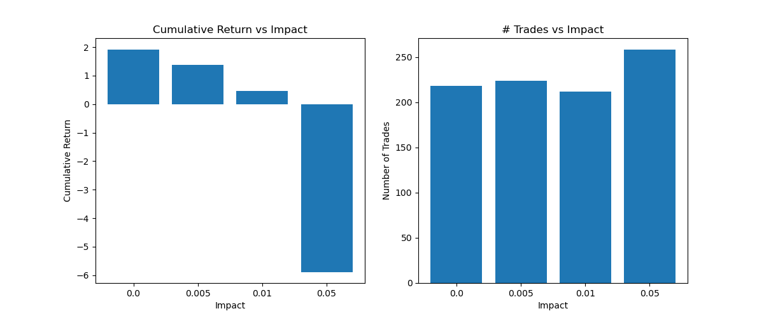
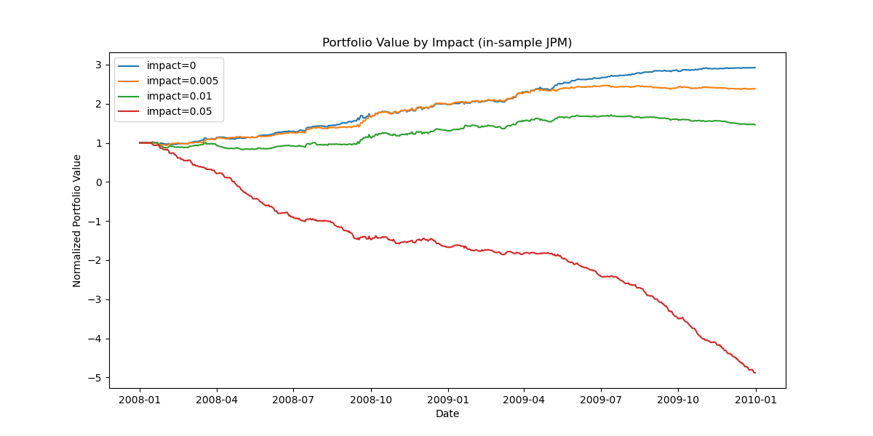
- Portfolio value from 2008 through 2009 as impact varies from 0 to 0.05.

- Side-by-side bar charts of cumulative return and # trades vs impact
Cumulative return drops monotonically from +192% at zero impact to −588% at impact = 0.05, confirming the first part of the hypothesis. The Sharpe ratio collapses similarly, and standard deviation explodes at impact = 0.05 as the learner churns. Trade count is non-monotonic: 218 to 224 to 212 to 258. I would have expected fewer trades as impact rises (higher buyHurdle/sellHurdle should filter out marginal labels), but at impact = 0.05 the learner trades more. This is explained by the label structure: at buyHurdle = 0.07, the in-sample window produces very few +1/−1 labels (most days become class 0), which starves each tree of signal-bearing training data. The trees become noisy class-0-biased predictors that flip predictions frequently on out-of-training-distribution feature combinations, generating spurious trades. Impact changes behavior, not just returns. Higher impact may sometimes destabilize learners if gone too far.
The portfolio-value chart makes this vivid: at impact = 0.05 the equity curve diverges from the other three by mid-2008 and spirals into deep negative territory, while the impact = 0 curve rides the in-sample crash-and-recovery cleanly. Any practical deployment should therefore either measure realistic impact from execution data before training, or make impact a tunable hyperparameter rather than a static constant.

Summary
The Random Forest Strategy Learner beats the Manual Strategy in-sample by a wide margin but fails out-of-sample. This demonstrates the bias-variance trade-off. Impact is not a parameter to take lightly, a 10x change in impact turns a profitable learner into a non-working one. To summarize, deploying learners on algorithmic trading should be done carefully. Backtests optimize based on past rewards, however those reward signals don't persist into the future in the experiments that we’ve seen.

