Project 1 – Martingale Report

Xing Liu (xliu397)

Abstract

This report evaluates the Martingale betting strategy through Monte Carlo simulation on an American roulette wheel. Two experiments were conducted: one with unlimited bankroll and one with a realistic $256 bankroll. Results demonstrate that while the strategy appears successful with unlimited funds (100% win rate), introducing a bankroll constraint reveals its fundamental flaw—a negative expected value of -$33.90 due to catastrophic bankruptcy events.

Introduction

Experiment 1: Unlimited Bankroll

In this experiment, I implemented the Martingale betting strategy with no bankroll constraints. The strategy involves betting on black (win probability = 18/38 ≈ 0.474), starting with a $1 bet, doubling after each loss, and resetting to $1 after each win. The target is to accumulate $80 in winnings.

I ran 1000 episodes of 1000 spins each using Monte Carlo simulation. Winnings were tracked in a NumPy array, and values were forward-filled after reaching the $80 target.
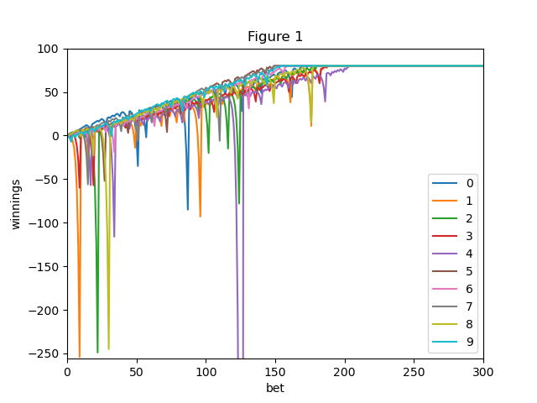Figure 1: 10 episodes showing individual winnings trajectories with unlimited bankroll.

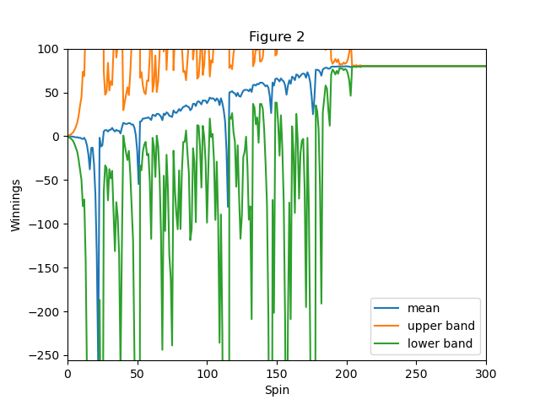Figure 2: Mean winnings ± standard deviation across 1000 episodes (unlimited bankroll).

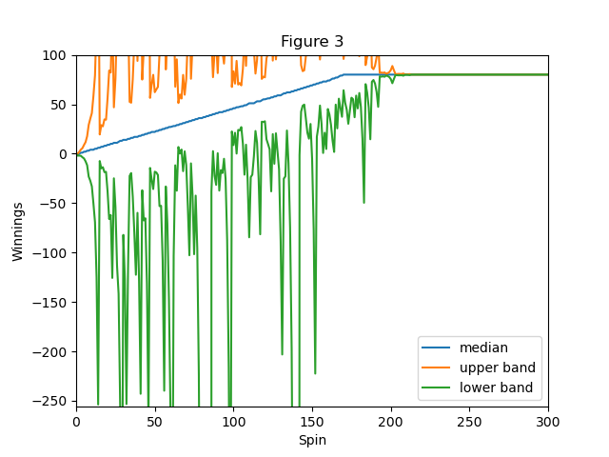Figure 3: Median winnings ± standard deviation across 1000 episodes (unlimited bankroll).

Experiment 2: $256 Bankroll

This experiment introduces a realistic constraint: a $256 bankroll. If winnings reach -$256, the gambler is bankrupt and must stop. Additionally, if the required bet exceeds available funds, the gambler can only bet their remaining balance.

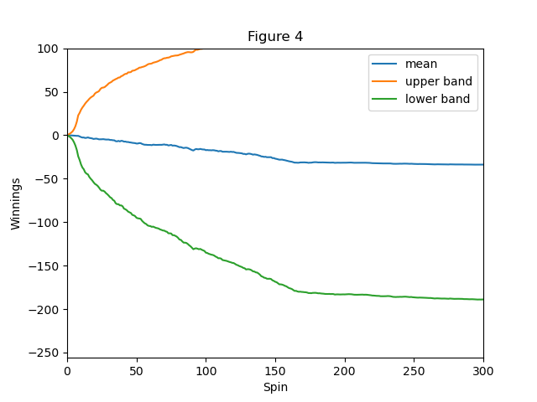Figure 4: Mean winnings ± standard deviation across 1000 episodes ($256 bankroll).

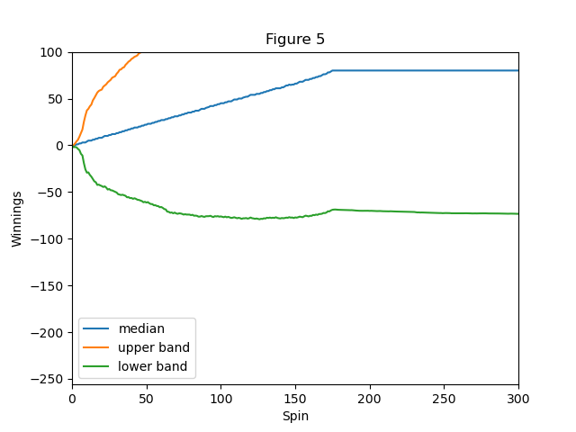Figure 5: Median winnings ± standard deviation across 1000 episodes ($256 bankroll).

Discussion

Question 1

The estimated probability of winning exactly $80 within 1000 sequential bets is 100% (1.0). This was calculated directly from the simulation output by counting episodes where final winnings reached $80 or greater: 1000 out of 1000 episodes succeeded.

This result occurs because the Martingale strategy with unlimited bankroll guarantees eventual recovery from any losing streak. Each betting round nets exactly +$1 profit regardless of how many consecutive losses occur. Mathematically, after N losses totaling $(2^N - 1), winning the next bet of $2^N yields a net gain of $1. With no bankroll limit, the gambler can always afford the next doubled bet, ensuring eventual success.

Question 2

The estimated expected value of winnings after 1000 sequential bets is $80.00. This was computed by taking the mean of final winnings across all 1000 episodes.

Since 100% of episodes reach the $80 target and stop betting (with values forward-filled), every episode contributes exactly $80 to the mean. The expected value equals the target amount because unlimited bankroll eliminates the risk of ruin that would otherwise reduce the average.

Question 3

Both the upper (mean + stdev) and lower (mean - stdev) lines stabilize at $80. The standard deviation lines converge and merge at $80.

As episodes progress, more gamblers reach the $80 target. Once an episode reaches $80, it stops changing (values are forward-filled). By approximately spin 200, nearly all 1000 episodes have reached $80. When all values are identical, the standard deviation becomes zero, causing both bands to converge to the mean at $80. The stabilization at $80 (rather than continuing upward) occurs because the strategy stops upon reaching the target.

Question 4

The estimated probability of winning exactly $80 within 1000 sequential bets is 66.1% (0.661). This was calculated from simulation output: 661 out of 1000 episodes ended with winnings ≥ $80.

This probability is significantly lower than Experiment 1 (100%) because the $256 bankroll introduces bankruptcy risk. A gambler who loses 8+ consecutive bets (1+2+4+8+16+32+64+128 = $255) will exhaust their bankroll before recovering. The probability of 8 consecutive losses is approximately (20/38)^8 ≈ 0.4%, but over the many betting rounds required to reach $80, this cumulative risk causes 33.9% of episodes to go bankrupt.

Question 5

The estimated expected value of winnings after 1000 sequential bets is -$33.90. This was computed by taking the mean of final winnings across all 1000 episodes.

This negative expected value can be verified mathematically using the win/loss probabilities:
- 66.1% of episodes win $80: 0.661 × $80 = $52.88
- 33.9% of episodes lose $256: 0.339 × (-$256) = -$86.78
- Expected value: $52.88 - $86.78 = -$33.90

This demonstrates the fundamental flaw of the Martingale strategy: while most gamblers win small amounts ($80), the minority who go bankrupt lose large amounts ($256). The catastrophic losses outweigh the frequent small wins, resulting in negative expected value.

Question 6

The upper band stabilizes around $100 and the lower band stabilizes around -$190. The standard deviation lines do not converge.
Unlike Experiment 1, outcomes in Experiment 2 are bimodal—episodes end at either +$80 (winners) or -$256 (bankrupt). By approximately spin 200, all episodes have reached a terminal state, causing the statistics to stabilize. However, because there remains a permanent split between winners and losers, the standard deviation stays large. The spread between +$80 and -$256 creates persistent variability that never disappears. The lines stabilize (stop changing) but do not converge (remain far apart) because the two distinct outcome groups maintain separation.

Question 7

Using expected values instead of individual episode results provides several benefits:

- Reduces random variance: A single episode could be unusually lucky (winning $80 quickly) or unlucky (going bankrupt). Expected values average across many trials, filtering out random noise.
- Reveals true long-term outcomes: In Experiment 2, any single episode has a 66% chance of success, which might suggest the strategy works. However, the expected value of -$33.90 reveals that over many attempts, a gambler will lose money on average.
- Law of Large Numbers: As trial count increases, the sample mean converges to the true expected value, providing increasingly accurate estimates of real-world performance.
- Enables informed decision-making: Expected value quantifies whether a strategy is profitable long-term. A positive expected value suggests profitability; negative suggests loss. Combined with standard deviation, it enables comprehensive risk assessment.
- Exposes hidden risks: The Martingale strategy's apparent success rate (66%) masks its negative expected value. Only by computing expectations do we see that frequent small wins cannot compensate for rare catastrophic losses.

Conclusion

The experiments demonstrate that the Martingale betting strategy's apparent success depends entirely on having unlimited funds. With no bankroll constraint, the strategy achieves 100% success and $80 expected value. However, realistic constraints ($256 bankroll) reveal its fatal flaw: a negative expected value of -$33.90 despite a 66% win rate. This highlights the importance of expected value analysis in evaluating betting and investment strategies - high win rates can mask negative long-term outcomes.

