Physical Network Dataset: Skeletons and Meshes

The Physical Network Consortium, CCNR

Thumbnail | Name | # of samples | Original data type | Skeleton (.swc) | Mesh | Pixel/voxel image | Tree graph
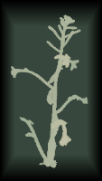 | arabidopsis | 52 | point cloud | Y | Y | Y | Y
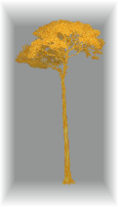 | tropical-tree | 29 | point cloud | Y | Y | N | Y
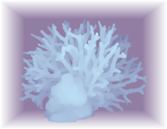 | coral | 28 | mesh | Y | Y | Y | Y
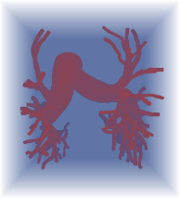 | vascular | 31 | mesh | Y | Y | Y | Y
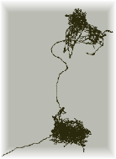 | neuron-fruit-fly-hemibrain | 71  (22,699) | voxel image | Y | Y | N | N
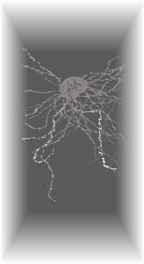 | neuron-human-h01 | 104  (46,378) | voxel image | Y | Y | N | N
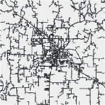 | power-grid | 229 | pixel image | Y | N/A | Y | Y
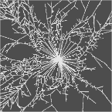 | fungal | 36 | skeleton | Y | N/A | N | N
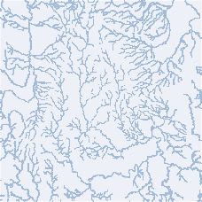 | watercourse-france | 1 | pixel image | Y | N/A | N | N
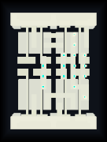 | integrated-circuit-pharosc | 478 | voxel image | Y | Y | Y | N

Thumbnail | Description | Link
 | 5 plants, scanned at 10+ times each | https://zenodo.org/record/5205562#.YpTE1hxBxuS
 | 10 from Guyana, 10 Indonesia, and 9 from Peru | http://lucid.wur.nl/datasets/terrestrial-lidar-of-tropical-forests
 | manually selected different species | https://3d.si.edu/corals
 | Human, pulmonary | https://www.vascularmodel.com/index.html
 | Fruit fly, brain, 3 random neurons | https://www.janelia.org/project-team/flyem/hemibrain
 | Human, brain | https://h01-release.storage.googleapis.com/explore.html
 | Power grids in Texas | https://www.entergy.com/view-outages/
 | Fungal networks. | https://github.com/aguilart/Fungal_Networks
 | Collection of all watercourses in the metropolitan France. | https://www.sandre.eaufrance.fr/atlas/srv/eng
 | Physical layouts of transistors. | http://www.vlsitechnology.org
neuron-human-h01:

The skeletons are generated by the skeletonization package, using the wavefront function:
sk.skeletonize.by_wavefront(fixed, waves=1, step_size=1)

