Best First Search

Greedy Search f(n)=h(n)

A\*Search f(n)=g(n)+h(n)

Greedy Search: f = h

hSLD(n):the direct distance from n to target node

Calculate each action from F, find the lowest evaluation one(heuristic), make it be the best action.

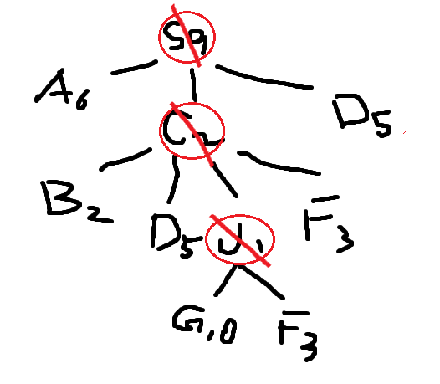

Open = [S9]; closed = [];

Open = [C2, D5, A6]; closed = [S9];

Open = [J1, B2, F3, D5, A6]; closed = [S9,C2];

Open = [G1o, B2, F3, D5, A6]; closed = [S9,C2, J1];

S9— A6 — G1o

S9—  C2 — J1— G1o

                                 J1— G1o

                C2— B2 — G1o

                C2— F3 — G2o

                C2— D5 — E5 — G2o

S9— D5 — E5 —G2o

