Ольга Ходина, 38 -когорта, 4-й спринт

# **Консоль**

## Задание 1

**Команда или последовательность команд, которой удалось получить нужные логи**:

grep -R "^233.201" /logs/2019/12

**Логи:**

logs/2019/12/apache_2019-12-18.txt:233.201.188.154 - - [18/12/2019:21:46:01 +0000] "DELETE /events HTTP/1.1" 403 3971

logs/2019/12/apache_2019-12-21.txt:233.201.182.9 - - [21/12/2019:21:56:20 +0000] "PATCH /users HTTP/1.1" 400 4118

## Задание 2

**Команды, которые создают директории bug1 и events:**

cd~

mkdir bug1

mkdir bug1/events

Команда, которой выбираешь запросы за указанный период. Это те запросы, которыми ты отбираешь логи в файл main.txt:

grep -Ri ‘3[01]/12/2019:21:3’ logs/2019/12/apache_2019-12-3*.txt > bug1/main.txt

**Команды, которыми ты кладёшь логи в файлы 400.txt и 500.txt из main.txt:**

cd bug1/events

touch 400.txt 500.txt;

grep ‘ 400’ bug1/main.txt>bug1/events/400.txt;

grep ‘ 500’ bug1/main.txt>bug1/events/500.txt;

(Можно еще сделать таким образом, сразу отобрать и по времени и по номеру ошибки:

1. grep -Ri ‘3[01]/12/2019:21:3’ logs/2019/12/apache_2019-12-3*.txt|grep ‘400’> bug1/events/400.txt;
2. grep -Ri ‘3[01]/12/2019:21:3’ logs/2019/12/apache_2019-12-3*.txt|grep ‘500’> bug1/events/500.txt;)

*Напиши тут команды

**400.txt**

cat bug1/events/400.txt  
*logs/2019/12/apache_2019-12-30.txt:80.57.170.51 - - [30/12/2019:21:35:12 +0000] "DELETE /users HTTP/1.1" 400 3623

logs/2019/12/apache_2019-12-30.txt:204.235.176.118 - - [30/12/2019:21:35:13 +0000] "POST /users HTTP/1.1" 400 4704

logs/2019/12/apache_2019-12-30.txt:82.95.203.67 - - [30/12/2019:21:35:19 +0000] "DELETE /lists HTTP/1.1" 400 3737

logs/2019/12/apache_2019-12-30.txt:155.242.215.46 - - [30/12/2019:21:35:38 +0000] "POST /playbooks HTTP/1.1" 400 4450

logs/2019/12/apache_2019-12-30.txt:189.176.85.0 - - [30/12/2019:21:35:39 +0000] "PATCH /alerts HTTP/1.1" 400 2732

logs/2019/12/apache_2019-12-30.txt:13.108.71.71 - - [30/12/2019:21:35:43 +0000] "PATCH /events HTTP/1.1" 400 3410

logs/2019/12/apache_2019-12-30.txt:195.213.133.182 - - [30/12/2019:21:35:46 +0000] "PUT /customers HTTP/1.1" 400 3085

logs/2019/12/apache_2019-12-30.txt:235.243.133.78 - - [30/12/2019:21:35:47 +0000] "PATCH /customers HTTP/1.1" 400 3264

logs/2019/12/apache_2019-12-30.txt:192.57.115.49 - - [30/12/2019:21:35:55 +0000] "POST /parsers HTTP/1.1" 400 2457

logs/2019/12/apache_2019-12-30.txt:71.0.49.244 - - [30/12/2019:21:35:55 +0000] "PUT /collectors HTTP/1.1" 400 2785

logs/2019/12/apache_2019-12-30.txt:224.159.206.126 - - [30/12/2019:21:36:02 +0000] "DELETE /customers HTTP/1.1" 400 4569

logs/2019/12/apache_2019-12-30.txt:131.35.106.246 - - [30/12/2019:21:36:04 +0000] "DELETE /lists HTTP/1.1" 400 2578

logs/2019/12/apache_2019-12-30.txt:216.24.42.208 - - [30/12/2019:21:36:06 +0000] "GET /parsers HTTP/1.1" 400 4597

logs/2019/12/apache_2019-12-30.txt:123.53.150.160 - - [30/12/2019:21:37:19 +0000] "PATCH /events HTTP/1.1" 400 4379

logs/2019/12/apache_2019-12-30.txt:61.129.127.103 - - [30/12/2019:21:37:32 +0000] "GET /lists HTTP/1.1" 400 2575

logs/2019/12/apache_2019-12-30.txt:90.216.4.78 - - [30/12/2019:21:37:34 +0000] "PATCH /lists HTTP/1.1" 400 3899

logs/2019/12/apache_2019-12-30.txt:204.250.214.208 - - [30/12/2019:21:37:36 +0000] "PATCH /parsers HTTP/1.1" 400 4742

logs/2019/12/apache_2019-12-30.txt:79.214.240.98 - - [30/12/2019:21:37:37 +0000] "POST /fieldsets HTTP/1.1" 400 4441

logs/2019/12/apache_2019-12-30.txt:65.47.42.12 - - [30/12/2019:21:37:39 +0000] "PATCH /customers HTTP/1.1" 400 2500

logs/2019/12/apache_2019-12-30.txt:251.118.141.34 - - [30/12/2019:21:37:41 +0000] "POST /customers HTTP/1.1" 400 3519

logs/2019/12/apache_2019-12-30.txt:205.20.166.196 - - [30/12/2019:21:37:51 +0000] "POST /users HTTP/1.1" 400 4032

logs/2019/12/apache_2019-12-30.txt:156.217.3.46 - - [30/12/2019:21:37:52 +0000] "PATCH /parsers HTTP/1.1" 400 2020

logs/2019/12/apache_2019-12-30.txt:48.240.198.167 - - [30/12/2019:21:37:57 +0000] "PATCH /playbooks HTTP/1.1" 400 4100

logs/2019/12/apache_2019-12-30.txt:101.255.159.211 - - [30/12/2019:21:37:59 +0000] "GET /auth HTTP/1.1" 400 2324

logs/2019/12/apache_2019-12-30.txt:80.76.98.203 - - [30/12/2019:21:38:00 +0000] "POST /playbooks HTTP/1.1" 400 3045

logs/2019/12/apache_2019-12-30.txt:85.64.63.255 - - [30/12/2019:21:38:13 +0000] "PATCH /collectors HTTP/1.1" 400 2291

logs/2019/12/apache_2019-12-30.txt:184.79.247.161 - - [30/12/2019:21:38:13 +0000] "PUT /alerts HTTP/1.1" 400 3557

logs/2019/12/apache_2019-12-30.txt:93.2.134.22 - - [30/12/2019:21:39:39 +0000] "DELETE /alerts HTTP/1.1" 400 3701

logs/2019/12/apache_2019-12-31.txt:86.34.86.182 - - [31/12/2019:21:35:10 +0000] "POST /auth HTTP/1.1" 400 3626

logs/2019/12/apache_2019-12-31.txt:167.37.16.117 - - [31/12/2019:21:35:17 +0000] "PATCH /customers HTTP/1.1" 400 3294

logs/2019/12/apache_2019-12-31.txt:199.128.92.19 - - [31/12/2019:21:35:43 +0000] "PUT /users HTTP/1.1" 400 4180

logs/2019/12/apache_2019-12-31.txt:162.152.99.143 - - [31/12/2019:21:35:59 +0000] "PUT /users HTTP/1.1" 400 4606

logs/2019/12/apache_2019-12-31.txt:83.115.59.224 - - [31/12/2019:21:37:26 +0000] "GET /alerts HTTP/1.1" 400 3489

logs/2019/12/apache_2019-12-31.txt:194.10.97.226 - - [31/12/2019:21:37:31 +0000] "DELETE /lists HTTP/1.1" 400 2447

logs/2019/12/apache_2019-12-31.txt:180.99.214.40 - - [31/12/2019:21:37:44 +0000] "DELETE /alerts HTTP/1.1" 400 2077

logs/2019/12/apache_2019-12-31.txt:154.152.205.4 - - [31/12/2019:21:37:50 +0000] "GET /playbooks HTTP/1.1" 400 3324

logs/2019/12/apache_2019-12-31.txt:197.82.125.54 - - [31/12/2019:21:37:52 +0000] "PUT /fieldsets HTTP/1.1" 400 4365

logs/2019/12/apache_2019-12-31.txt:115.89.87.219 - - [31/12/2019:21:38:06 +0000] "PUT /playbooks HTTP/1.1" 400 2589

logs/2019/12/apache_2019-12-31.txt:100.77.15.14 - - [31/12/2019:21:38:07 +0000] "GET /fieldsets HTTP/1.1" 400 4911

logs/2019/12/apache_2019-12-31.txt:22.33.159.242 - - [31/12/2019:21:38:07 +0000] "GET /playbooks HTTP/1.1" 400 3955

logs/2019/12/apache_2019-12-31.txt:149.148.229.11 - - [31/12/2019:21:39:16 +0000] "GET /users HTTP/1.1" 400 2071

logs/2019/12/apache_2019-12-31.txt:236.107.64.192 - - [31/12/2019:21:39:17 +0000] "PATCH /users HTTP/1.1" 400 2791

logs/2019/12/apache_2019-12-31.txt:24.156.105.39 - - [31/12/2019:21:39:23 +0000] "GET /lists HTTP/1.1" 400 2902

logs/2019/12/apache_2019-12-31.txt:193.50.164.254 - - [31/12/2019:21:39:23 +0000] "PUT /playbooks HTTP/1.1" 400 3296

logs/2019/12/apache_2019-12-31.txt:18.123.104.91 - - [31/12/2019:21:39:52 +0000] "GET /collectors HTTP/1.1" 400 4372

logs/2019/12/apache_2019-12-31.txt:234.218.148.4 - - [31/12/2019:21:39:54 +0000] "PUT /users HTTP/1.1" 400 2509

**500.txt.**  
cat bug1/events/500.txt

logs/2019/12/apache_2019-12-30.txt:64.250.112.189 - - [30/12/2019:21:35:13 +0000] "PUT /parsers HTTP/1.1" 500 4639

logs/2019/12/apache_2019-12-30.txt:193.253.101.180 - - [30/12/2019:21:35:31 +0000] "PATCH /alerts HTTP/1.1" 500 2944

logs/2019/12/apache_2019-12-30.txt:197.106.117.194 - - [30/12/2019:21:35:31 +0000] "PATCH /parsers HTTP/1.1" 500 3519

logs/2019/12/apache_2019-12-30.txt:247.124.71.67 - - [30/12/2019:21:35:45 +0000] "PUT /alerts HTTP/1.1" 500 2746

logs/2019/12/apache_2019-12-30.txt:62.88.204.119 - - [30/12/2019:21:35:51 +0000] "PUT /auth HTTP/1.1" 500 2666

logs/2019/12/apache_2019-12-30.txt:125.156.142.26 - - [30/12/2019:21:36:01 +0000] "PATCH /events HTTP/1.1" 500 3460

logs/2019/12/apache_2019-12-30.txt:144.170.212.70 - - [30/12/2019:21:36:04 +0000] "DELETE /parsers HTTP/1.1" 500 2599

logs/2019/12/apache_2019-12-30.txt:59.39.200.252 - - [30/12/2019:21:36:05 +0000] "GET /alerts HTTP/1.1" 500 2650

logs/2019/12/apache_2019-12-30.txt:150.136.200.100 - - [30/12/2019:21:37:24 +0000] "POST /lists HTTP/1.1" 500 2684

logs/2019/12/apache_2019-12-30.txt:84.81.25.45 - - [30/12/2019:21:37:25 +0000] "POST /auth HTTP/1.1" 500 2052

logs/2019/12/apache_2019-12-30.txt:30.222.160.141 - - [30/12/2019:21:37:30 +0000] "PATCH /parsers HTTP/1.1" 500 2017

logs/2019/12/apache_2019-12-30.txt:117.87.158.36 - - [30/12/2019:21:37:34 +0000] "POST /fieldsets HTTP/1.1" 500 4056

logs/2019/12/apache_2019-12-30.txt:212.153.128.212 - - [30/12/2019:21:37:42 +0000] "PUT /fieldsets HTTP/1.1" 500 3259

logs/2019/12/apache_2019-12-30.txt:58.188.83.217 - - [30/12/2019:21:37:46 +0000] "POST /playbooks HTTP/1.1" 500 3947

logs/2019/12/apache_2019-12-30.txt:193.123.131.146 - - [30/12/2019:21:37:47 +0000] "PUT /lists HTTP/1.1" 500 3902

logs/2019/12/apache_2019-12-30.txt:182.7.179.91 - - [30/12/2019:21:37:48 +0000] "GET /users HTTP/1.1" 500 2950

logs/2019/12/apache_2019-12-30.txt:10.25.168.164 - - [30/12/2019:21:38:05 +0000] "PATCH /playbooks HTTP/1.1" 500 3858

logs/2019/12/apache_2019-12-30.txt:215.201.210.173 - - [30/12/2019:21:38:11 +0000] "PATCH /customers HTTP/1.1" 500 3277

logs/2019/12/apache_2019-12-30.txt:179.241.103.167 - - [30/12/2019:21:39:23 +0000] "POST /lists HTTP/1.1" 500 3669

logs/2019/12/apache_2019-12-30.txt:147.188.170.252 - - [30/12/2019:21:39:33 +0000] "POST /fieldsets HTTP/1.1" 500 3313

logs/2019/12/apache_2019-12-30.txt:1.249.123.189 - - [30/12/2019:21:39:36 +0000] "PATCH /alerts HTTP/1.1" 500 4734

logs/2019/12/apache_2019-12-30.txt:124.114.135.105 - - [30/12/2019:21:39:41 +0000] "PATCH /customers HTTP/1.1" 500 3348

logs/2019/12/apache_2019-12-30.txt:35.215.100.202 - - [30/12/2019:21:39:43 +0000] "PUT /alerts HTTP/1.1" 500 4345

logs/2019/12/apache_2019-12-30.txt:86.222.23.128 - - [30/12/2019:21:39:44 +0000] "PATCH /alerts HTTP/1.1" 500 2230

logs/2019/12/apache_2019-12-30.txt:20.161.75.95 - - [30/12/2019:21:39:48 +0000] "DELETE /users HTTP/1.1" 500 2412

logs/2019/12/apache_2019-12-30.txt:196.18.151.117 - - [30/12/2019:21:39:55 +0000] "PUT /events HTTP/1.1" 500 4439

logs/2019/12/apache_2019-12-30.txt:77.101.138.151 - - [30/12/2019:21:39:57 +0000] "PUT /lists HTTP/1.1" 500 2194

logs/2019/12/apache_2019-12-31.txt:208.205.133.127 - - [31/12/2019:21:35:17 +0000] "DELETE /alerts HTTP/1.1" 500 4561

logs/2019/12/apache_2019-12-31.txt:20.145.255.91 - - [31/12/2019:21:35:30 +0000] "GET /parsers HTTP/1.1" 500 3051

logs/2019/12/apache_2019-12-31.txt:91.66.134.13 - - [31/12/2019:21:35:53 +0000] "POST /lists HTTP/1.1" 500 3319

logs/2019/12/apache_2019-12-31.txt:31.88.211.206 - - [31/12/2019:21:35:57 +0000] "DELETE /events HTTP/1.1" 500 2325

logs/2019/12/apache_2019-12-31.txt:171.37.114.114 - - [31/12/2019:21:37:39 +0000] "DELETE /fieldsets HTTP/1.1" 500 3253

logs/2019/12/apache_2019-12-31.txt:223.157.242.167 - - [31/12/2019:21:37:59 +0000] "POST /users HTTP/1.1" 500 2283

logs/2019/12/apache_2019-12-31.txt:98.181.102.34 - - [31/12/2019:21:38:06 +0000] "PATCH /fieldsets HTTP/1.1" 500 4672

logs/2019/12/apache_2019-12-31.txt:254.74.22.79 - - [31/12/2019:21:38:06 +0000] "PUT /lists HTTP/1.1" 500 2259

logs/2019/12/apache_2019-12-31.txt:103.46.238.3 - - [31/12/2019:21:38:09 +0000] "PUT /lists HTTP/1.1" 500 3992

logs/2019/12/apache_2019-12-31.txt:41.62.205.107 - - [31/12/2019:21:39:20 +0000] "PATCH /alerts HTTP/1.1" 500 3631

logs/2019/12/apache_2019-12-31.txt:22.53.105.197 - - [31/12/2019:21:39:31 +0000] "DELETE /collectors HTTP/1.1" 500 4202

logs/2019/12/apache_2019-12-31.txt:178.22.133.42 - - [31/12/2019:21:39:43 +0000] "PUT /alerts HTTP/1.1" 500 4648

logs/2019/12/apache_2019-12-31.txt:102.247.13.50 - - [31/12/2019:21:39:55 +0000] "PATCH /auth HTTP/1.1" 500 3736

# **База данных**

## Задание 1

Число автомобилей:  
5529

**Запрос, которым тебе удалось решить задачу.**

**psql -U morty**

**\ls**

**\c chicago_taxi**

**\dt**

**SELECT**

**COUNT(*)**

**FROM**

**cabs;**

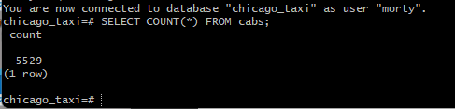

## Задание 2

Список компаний с числом автомобилей меньше 100.

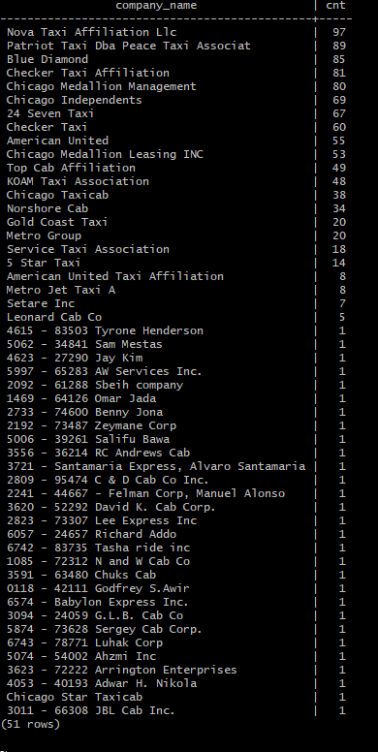

**Запрос, которым тебе удалось решить задачу.**

**SELECT**

**COUNT(cab_id) AS cnt,**

**company_name AS compane_name**

**FROM**

**cabs**

**GROUP BY**

**company_name**

**HAVING**

**COUNT(cab_id) < 100**

**ORDER BY**

**cnt DESC;**

## 

## Задание 3

Таблица с данными за указанный период.

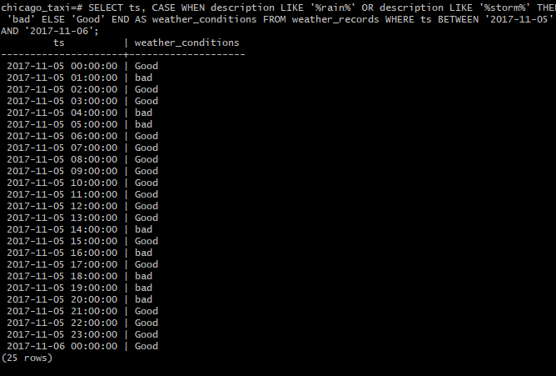

Запрос, которым удалось решить задачу.

**SELECT**

**ts,**

**CASE WHEN description LIKE '%rain%' OR description LIKE '%storm%' THEN 'Bad' ELSE 'Good' END AS weather_conditions**

**FROM**

**weather_records**

**WHERE**

**ts BETWEEN ‘2017-11-05’ AND ‘2017-11-06’;**

## Задание 4

Таблица с данными за указанный период.

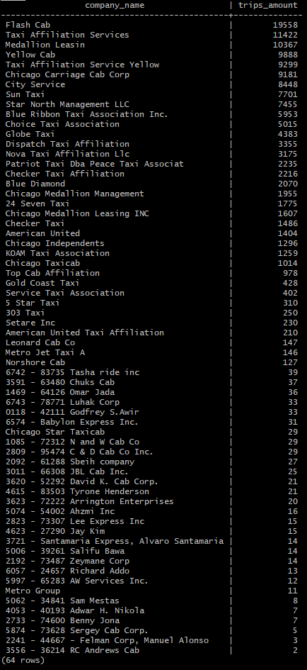

**Запрос, которым удалось решить задачу.**

**SELECT**

**cabs.company_name,**

**COUNT(trips.cab_id) AS trips_amount**

**FROM**

**trips INNER JOIN cabs ON cabs.cab_id=trips.cab_id**

**WHERE**

**start_ts BETWEEN '2017-11-15 00:00' AND '2017-11-16 23:59’**

**GROUP BY**

**company_name**

**ORDER BY**

**trips_amount DESC;**