Benjamin Nguyen
Computer Vision

Images:

Snapshot of the headshot image and its Fourier magnitude image.

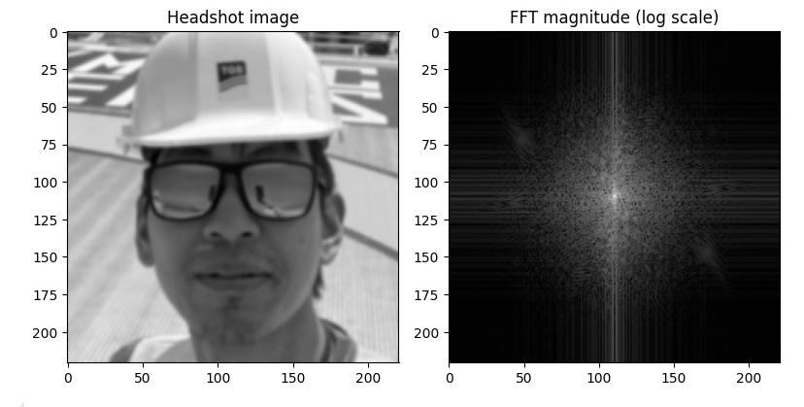

Snapshot of my low-pass headshot image and its Fourier magnitude.

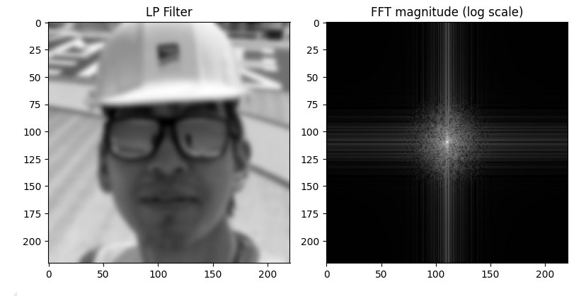

Snapshot of the 2nd image:

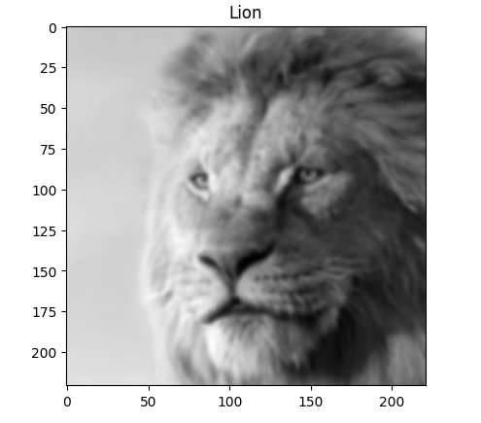

and its high-pass filtered image, and the Fourier magnitude of the high-pass image:
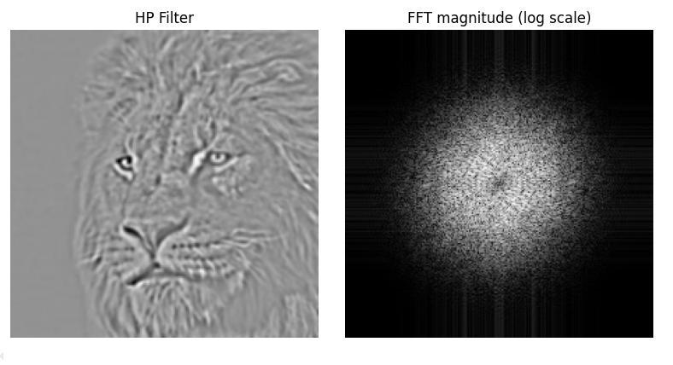

Snapshot of combined image and its Fourier magnitude.
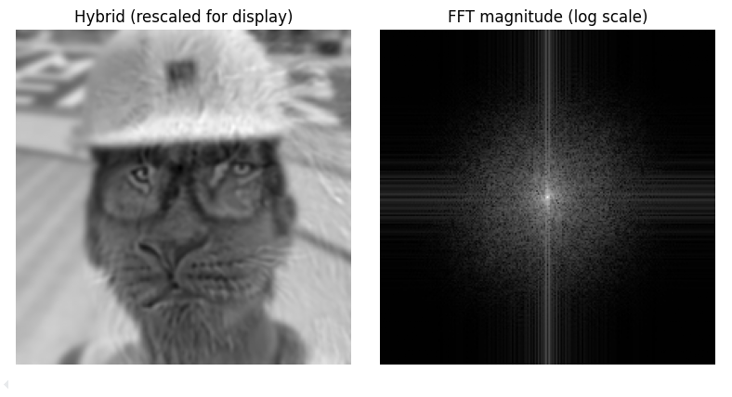
Snapshot of the code (next page)
