Benjamin Nguyen
Computer Vision
Homework 4: Edge Detection

Snapshot of my code:
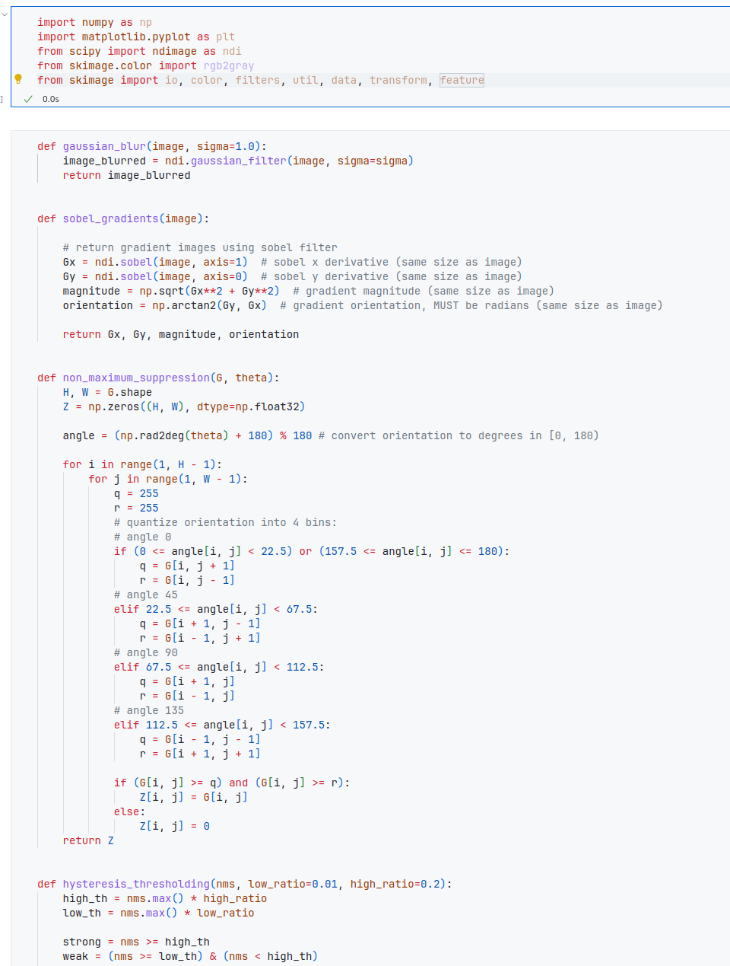
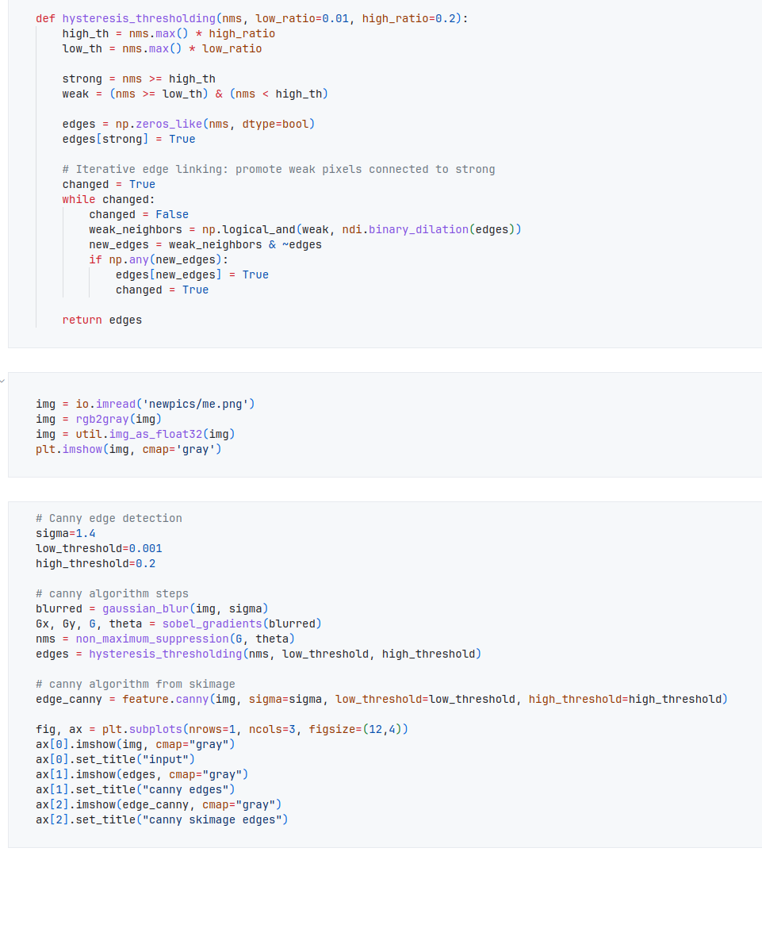
The snapshot of my headshot input image, candy edge image output and candy edge image:
