Hoang Anh (Benjamin) Nguyen
Computer Vision

HW2: Filtering

1. Snapshot of the code:

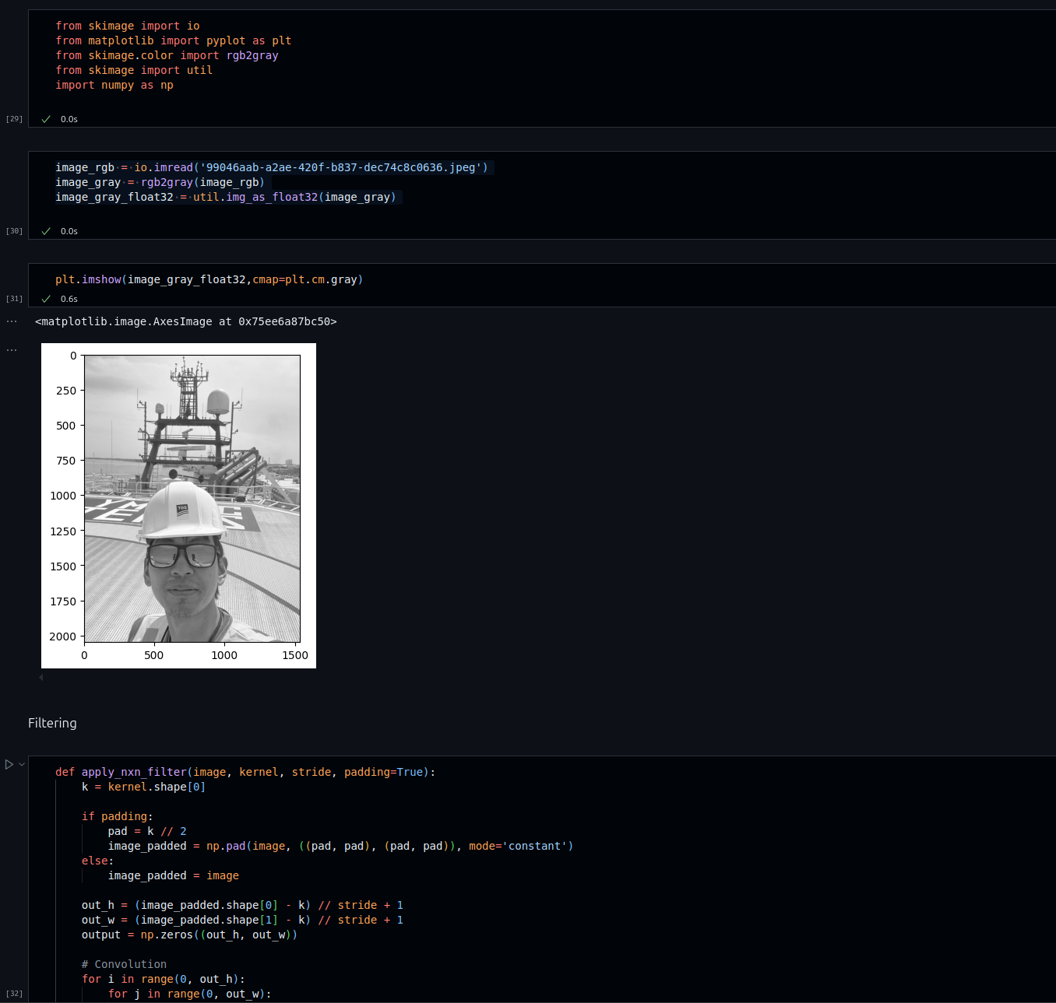
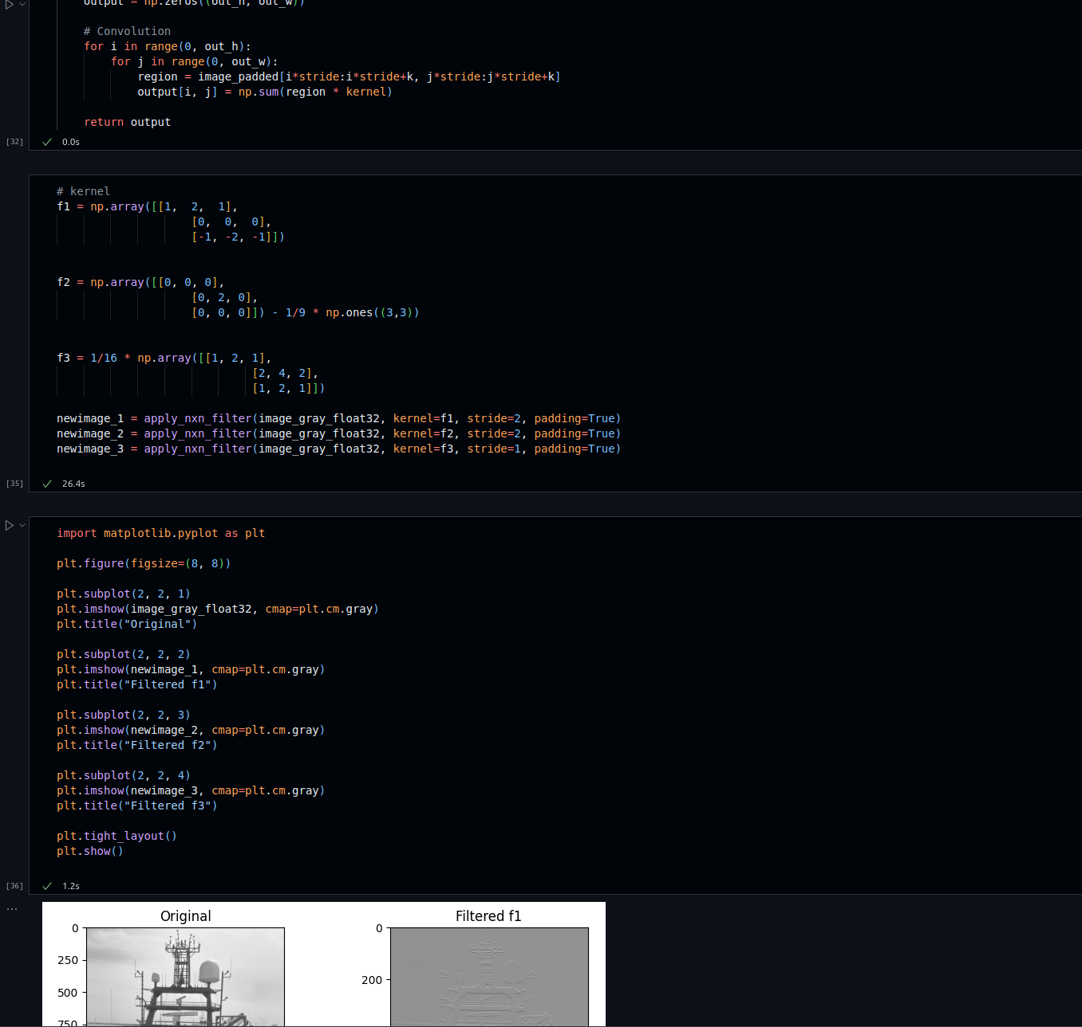

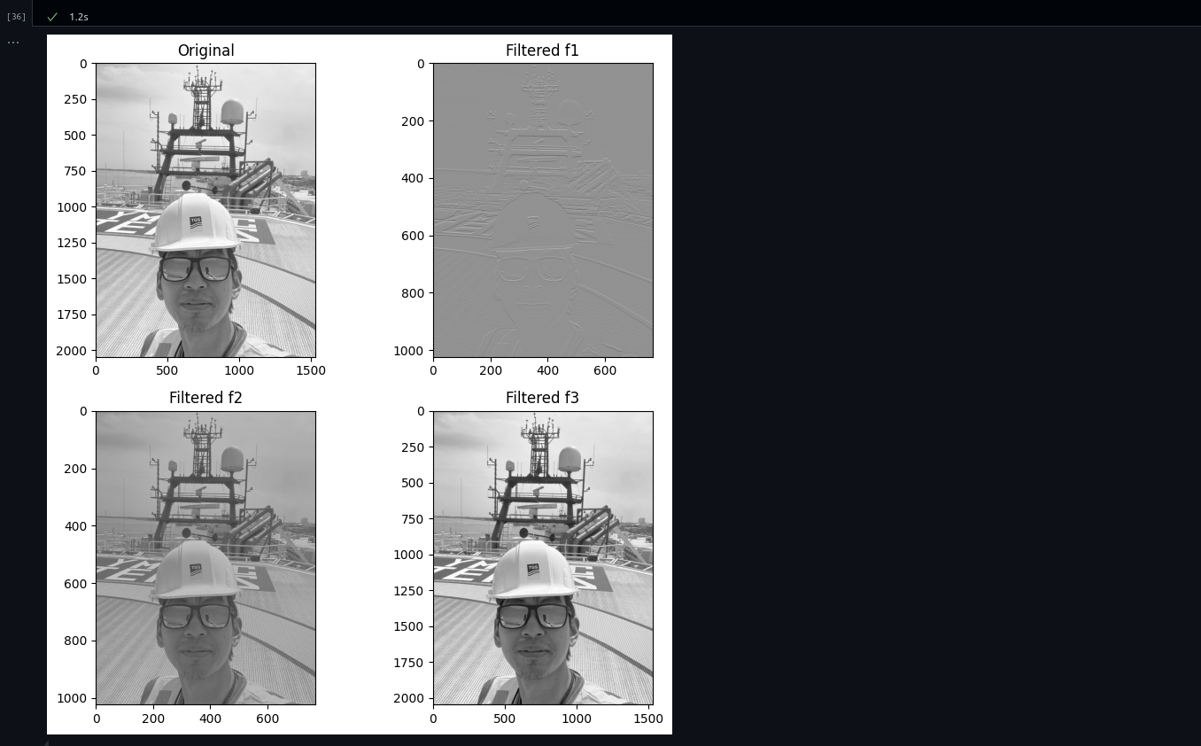
2. Explanation

Filter f1 and filter f2 reduce the size of the original image because I used stride = 2.
f1: Sobel filter: in this case, the filter detects horizontal edges.
f2: Removes smooth background, keeps fine details.
f3: Gaussian blur: smooths the image, reduces noise and detail.

