**Ganpat University**

**Faculty of Engineering & Technology**

**Computer Science & Engineering**

**(2CSE204) Basics of Operating System and Shell Scripting**

**Name: Jaymin Gondaliya**

**Enrollment No: 23162171007**

**Sem - 2**

**Branch: CS**

**Class: B**

**Batch: 25**

**Practical 1**

1. From student user, change the user to root and identify which user is currently logged in?

Command: su - and whoami

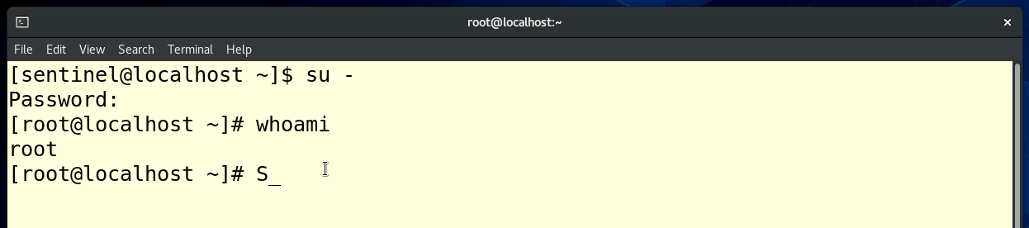

1. Display current date and time in following format: **dd/mm/yyyy-hh:mm:ss**

Command: date +'%d/%m/%Y-%H:%M:%S'

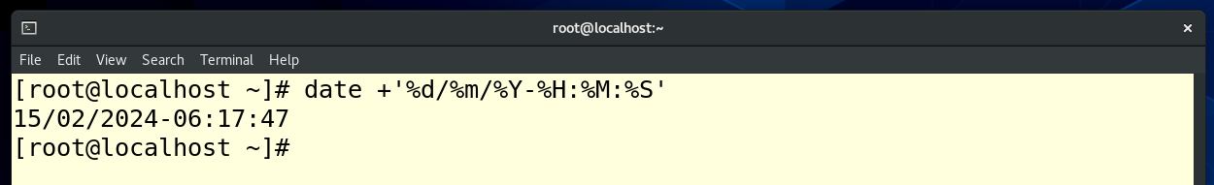

1. Using multiple commands in one line only, display current month name in full and day in abbreviated format.

Command: date +"%B" && date +"%a"

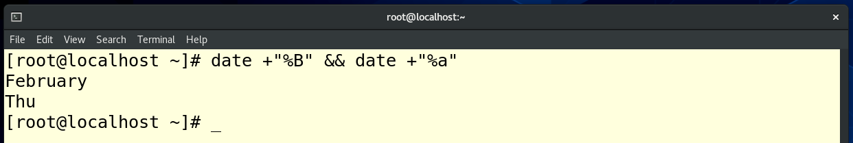

1. Display first 4 lines of /etc/yum.repos.d/rhel_dvd.repo file

Command: head -n 4 /etc/passwd

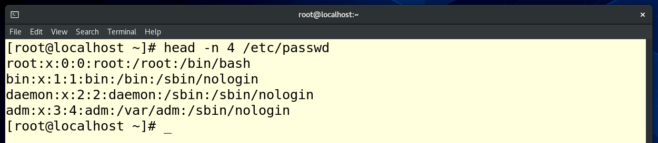

1. Display last 5 lines of /etc/yum.repos.d/rhel_dvd.repo file

Command: tail -n 4 /etc/passwd

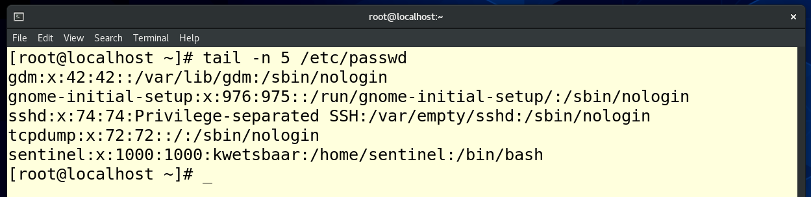

1. How many bytes are occupied by /var/log/secure file?

Command: state /var/log/secure, or we can use ls -l

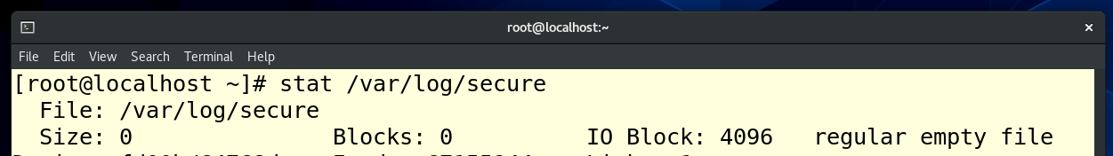

1. How many lines of content is present in /etc/shadow file?

Command: wc -l /etc/shadow

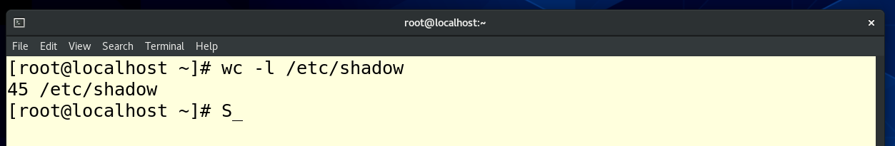

1. List all the commands executed by you so far and execute the 10th command.

Command: history , for 10th command “!10” (in my case 10th command was clear so I execute 11th command )

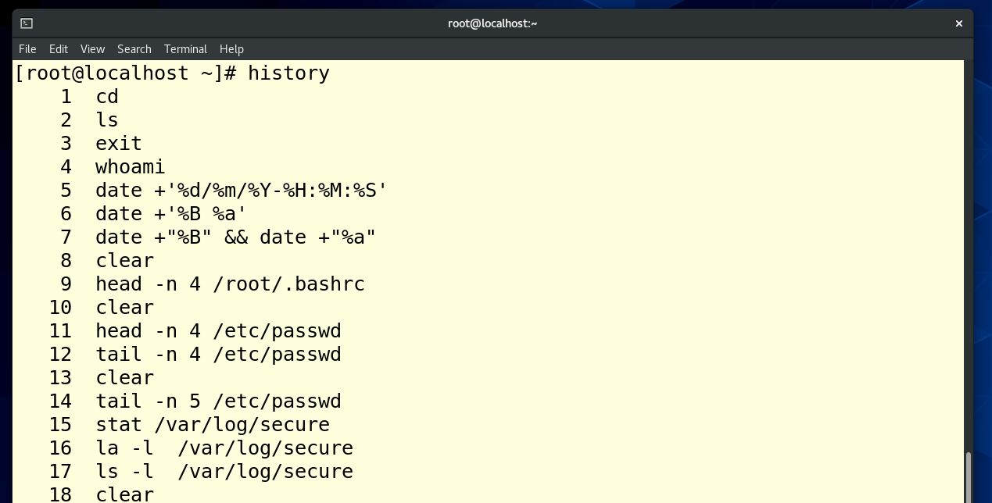

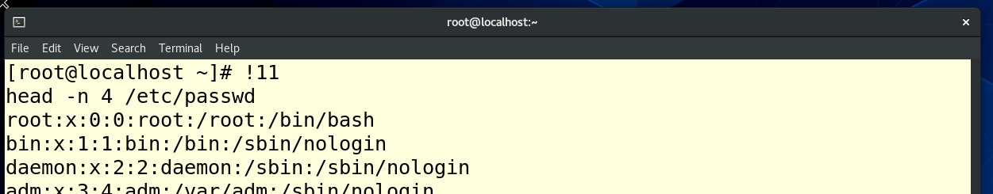

1. Display the contents of /var/log/secure file. - Command: cat /var/log/secure

