**Ganpat University**

**(2CSE204) Basics of Operating System and Shell Scripting**

**Name: Jaymin Gondaliya**

**Enrollment No: 23162171007**

**Sem - 2**

**Branch: CS**

**Class: B**

**Batch: 25**

**Practical-10**

1. List the current network scenario of your system.

Command – ifconfig

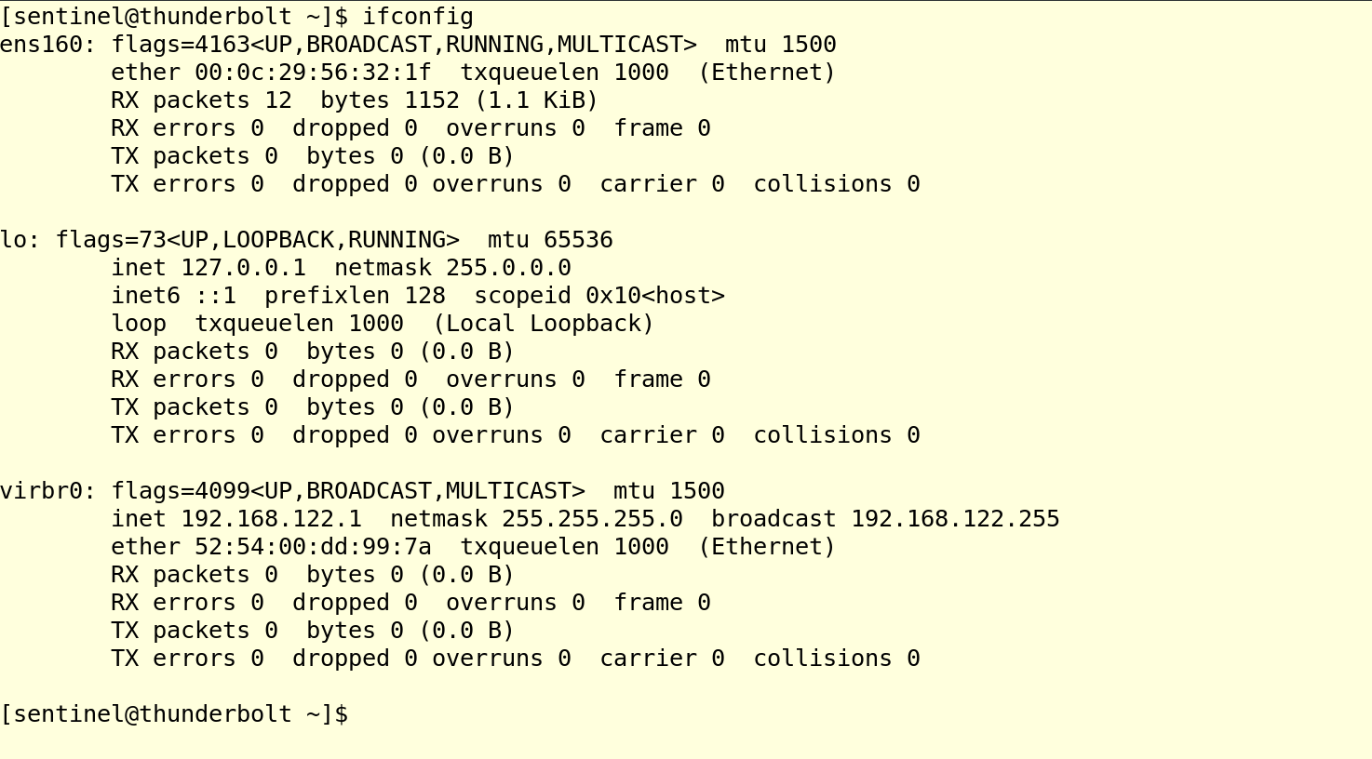

1. Configure your IP Address, Gateway and DNS as follows:

IP Address:192.168.100.XXX/24

Gateway 192.168.100.100

DNS:192.168.100.100

(The name of the connection should be yourname_surname)

Command - sudo nmcli connection add con-name jaimin_gondaliya ifname ens160 type ethernet ipv4.method manual ipv4.addresses 192.168.100.49/24 ipv4.gateway 192.168.100.100 ipv4.dns 192.168.100.100

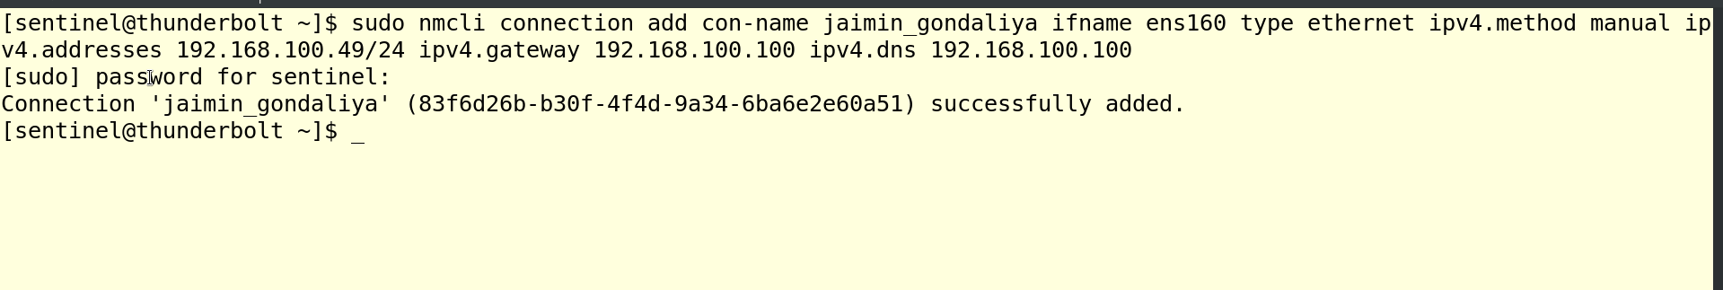

1. Activate the newly added network connection

Command - nmcli connection up jaimin_gondaliya

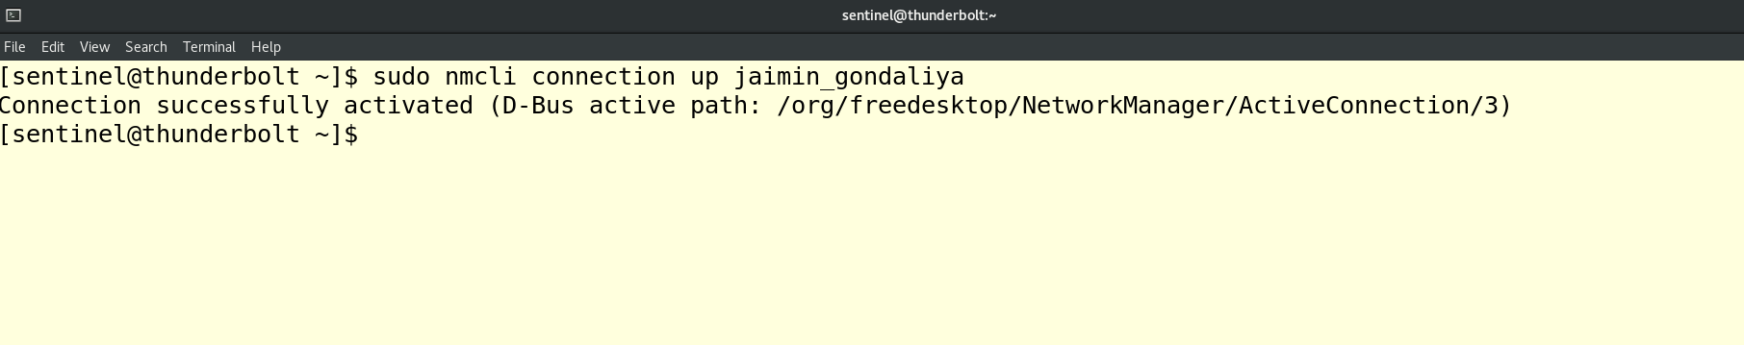

1. Display the details of newly added connection

Command - nmcli connection show jaimin_gondaliya

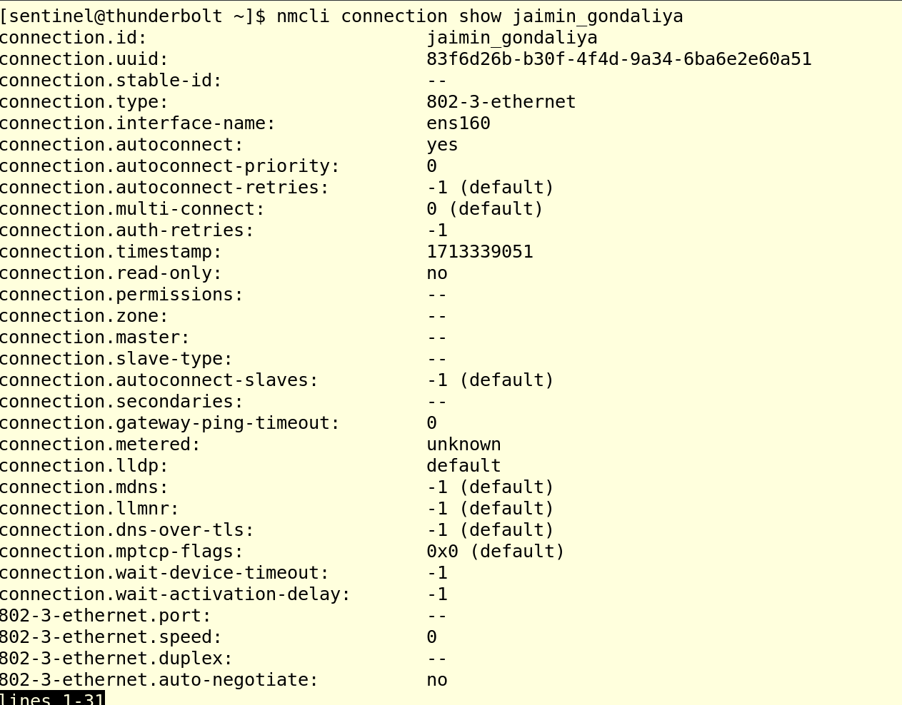

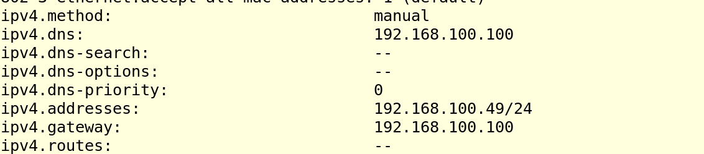

1. Delete the newly added connection and restore the previous network connection scenario.

Command – nmcli connection delete jaimin_gondaliya

