**Ganpat University**

**(2CSE204) Basics of Operating System and Shell Scripting**

**Name: Jaymin Gondaliya**

**Enrollment No: 23162171007**

**Sem - 2**

**Branch: CS**

**Class: B**

**Batch: 25**

**Practical-11**

**Using RPM, perform the following tasks:**

1. List the configurations files related to openssh-clients and openssh-server

Command - rpm -qc openssh-clients , rpm -qc openssh-server

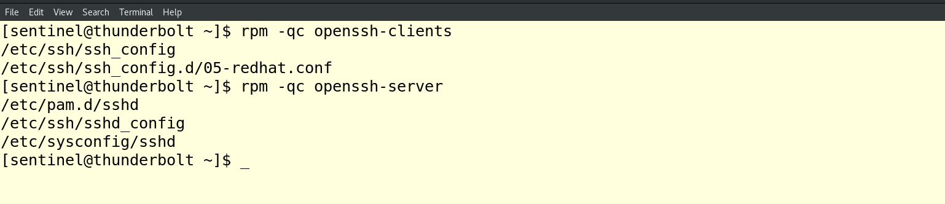

1. List all the information related to gedit package.

Command – rpm -qi gedit

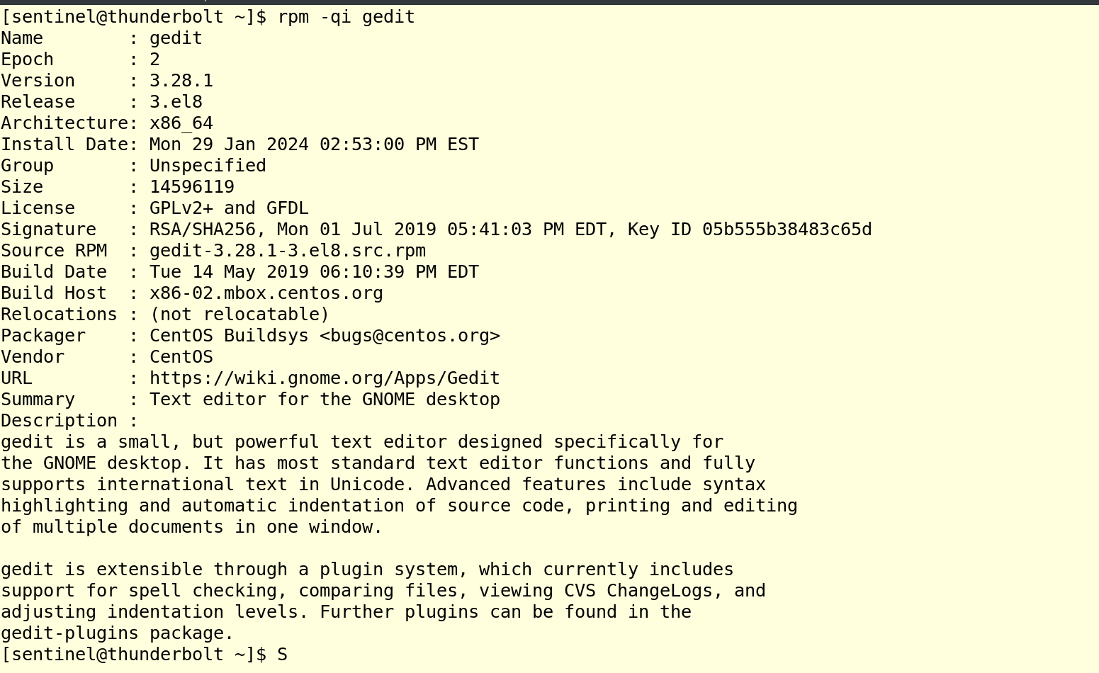

1. List all the packages installed on your system.

Command - rpm -qa

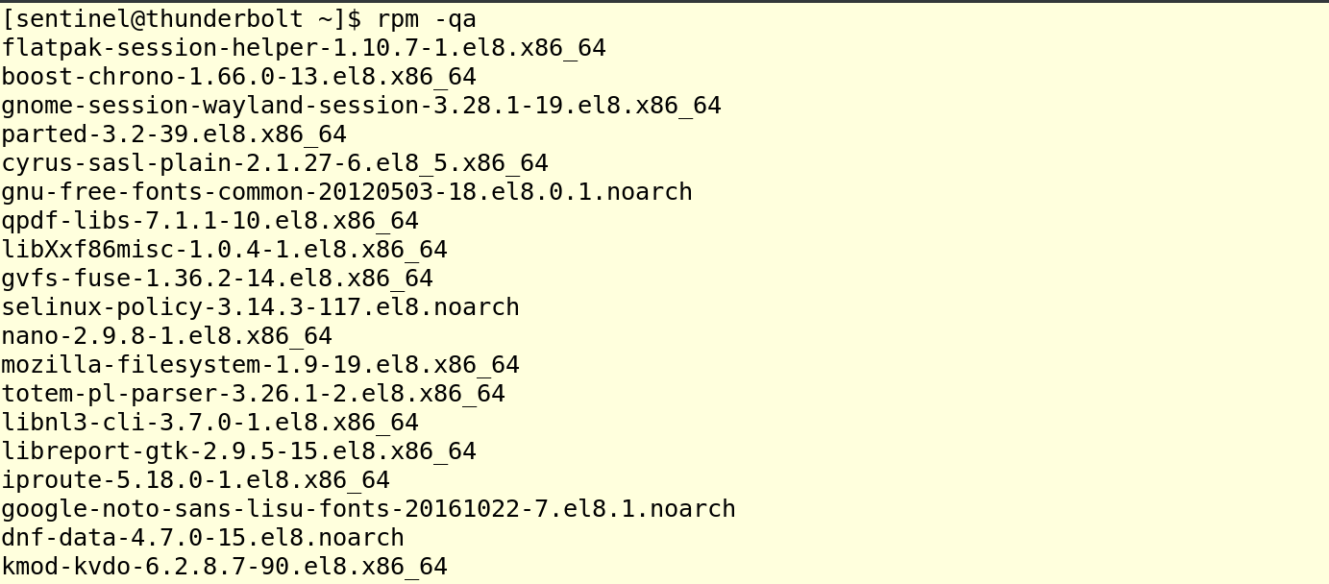

**Using yum, perform the following tasks:**

1. Install Apache server in your system and verify whether it is installed correctly or not.

Command – sudo yum install httpd ,

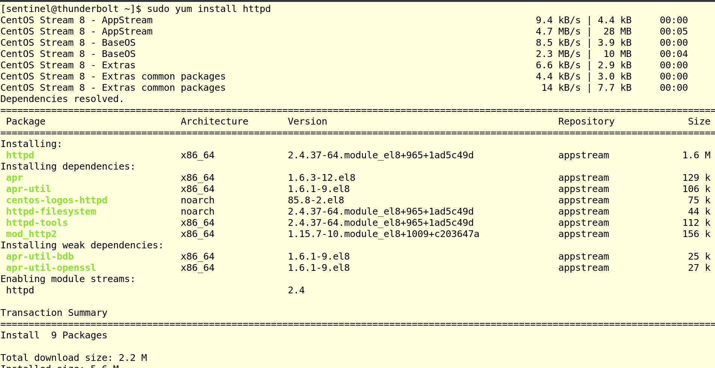

Command – sudo systemctl start httpd , sudo systemctl status httpd

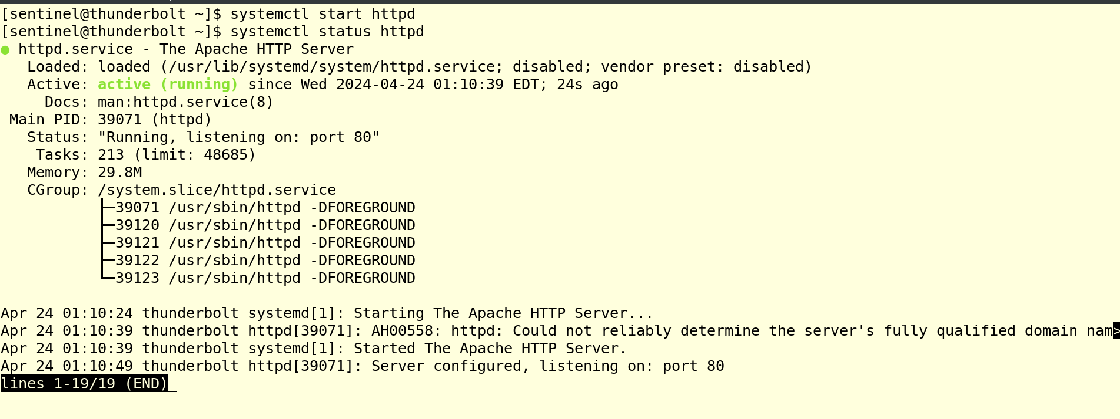

1. Create a directory with **your_name** at appropriate location and access the same from localhost.

