**Ganpat University**

**(2CSE204) Basics of Operating System and Shell Scripting**

**Name: Jaymin Gondaliya**

**Enrollment No: 23162171007**

**Sem - 2**

**Branch: CS**

**Class: B**

**Batch: 25**

**Practical-12**

1. Set your system clock in such a way that it is NTP client of classroom.exaple.com and verify the same

Command – nano /etc/chrony.conf , chronyc sources -v

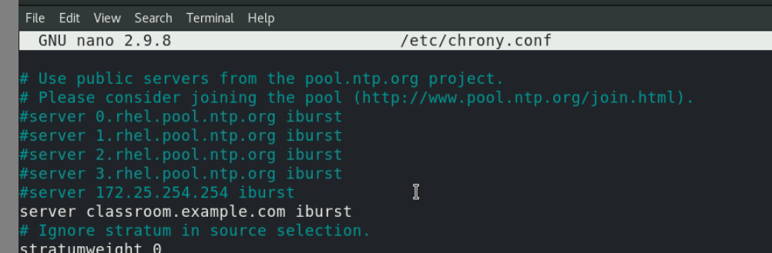

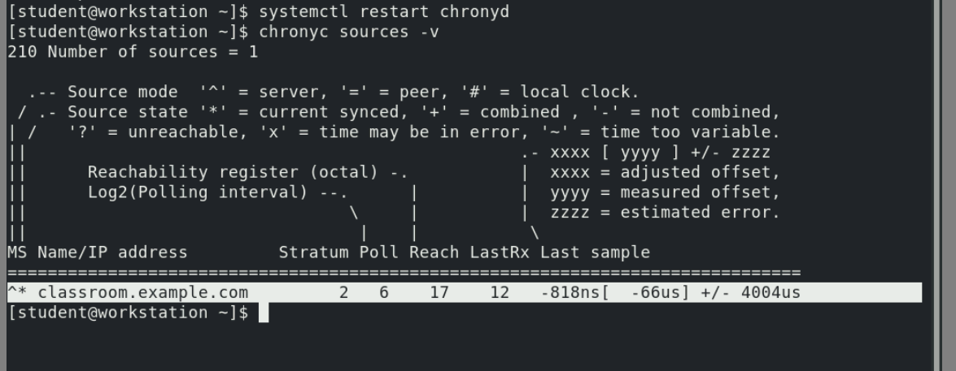

1. Create an archive of /usr/local directory and compress it as /root/yourname_surname.tar.xz

List of files must be visible at the time of compression

Command – sudo tar -cvJF /root/jaimin_gondaliya.tar.xz /usr/local

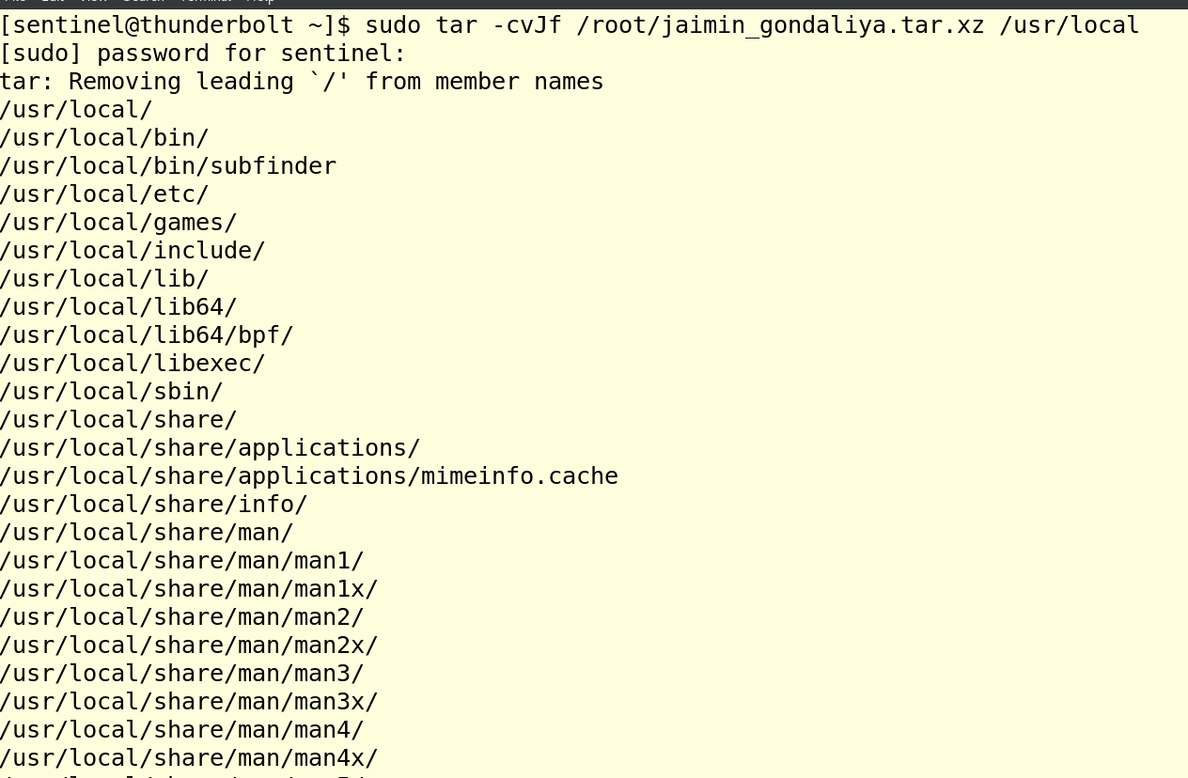

1. Display the list of directories/files present inside the compressed file

Command - tar -tvf jaimin_gondaliya.tar.xz

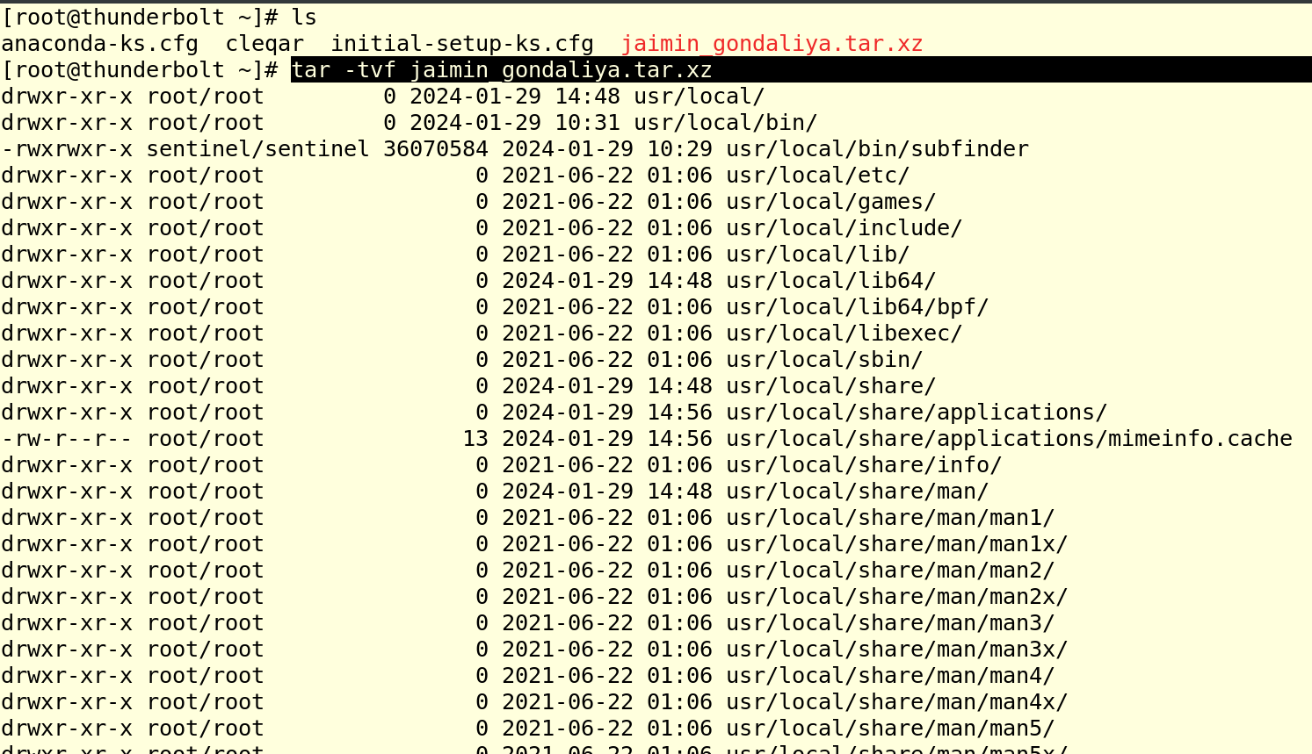

1. Extract the compressed file in such a way that the names of directories/files must be visible while extraction.

Command – tar -xvf /root/jaimin_gondaliya.tar.xz -c /

