**Ganpat University**

**Faculty of Engineering & Technology**

**Computer Science & Engineering**

**(2CSE204) Basics of Operating System and Shell Scripting**

**Name: Jaymin Gondaliya**

**Enrollment No: 23162171007**

**Sem - 2**

**Branch: CS**

**Class: B**

**Batch: 25**

**Practical 2**

1. Create a Directory named India with subdirectories Gujarat, UP, Rajasthan and Delhi. All these 4 directories must be created along with India only. Each subdirectory contains three files with names stateX (where state is state's name and X is 1 to 4)

Command: mkdir -p India/{Gujarat,UP,Rajasthan,Delhi} ,

touch India/{folder_name}/{file_name} India/{folder_name}/{file_name} India/{folder_name}/{file_name}

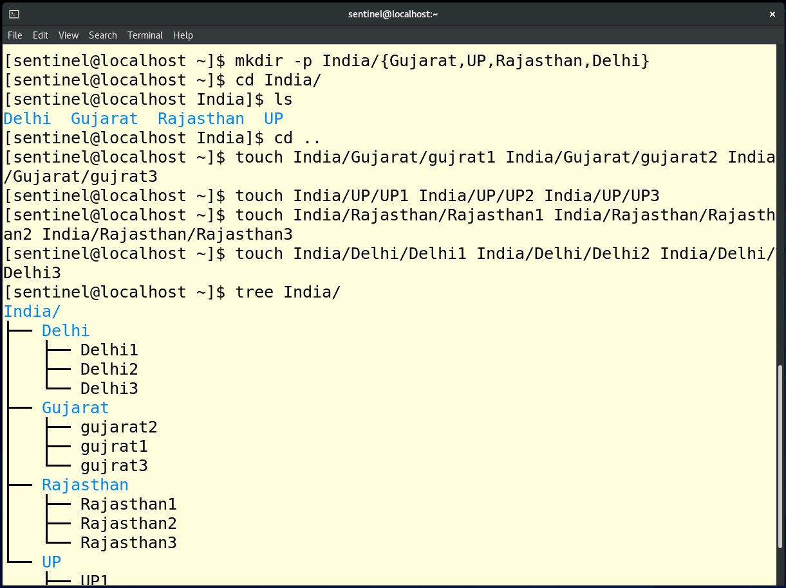

1. One more directory Delhi_Copy contains files copied from the Delhi directory.

Command: mkdir India/Delhi_Copy , cp India/Delhi/* India/Delhi_Copy

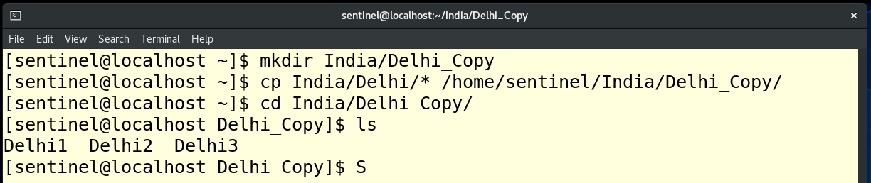

1. One more directory Gujarat_Move contains the files moved from Gujarat directory.

Command: mkdir India/Gujarat_Move , mv India/Gujarat/* India/Gujarat_Move

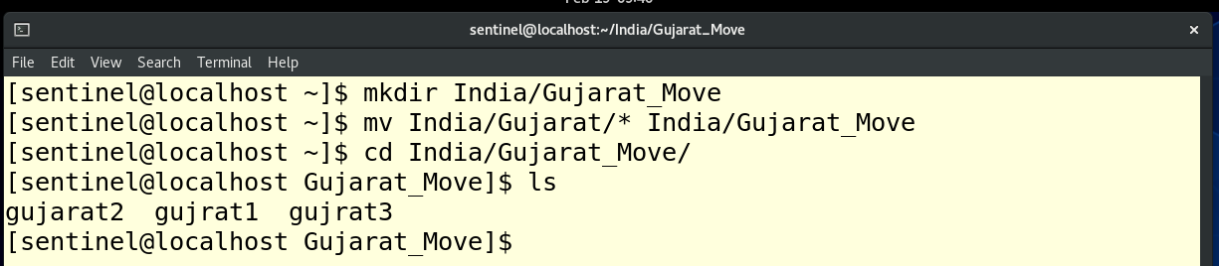

1. UP and Rajasthan directories along with their internal files should be copied to /tmp directory

Command: cp -r India/UP /tmp ; cp -r India/Rajasthan /tmp

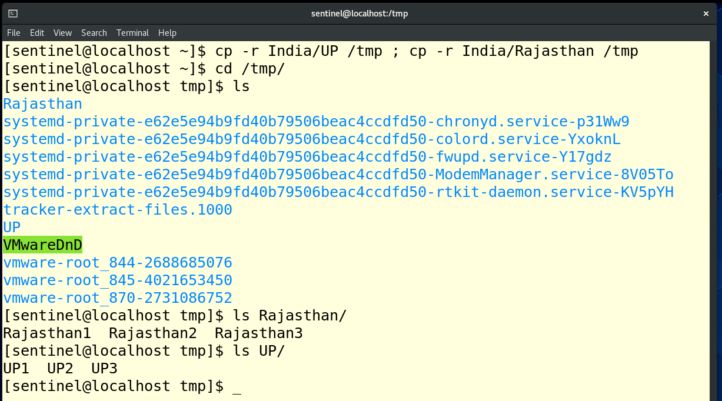

1. Entire India directory should be removed without removing individual subdirectories and files.

Command: rm -r India

