**Ganpat University**

**Faculty of Engineering & Technology**

**Computer Science & Engineering**

**(2CSE204) Basics of Operating System and Shell Scripting**

**Name: Jaymin Gondaliya**

**Enrollment No: 23162171007**

**Sem - 2**

**Branch: CS**

**Class: B**

**Batch: 25**

**Practical 3**

1. Create following files inside /tmp/yourname directory:

Command: touch user{v,w}{1..3} user{x,y}{1..2} userz

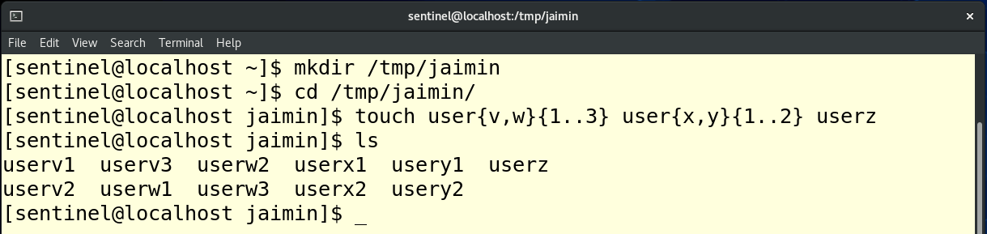

1. Display the following statements on terminal: Currently logged in user is username Define a variable named mynumber which contains your name and display it as: My enrolment number is mynumber Today’s date is date_in_yyyy_mm_dd_format

Command: user=$whoami , echo “current logged in user is $user”

num=23162171007 , echo “my enrolment number is $num”

date=$(date +%Y-%m-%d) , echo “todays date is $date”

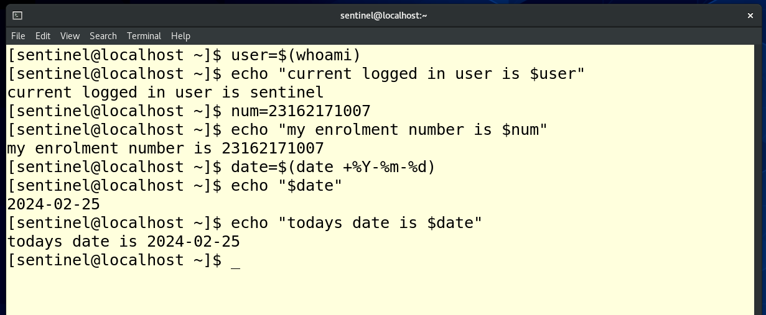

1. Create a soft link of the file /tmp/mydir/boss on student user’s desktop which contains the content “Softlink Example” and verify that the behaviour of soft link is same as a shortcut of a file.

Command: echo “soft link example test test” > /tmp/mydir/boss , ln -s /tmp/mydir/boss /home/sentinel/Desktop/boss_sodtlink , cd Desktop , ls -l boss_softlink,

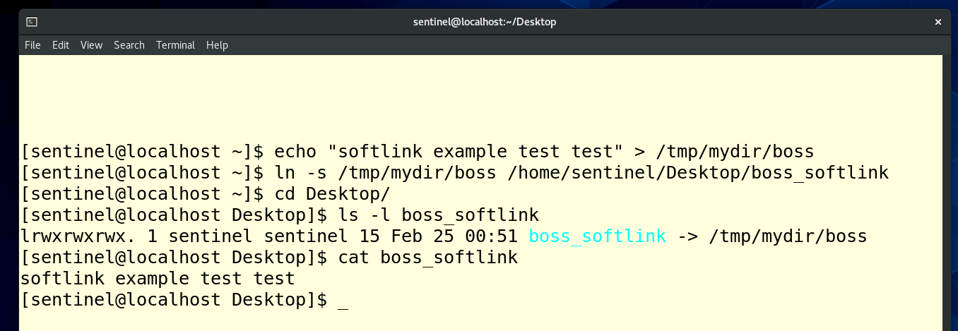

1. Create a hard link to the file /tmp/mydir/boss2 on student user’s desktop which contains the content “Hardlink Example” and verify that the behaviour of hard link is same as a copy of a file.

Command: ln /tmp/mydir/boss2 /home/jaimin/Desktop/hardlink_example

