**Ganpat University**

**Faculty of Engineering & Technology**

**Computer Science & Engineering**

**(2CSE204) Basics of Operating System and Shell Scripting**

**Name: Jaymin Gondaliya**

**Enrollment No: 23162171007**

**Sem - 2**

**Branch: CS**

**Class: B**

**Batch: 25**

**Practical 4**

1. List the directories and files present at /var/log and its output should be stored in /tmp/yourname/prac41 file

Command: ls -la /var/log > /tmp/jaimin/prac41

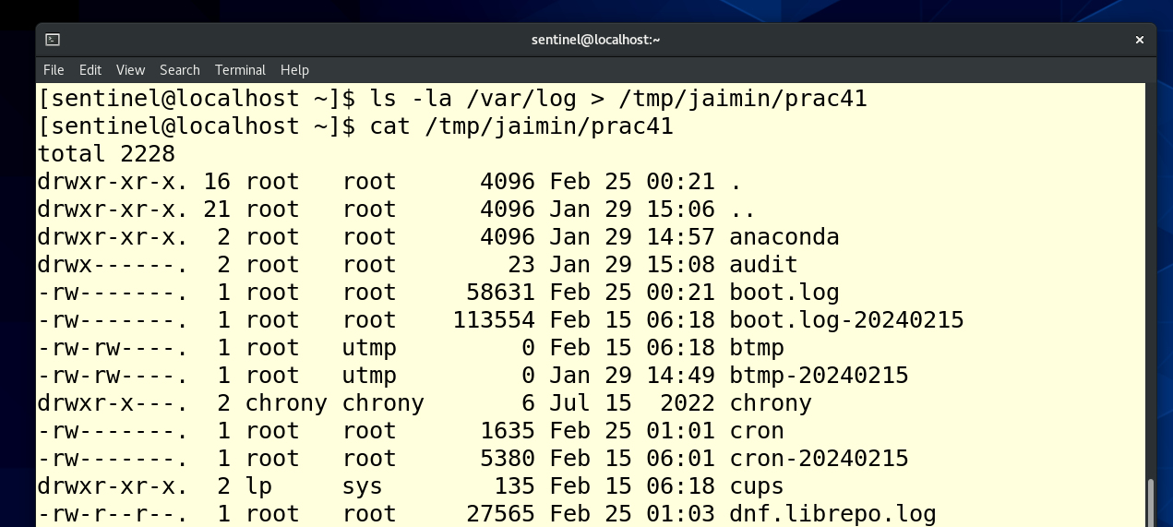

1. Store the first 10 lines of /etc/passwd file in /tmp/yourname/prac42 file and also display the last 5 lines from those 10 lines on terminal. Both the operations should execute at the same time.

Command: head -n 10 /etc/passwd > /tmp/jaimin/prac42 && tail -n 5 /tmp/jaimin/prac42

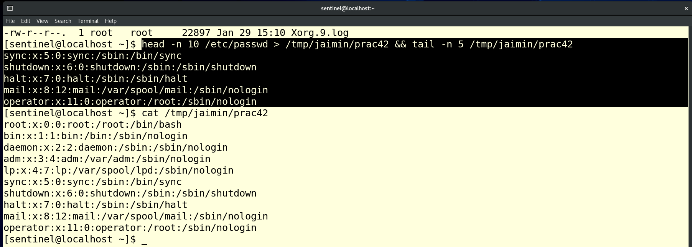

1. List all the files and directories present in /etc directory whose name starts with a, c and e. This output should be stored in /tmp/yourname/prac33 in such a way that previous content of the file does not get affected.

Command: ls -d /etc/[ace]* >> /tmp/jaimin/prac33

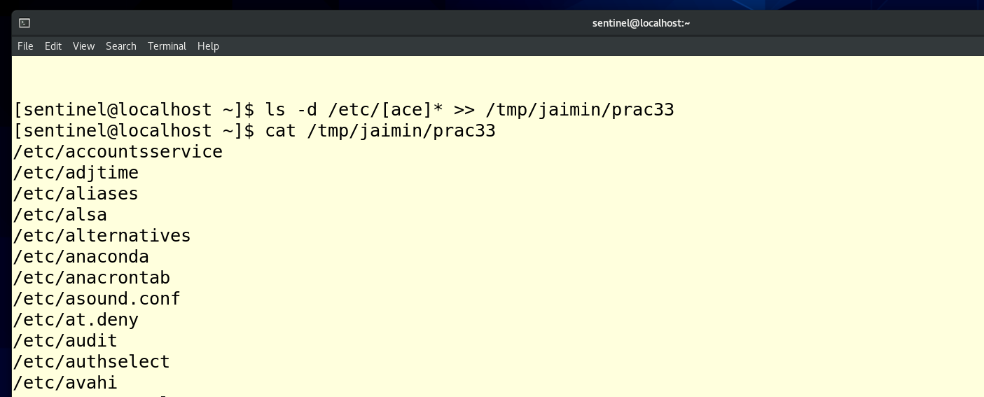

1. Generate some error by using false command but that error should neither be displayed on terminal nor stored in any file.

Command: jaimin > /dev/null 2>&1



1. Demonstrate the usage of shell and environment variables with a suitable example.

