**Ganpat University**

**Faculty of Engineering & Technology**

**Computer Science & Engineering**

**(2CSE204) Basics of Operating System and Shell Scripting**

**Name: Jaymin Gondaliya**

**Enrollment No: 23162171007**

**Sem - 2**

**Branch: CS**

**Class: B**

**Batch: 25**

**Practical-5**

1. **Create the following users, groups and group members:**

* User ‘Virat’, ‘Rohit’ and ‘Shubman’ and Group ‘cricket’.
* The user ‘Virat’ belongs to the ‘IPL’ group as a secondary group.
* For User ‘Rohit’, ‘cricket’ group should be primary and ‘IPL’ should be secondary. Virat, ‘Rohit’, and ‘Shubman’ should have password “batsman”
* User ‘Shubman’ who does not have access to interactive shell on the system and who is also a member of ‘IPL’ group.

Command:

sudo useradd -m Virat

sudo useradd -m Rohit

sudo useradd -M -s /sbin/nologin Shubman

echo "Virat:batsman" | sudo chpasswd

echo "Rohit:batsman" | sudo chpasswd

echo "Shubman:batsman" | sudo chpasswd

sudo groupadd cricket

sudo groupadd IPL

sudo usermod -aG IPL Virat

sudo usermod -g cricket Rohit

sudo usermod -aG IPL Rohit

sudo usermod -aG IPL Shubman

-s /bin/bash: Specifies the default shell for the user (except for Shubman, who has /sbin/nologin as the shell).

echo "Virat:batsman" | chpasswd: Sets the password for the user

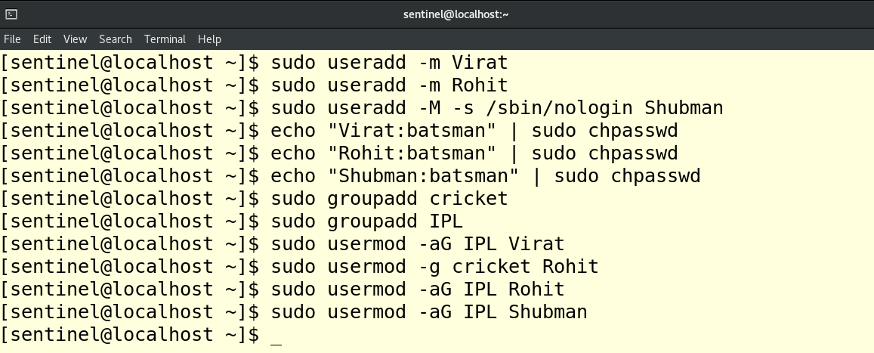

Cat /etc/group - for verify

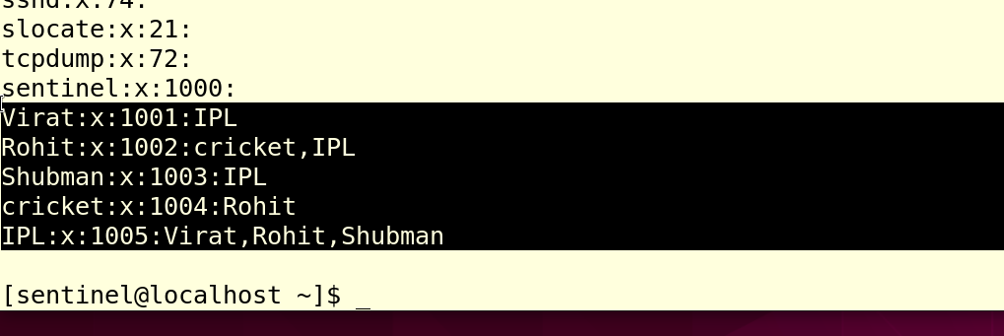

1. **Create the following users, groups and group members:**

* group named adminuser with groupid 1020.
* A user named woody, which belongs to the adminuser, this group is the user's primary group
* A user named buzz, belonging to the adminuser, is a supplementary group for the user
* Users woody, buzz, and sid, the password should be set to “password321”
* A user named sid, which has no interactive shell in the system and is not a member of the adminuser group

Command:

sudo groupadd -g 1020 adminuser

sudo useradd -m -g adminuser woody

sudo useradd -m -G adminuser buzz

sudo useradd -M -s /sbin/nologin sid

echo "woody:password321" | sudo chpasswd

echo "buzz:password321" | sudo chpasswd

echo "sid:password321" | sudo chpasswd

sudo usermod -aG adminuser buzz

sudo usermod -aG adminuser woody

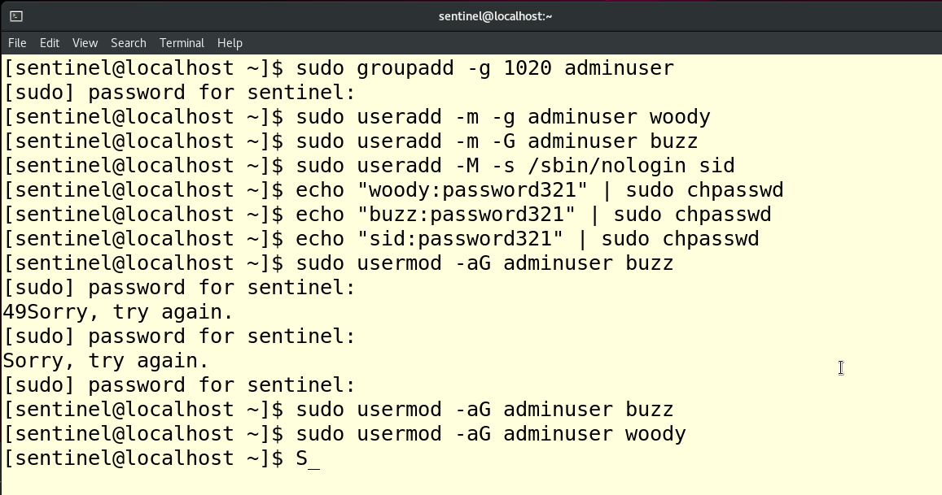

Cat /etc/group – to verify

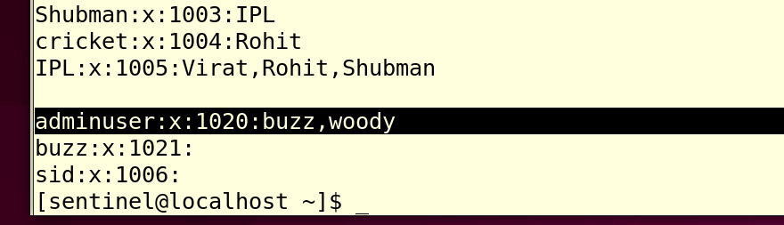

Cat /etc/passwd – verify user entry

