**Ganpat University**

**(2CSE204) Basics of Operating System and Shell Scripting**

**Name: Jaymin Gondaliya**

**Enrollment No: 23162171007**

**Sem - 2**

**Branch: CS**

**Class: B**

**Batch: 25**

**Practical-6**

1. Create a user with yourname_surname with some password and lock the account so that the user should not be able to login.

Command: sudo useradd gondaliya_jaymin

echo "1234" | sudo passwd --stdin gondaliya_jaymin

sudo passwd -l gondaliya_jaymin

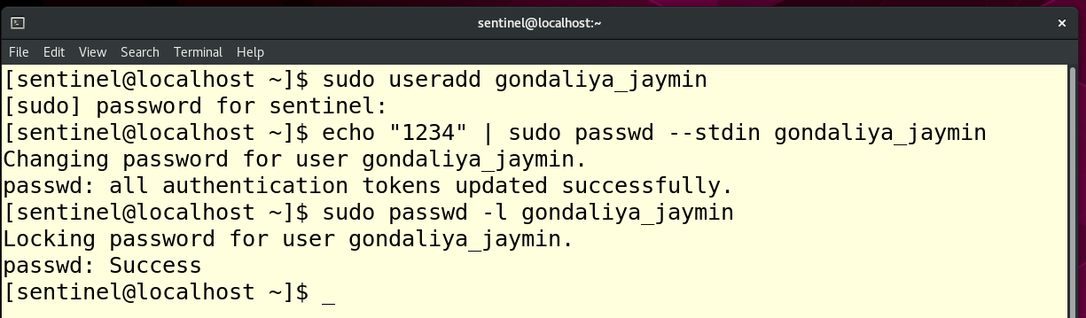

1. Unlock the the user and now the user should be able to login

Command: sudo passwd -u gondaliya_jaymin

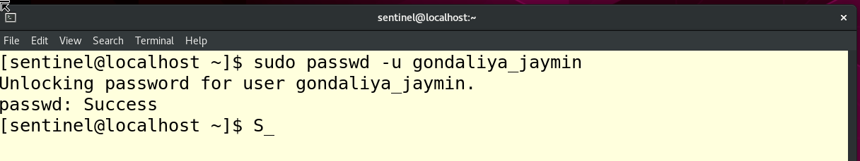

1. Set the password policy of the user in such a way that he needs to change password on next login.

Command: sudo chage -d 0 gondaliya_jaymin

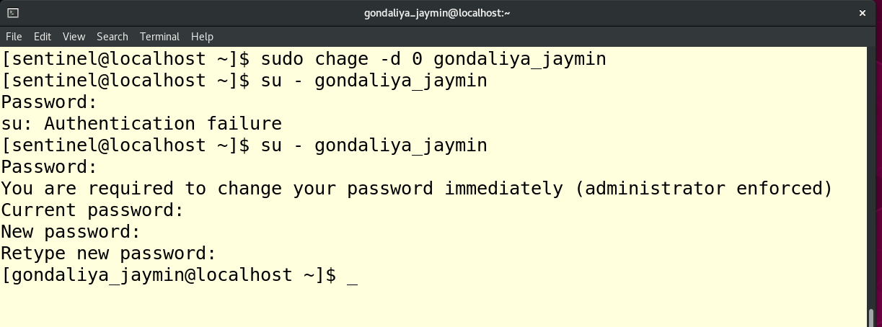

1. Change the password policy for the user to require a new password every 90 days with a warning period of 10 days and an inactive period of 15 days.

Command: sudo chage -M 90 -W 10 -I 15 gondaliya_jaymin

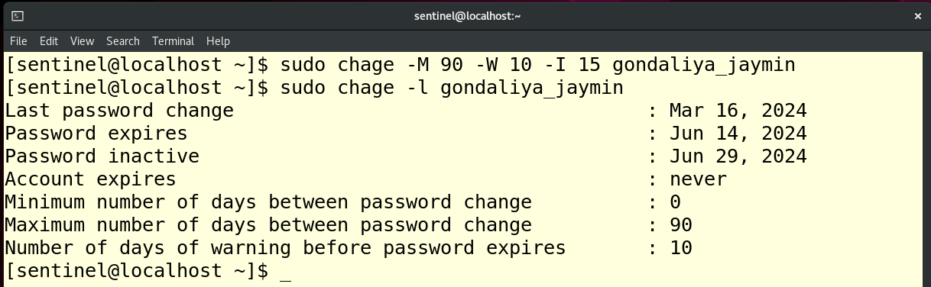

1. User’s account must expire after 180 days from the date of user creation

Command: sudo chage -E $(date -d "+180 days" +%Y-%m-%d) gondaliya_jaymin

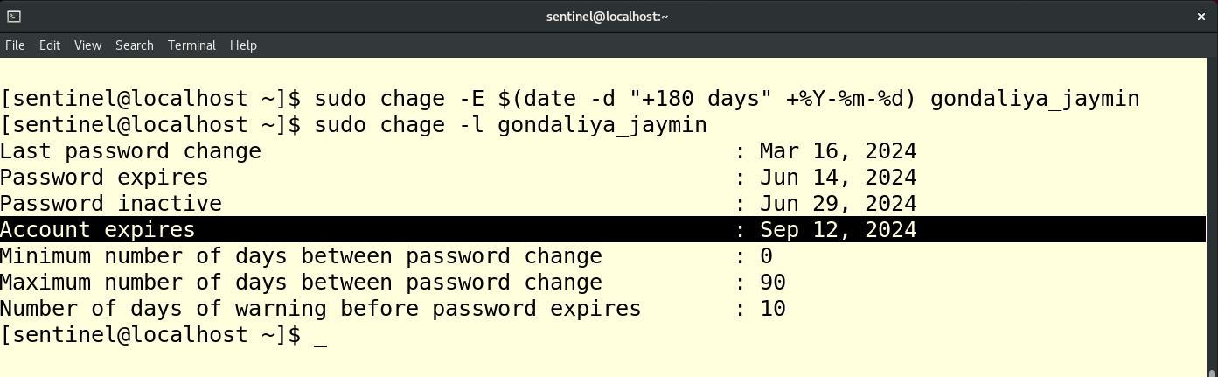

1. Verify the password policy

Command: sudo chage -l yourname_surname

