**Ganpat University**

**(2CSE204) Basics of Operating System and Shell Scripting**

**Name: Jaymin Gondaliya**

**Enrollment No: 23162171007**

**Sem - 2**

**Branch: CS**

**Class: B**

**Batch: 25**

**Practical-7**

1. There is a directory named ***attendance*** and its group owner is ***your_name***.

Command - mkdir attendance , touch attendance/BOSS attendance/CO attendance/BCS attendance/LA

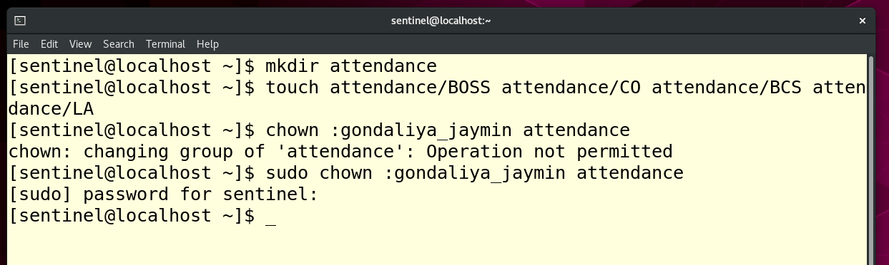

1. The group **teaching** contains four members named **user1** to **user4**.

Command – sudo adduser user1 , sudo usermod -a -G teaching user1 (same commands for other user)

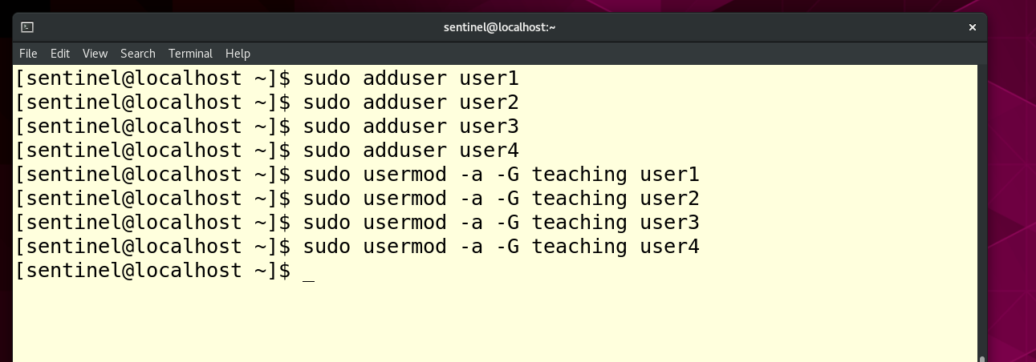

1. The attendance directory contains four files BOSS, CO, BCS and LA. The group owner of all these files should also be your_name

Command – sudo chown :gondaliya_jaymin attendance/BOSS attendance/CO attendance/BCS attendance/LA

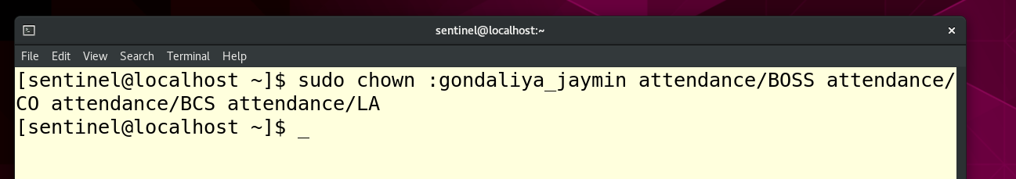

1. Following mapping should be applied on users and files with write access, and the same should be the owners of respective files: BOSS: user1 ,CO: user2 ,BCS: user3 ,LA: user4

Command – sudo chown user1 attendance/BOSS (same for other users)

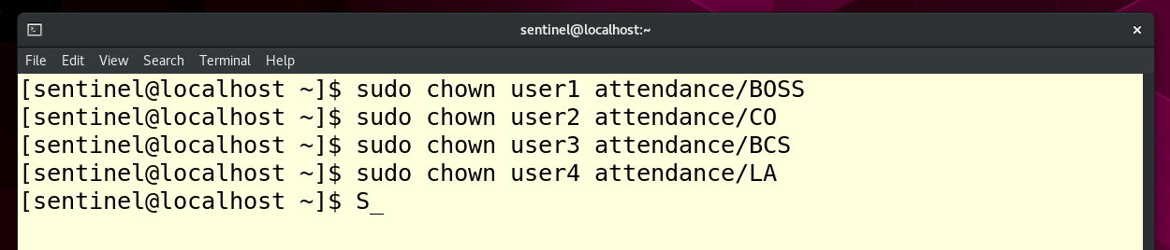

1. Only the owners of these files should be able to delete the files inside the attendance directory.

Command – sudo chmod 660 attendance/BOSS attendance/CO attendance/BCS attendance/LA

