**Ganpat University**

**(2CSE204) Basics of Operating System and Shell Scripting**

**Name: Jaymin Gondaliya**

**Enrollment No: 23162171007**

**Sem - 2**

**Branch: CS**

**Class: B**

**Batch: 25**

**Practical-8**

1. Create two users in different machines (servera and serverb) with same name (yourname_surname) and verify remote access from both ends.

Commands(servera) – sudo useradd -m jaimin_gondaliya , sudo passwd jaimin_gondaliya

Commands(serverb) – sudo useradd -m jaimin_gondaliya , sudo passwd jaimin_gondaliya

For verifying run ssh jaimin_gondaliya@servera (In server b) , ssh jaimin_gondaliya@serverb (In server a)

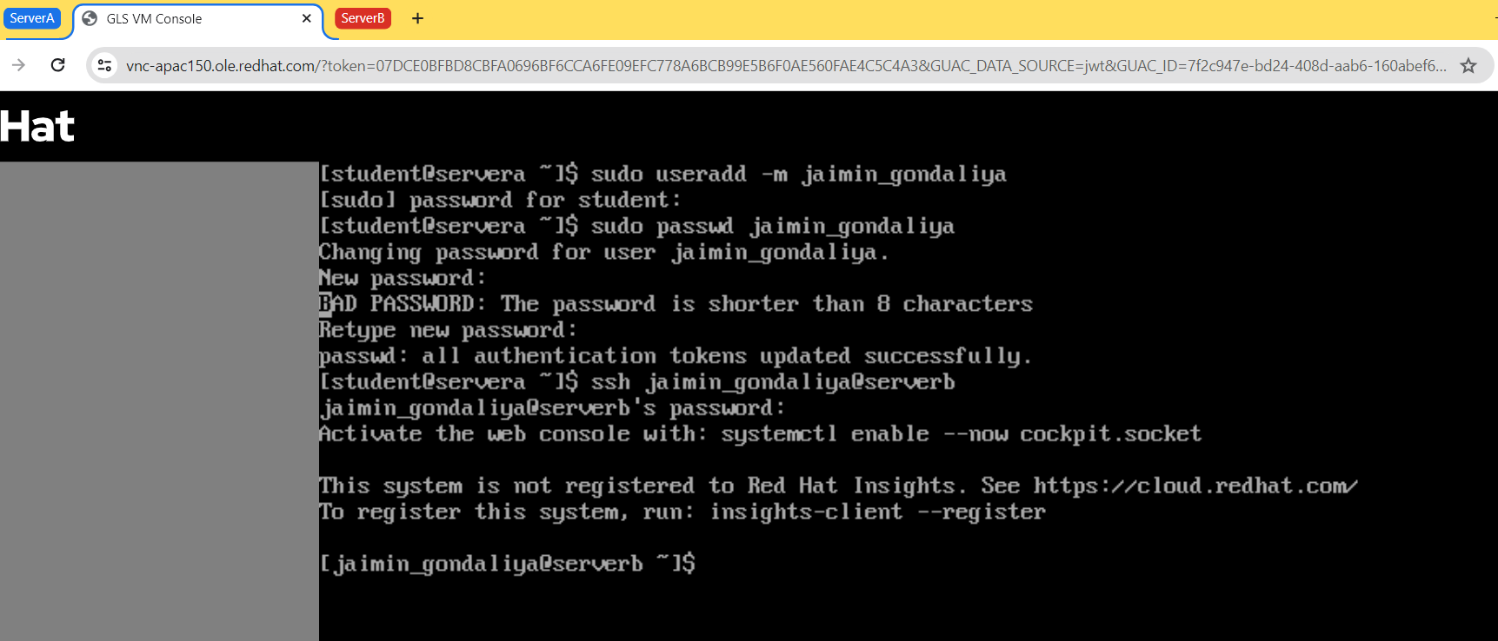

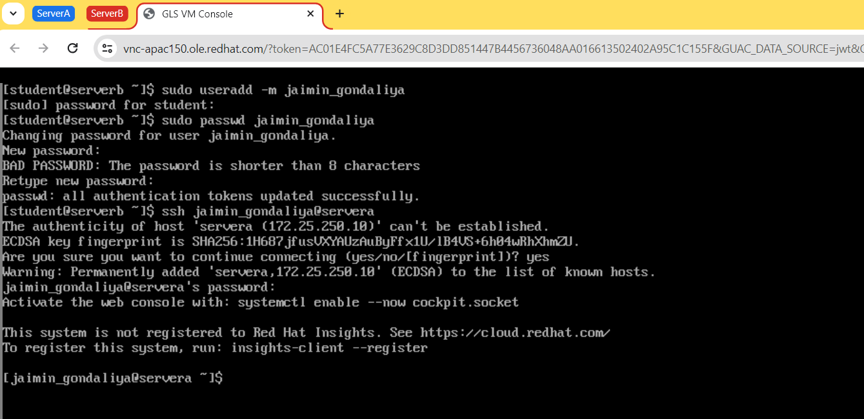

1. Configure one machine (servera) in such a way that if the public key of a remote user is modified, then it gets restored and the user successfully gets remote access to another server.

Modify the known_hosts serverb key (nano /.ssh/known_hosts)

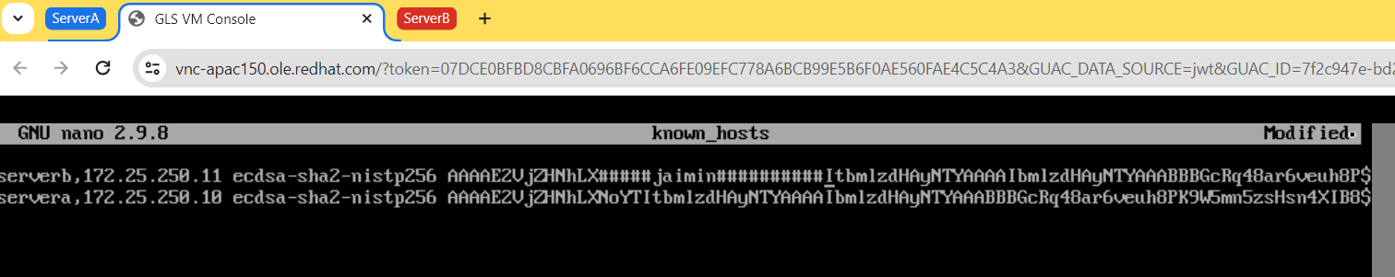

After Modified user successfully access to serverb from servera

