**Ganpat University**

**(2CSE204) Basics of Operating System and Shell Scripting**

**Name: Jaymin Gondaliya**

**Enrollment No: 23162171007**

**Sem - 2**

**Branch: CS**

**Class: B**

**Batch: 25**

**Practical-9**

1. Configure one machine (servera) in such a way that if the public key of a remote user is modified then login is restricted.

Command – serverb - sudo /etc/ssh/sshd_config (change pubkeyauthentication to yes)

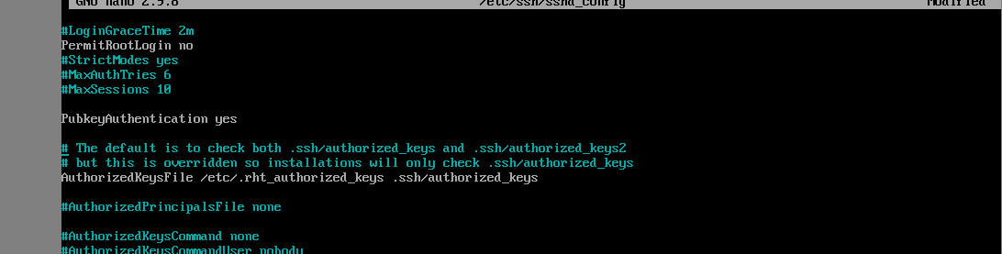

try logged in to serverb – ssh student@serverb

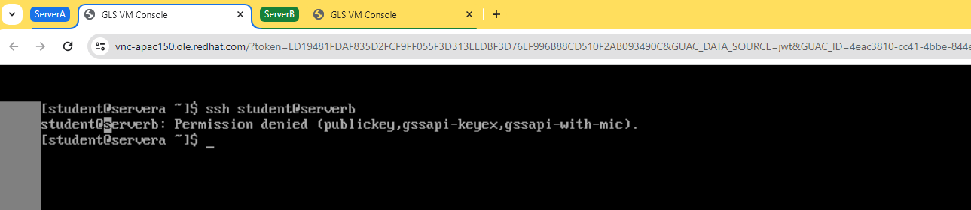

1. Enable password-less authentication for the user to access remote server.

Command- ssh-keygen (generate key) , ssh-copy-id student@serverb , ssh student@serverb (logged In without password)

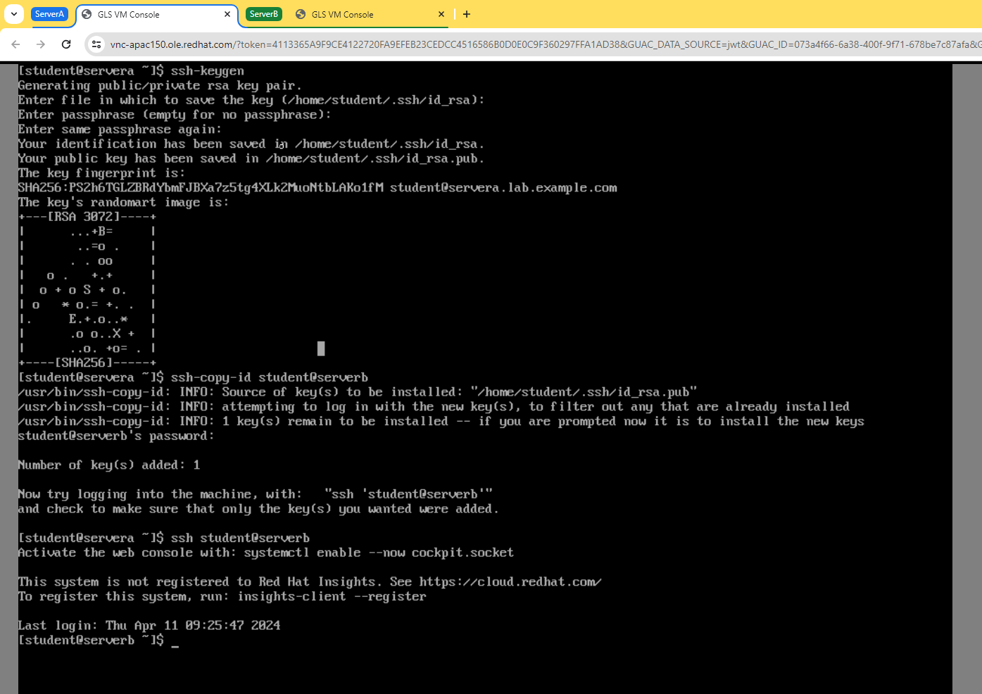

1. On serverb, restrict root login to any system.

Command – logged in serverb as a root user and change PermitRootLogin to No (nano /etc/ssh/sshd_config) , systemctl restart sshd

