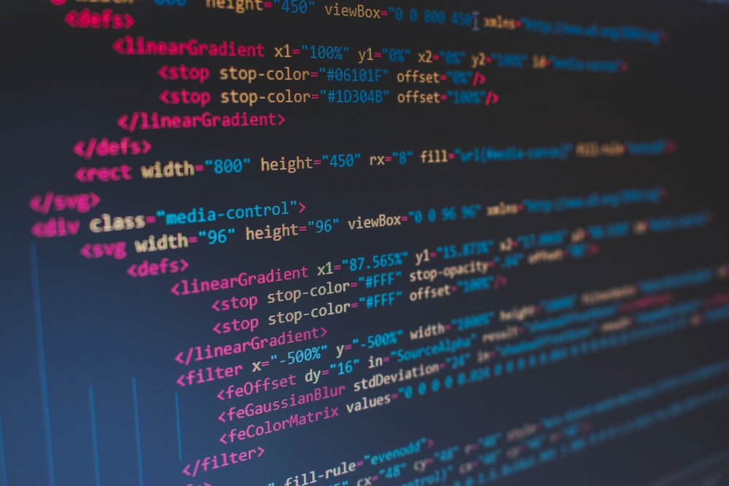

|  |
| --- |
| C++  MINIPROJECT |
|  |
| JULY 05  NAME: R.S.SANCHITH  ROLL : 21BIT046  WORK : BILLING SYSTEM |

# BILLING SYSTEM

✯ BILLING

✯ EDITING PRODUCTS

✯ MAINTAING STOCKS

✯ TO PRINT BILLS WITH DATE

✯ TO CALCULATE NET AMOUNT

✯ ADMIN CONTROLS

✯TO STORE THE PRODUCT DETAILS IN THE FILES

✯SAVE AND READ FROM FILE

|  |
| --- |
| TOPIC: THE BILLING SYSTEM  AIM:  TO CREATE A BILLING SYSTEM WITH USING C++ LANGUAGE WHICH MAKES BILLING MORE EASIER THAN WRITING IT . IT IS MORE ACCURATE THAN MANUAL BILLS. |
| MODULES |

CODE:

#include <iostream>

#include <string>

#include <fstream>

#include<ctime>

using namespace std;

class product

{

public:

int stock,cp,sp,total,quan,bill;

string id,name;

product()

{

name="";

id="";

cp=0;

sp=0;

stock=0;

}

product(string a,string b,int c,int d,int e)

{

name=a;

id=b;

stock=c;

cp=d;

sp=e;

}

void getdetail()

{

cout<<"\n____________________________________\n";

cout<<"ENTER THE PRODUCT NAME:";

cin>>name;

cout<<"ENTER THE PRODUCT ID:";

cin>>id;

cout<<"ENTER SELLING PRICE :";

cin>>sp;

cout<<"ENTER COST PRICE:";

cin>>cp;

cout<<"ENTER TOTAL NUMBER OF STOCKS ADDED:";

cin>>stock;

}

void printdetail()

{

cout<<"\n --------------------------------";

cout<<"\n|PRODUCT NAME :"<<name ;

cout<<"\n|PRODUCT ID :"<<id ;

cout<<"\n|PRODUCT STOCK :"<<stock ;

cout<<"\n|PRODUCT CP :"<<cp ;

cout<<"\n|PRODUCT SP :"<<sp ;

cout<<"\n ---------------------------------";

}

void billy();

void editdetail()

{

string bax;

cout<<"PRODUCT NAME:"<<name;

cout<<"\nDO YOU WANT TO CHANGE THE STOCKS or PRICE?";

cin>>bax;

if(bax == "STOCKS"||"stocks"||"stock"||"STOCK")

{

cout<<"\nENTER THE STOCK:";

cin>>stock;

}

else if(bax == "PRICE"||"price")

{

cout<<"ENTER THE CP:";

cin>>cp;

cout<<"ENTER THE SP:";

cin>>sp;

}

else

{

cout<<"\nENTER THE STOCK:";

cin>>stock;

cout<<"ENTER THE CP:";

cin>>cp;

cout<<"ENTER THE SP:";

cin>>sp;

}

}

friend void bill();

};

void product::billy()

{

cout<<name<<"\t\t"<<sp<<"\t\t"<<quan<<"\t\t"<<total<<"\n";

}

int main()

{

fstream bill;

fstream save;

int e=0,n=3,ch,sn=1,i,ch1,h=0,q,net=0,n0,no,cp,sp,stock;

string user,pass,x,name,id;

product obj[100];

time_t now = time(0);

tm *ltm = localtime(&now);

obj[1]={"RULLED NOTE","8902901035094",25,40,55};

obj[2]={"PONDS POWDER","8901030708152",30,10,15};

obj[3]={"COMFORT BLACK","8901030856341",25,2,4};

ifstream take("products.txt");

take>>no;

n=no;

for(i=4;i<=no;i++)

{

take>>name;

obj[i].name=name;

take>>id;

obj[i].id=id;

take>>cp;

obj[i].stock=cp;

take>>sp;

obj[i].cp=sp;

take>>stock;

obj[i].sp=stock;

}

take.close();

while(h==0)

{

e=0;

cout<<"****************************";

cout<<"\n---ENTER EXIT TO QUIT---";

cout<<"\nENTER USERNAME:";

cin>>user;

cout<<"ENTER PASSWORD:";

cin>>pass;

cout<<"\n****************************";

if(pass=="admin123")

{

while(e==0)

{

cout<<"\n_____________\n\n";

cout<<"1)PRODUCT DETAILS\n";

cout<<"2)ADD PRODUCT\n";

cout<<"3)EDIT PRODUCT\n";

cout<<"4)CHECK STOCKS\n";

cout<<"5)EXIT MAINMENU";

cout<<"\n_____________\n";

cout<<"ENTER CHOICE:";

cin>>ch;

switch(ch)

{

case 1:

{

cout<<"enter id";

cin>>x;

for(i=1;i<=n;i++)

{

try

{

if(obj[i].id == x)

{

throw id;

}

}

catch (string id)

{

obj[i].printdetail();

}

}

break;

}

case 2:

{

n++;

obj[n].getdetail();

bill.open("stock.txt",ios::out);

for(i=1;i<=n;i++)

{

bill<<"\n --------------------------------";

bill<<"\n|PRODUCT NAME :"<<obj[i].name ;

bill<<"\n|PRODUCT ID :"<<obj[i].id ;

bill<<"\n|PRODUCT STOCK :"<<obj[i].stock ;

bill<<"\n|PRODUCT CP :"<<obj[i].cp ;

bill<<"\n|PRODUCT SP :"<<obj[i].sp ;

bill<<"\n ---------------------------------\n";

}

bill.close();

save.open("products.txt",ios::out);

save<<n<<"\n";

for(i=4;i<=n;i++)

{

save<<obj[i].name<<" "<<obj[i].id<<" "<< obj[i].stock<<" "<<obj[i].cp<<" "<< obj[i].sp<<"\n";

}

save.close();

break ;

}

case 3:

{

cout<<"ENTER THE PRODUCT ID :";

cin>>x;

for(i=1;i<=n;i++)

{

if(x==obj[i].id)

{

obj[i].editdetail();

}

}

bill.open("stock.txt",ios::out);

for(i=1;i<=n;i++)

{

bill<<"\n --------------------------------";

bill<<"\n|PRODUCT NAME :"<<obj[i].name ;

bill<<"\n|PRODUCT ID :"<<obj[i].id ;

bill<<"\n|PRODUCT STOCK :"<<obj[i].stock ;

bill<<"\n|PRODUCT CP :"<<obj[i].cp ;

bill<<"\n|PRODUCT SP :"<<obj[i].sp ;

bill<<"\n ---------------------------------\n";

}

bill.close();

save.open("products.txt",ios::out);

save<<n<<"\n";

for(i=4;i<=n;i++)

{

save<<obj[i].name<<" "<<obj[i].id<<" "<< obj[i].stock<<" "<<obj[i].cp<<" "<< obj[i].sp<<"\n";

}

save.close();

break ;

}

case 5:

{

e=1;

break;

}

case 4:

{

cout << string(22, '\n');

cout<<"-------STOCKS-------";

for(i=1;i<=n;i++)

{

cout<<"\n"<<obj[i].name<<" = "<<obj[i].stock;

}

break;

}

default:

{

cout<<"ENTER A VALID OPTION";

}

}

}

}

else if(pass=="bill123")

{

e=0;

while(e==0)

{

x=1;

cout<<"\n_____________\n\n";

cout<<"1)NEW BILL\n";

cout<<"2)MAINMENU";

cout<<"\n_____________\n";

cout<<"ENTER CHOICE:";

cin>>ch1;

switch(ch1)

{

case 1:

{

while(x!="0")

{

cout<<"\nENTER ID:";

cin>>x;

for(i=1;i<=n;i++)

{

if(x==obj[i].id)

{

cout<<"ENTER QUANTITY:";

cin>>obj[i].quan;

if(obj[i].stock>=obj[i].quan)

{

obj[i].bill=1;

obj[i].stock= obj[i].stock-obj[i].quan;

obj[i].total=obj[i].quan*obj[i].sp;

}

else

{

cout<<"AVAILABLE STOCK IS ONLY:"<<obj[i].stock;

cout<<"\nSTOCKS MUST BE ADDED TO"<<obj[i].name;

}

}

}

}

save.open("products.txt",ios::out);

save<<n<<"\n";

for(i=4;i<=n;i++)

{

save<<obj[i].name<<" "<<obj[i].id<<" "<< obj[i].stock<<" "<<obj[i].cp<<" "<< obj[i].sp<<"\n";

}

save.close();

cout << string(22, '\n');

cout << "✸ DATE: "<<ltm->tm_mday<<"/"<< 1 + ltm->tm_mon<<"/"<< 1900 + ltm->tm_year;

cout<<"\n___________________⫷ ⫸WELCOME TO MEPCO STORE⫷ ⫸__________________\n";

cout<<"NAME\t\tCOST\t\tQUANTITY\t\tTOTAL\n";

for(i=1;i<=n;i++)

{

if(obj[i].bill==1)

{

net=obj[i].total + net;

obj[i].billy();

}

}

cout<<"\n\t\t\t\t\t___________________";

cout<<"\n\t\t\t\t\t| |";

cout<<"\n\t\t\t\t\t|NET AMOUNT:"<<net<<"rs";

cout<<"\n\t\t\t\t\t|_________________|";

cout<<"\n__________________________THANK YOU__________________________\n\n";

for(i=1;i<=n;i++)

{

obj[i].bill=0;

}

break;

}

case 2:

{

e=1;

break;

}

}

}

}

else if(pass=="exit"||"EXIT")

{

cout<<"\nতততততTHANK YOUততততত";

h=1;

}

else

{

cout<<"INVALID PASSWORD PLS TRY AGAIN";

}

}

return 0;

}

SOCIAL USE:

At its most basic description: billing software allows you to track the products and services your customers use, generate and send taxes, and receive payments. However, some billing platforms are capable of much more. They can automate the repetitive tasks your finance team struggles with on a daily basis. For example, some billing applications provide time tracking so that you can monitor how much time you’re spending on a client’s work – which is critical if you bill by the hour. In addition, billing software may also offer a variety of reports, track debt, manage collections and connect to key solutions to manage things such as taxation and payment processing. And, this is just the tip of the iceberg,

And we have just a created a basic outline of a billing system.

OUTPUTS :

THE OUTPUTS OF THE PROGRAM WAS SUCCESS.THE OUTPUTS ARE PINNED IN THE UPCOMMING PAGES

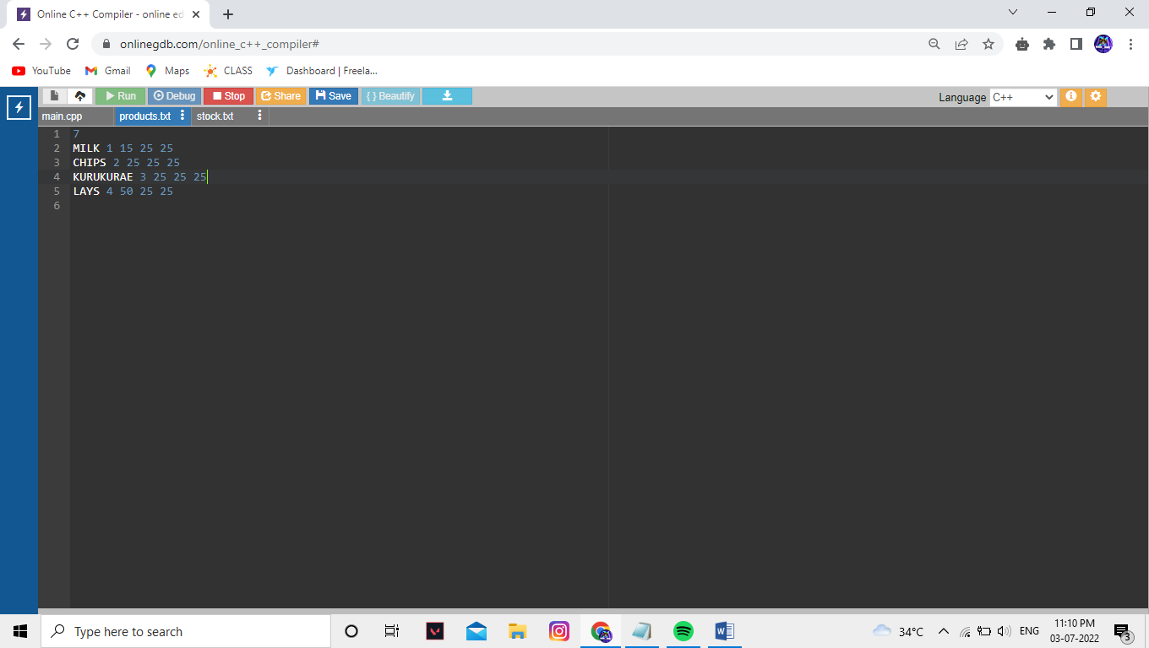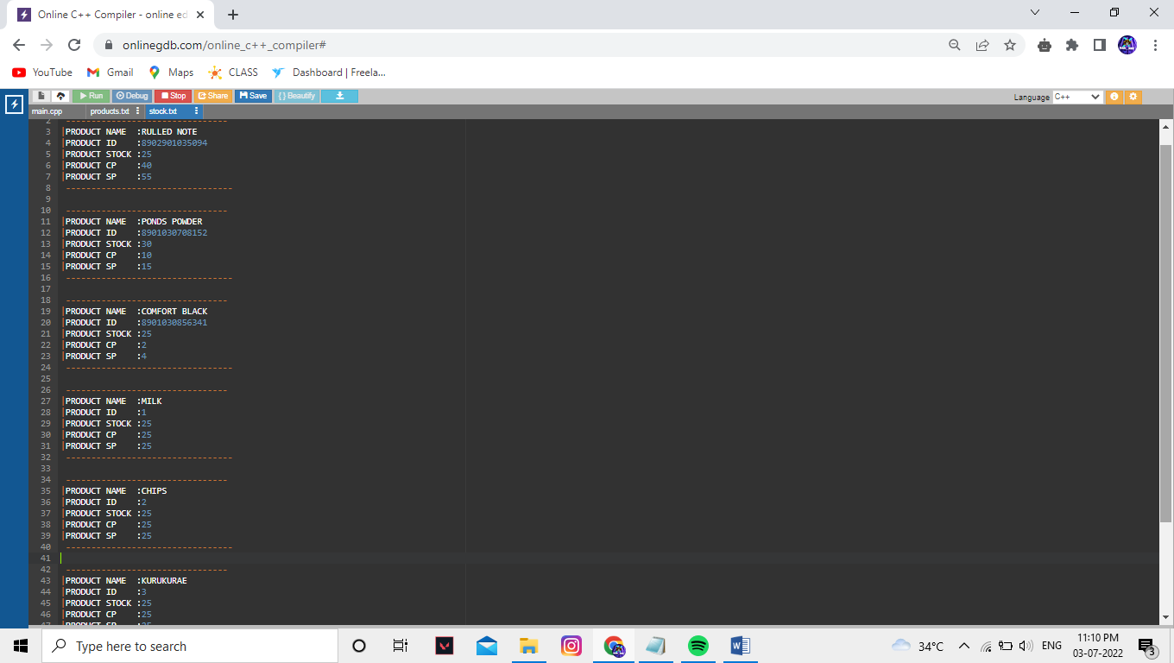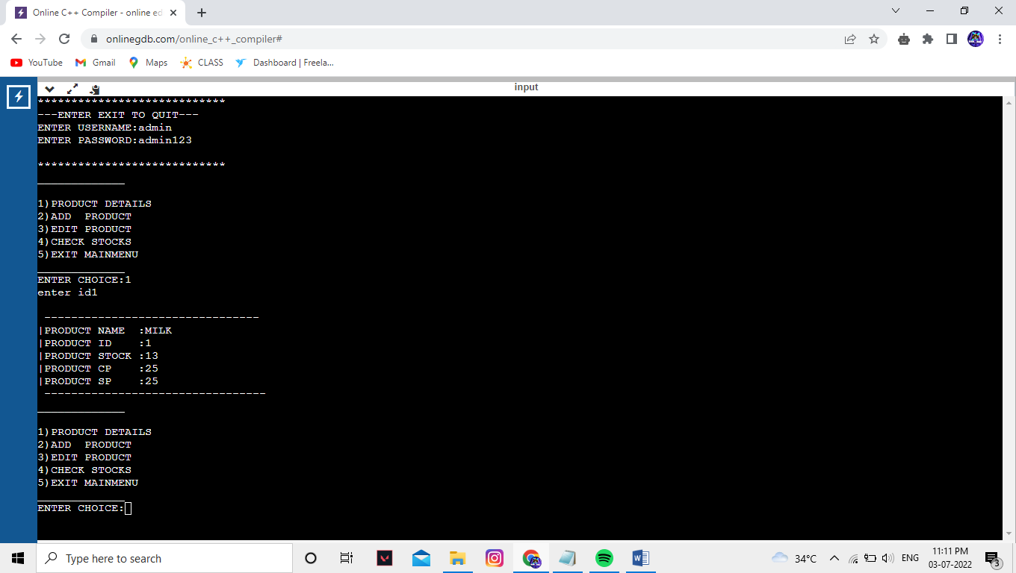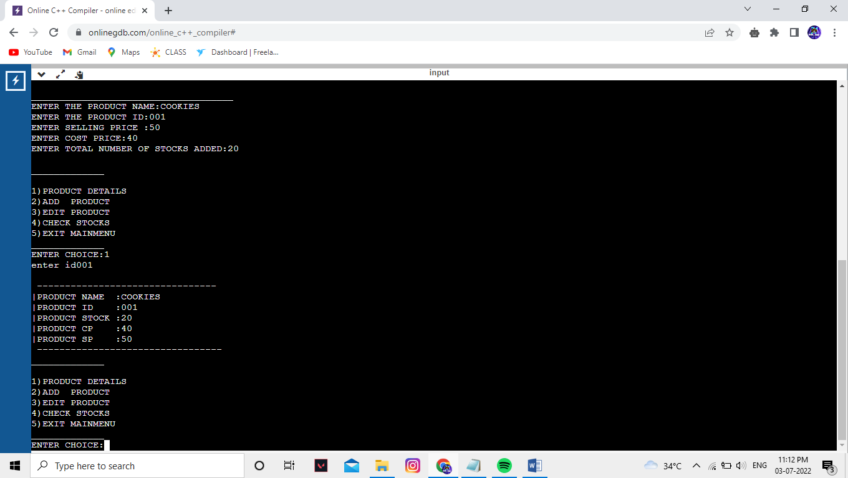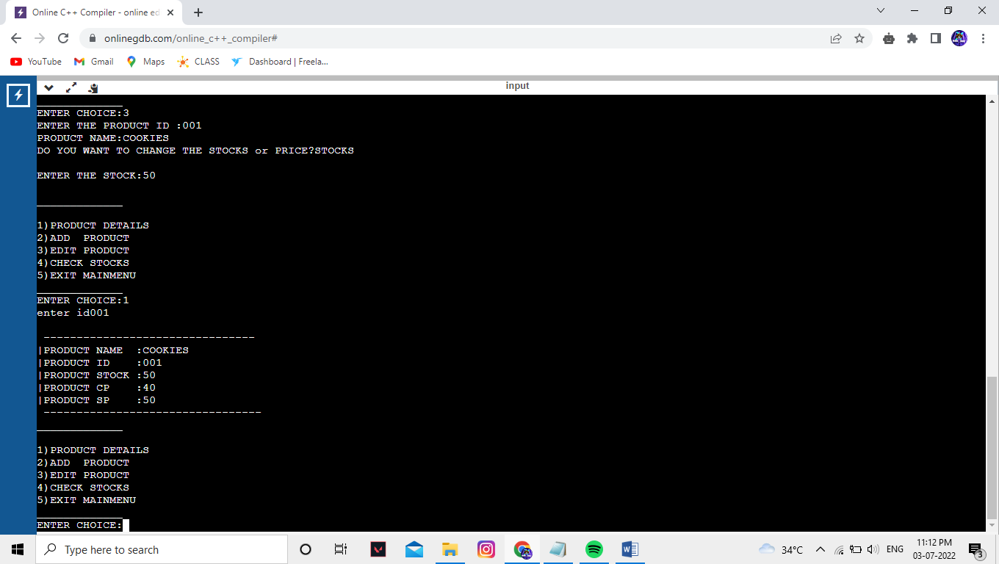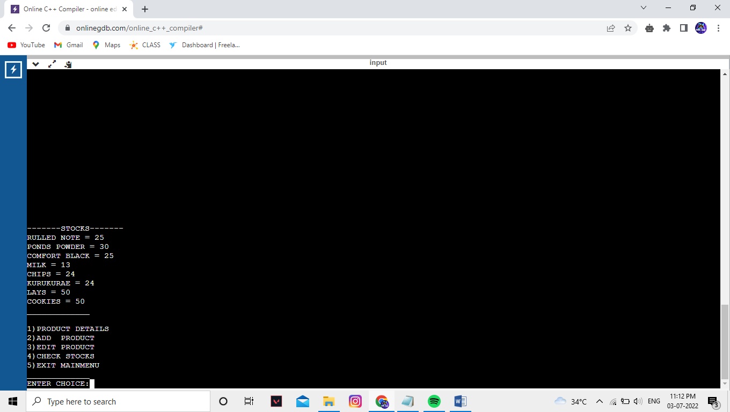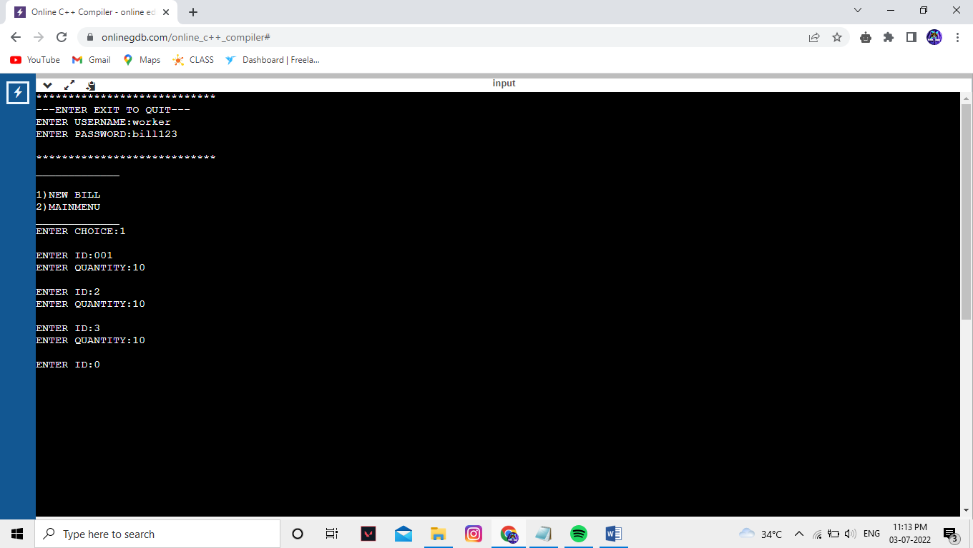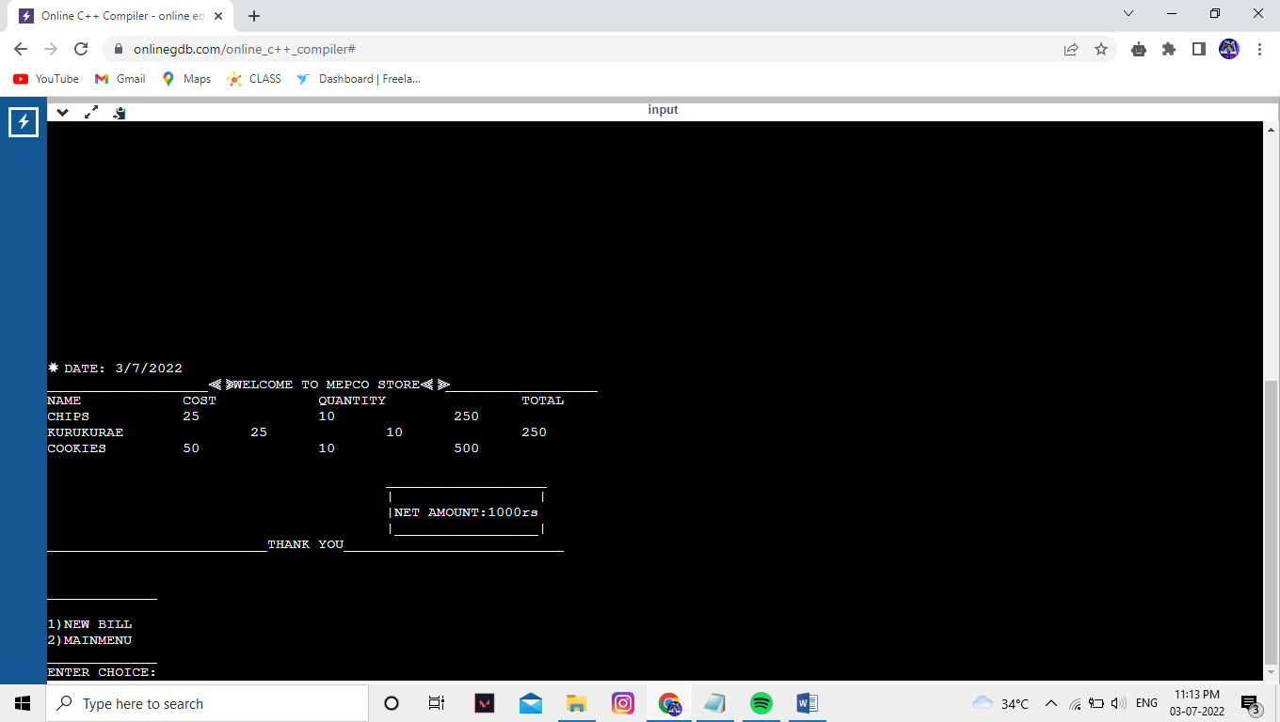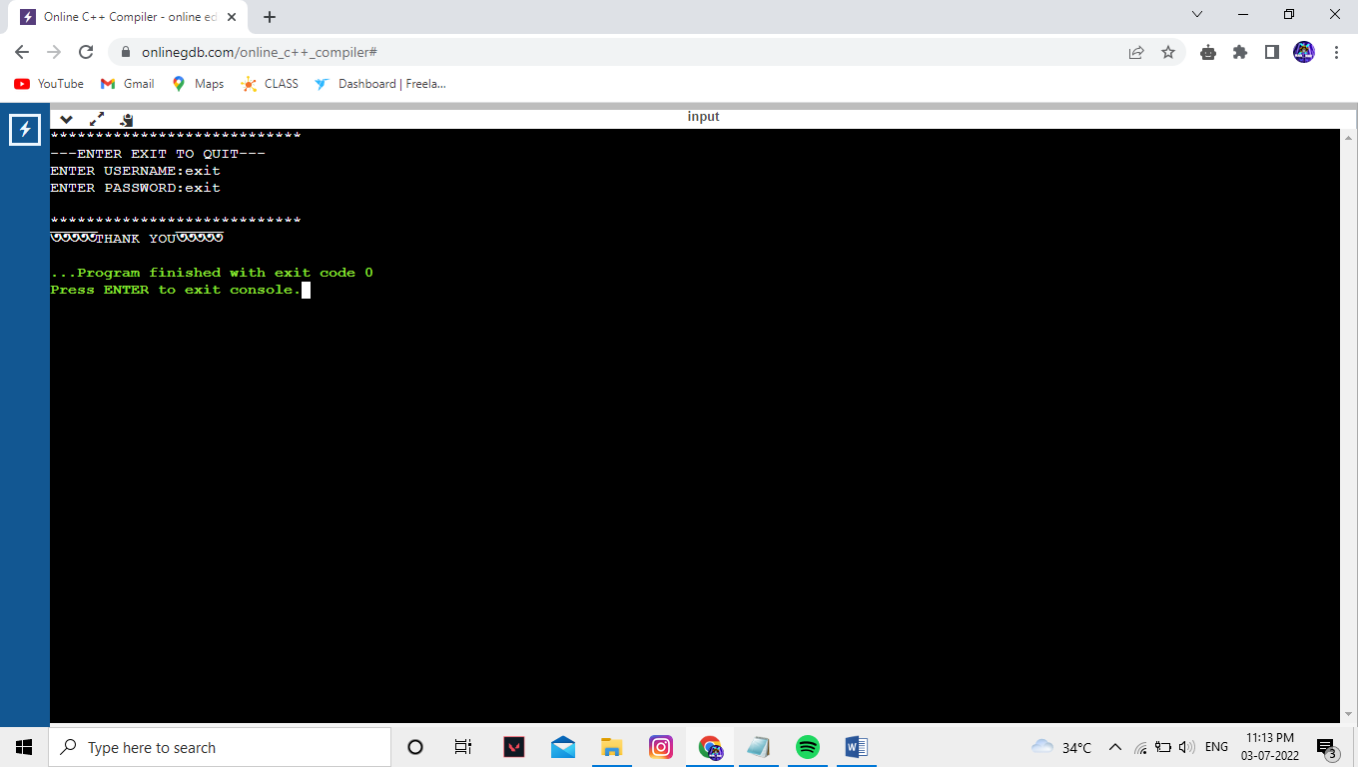

MODULES USED:

* CLASS & ARRAY OBJECT
* DEFAULT OPERATOR
* ARGUMENT OPERATOR
* FRIEND FUNCTION
* EXEPTIONAL HANDLING
* FILES IN C++
* READING A FILE
* WRITING IN A FILE
* HEADER FILE FOR TIME