# Web Design & Development CA2

Owen Doherty – x00076082

David Berry – x00125134

Rebekah Hayden – x00128369

## Introduction:

We decided to do our project on the Irish band Keywest. We wanted to make our website easy to navigate and straightforward to use so that people of all ages can easily navigate their way around the website and find what they are looking for. Our target audience is mainly focused towards people who are interested in and are fans of the band, or people generally interested in music. We have the 3 of us, who are working on the site as administrators, all having access to modify and update the website as needs be. If control of the website was to be passed on from ourselves, the management of the band and band members themselves would have access to modify the site.

Normal users of the site will be mainly directed there from the band. From our site, users will have access to all of the band’s social media accounts, an about section so as people can find out more information about the band, also a tour dates section to find out if the band are playing in your area(this will be our page in which we can create, update and delete from a database), a gallery which users can view images of the band’s live performances and a video page containing some of the band’s official videos featured on Youtube.

## Site Structure and Navigation:

As outlined above, our site will contain a homepage, an about page, a tour dates page, an image gallery and a page dedicated to videos of the band. Our site will contain a navbar which will be fixed in its location and will be the same navbar across all pages. Also featured on our navbar will be icons related to various social media platforms such as Twitter and Facebook. These icons will link to the band’s official social media accounts on these platforms. We aim to make our site as consistent and easy to use as possible for users.

Our site is going to be designed using desktops so our initial design will be based on desktops, however we aim to design our site so that it will be responsive and will scale to fit smaller devices such as tablets and mobile devices. This is influenced by how much we all use smaller devices rather than laptops and desktops. On average, we spend between approx 90-120 minutes per day on our phones, so we felt it would be necessary to ensure our design will cater for these devices.

We have decided that our Tour Date page will be the dynamic page when we begin the database part of the CA, it will be connected to an external database and the administrator will be able to add/delete/update tour dates on this page.

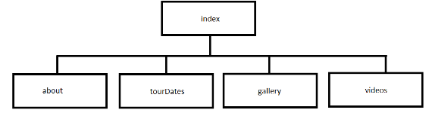

## Home Page:

## About Page:

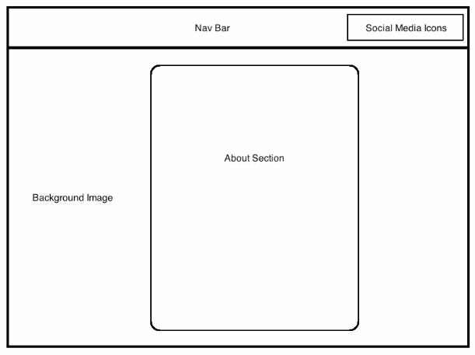

## Tour Dates Page:

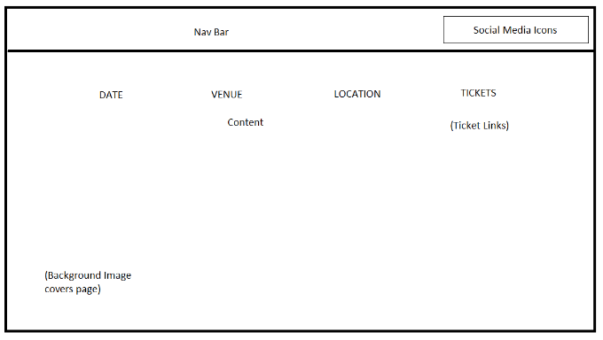

## Gallery Page:

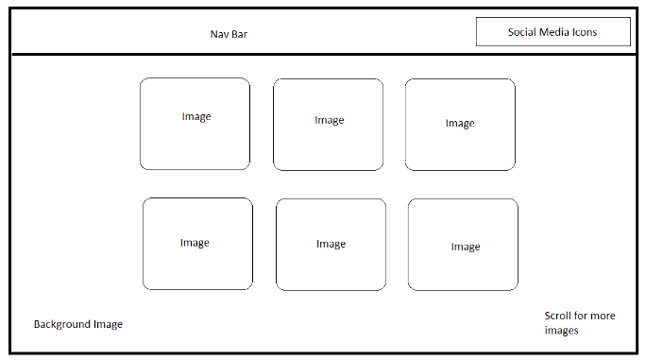

## Videos Page:

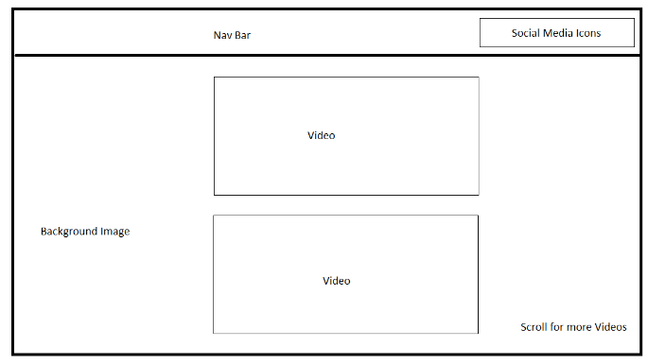

## Site Structure and Navigation continued:

For our website, we have decided to use a lot of dark colours in our design. We want the site to appear slick and cool in line with the image of a band. We have decided to use a grayscale filter with images that have colour in them. The images we will use for our carousel will be taken from Keywest’s social media accounts other online images of the band. For our background images, we will also use a grayscale filter on images that may need it. These images will be related to page in which they are located (e.g. About page background image will be an image of Dublin as that is where the band is located, Tour Dates page will feature an image of a crowd at a concert etc.). The Tour Dates page will also have buttons that will link to where the user can buy the tickets to the upcoming events.

The text we will use for the site will be simple and easy to read. We will most likely use letter spacing in sections with a heavy amount of text (e.g. the About section) to ensure that the content of these sections are legible. The other media which will be used will be videos. These videos will be embedded into our site and will come directly from Keywest’s official Youtube channel which will also be linked in a social media icon in our navbar.