***X00127602 – Rachel Hawe***

***Deploying Application***

**PART ONE : ZEIT**

While trying to deploy your app using Zeit you need to first download the application. After the initial download you can open your project and then create a file called “now.json”. Inside the file should be the following code printed below. (NB it is also important that this file is at the root of your project and not hidden away in sub folders)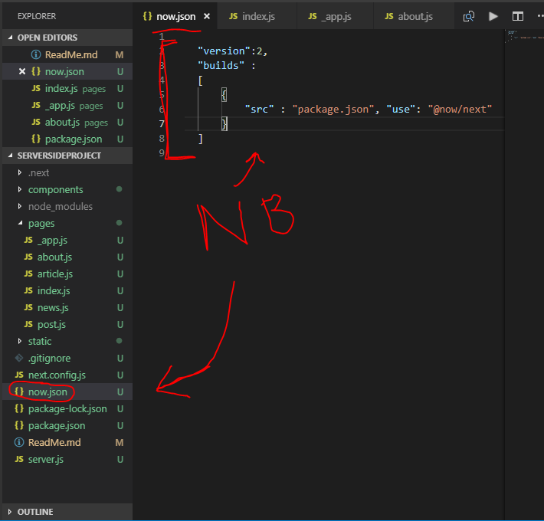

After you have inserted the following you can open a new terminal and type the key word “now” as a command. It gathers all you files from your package.json and starts to compile them giving you the URL where you can view your site from. (Nothing will show until the code has been successful and error free.

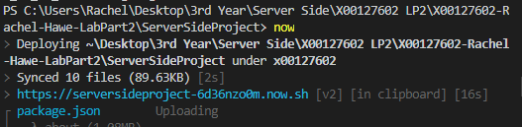

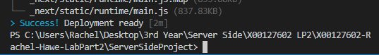

(Above you can see it has been a Success and can now view the URL that was provided. )

Your website will appear as it has before when we ran it locally. And we will just check that all pages are behaving and running as they have been before.

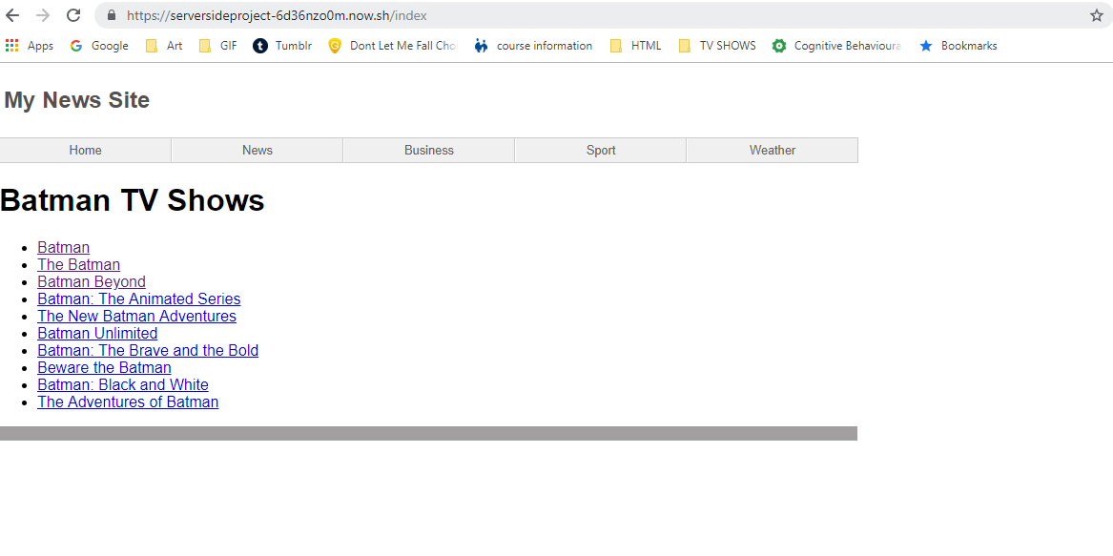

Heres the link I was given : [**https://serversideproject-6d36nzo0m.now.sh/index**](https://serversideproject-6d36nzo0m.now.sh/index)

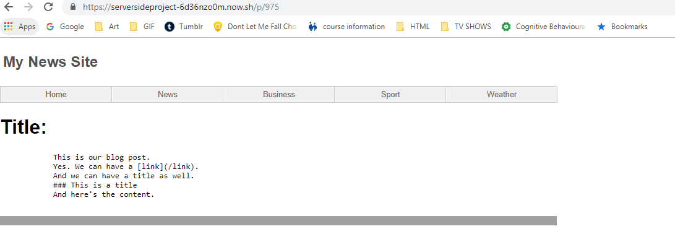

[**https://serversideproject-6d36nzo0m.now.sh/p/975**](https://serversideproject-6d36nzo0m.now.sh/p/975)

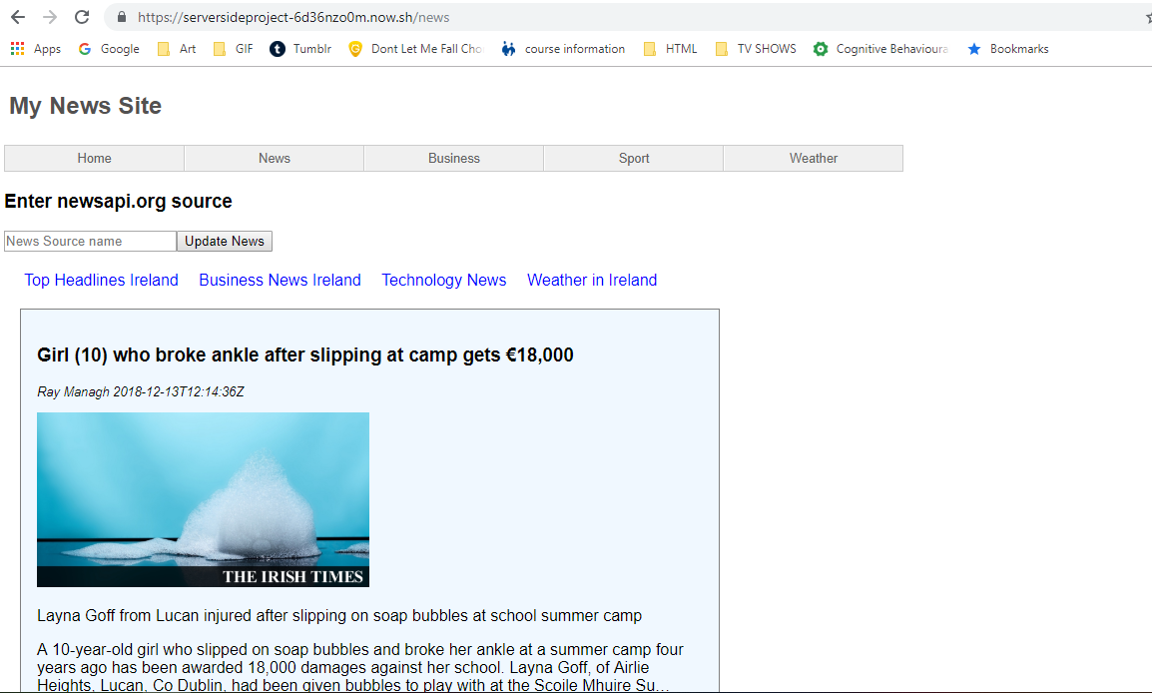

[**https://serversideproject-6d36nzo0m.now.sh/news**](https://serversideproject-6d36nzo0m.now.sh/news)

I wanted to ensure this wasn’t a local project so I asked a friend on a different server and leaving through a different gateway to test it and he got the same display luckily. So we are no guaranteeing this is not a local project it is global to view it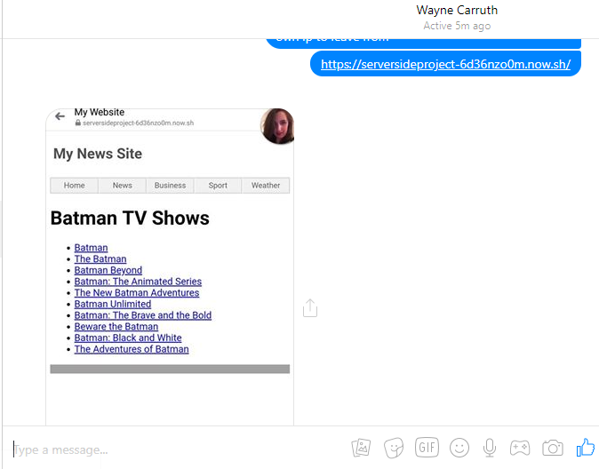

**REFERENCES AND TOOLS:**

Through this website it explained the use of cross-env and I found the more I read up on it the less I questioned the use for it.

[**https://www.npmjs.com/package/cross-env**](https://www.npmjs.com/package/cross-env)

Below is a step by step walkthrough of how the get your app deploying unfortuantly this was using MAC’s operating systems so the commands where a little different so a bit more research had to be done and therefore that’s why I needed the other links.

[**https://nextjs.org/learn/basics/deploying-a-nextjs-app**](https://nextjs.org/learn/basics/deploying-a-nextjs-app)

When running through npm it kept giving errors after much searching I found I was missing the cross-env import and therefore it wouldn’t work properly on the ports I wanted it to and kept throwing errors.

[**https://github.com/JeffreyWay/laravel-mix/issues/131**](https://github.com/JeffreyWay/laravel-mix/issues/131)

**PART 2 – HEROKU**

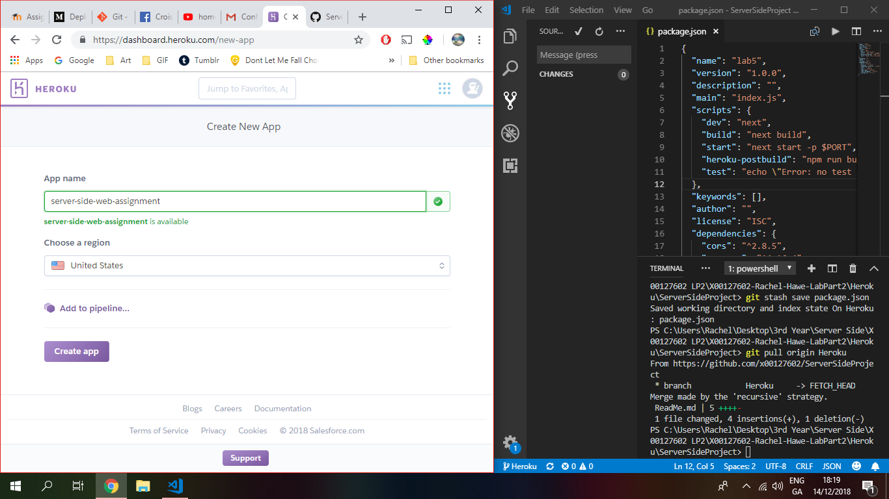

Set up my Heroku account

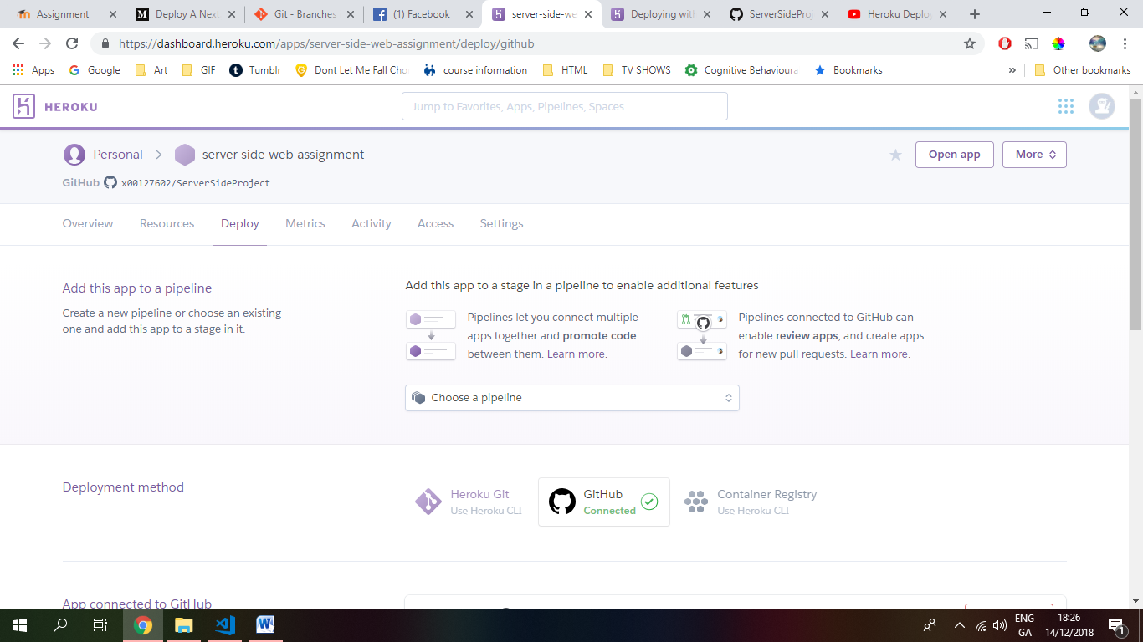

Made a place to hold out new application

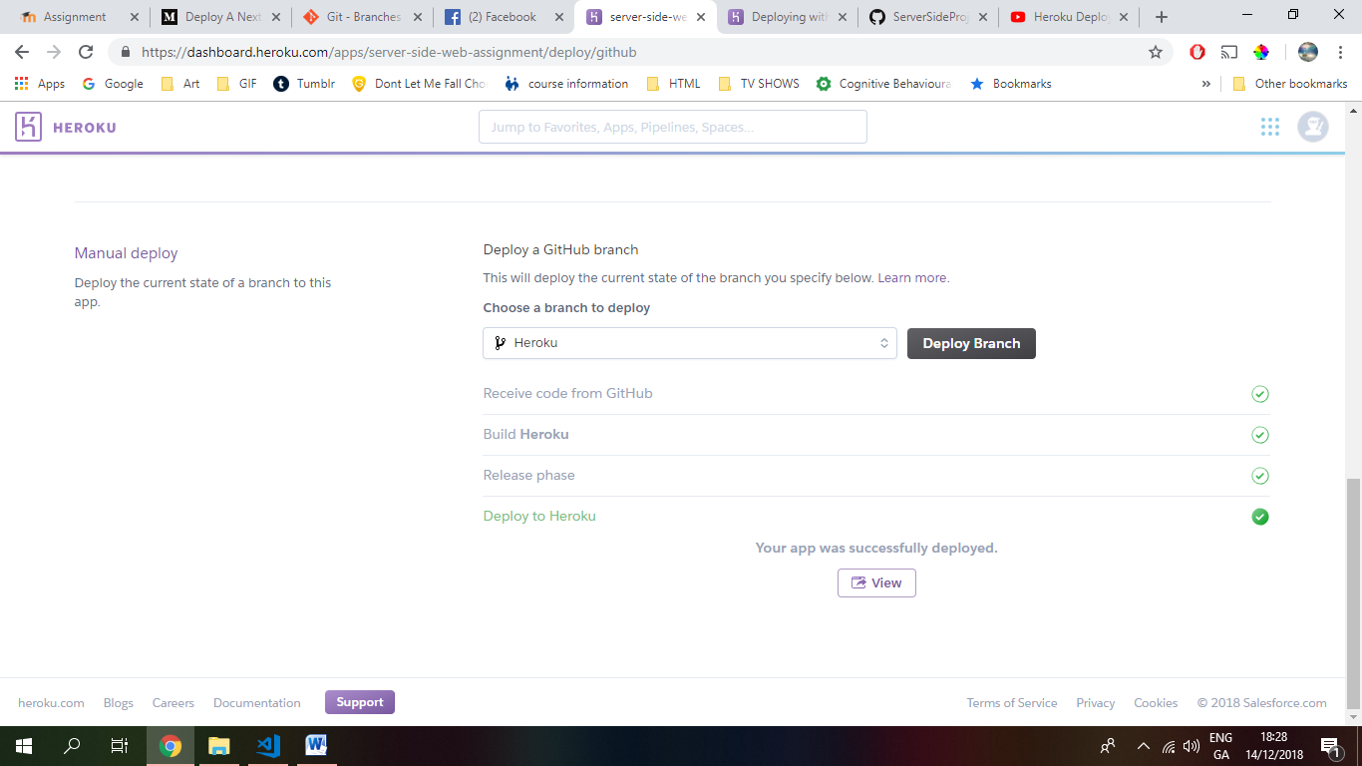

Connected my github account to heroku selecting which project and branch we want to deploy

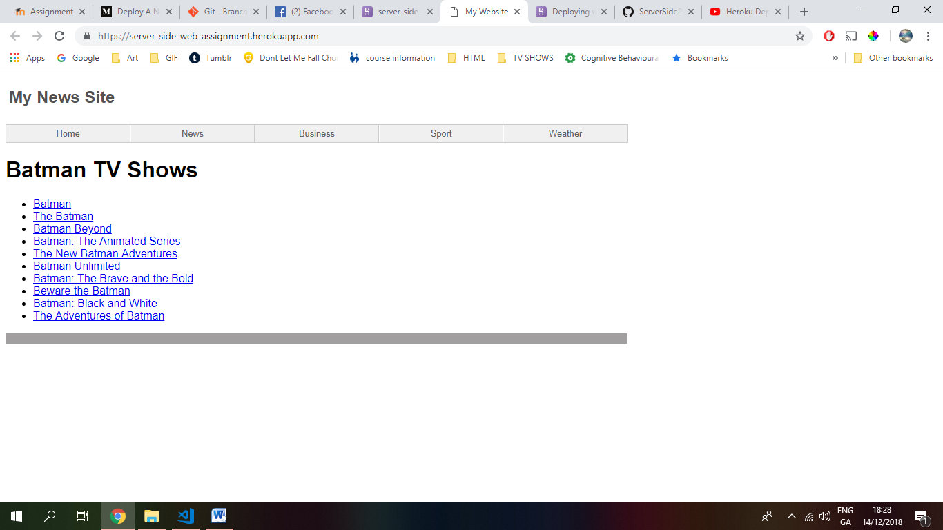

What our index page looks like after its been deployed

Heres the URL Given: <https://server-side-web-assignment.herokuapp.com/>

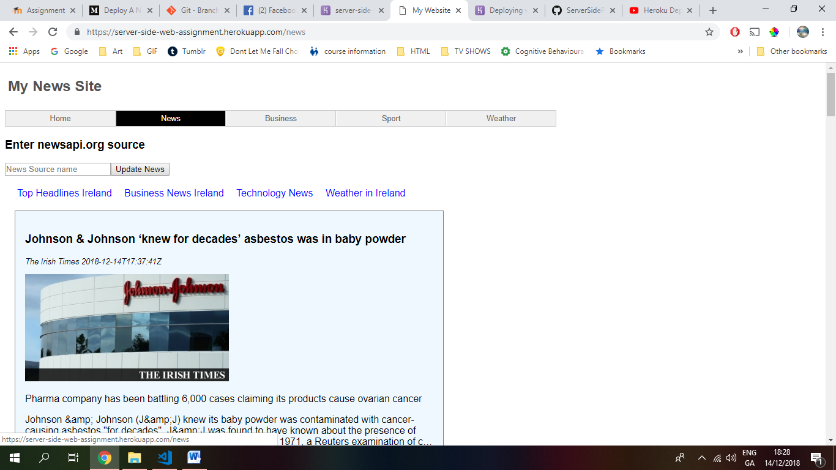

Along with a few other pages displaying.

Heres the link for our news page: <https://server-side-web-assignment.herokuapp.com/news>

**REFERENCES AND TOOLS:**

This was the deployment website we are using.

[**https://dashboard.heroku.com/apps**](https://dashboard.heroku.com/apps)

This is the written step by step of deploying your app using heroku along with the code that needs to be inserted or changed to get your app working error free.

[**https://medium.com/@jacoboakley/deploy-a-next-js-app-on-heroku-69bcb01db1b7**](https://medium.com/@jacoboakley/deploy-a-next-js-app-on-heroku-69bcb01db1b7)

The youtube video gave me a visual of how to go step by step to connect your github and deploy an applivation from there.

[**https://www.youtube.com/watch?v=3tK9qIdoJ6I**](https://www.youtube.com/watch?v=3tK9qIdoJ6I)

**OTHERS**

Helped me understand how to create separate branches in github.

<https://git-scm.com/book/en/v2/Git-Branching-Branches-in-a-Nutshell>