# Project Research Document

# NLP Loan Bot

X0141559 Aoife Bergin

## Detailed Discussion

The goal is to make an intuitive chat bot to handle the first step in the loan process.

This system is a tool to help customers of a bank interact with software on the web page to aid in the first step in applying for a loan, they can then be passed over to the loan advisor to complete the transaction

The bot will answer questions on loans and allow potential borrowers to get loan quotes.

The bot will inform potential borrowers about the different types of loans available and feed them back some loan calculations based on the user inputs.

The notion of a chat bot essentially replaces the ‘human’ at the other end of the chat and replaces them with a bot which can be trained to learn how best to help customers.

The customers feel as though they are having a human conversation, this benefits the customer as they do not have to wait for an agent to become free, and benefits the bank as they do not have to hire a member to take the chat.

According to the computer financial consultants Gartner “by 2020 chatbots will be handling no less than 85% of all customer service interactions” (Marous, 2019 ),.

The chat bots can be more efficient than human interaction as proved in a recent medicine AI study by Dr Luis Eduardo Juarez-Orozco of the Turku PET Centre in Finland where he uncovered his Logiboost application could predict heart attack with 90 percent accuracy, which is said to be better than that of doctors, discussed in (aimultiple.com, 2019).

This bot will have a menu of precomposed questions for the user to choose from, however the user can also type any question they wish and the bot can handle this.

Repeating questions can be stored in the database to help the loan advisors when they are analysing trends.

The latest rates will be pulled via a financial API to make for accurate quotes.

The bot will have the ability to be integrated with Facebook messenger and a UI.

Quotes generated will be stored in a data store and can be pulled by the loan advisors when they are calling to follow up with the sale and capturing the users email in the database for marketing purposes.

The bot can chat in different languages and remember users when they come back to chat after a certain period of time has elapsed, each user will be assigned an id in the database for this purpose.

This project contains the ability of training the data to give recommendations to future borrowers, this can be done via LUIS as it trains the model to be intelligent. The bot can email to customers so that they can view the quote generated via aws SNS.

The users can log into the dashboard using aws Cognito pools to chat to the bot in a secure setting as they will be giving sensitive information to the bot and they will be auto logged out after a certain period.

Microsoft bot framework, React and NodeJS will be used to implement the solution. Cosmos DB for a data store. If time allows to implement a function to email users when the rates change and to make the dashboard UI more intuitive.

The users are the prospective borrowers or anyone who is curious if they qualify for a loan or what the current rates are.

## Existing Applications in this domain

|  |  |  |  |  |  |  |  |
| --- | --- | --- | --- | --- | --- | --- | --- |
|  | **Comparison List** | |  |  |  |  |  |
|  |  |  |  |  |  |  |  |
|  | **Subject/Item** | **BAML Erica** | **Microsoft Xiaolce** | **Ally Bank** | **Wells Fargo** | **This Project** |  |
|  | **Social Media Integration** | ✗ | **✔** | ✗ | **✔** | **✔** |  |
|  | **Logging Conversations** | **✔** | **✔** | **✔** | **✔** | **✔** |  |
|  | **Make Calculations & recommendations** | **✔** | ✗ | **✔** | **✔** | **✔** |  |
|  | **Answer Questions** | **✔** | **✔** | **✔** | **✔** | **✔** |  |
|  |  |  |  |  |  |  |  |

A great example that was discussed in American Banker(2018) of a chat bot is called Erica who was made by Bank of America, they did an excellent marketing campaign around the launch and this is said to be accredited to the major success it has been. Erica allows customers to filter through transactions, allows the functionality to add up transactions, even lets customers pay bills.

Microsofts offering of Xiaolce although not in the financial space is of interest and became a social media star. It is a bot that chats to users and appears as a friend. The bot can speak mandarin and Microsoft indexed over 7 million public conversations so that she could speak fluidly. She offers context understanding an image recognition. Users failed to notice they were chatting to a bot for up to ten minutes.

Ally bank has a solution that can be accessed via text or voice and can make payments, and transfers. Ally bank chatbot also uses natural language to better meet customers needs for the future by leveraging machine learning and looking at past transactions and saving habits.

Wells Fargo uses a chatbot which is integrated with Facebook messenger. Using natural language, it can tell the customer their most recent transactions and bank account details, allowing customers to be served through social media channels.

## Platform, Technologies and Libraries

For the bot Framework Microsoft Azure was chosen, it is easily integrated with Facebook Messenger and trumps other frameworks with added features for example the ability to use translations.

The bot framework is made up of an open source SDK and tools for end-to-end bot development. Microsoft bot framework seamlessly integrates with LUIS and other Azure cloud services to make bot development a more pleasant experience. Yeoman will be used for generating the bot.

LUIS will be used to implement some intelligence in the bot, Luis is able to understand the users goals by understanding the intents and it can decipher entities from the sentence, for example “I want to order a coffee” is an example of an intent. “Coffee” would be an example of the entity.

QnA Maker is an API service which will be used to create a question and answer layer over the data, QnA continually learns from the users behaviour so we can say that our model will be trained be intelligent.

Microsoft chit-chat is an innovative service that allows a developer to add a personality to the bot, the professional personality will be a good fit for this project.

Direct Line API will be used to communicate between the bot and the client, for delivery, retrieval and authentication of messages.

Terraform for spinning up infrastructure. Route 53 for hosting a bot domain.

Azure CI/CD for the Pipelines.

Cosmos DB for data storage and retrieval, this is chosen because a no relational database is better suited to storing large and unpredictable data. This project will contain scenarios where the user is typing text and we cannot pre-empt what they will type or how much text they will want to write, so a document store model is a good fit.

Visual studio code will be the editor of choice and a private GitHub repository will be used to store the code.

AWS Cognito pools for login to the dashboards and AWS SNS messages to send users emails with loan quotes.

React to have a simple dashboard for the user to navigate and chat with their bot inside. NodeJS will be the language of choice. An open source UI for the Microsoft bot exists in a GitHub repository and is of interest to this project.

## The risks

The challenge will be working with technologies that are new, learning and implementing them in the time given. It can take some time to learn a new technology and there is also other elements to that like installing new software on your machine can take time and as a windows machine will be used for this project there will most likely be some compatibility issues and workarounds that will need to be made.

This project relies heavily on the application logic given that the UI will be relatively simple in terms of a chatbot UI. If the logic not correct it can impact the overall impression of how the bot works.

There needs to be a lot of research conducted into the area of loans within the retail banking sector, it is crucial that the business model is understood so that the logic can be applied correctly.

The frameworks which chosen are always being upgraded and things can change in certain libraries and editions of software and services, this could cause issues especially to services which are relied heavily upon, e.g. npm.

Architecture Diagram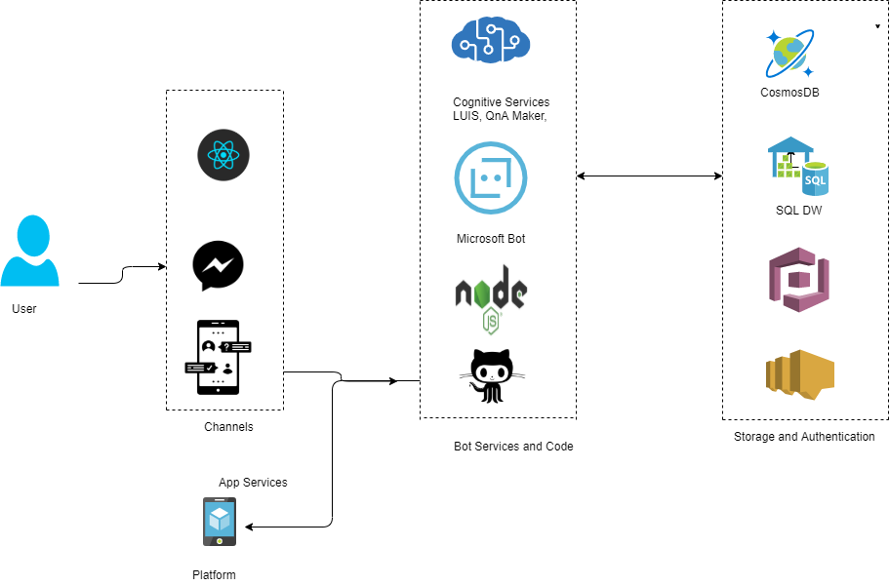

Bibliography

Penney Crosman (June 13, 2018) ‘A million people use Bank of America's erica chatbot . American Banker

Retrieved from <https://www.americanbanker.com/news/mad-about-erica-why-a-million-people-use-bank-of-americas-chatbot> (Accessed: October 05, 2019).

aimultiple.com (September 09, 2019 ) ‘Top 25 successful chatbots of 2019 & Reasons for their success‘ aimultiple.com Retrieved from <https://blog.aimultiple.com/top-chatbot-success/> (Accessed: October 05, 2019).

Jim Marous (January 08, 2019) ‘Meet 11 of the Most Interesting Chatbots in Banking ‘. The Financial Brand

Retrieved from <https://www.americanbanker.com/news/mad-about-erica-why-a-million-people-use-bank-of-americas-chatbot> (Accessed: October 05, 2019).

LUIS (Language Understanding) – Cognitive Services – Microsoft Azure (January 08, 2019) ‘LUIS‘. LUIS (Language Understanding) – Cognitive Services – Microsoft Azure Retrieved from https://luis.ai/home (Accessed: October 05, 2019).

|  |
| --- |
|  |

|  |
| --- |
|  |